

First European Survey on Language Competences:
Final Report

Version 4.0 21 June 2012
Including appendix with England results


The following abbreviations are in used in this report.
Abbreviations | In full
CB | Computer-based
CCO | Core Curriculum/Entitlement Option
CEFR | Common European Framework of Reference
CLIL | Content and Language Integrated Learning
CS | Compulsory Subject
DDR | Deutsche Demokratische Republik (German Democratic Republic)
EC | European Commission
ESLC | European on Language Competences
FL | Foreign Language
FLL | Foreign Language Learning
ICT | Information and Communication Technologies
ISCED | International Standard Classification of Education
NA | Not applicable
NQ | National Questionnaire
NRC | National Research Coordinator
OECD | Organisation for Economic Co-operation and Development
PB | Paper-based
PISA | Programme for International Student Assessment
PQ | Principal Questionnaire
SQ | Student Questionnaire
TL | Target Language
TQ | Teacher Questionnaire

Special thanks
SurveyLang would also like to thank the following people, institutions and boards for their contribution to the ESLC:
- The European Commission, their experts and the Advisory Board of the European Indicator of Language Competence have provided invaluable, constructive feedback throughout the project and have contributed to key decisions on technical issues.
- NRCs had a fundamental role in the ESLC. This project would simply not have been possible without their dedication and efforts.
- The SurveyLang Program Board, consisting of one member of each project partner, have met regularly throughout the project to review the project’s progress and have taken key decisions on work processes and technical issues. Michael Milanovic, the CEO of Cambridge ESOL, and Jan Wiegers, a Director at Cito, have shared the role of Chair of this group.
- SurveyLang would like to offer special thanks to Norman Verhelst, Project Director from February 2008 - December 2010, for his contribution and input to the ESLC. His work was fundamental in shaping the project and in developing and contributing to many of the technical solutions adopted.
Table of Contents

1 Introduction 1
1.1 Key features of the ESLC 2
1.2 This report 4
1.3 References 5
2 Population description 7
2.1 Introduction 7
2.2 ISCED levels, international grades and age in the population 7
2.3 Organisational structure of the educational systems 9
2.4 Organisation of foreign language learning 10
2.5 Population features and outcomes of the ESLC 14
3 The language tests 16
3.1 Overview 16
3.2 The link to the CEFR 16
3.3 Illustration of CEFR levels: Writing 19
3.4 Illustration of CEFR levels: Reading and Listening 20
3.5 The student questionnaire can-do statements 22
3.6 References 28
4 Language Tests: results 30
4.1 Overview 30
4.2 Global CEFR levels achieved 30
4.3 Performance in first and second target language, by educational system 32
4.4 Performance in each language and skill, by educational system 37
4.5 References 44
5 The context of foreign language teaching 46
5.1 Introduction 46
5.2 Basis for life-long learning of foreign languages 47
5.3 Language friendly living environment 49
5.4 Language friendly schools 50
5.5 Teacher initial and in-service training 57
5.6 Main findings 62
5.7 References 65
6 Relation of context factors with foreign language proficiency 68
6.1 Introduction 68
6.2 The effect of a basis for lifelong learning of foreign languages 69
6.3 The effect of a language friendly living environment 72
6.4 The effect of language friendly schools 74
6.5 The effect of teacher initial and in-service training 81
6.6 Main findings 84
6.7 References 85
7 Conclusions 87
7.1 Findings: language proficiency 87
7.2 Findings: the contextual questionnaires 91
7.3 References 93
8 Appendices 95
8.1 Can do statements 95
8.2 The language tests 97
8.3 The context of foreign language teaching 149
8.4 Managing and implementing the ESLC 222
8.5 Data tables 225
8.6 Appendix: England results 226

Reader’s guide to abbreviations and codes used in this report
The following educational system and language codes are used throughout this report.
Participating educational system | Educational system code | Questionnaire language(s) | Language code
Flemish Community of Belgium | BE nl | Dutch | Nl
French Community of Belgium | BE fr | French | Fr
German Community of Belgium | BE de | German/French | de, fr
Bulgaria | BG | Bulgarian | Bg
Croatia | HR | Croatian | Hr
England | UK-ENG | English | En
Estonia | EE | Estonian; Russian | et, er
France | FR | French | Fr
Greece | EL | Greek | El
Malta | MT | English | En
Netherlands | NL | Dutch | Nl
Poland | PL | Polish | Pl
Portugal | PT | Portuguese | Pt
Slovenia | SI | Slovene | Sl
Spain | ES | Spanish, Basque, Catalan, Galician, Valencian | es, Spanish-Basque Spanish-Catalan, Spanish-Galician, Spanish-Valencian
Sweden | SE | Swedish | Sv

Chapter 1: Introduction

Introduction
The European Survey on Language Competences (ESLC), the first survey of its kind, is designed to collect information about the foreign language proficiency of students in the last year of lower secondary education (ISCED2) or the second year of upper secondary education (ISCED3) (UNESCO 1997) in participating countries or country communities (referred to herein as educational systems). The intention was ‘not only to undertake a survey of language competences but a survey that should be able to provide information about language learning, teaching methods and curricula.” (European Commission 2007a). As the European Commission (2005) states, ‘it is important for Member States to be able to contextualise the data‘, and thus the language tests should ‘be complemented by questionnaires to teachers and pupils to gather contextual information’.
The ESLC is a collaborative effort among the 16 participating educational systems and SurveyLang partners to measure the language proficiency of approximately 53,000 students across Europe, to assist the European Commission in establishing a European Indicator of Language Competence to monitor progress against the March 2002 Barcelona European Council conclusions. These conclusions called for ‘action to improve the mastery of basic skills, in particular by teaching at least two foreign languages from a very early age’ and also for the ‘establishment of a linguistic competence indicator’ (European Commission 2005). As the Commission (European Commission 2005) states, the decision to launch the ESLC ‘arose from the current lack of data on actual language skills of people in the European Union and the need for a reliable system to measure the progress achieved’. The ESLC was therefore initiated by the Commission with the aim that: ‘the results collected will enable the establishment of a European Indicator of Language Competence and will provide reliable information on language learning and on the language competences of young people’ (European Commission 2007a) as well as providing ‘strategic information to policy makers, teachers and learners in all surveyed countries’ through the collection of contextual information in the background questionnaires (European Commission 2007b).
Each educational system tested students in two languages; the two most widely taught of the five most widely taught European languages: English, French, German, Italian and Spanish. This effectively meant that there were two separate samples within each educational system, one for the first test language, and one for the second. Each sampled student was therefore tested in one language only.
The ESLC sets out to assess students’ ability to use language purposefully, in order to understand spoken or written texts, or to express themselves in writing. Their observed language proficiency is described in terms of the levels of the Common European Framework of Reference (Council of Europe 2001), to enable comparison across participating educational systems. The data collected by the ESLC will allow participating educational systems to be aware of their students’ relative strengths and weaknesses across the tested language skills, and to share good practice with other participating educational systems.

To “facilitate a more productive comparison of language policies, and language teaching methods” (European Commission 2005:5) context questionnaires were administered to the students tested, their teachers of foreign languages, and their institution principals. In addition, system-wide information was collected through the National Research Coordinators. The context questionnaires provide information on a range of policies of the European Commission aimed at improving foreign language competences.
The ESLC data adds significantly to the knowledge base that was previously available at European level or from official national statistics. The data should prove a valuable resource for researchers, policy makers, educators, parents and students and will enable them to review progress towards achieving the March 2002 Barcelona European Council conclusions of learning two foreign languages from an early age.
SurveyLang recognises the contribution of all of its partners and National Research Coordinators (NRCs) in the delivery of the survey. The ESLC is methodologically complex and its implementation has required a considerable collaborative effort by the participating educational systems with SurveyLang. The in-country administration of the survey was the responsibility of the representatives of each educational system (National Research Coordinators, or NRCs). Implementing the ESLC depended not only on this collaboration but also on pooling the expertise of SurveyLang partners to develop and exploit innovative methodologies, test instruments and technologies.

Key features of the ESLC
Key features of the ESLC are outlined in brief below.
Sample size: Approximately 53,000 students enrolled in schools in 16 participating educational systems were assessed in the ESLC Main Study 2011.
Tested education level: Students were tested at the last year of lower secondary education (ISCED2) or the second year of upper secondary education (ISCED3) in participating educational systems.
Tests and questionnaires: The language tests covered three language skills: Listening, Reading and Writing in five test languages: English, French, German, Italian and Spanish. Each student was assessed in two out of these three skills in one test language and also completed a contextual questionnaire. Students were tested at one of three overlapping levels on the basis of a routing test. The language tests measure achievement of levels A1 to B2 of the Common European Framework of Reference (CEFR) (Council of Europe, 2001). The pre-A1 level which is also reported indicates failure to achieve A1. Language teachers and school principals at sampled schools also completed a contextual questionnaire.
Testing mode: The ESLC was administered in both paper and computer-based formats. The Teacher and Principal Questionnaires were administered through an internet based system.
Testing duration: Students had either 30 minutes or 45 minutes to complete each test. All Listening and Reading tests were set at 30 minutes. The low and intermediate Writing tests were set at 30 minutes, while the high level Writing test and Student Questionnaires (including a CEFR self-assessment) were set at 45 minutes. The total testing time for a student, including the questionnaire, was thus 105 or120 minutes.
Summary of tested languages, levels and testing mode across participating educational systems: The table below provide a summary of the tested languages, levels and testing mode of each educational system. Further details on the tested languages and levels can be found in Chapter 4 on sampling in the ESLC Technical Report.
Table 1: Educational system testing design summary
Educational system | First most widely taught foreign language | Testing grade for ‘First’ language | Second most widely taught foreign language | Testing grade for ‘Second’ language | Testing mode
Flemish Community of Belgium (BE nl) | French | ISCED2 | English | ISCED3 | CB
French Community of Belgium (BE fr) | English | ISCED3 | German | ISCED3 | CB
German Community of Belgium (BE de) | French | ISCED2 | English | ISCED3 | PB
Bulgaria (BG) | English | ISCED3 | German | ISCED3 | PB
Croatia (HR) | English | ISCED2 | German | ISCED2 | CB, PB
England (UK-ENG) | French | ISCED3 | German | ISCED3 | PB
Estonia (EE) | English | ISCED2 | German | ISCED2 | CB, PB
France (FR) | English | ISCED2 | Spanish | ISCED2 | PB
Greece (EL) | English | ISCED2 | French | ISCED2 | PB
Malta (MT) | English | ISCED2 | Italian | ISCED2 | PB
Netherlands (NL) | English | ISCED2 | German | ISCED2 | CB
Poland (PL) | English | ISCED2 | German | ISCED2 | PB
Portugal (PT) | English | ISCED2 | French | ISCED2 | CB
Slovenia (SI) | English | ISCED2 | German | ISCED2 | PB
Spain (ES) | English | ISCED2 | French | ISCED2 | PB
Sweden (SE) | English | ISCED2 | Spanish | ISCED2 | CB, PB

Outcomes – the ESLC delivers the following outcomes:
- A profile of the language proficiency of sampled students. Contextual indicators providing a broad range of information on the context of foreign language teaching policies and foreign language learning at student, teacher and school level
- Information on the relationship between language proficiency and the contextual indicators
- A resource and knowledge base for policy analysis and research.

This report
This Final Report is concerned with the results of the ESLC. Technical aspects of the ESLC are addressed separately in the ESLC Technical Report.
Note that England completed the survey later and results are provided in a separate appendix to this Report. For clarity, no results in the Final Report include England.
This report includes the following sections:
- Chapter 2 describes the tested population: the students, the organisational structure of the education systems and of language teaching,
- Chapter 3 describes the approach to constructing language tests and linking to the CEFR levels. It illustrates the test tasks for Writing, Reading and Listening and provides examples of Writing production; it also discusses the results of students’ self-ratings on 16 CEFR-related can-do statements.
- Chapter 4 presents results, globally, by first and second target languages, and by tested language, for each skill.
- Chapter 5 presents the descriptive results of the Student and Teacher and Principal Questionnaires, showing each educational system’s status on each estimated index.
- Chapter 6 presents the results of the regression analyses which explore the relation between questionnaire indices and performance on the language tests.
- Chapter 7 offers a brief summary and discussion of the most significant outcomes.
Policy-relevant findings can be found in chapters 4 to 6, and are summarised in chapter 7.
The data underlying the major graphs in this report together with standard errors are provided in the EXCEL file ESLC Appendix all tables chapters 4-5-6.xls , available with this report.

References
Council of Europe (2001) Common European Framework of Reference for Languages: Learning, Teaching, Assessment. Cambridge: Cambridge University Press
European Commission (2005) Commission Communication of 1 August 2005 - The European Indicator of Language Competence [COM(2005) 356 final - Not published in the Official Journal], retrieved 18 January 2012, from http://europa.eu/legislation_summaries/education_training_youth/lifelong_learning/c11083_en.htm
European Commission (2007a) Communication from the Commission to the Council of 13 April 2007 entitled “Framework for the European survey on language competences” [COM (2007) 184 final – Not published in the Official Journal]
European Commission (2007b) Terms of Reference: Tender no. 21 “European Survey on Language Competences”. Contracting Authority: European Commission
UNESCO (1997) International Standard Classification of Education, 1997 United Nations Educational Scientific and Cultural Organization

Chapter 2: Population description

Population description

Introduction
In this chapter the different populations in the ESLC (2010-2011) are described. The populations differ by educational system and target language. The research-population for each target language in an educational system consists of students in the last year of lower secondary education (ISCED2) or the second year of upper secondary education (ISCED3). In addition, students in the research-population are attending educational institutions located within the educational system and studying the specific language to be tested for a defined minimum period of one academic year prior to the testing year. The sampling chapter (chapter 4) of the ESLC Technical Report has further details about the testing grades for each educational system.
The decision to test one or both target languages in some educational systems at ISCED3 has been taken when the target language is not taught at ISCED2 in an educational system, or has been taught for too short a period for students to have completed one academic year’s study prior to testing.
In each educational system two target languages were tested: the two most widely taught foreign languages in the educational system from the five most widely taught foreign languages in Europe (English, French, German, Italian and Spanish).

ISCED levels, international grades and age in the population

Survey design
Table 2 shows the target languages per educational system, the ISCED level and international grade (where international grade 1 is the first grade of compulsory ISCED1) in which the students were placed at the time of the test and the student’s typical age at the time of the test (2010-2011).
In three educational systems students were not tested in the first and second most widely taught foreign languages as these were not among the five most widely taught languages in Europe that were included in the ESLC. In these educational systems, the languages tested are the first and third (Bulgaria and Estonia) or second and third (the French Community of Belgium).
In the majority of educational systems, students were tested at the end of ISCED2, except for the Flemish and German Communities of Belgium (second target language), the French Community of Belgium, Bulgaria and England where students were tested in ISCED3.
In general, the typical age of the students tested was 14 or 15, but in Bulgaria the typical age was 16 and in the Flemish and German Communities of Belgium the typical age of the first target language population was 13.
For the majority of the students, the international grade in which they were enrolled at the time of the test was either grade 9 or grade 10. In the Netherlands, the grade in which the students were enrolled depended on the school type they were in; for both school types the testing grade was the last grade of ISCED2. In the Flemish and German Communities of Belgium the testing grade differed for the different populations; grade 8 for the first target language and grade 10 for the second target language. In Croatia, students were tested in grade 8 in both target languages.
Table 2: Survey Design
 |  | Target language 1 |  |  |  | Target language 2
Educational system |  | TL1 | ISCED level | Typical age | International grade | TL2 | ISCED level | Typical age | International grade
Flemish Community of Belgium | BE nl | FR | 2 | 13 | 8 | EN | 3 | 15 | 10
French Community of Belgium | BE fr | EN ^{2nd} | 3 | 15 | 10 | DE ^{3rd} | 3 | 15 | 10
German Community of Belgium | BE de | FR | 2 | 13 | 8 | EN | 3 | 15 | 10
Bulgaria | BG | EN | 3 | 16 | 10 | DE ^{3rd} | 3 | 16 | 10
Croatia | HR | EN | 2 | 14 | 8 | DE | 2 | 14 | 8
England | UK-ENG | FR | 3 | 15 | 11 | DE | 3 | 15 | 11
Estonia | EE | EN | 2 | 15 | 9 | DE ^{3rd} | 2 | 15 | 9
France | FR | EN | 2 | 14 | 9 | ES | 2 | 14 | 9
Greece | EL | EN | 2 | 14 | 9 | FR | 2 | 14 | 9
Malta | MT | EN | 2 | 15 | 11 | IT | 2 | 15 | 11
Netherlands | NL | EN | 2 | 14-15 | 9-10 | DE | 2 | 14-15 | 9-10
Poland | PL | EN | 2 | 15 | 9 | DE | 2 | 15 | 9
Portugal | PT | EN | 2 | 14 | 9 | FR | 2 | 14 | 9
Slovenia | SI | EN | 2 | 14 | 9 | DE | 2 | 14 | 9
Spain | ES | EN | 2 | 15 | 10 | FR | 2 | 15 | 10
Sweden | SE | EN | 2 | 15 | 9 | ES | 2 | 15 | 9

Organisational structure of the educational systems

Starting age of compulsory education
Figure 1 represents the starting age of compulsory education per educational system as reported in the national questionnaire. The figure shows that in 10 of the 16 educational systems compulsory education starts at the age of 6. In four educational systems, compulsory education starts at the age of 5 (England, Greece, Malta and the Netherlands) and in two educational systems compulsory education starts at the age of 7 (Estonia and Sweden).
Figure 1: Starting age (onset) of compulsory education

Duration of ISCED levels 1 and 2
Figure 2 represents the duration of ISCED levels 1 and 2 per educational system. In the majority of educational systems the duration of ISCED2 is shorter than the duration of ISCED1; the modal duration of ISCED1 is six years and the modal duration of ISCED2 is three years. Exceptions are Bulgaria and Croatia, where the duration of both ISCED levels is four years. Malta has the longest total duration of ISCED levels 1 and 2 together (11 years), followed by Spain (10 years) and the Netherlands (either 9 or 10 years, depending on the school type).
Figure 2: Duration of ISCED levels 1 and 2 in number of grades

Organisation of foreign language learning

Compulsory foreign language learning
Table 3 shows the number of foreign languages that are compulsory for (almost) all students in a particular grade. If two numbers are shown, these are the minimum and the maximum number of foreign languages that are compulsory for students if the numbers differ for different types of study in an educational system. Grades 0, -1, -2 and -3 are grades prior to the first grade of ISCED1 (international grade 1).

Table 3: Number of Languages Compulsory for All Students by International Grade
 | BE de | BE  fr | BE  nl | BG | EE | EL | ES | FR | HR | MT | NL | PL | PT | SE | SI | UK-ENG
-3 |  |  |  | 0 | 0 |  |  |  | 0 |  |  | 0 |  | 0
-2 | 1 | 0 | 0 | 0 | 0 | 0 | 1 | 0 | 0 |  | 0 | 0 | 0 | 0 | 0
-1 | 1 | 0 | 0 | 0 | 0 | 0 | 1 | 0 | 0 | 0 | 0-1* | 0 | 0 | 0 | 0 | 0
0 | 1 | 0 | 0 | 0 | 0 | 0 | 1 | 0 | 0 | 0 | 0-1* | 0 | 0 | 0 | 0 | 0
1 | 1 | 0 | 0 | 0 | 1* | 0-1 | 1 | 0 | 1 | 1 | 0-1* | 1 | 1* | 0* | 0 | 0
2 | 1 | 0 | 0 | 1 | 1 | 0-1 | 1 | 1 | 1 | 1 | 0-1* | 1 | 1 | 0* | 0 | 0
3 | 1 | 0 | 0 | 1 | 1 | 1 | 1 | 1 | 1 | 1 | 0-1* | 1 | 1 | 0* | 0 | 0
4 | 1 | 0 | 0 | 1 | 2* | 1 | 1 | 1 | 1 | 1 | 0-1* | 1 | 1 | 1* | 1 | 0
5 | 1 | 1 | 1 | 1 | 2 | 2 | 1 | 1 | 1 | 1 | 1* | 1 | 1* | 1 | 1 | 0
6 | 1 | 1 | 1 | 1 | 2 | 2 | 1 | 1 | 1 | 1 | 1* | 1 | 1 | 1-2 | 1 | 0
7 | 1 | 1 | 0-1 | 1 | 2 | 2 | 1 | 1 | 1 | 2 | 1-3 | 2 | 2* | 1-2 | 1-2 | 1*
8 | 1*-2* | 1 | 0-2 | 1 | 2 | 2 | 1 | 2 | 1 | 2 | 1-3 | 2 | 2 | 1-2 | 1-2 | 1
9 | 1*-3* | 0-1 | 0-2 | 2 | 2 | 2 | 1 | 1-2 | 1-3 | 2 | 1-3 | 2 | 2 | 1-2 | 1-2 | 1
10 | 1-3 | 0-1 | 0-3 | 2 | 2 | 2 | 1 | 2 | 1-3 | 2 | 1 | 1-2 | 1* | 1-3* | 1-2 | 0
11 | 1-3 | 0-3 | 0-3 | 2 | 2 | 1 | 0-1 | 1-2 | 1-3 | 2 | 1 | 1-2 | 1 | 1-3 | 1-2 | 0
12 | 1-3 | 0-3 | 0-3 | 2 | 2 | 1 | 0-1 | 1-2 | 1-3 | 0-1 | 0-1 | 2 | 1 | 1-3 | 1-2 | 0
13 |  |  |  |  |  |  |  |  |  | 0-1 |  |  |  |  | 1-2 | 0
* Variable starting grade; ▪=ISCED1; ▪=ISCED2; ▪=ISCED3
As Table 3 shows, there is some variance in the number of languages that are compulsory for all students.
Table 4 shows whether foreign language learning (FLL) is a compulsory subject or a core curriculum/entitlement option in the curriculum as specified by the central (or highest level) authorities. Foreign languages are a core curriculum option or entitlement option when “schools (according to the centrally determined curriculum) must offer at least one foreign language among the set of optional subjects. According to the same centrally determined curriculum, each pupil must choose at least one subject (which does not have to be a language) from this set of subjects.” (Eurydice, Key Data on Teaching Languages at School in Europe 2008:113).
Table 4: FLL is a Compulsory Subject (CS) or a Core Curriculum/Entitlement Option (CCO) in the curriculum*
Educational system | ISCED1 |  | General ISCED2 |  | Vocational ISCED2 |  | General ISCED3 |  | Vocational ISCED3
 | CS | CCO | CS | CCO | CS | CCO | CS | CCO | CS | CCO
BE de | 2 | 0 | 2 | 0 | NA | NA | 2 | 0 | 2 | 0
BE fr | 2 | 0 | 2 | 0 | NA | NA | 2 | 0 | 1 | 0
BE nl | 2 | 0 | 1 | 0 | NA | NA | 2 | 0 | 1 | 0
BG | 2 | 0 | 2 | 1 | NA | NA | 2 | 1 | 2 | 1
EE | 2 | 0 | 2 | 0 | NA | NA | 2 | 0 | 2 | 0
EL | 2 | 0 | 2 | 0 | NA | NA | 2 | 2 | 2 | 0
ES | 2 | 0 | 2 | 2 | NA | NA | 2 | 2 | 1 | 1
FR | 2 | 0 | 2 | 0 | NA | NA | 2 | 1 | 2 | 0
HR | 2 | 2 | 2 | 2 | NA | NA | 2 | 2 | 2 | 1
MT | 2 | 0 | 2 | 2 | NA | NA | 0 | 1 | 2 | 1
NL | 2 | 0 | 2 | 2 | 2 | 2 | 2 | 2 | 1 | 1
PL | 2 | 0 | 2 | 0 | NA | NA | 2 | 0 | 2 | 0
PT | 2 | 0 | 2 | 0 | 2 | 0 | 2 | 0 | 2 | 0
SE | 2 | 0 | 2 | 0 | NA | NA | 2 | 0 | 2 | 0
SI | 2 | 0 | 2 | 2 | NA | NA | 2 | 2 | 2 | 0
UK-ENG | 0 | 2 | 2 | 0 | NA | NA | 0 | 2 | 0 | 2
* As specified by the central (or highest level) authorities. NA=Not applicable (No vocational ISCED2); 0=For none; 1=Only for students in certain types of study; 2=For all (or almost all) students.
In general, foreign language learning is a compulsory subject for all (or almost all) students in ISCED levels 1, 2 and 3. Exceptions are:
- ISCED1 in England, where foreign language learning is a core curriculum/entitlement option for all (or almost all) students
- ISCED1 in Slovenia, where foreign language learning is a core curriculum/entitlement option for some students
- general ISCED2 in the Flemish Community of Belgium, where foreign language learning is only compulsory for students in certain types of study
- general and vocational ISCED3 in England, where foreign language learning is a core curriculum/entitlement option for all (or almost all) students
- general ISCED3 in Malta, where foreign language learning is a core curriculum/entitlement option for students in certain types of study
- vocational ISCED3 in the Flemish and French Communities of Belgium, Spain and the Netherlands, where foreign language learning is compulsory for students in certain types of study.
Specific languages that are mandatory in the foreign language curriculum for all (or almost all) students are:
- English in ISCED1 and ISCED2 in Greece, ISCED1, ISCED2 and ISCED3 (general) in the Netherlands, ISCED1, ISCED2 and ISCED3 (vocational) in Malta, ISCED1, ISCED2 and ISCED3 (general and vocational) in Sweden and ISCED3 (general and vocational) in the German Community of Belgium
- French in ISCED1, ISCED2 and ISCED3 (general and vocational) in the German Community of Belgium and in ISCED1 in the Flemish Community of Belgium.
Educational systems where no specific languages are mandatory for all (or almost all) students in ISCED1 or ISCED2 are: the French Community of Belgium, Bulgaria, Croatia, England, Estonia, France, Poland, Portugal, Spain and Slovenia. In the six other participating educational systems the first target language is mandatory in at least ISCED1 or ISCED2. In the German Community of Belgium the second target language (English) is mandatory for all (or almost all) students in ISCED3. This is relevant information as in the German Community of Belgium the second target language population was tested in ISCED3.

Teaching time for foreign languages
Table 5 shows recommendations for the minimum annual teaching time in hours for foreign languages as a compulsory subject during ISCED1 and during general ISCED2 (on average across grades). As shown in the table, most central (or highest level) authorities of educational systems give recommendations for the minimum annual teaching time for foreign languages as a compulsory subject. For ISCED1 most educational systems recommend between 30 and 80 hours on average per year. In general ISCED2 the differences between educational systems are larger. For ISCED1 and ISCED2, the minimum recommended teaching time is least for the French Community of Belgium and most for Malta.
For four educational systems, central (or highest level) authorities do not give recommendations for the minimum annual teaching time for foreign languages as a compulsory subject: the Flemish and German Communities of Belgium, England, and the Netherlands.

Table 5: Minimum Annual Teaching Time (hours=60 minutes) Recommended by the Central (or Highest Level) Authorities for Foreign Languages as a Compulsory Subject (on Average across Grades)
 | BE de | BE fr | BE nl | BG | EE | EL | ES | FR
ISCED1 | * | <30 | * | 30-80 | 30-80 | 30-80 | 30-80 | 30-80
General ISCED2 | * | 30-80 | * | 30-80 | 130-180 | 80-130 | 80-130 | 130-180
 | HR | MT | NL | PL | PT | SE** | SI | UK-ENG
ISCED1 | 30-80 | 80-130 | * | 30-80 | 30-80 | 30-80 | 30-80 | *
General ISCED2 | 30-80 | >180 | * | 80-130 | 130-180 | 30-80 | 130-180 | *
* No recommendations. ** No separate recommendations for ISCED1 and general ISCED2.

Population features and outcomes of the ESLC
When comparing the foreign language results of educational systems we have to keep in mind that the populations differ in aspects such as:
- the number of years that students have had compulsory education at the time of testing (based on the starting age of compulsory education and the typical age of test)
- whether the target language is compulsory for all (or almost all) students in the ISCED level in which students were tested
- how many foreign languages are compulsory for students in the testing grade.
All these aspects in which the populations differ might have an effect on the test results and therefore on the outcomes of the ESLC. For example, if a foreign language is not a compulsory subject for students, students who did not choose the subject for different reasons are not included in the research-population.

Chapter 3: The language tests

The language tests

Overview
As specified in the Communication from the Commission to the Council “Framework for the European Survey on Language Competences” (13 April 2007), test performance in the ESLC is to be interpreted with reference to the proficiency levels defined in the Common European Framework of Reference for languages (CEFR).
This chapter briefly summarises the processes of test development and of standard setting to show how the ESLC language tests set out to measure the language ability of students in a way that relates validly to the CEFR. Much fuller treatment of these work areas is provided in the Technical Report (chapters 2 and 11)
It considers the status of the CEFR levels: where do they come from? What kind of reality do they relate to? Are they understood the same way in different countries?
Sections 3.3 and 3.4 make reference to the language test tasks to illustrate how students’ proficiency progresses across the CEFR levels. For the skill of Writing we can illustrate students’ proficiency directly through samples of actual written performance. For the indirectly observed skills of Reading and Listening we can illustrate through a sample of the tasks developed for the ESLC.
Finally, Section 3.5 offers a lateral view on language learning achievements: a study of the can-do statements included in the Student Questionnaire. The 16 CEFR-related statements reflect students’ self-ratings of their own abilities in Reading, Writing, Speaking and Listening. These statements were not, for reasons which are explained, used as evidence in finalising standards; but we believe that they do enrich the picture of language proficiency given by the ESLC, and indicate areas where further empirical research could contribute to our understanding.

The link to the CEFR

The CEFR and the nature of its levels
The CEFR is two kinds of framework. Conceptually, it lists the many ways in which contexts of learning differ, in terms of purpose, students, teaching methodology and so on. It provides a common language for talking about language learning and teaching. This is its first purpose. Secondarily it provides a set of reference proficiency levels. It claims that despite the differences between contexts of language learning it is possible and useful to compare them in terms of level. The levels are a neutral point to which any specific context of learning can be referred. They are illustrated by a large number of descriptive scales, only a subset of which may be relevant for describing any particular context of learning. The variety of scales thus caters partially to the need to describe different contexts in different terms.
Where do the levels come from? They formalise conceptual levels with which English Language Teaching (schools, teachers and publishers) had operated for some years – with familiar labels such as ‘intermediate’ or ‘advanced’. As Brian North, a co-author of the CEFR says: ‘The CEFR levels did not suddenly appear from nowhere.’ . The 1977 Ludwighaven Symposium was the first discussion of a possible set of “Council of Europe levels”. This was illustrated with reference to Cambridge Proficiency and the First Certificate exams (now associated with C2 and B2), and to the Council of Europe-sponsored Threshold and Waystage learning objectives (now associated with B1 and A2).
So the levels can be seen to reflect an existing reality inhering in large populations of language learners. These learners progress through a series of stages in their learning career, each stage supported by appropriate courses, coursebooks and tests, which spring up as needed around each language. The levels reflect a progression of steps sufficiently accessible as learning targets but sufficiently distinct as learning achievements - they have developed in an organic way in response to need , .
But: there is clearly also a conventional element to the levels. Each educational context, and each widely-learned language, may have developed well-embedded understandings of levels, and accreditation systems with well-embedded standards. Thus we may expect that particular contexts or particular languages may refer the CEFR level descriptors to different realities, and thus interpret them differently.
A common understanding of levels is clearly a goal worth pursuing, for purposes within education and beyond it. There are currently no ways of enforcing such an understanding, and this would be undesirable, even if possible. More likely is a gradual convergence of use across countries and languages, informed by authoritative points of reference. These will arise from studies with an explicitly multilingual focus. As the most significant and carefully-designed such study yet, the ESLC can contribute to this process of convergence.

Constructing tests linked to the CEFR
To link tests in five languages to the CEFR the first requirement is that these tests be comparable with each other and relate validly to the CEFR. As described more fully in Chapter 2 of the ESLC Technical Report, the language tests developed for the ESLC set out to reflect the CEFR’s action-oriented, functional model of language use, while ensuring relevance for 15-year-olds in a school setting. The socio-cognitive model adopted is based on the CEFR’s model of language use and learning, and identifies two dimensions – the social dimension of language in use, and the cognitive dimension of language as a developing set of competences, skills and knowledge. These were used to define testable abilities at each proficiency level. In order that the resulting test construct should be implemented comparably across languages, these abilities were mapped to specific task types, drawing chiefly on task types used successfully by the consortium’s language partners in their exams.
Consistency of approach and of level across languages was further pursued in the item writing and development process. The language partners followed explicit formal procedures including cross-language vetting of all tasks to achieve a shared understanding of the construct and how the tasks should measure it.
The final set of tasks was narrowed down in three stages: trialling, pretesting and the Field Trial, such that only one third of the developed material was used in the Main Study.
These design and implementation procedures, more fully described in the Technical Report (Chapter 2) not only allow us some confidence that the tests constructed for each language and skill relate validly to the CEFR, but also that the difficulty of the tasks should be broadly comparable across languages. This was one source of evidence for setting standards (see below and Chapter 11 of the ESLC Technical Report).

Setting standards
Setting standards for the ESLC in CEFR terms is a complex enterprise. It requires human judgment informed by evidence, and given the need to defend the comparability of standards across five languages, a process of reconciliation of evidence.
Standard setting was the focus of a conference in September 2011. This was a major event with over 70 participants. Five panels of judges worked separately per language, the size of the panels varying from 21 for English to 8 for Italian. Participants included NRCs or their nominees, SurveyLang language partners and experts invited by them, and representatives of the European Commission, including a member of the expert committee for the project.
The procedures adopted at the conference largely reflect approaches described in the Manual for relating examinations to the Common European Framework, (Council of Europe 2008). Reading and Listening required a task-based approach, informed by evidence on the difficulty of tasks estimated from Main Study data. For Writing, judgments focused on examples of performance, again taken from the Main Study.
Standard setting was preceded by a separate multilingual alignment study for Writing, conducted by email, which used in the final analysis the judgments of 80 participants, many of whom also took part in the standard setting conference.
Following the standard setting conference a careful process of reconciliation was conducted by SurveyLang experts, to ensure maximum convergence across languages, where convergence could reasonably be sought. The multilingual alignment study for Writing provided useful evidence here, as did the language test tasks themselves, and the whole test construction and validation process, which aimed at ensuring their broad comparability across languages.
For a full account of standard setting see Chapter 8 of the ESLC Technical Report.

Illustration of CEFR levels: Writing
The Main Study used 8 Writing tasks: 2 at each of the 4 levels A1-B2. Students were tested at one of 3 overlapping test levels: A1-A2, A2-B1 or B1-B2. Students taking the lowest level test responded to 3 tasks: 2 A1 tasks and 1 A2 task, or vice-versa. Students at the middle test level responded to 2 tasks, at A2 and B1, while students at the high level responded to 2 tasks, at B1 and B2.
As described in greater detail in Chapter 1 of the ESLC Technical Report, Writing performances were marked on two criteria, language and communication.
- Communication addresses the question: how completely does the response address the task? - i.e. how successfully is the task fulfilled, in terms of communicating the content or information required. Specific points to address: How many of the content points are dealt with clearly? How well are the points expanded? Is the style appropriate given the purpose and addressee?
- Language addresses the question: how adequate to the task is the vocabulary, linguistic organisation and accuracy? Specific aspects of language to consider include: coherence, vocabulary, cohesion, accuracy.
In this report 4 of the 8 writing tasks – one at each CEFR level - are used to illustrate the progression from A1 to B2. In this chapter we include just one illustration, for an A1 task in English (Figure 3). Appendix 8.2.2 presents all 4 tasks for each of the 5 languages, enabling the reader to judge the comparability of the tasks across languages.
Figure 3 Example A1 English writing task: “holiday photo”
EN - Holiday photo
You are on holiday. Send an email to an English friend with this photo of your holiday.
Tell your friend about:
• the hotel
• the weather
• what the people are doing
Write 20–30 words.
Sample performances are then used to exemplify the progression of levels. Appendix 8.2.2 presents for each task and each of the 5 languages a performance which demonstrates ability at the intended level, alongside a performance which fails to achieve the level. Figure 4 illustrates for the above A1 task in English.

Figure 4 Example performances for English A1 task “holiday photo”
Task | Achieves A1 | Pre-A1
A1  Holiday photo | "Hi! I living in Hotel Bellevue and this is nice, We have swimming pool and a nice resturant. The weather is very good, its sunny and very hot. And the people play vollyball and they are nice.  Good bye!" | They play voleyball. The namn of the hotel is Belleevue. Have a greates tree.
The performances used here as examples have been selected using statistical information on the ability of the student, as well as a subjective judgment of their overall representativeness of the level. They represent clear achievement or clear failure, rather than borderline performance. In this report no explanation is offered of why a given example achieves or fails, as the purpose is simply to illustrate. However, such explanation of criteria for success was important in the ESLC where exemplars were used for training and standardisation of markers.

Illustration of CEFR levels: Reading and Listening
Levels of performance for Reading and Listening cannot be illustrated as directly as in the case of Writing. Instead of evaluating students’ productions directly we must look at the test tasks themselves and think of the score on each task which would demonstrate achievement of a CEFR level. This is a significantly more abstract task.
Figure 5 below illustrates with an English Reading task at A1 level. All of the publicly released Main Study tasks are presented in Appendix 8.2.3.1.
Figure 5 Example task (English Reading type 2-A1)
You will read a notice about a cat. For the next 4 questions, answer A, B or C.
Leo is lost. He’s my little cat. He’s white with black paws. He’s small and very sweet. He has brown eyes. He wears a grey collar. He didn’t come home on Monday and it’s Thursday today. That’s a long time for a little cat!
Leo often sits on top of the houses near here between Smith’s baker’s shop and King Street. If you find him in your garden or under your car, please telephone me immediately. Please note – Leo doesn’t like it when people pick him up, and he doesn’t like milk.
Thank you for your help!
Sophie Martin
tel: 798286

1 | What colour is Leo? |  |  | 3 | Where does Leo like to go?
 | A | white and grey |  |  | A | in gardens
 | B | brown and grey |  |  | B | under cars
 | C | black and white |  |  | C | on houses
2 | Sophie saw Leo |  |  | 4 | If you find Leo
 | A | yesterday. |  |  | A | phone Sophie.
 | B | a few days ago. |  |  | B | give him some milk.
 | C | a week ago. |  |  | C | tell the baker.

Figure 6 shows graphically for all the tasks used in English Reading the performance level (i.e. the score) needed to demonstrate achievement of a CEFR level. The task illustrated above is the third up from the bottom: 2-A1. All the publicly released tasks are indicated with a bullet ● in the graphic. Appendix 8.2.3.2 presents similar graphics for all five languages and the two skills of Reading and Listening.
Figure 6 Scores demonstrating CEFR levels: Example of English reading
To explain Figure 6: each task is shown as a horizontal line. The left-hand end of the line represents a score of 50% on the task - a figure chosen to represent basic mastery in relation to that task. The right-hand end represents a score of 80% - a figure chosen to indicate full mastery. The vertical lines are the level cutoffs as determined by the standard setting. Thus task 2-A1 illustrated above needs a score of about 60% to demonstrate A1 performance. A perfect score on this task would demonstrate something like A2 performance. The horizontal axis represents ability, increasing from left to right on a logit scale. The scale units are omitted.
This form of presentation is in fact a simpler form of that used at standard setting for Reading and Listening. In standard setting, as described in above and more fully in Chapter 8 of the ESLC Technical Report, judges set standards by drawing cutoffs on charts which displayed in this way the relative difficulty of tasks as found in the test administration.
Bear in mind that given the targeted testing approach, advanced students were not given A1 tasks and low level students were not given B2 tasks. The graphics in fact make clear how important the targeted testing approach is given the range of ability in the population. Each task measures only within a limited range.
For more information on other task types not publicly released the reader may consult Appendix 1, which describes the full set of task types in terms of testing focus, text type, the kind of response elicited, and CEFR levels targeted. Appendix 1 in the ESLC Technical report has examples of all of these task types, for a selection of languages.

The student questionnaire can-do statements

The can-do statements
Students responded to 16 can-do statements, providing a self-evaluation of their competence in the tested language. For convenience, the statements were administered as part of the Student Questionnaire but were analysed separately from the questionnaire responses.
The purpose of including the can-do statements was to provide potential evidence for empirically validating the standards set. The complementary nature of standard setting and external validation is emphasized by the Manual for relating examinations to the CEFR (Council of Europe 2008 Chapter 7).When standards are set evidence should be sought, possibly over a longer timeframe, for their validity. Within the timeframe of the ESLC there is limited scope for external validation; however, two aspects of the ESLC can be seen to fall under this heading:
- the Alignment Study for Writing, which offers independent empirical verification of the comparability of standards across languages. As described in section 8.5 of the ESLC Technical Report, it provides confirmatory evidence that these standards are indeed comparable
- the can-do statements included in the Student Questionnaire.
The statements were taken directly or adapted from the descriptor scales used in the CEFR to illustrate the levels. Statements were chosen to be relevant to the target population.
Table 6 shows the can-do statements. Statements for Speaking were included, because even if Speaking is not a skill tested in the ESLC, it was considered worthwhile to elicit students’ own perceptions of their competence in Speaking relative to the tested skills of Reading, Listening and Writing. As shown in FIGURE below, student perceptions of relative competence in the different skills were quite stable across the tested languages.
Table 6: CEFR can-do statements included in student questionnaire
 | Reading | Listening | Writing | Speaking
B2 | I can scan quickly through long and complex texts, locating relevant details. | I can understand most TV news and current affairs programmes. | I can write clear, detailed descriptions, such as a review of a film, book or play. | I can explain my viewpoint on a topical issue giving the advantages and disadvantages of various options.
B1 | I can recognise significant points in straightforward newspaper articles on familiar subjects. | I can understand the main points of radio news bulletins and simpler recorded material about familiar subjects delivered relatively slowly and clearly. | I can write personal letters describing experiences, feelings and events in some detail. | I can enter unprepared into conversation and express personal opinions and exchange information on familiar topics.
A2 | I can understand a letter from a friend expressing personal opinions, experiences and feelings. | I can understand what is said clearly, slowly and directly to me in simple everyday conversation, if the speaker can take the trouble. | I can write very short, basic descriptions of events, past activities and personal experiences. | I can tell a story or describe something in a simple list of points.
A1 | I can get an idea of the content of simple informational material and descriptions, especially if there is visual support. | I can understand questions and instructions if people speak carefully and slowly, and I can follow short, simple directions. | I can write a few words and phrases that relate to myself, my family, where I live, my school. | I can ask and answer simple questions, make and respond to simple statements on very familiar topics.

Analysis of student responses to the can-do statements
Figure 7 shows the number of can do statements endorsed. Scores of zero, and scores of 16 (i.e. perfect scores) are more frequent than would be expected from the shape of the distributions. Scores are shown as proportions. For English 22% of students endorsed all 16 statements. Similar effects are noted for all languages. The high percentage of students endorsing all statements may reflect a ceiling effect, or it may equally well reflect a response strategy.

Figure 7 Can do scores
As it appeared that a proportion of students had adopted a strategy of simply endorsing all the statements, all students with perfect scores were removed from the analysis reported below
Response data were analysed using the FACETS (Linacre 2011) multi-faceted Rasch software package.
Figure 8 summarises an analysis estimating the difficulty of each can-do item, thus giving a simple picture of progression by skill, as self-assessed by students. The figure shows the calibrated statements arranged in descending difficulty.
Figure 8 Calibration of 16 can-do statements
Separation by the intended CEFR level is clearer at higher levels. The Listening statements at A1 and A2 are perceived to be similar in difficulty, and indeed, appear to be rather similar. While Writing is clearly perceived as the most difficult skill at B1 and B2, it is not so at the lower levels, the A1 Writing statement being the easiest of all.
A second analysis allows a summary view of how the difficulty of the four skills is rated by students.
Figure 9 Can-do statements, all educational systems, by skill and language tested
In terms of relative proficiency level, students of English rate themselves higher than other languages, which is not unexpected given that English is the first target language in most educational systems. The relative levels claimed for the other languages are not confirmed by the language test outcomes.
As Figure 9 shows, the perceived relative difficulty of the four skills is similar across all five tested languages: generally, Reading is perceived as easiest, followed by Listening, then Speaking, then Writing. Italian shows a different order, with Reading and Listening nearly equal in difficulty and Writing slightly easier than Speaking. As Italian was tested in only one educational system (Malta), this may reflect characteristic features of the Maltese context.
That students’ perceptions of their relative ability in the different skills are quite similar across languages might have motivated, for example, an adjustment to the standards for Listening and Reading, to make Reading relatively slightly easier. Within the constraints of the ESLC project, without the possibility of further validation, it was decided not to use the can-do evidence in this way. However, further research might be worthwhile to explore how such evidence might be validly used in future iterations of the ESLC.
Comparison of students’ self-ratings with their actual level of performance in the language tests reveals an interesting phenomenon: their understanding of CEFR can-do statements reflects quite strongly standards in their own educational system. The self-ratings are normative rather than related to a fixed criterion.
Figure 10 below illustrates for German Reading and Listening (graphs for all the five languages are in Appendix below). The horizontal axis shows can-do scores from 1 to 4, that is, the number of statements pertaining to each skill which students endorsed. A score of 4 indicates that all statements up to B2 were endorsed. For simplicity scores of zero are not shown.
The vertical axis shows the mean ability of the group endorsing a given number of statements, as estimated from the language test responses. The lines ranged on the vertical axis show the results by educational system.
Figure 10 Can-do scores and test performance by educational system: German Reading and Listening
For each educational system there is a generally positive relationship between the can-do self-ratings of students and their estimated ability. However, the actual results of educational systems vary considerably. Students in the lowest performing educational system who rate themselves at B2 level are actually achieving lower levels than students in the highest performing educational system who rate themselves at A1.This general pattern is observed for all tested languages, as further shown in Appendix below. What these graphs also demonstrate is that the can-do statements discriminate far less than the language tests.
Writing produced an unexpected effect where the group of students endorsing 4 statements tends to perform worse than those of students endorsing 3 or fewer statements. This effect is found for all languages. Note that the most difficult statement in Figure 8 Calibration of 16 can-do statements above is a Writing statement: “I can write clear, detailed descriptions, such as a review of a film, book or play”. It may be that there is a validity issue with the responses of a proportion of students who endorsed this difficult statement. Writing is included in the regression analysis reported below but not illustrated here.
The above figures show for Reading and Listening that although individual students’ self-ratings taken alone may not predict their absolute CEFR level very well, within one educational system they may predict quite well. Table 7 below reports a multiple-regression analysis exploring how well language test performance is predicted by the factors of Educational system (the mean ability within an educational system, specific to the tested skill) and Self-rating (endorsing 1 to 4 statements). A third variable Skill is used to deal with the different origin of each skill scale. The predictive power of the educational system on its own is generally moderate to good, but Self-rating contributes further power.
Table 7 Predicting language test performance from can-do self-ratings
 | Independent variables: | Educational system | Self rating + Educational system
English | Adjusted R Square | 0.563 | 0.857
English | Standard Error | 0.776 | 0.445
French | Adjusted R Square | 0.693 | 0.798
French | Standard Error | 0.769 | 0.623
German | Adjusted R Square | 0.703 | 0.837
German | Standard Error | 0.580 | 0.430
Italian | Adjusted R Square | 0.472 | 0.746
Italian | Standard Error | 1.285 | 0.778
Spanish | Adjusted R Square | 0.783 | 0.868
Spanish | Standard Error | 0.761 | 0.593

The fact that the accuracy of these self-ratings can be shown to be at best context-dependent and relative means that they can contribute little evidence for where the criterion-referenced CEFR standards should lie. For this reason it was decided not use them in finalising the standard setting.

References

Council of Europe (2008). Relating Language Examinations to the Common European Framework of Reference for Languages: Learning, Teaching, Assessment (CEFR) A Manual. Strasbourg, France: Council of Europe. Retrieved from: http://www.coe.int/t/dg4/linguistic/manuel1_en.asp
Ek, J. A. v. and J. L. M. Trim (1998). Waystage 1990. UK, Cambridge University Press.
Jones, N. (2005). "Raising the Languages Ladder: constructing a new framework for accrediting foreign language skills." Research Notes 19: 15-19.
Linacre, M (2011) FACETS. http://www.winsteps.com/facets.htm
North, B. (2006). The Common European Framework of Reference: Development, Theoretical and Practical Issues. 'A New Direction in Foreign Language Education: The Potential of the Common European Framework of Reference for Languages' Symposium. Osaka University of Foreign Studies, Japan.
Taylor, L. and N. Jones (2006). "Cambridge ESOL exams and the Common European Framework of Reference " Research Notes(24): 2-5.

Chapter 4: Language tests: results

Language Tests: results

Overview
Section 4.2 shows the global results as the proportion of students achieving each CEFR level in the skills of Reading, Listening and Writing. This is a simple average across the participating educational systems.
Section 4.3 presents the language test outcomes by educational system and by skill. Results in first and second target languages are compared.
Section 4.4 compares performance in the five tested languages.
The tables included here can be used to make broad comparisons across educational systems. However, it is important to remember that there are important differences between educational systems and languages, in terms not only of the structure of teaching programmes, but of a range of factors lying beyond the realm of formal education. Beyond simple comparison of these headline results, the reader is recommended to pay attention to Chapter 2 which describes the tested populations, and Chapters 5 and 6, which describe the Questionnaire outcomes, and explore the relation between language learning outcomes and the range of policy issues addressed by the questionnaires.

Global CEFR levels achieved
Table 8 shows the percentage of students achieving each CEFR level (including pre-A1), by first and second target language, for each tested skill. In this summary results are equally weighted across the participating educational systems. Second target language percentages are shown in italics.
The descriptors are taken from the Common European Framework of Reference, Table 1. Common Reference Levels: global scale (Council of Europe 2001:24). Where this table identifies “plus levels” the descriptor used is the lower of the two, i.e. it describes basic achievement of the level. For results summarised by educational system see section 4 below.
In order to be able to report an A1 level it is, of course, necessary to report a Pre-A1 level, identifying students who have not achieved the level of competence intended by A1. The CEFR does not provide descriptors for the Pre-A1 level reported in this study – that is, it is defined negatively. This does not imply a problem of measurement or interpretation for this survey, because the design of the low-level tests is such as to measure well around the A1 threshold, providing fully adequate information for distinguishing Pre-A1 students. Thus the A1 threshold is no different to the A2, B1 or B2 thresholds: it identifies positive achievement of the level.

Table 8 Global CEFR levels – 1st and 2nd target language - all educational systems equally weighted
CEFR |  | Reading |  | Listening |  | Writing
B2 | 1st 28%  2nd  16% | Can read with a large degree of independence, adapting style and speed of reading to different texts and purposes, and using appropriate reference sources selectively. Has a broad active reading vocabulary, but may experience some difficulty with low frequency idioms. | 1st 32%  2nd 15% | Can follow extended speech and complex lines of argument provided the topic is reasonably familiar, and the direction of the talk is sign-posted by explicit markers. | 1st 14%  2nd 6% | Can write clear, detailed texts on a variety of subjects related to his/her field of interest, synthesising and evaluating information and arguments from a number of sources. Can express news and views effectively in writing, and relate to those of others.
B1 | 14%  12% | Can read straightforward factual texts on subjects related to his/her field and interest with a satisfactory level of comprehension. | 16%  14% | Can understand the main points of clear standard speech on familiar matters regularly encountered in work, school, leisure etc., including short narratives. | 29%  17% | Can write straightforward connected texts on a range of familiar subjects within his field of interest, by linking a series of shorter discrete elements into a linear sequence. Can write personal letters and notes asking for or conveying simple, getting across the point he/she feels to be important.
A2 | 12%  14% | Can understand short, simple texts containing the highest frequency vocabulary, including a proportion of shared international vocabulary items. | 13%  16% | Can understand phrases and expressions related to areas of most immediate priority (e.g. very basic personal and family information, shopping, local geography, employment) provided speech is clearly and slowly articulated. | 24%  22% | Can write a series of simple phrases and sentences linked with simple connectors like ‘and’, ‘but’ and ‘because’. Can write short, simple formulaic notes relating to matters in areas of immediate need.
A1 | 32%  40% | Can understand very short, simple texts a single phrase at a time, picking up familiar names, words and basic phrases and rereading as required. | 23%  35% | Can follow speech which is very slow and carefully articulated, with long pauses for him/her to assimilate meaning. | 24%  35% | Can write simple isolated phrases and sentences. Can ask for or pass on personal details in written form.
Pre-A1 | 14% 18% | No CEFR description | 16% 20% | No CEFR description | 9% 20% | No CEFR description

Performance in first and second target language, by educational system
Two languages were tested in each educational system, designated first and second target language. The designation is at national or regional level – it does not refer to the language learning experience of any individual student.
In some educational systems a second language is not introduced until ISCED3. It was also a requirement of the Terms of Reference that sampled students should have completed at least one year’s study of the language. See chapter 2 on the sampled population for more information.
In the charts the first and second target language is shown below each educational system identifier.
The charts in this and following sections show results in terms of percentage of students achieving each CEFR level. Five levels are identified: Pre-A1 up to B2. It is important that A1 should be recognised as a positive learning achievement – it is not a synonym of “beginner”. The Pre-A1 category denotes students who have not achieved A1.
Educational systems are shown ordered, to make the charts easier to interpret. The ordering principle defines higher performance as having relatively more students at levels B1 and B2, and relatively fewer at Pre-A1 and A1. To be precise, performance is summarised as (1-proportion at Pre-A1 + 1-proportion at A1 + proportion at B1 + proportion at B2) / 4. The ordering is done by skill, so that the order of countries may vary across skills.
Different ordering principles would reflect different choices of priority, and produce somewhat different results. The principle used here attempts to reflect performance across the possible range of achievement.
The data underlying the graphs in this section together with standard errors are provided in the EXCEL file ESLC Appendix all tables chapters 4-5-6.xls, available with this report.

First target language
Figure 11: First target language Reading: CEFR levels by educational system
Figure 11 shows the percentage of students achieving each level in first target language Reading, by educational system. To explain this and subsequent figures:
- The educational systems are ordered from left (lower performance) to right (higher performance). Each column is one educational system (Table 1 in the Introduction explains the country codes used in these figures).
- The scale from 0% to 100% on the left shows, for example, that in the German community of Belgium (Bde), whose first target language is French (FR), about 10% of students are at pre-A1, slightly less than 40% of students are at A1 or lower, and 60% are at A2 or lower.
- The scale from 100% to 0% on the right can be read downwards: 20% of students in the German community of Belgium are at B2, slightly less than 40% are at B1 or higher, more than 60% are at A2 or higher, and about 90% are at A1 or higher.
Figure 11 shows that in two educational systems (Malta and Sweden) over 50% of students achieve B2 in Reading. In two more entities 50% achieve B1 or higher. In five more 50% achieve A2 or higher. In nearly all entities at least 80% of students achieve A1 or higher.
Figure 12: First target language Listening CEFR levels by educational system
Figure 12 shows that compared with Reading, Listening has produced more extreme results, with relatively more students at B2 in the higher-performing entities.
Figure 13: First target language Writing CEFR levels by educational system
Figure 13 for Writing shows a rather different profile to Reading and Listening. This may reflect the different standard setting procedures applicable to the productive skill of Writing, as against the objectively-marked skills of Reading and Listening. Students are more evenly distributed across levels, with fewer achieving B2, but also fewer failing to achieve A1.
What is clear for all the skills is that for first target language, levels achieved vary widely across educational systems. In the highest-performing educational systems the majority of students demonstrate B2 competence in Reading and Listening, while in the lowest-performing educational systems the majority of students do not exceed A1 in these skills.
The first target language is English in all but two cases – the Flemish and German Communities of Belgium, where it is French.
It seems that a proportion of students are gaining little practical benefit from studying the first target language, given that in several educational systems 20% or more of students do not achieve A1 in the tested skill.

Second target language
Figure 14: Second target language Reading CEFR levels by educational system
Figure 14 shows that in most educational systems the majority of students are achieving A1 in second target language Reading. In about half the educational systems 20% or more of students are not achieving A1. More positively, in more than half the educational systems 20% or more of students are achieving B1.
The two most highly performing entities – the Flemish and German Communities of Belgium – have English as second target language.
Figure 15: Second target language Listening CEFR levels by educational system
Figure 15 shows a similar picture for second target language Listening to that for Reading.
Figure 16: Second target language Writing CEFR levels by educational system
As with first target language Writing, Figure 16 shows fewer very high (B2) performances, but in contrast, quite a high number of students in many educational systems failing to achieve A1.
Generally performance is lower for the second target language, which is not unexpected given the generally later onset of learning and possibly much shorter period of learning.
For all skills, percentages of students not achieving A1 are high in several educational systems. At the same time, in more than half the educational systems 20% or more of students are achieving B1.

Evaluating the differences between educational systems
For both first and second target languages levels of achievement vary widely across educational systems – in Listening for example, from less than 10% achieving B2 in the first target language to almost 80%. This is not solely an educational system-level effect – for example, Sweden tops the table for Listening in the First target language (English) but comes next to last in the second target language (Spanish). Nonetheless, there are educational systems which do seem to be doing better or worse at languages generally. As the figures in section 4.3 show, three educational systems fall in the bottom half of the ranking for both first target language and second target language (France, Poland, Portugal). Three educational systems appear in the top half for both languages (Netherlands, Malta, Estonia).
The significance of such differences should be evaluated carefully, taking into account the range of factors which make simple comparison of performance difficult (see Chapter 2). Nonetheless, it is generally accepted that the lower levels of the CEFR require less learning time/effort than the higher levels, and that within Europe the A1 level should be a readily accessible first target. The Association of Language Testers in Europe (ALTE), based on members’ experience of their own CEFR-linked examinations, estimate the number of guided teaching hours needed to fulfil the aims of CEFR A1 at approximately 90 - 100 hours, and for A2 approximately 180 - 200 hours. Such estimates offer only the broadest guidance, and every learner is different. None the less, they give some indication of what should be achievable.

Performance in each language and skill, by educational system
The graphs in this section show outcomes by each tested language and skill. This enables a direct comparison of performance by educational systems in a specific language.
According to the ESLC terms of reference, the two languages to be tested in a given educational system are the two most-studied foreign languages of the five tested. The effect of this rule is that the five languages are tested in very different numbers of educational systems, from 15 for English to just one for Italian. The comparisons that can be made at this level are thus somewhat limited. Certainly the ESLC data cannot give a representative picture of how widely the five languages are studied in Europe, or of the levels achieved.
The number (1) or (2) by each country indicates first or second target language.

English
Figure 17: English Reading CEFR levels by educational system
Figure 18: English Listening CEFR levels by educational system
Figure 19: English Writing CEFR levels by educational system

French
Figure 20: French Reading CEFR levels by educational system
Figure 21 French Listening CEFR levels by educational system
Figure 22: French Writing CEFR levels by educational system

German
Figure 23: German Reading CEFR levels by educational system
Figure 24: German Listening CEFR levels by educational system
Figure 25: German Writing CEFR levels by educational system

Italian
Figure 26: Italian Reading CEFR levels by educational system
Figure 27: Italian Listening CEFR levels by educational system
Figure 28: Italian Writing CEFR levels by educational system

Spanish
Figure 29: Spanish Reading CEFR levels by educational system
Figure 30: Spanish Listening CEFR levels by educational system
Figure 31: Spanish Writing CEFR levels by educational system

References
Council of Europe (2001) Common European Framework of Reference for Languages: Learning, Teaching, Assessment. Cambridge: Cambridge University Press

Chapter 5: The context of foreign language teaching

The context of foreign language teaching

Introduction
The ESLC has sought to provide policy-relevant information about students’ foreign language competence. The main goal of the contextual information is to “facilitate a more productive comparison of language policies, and language teaching methods between Member States, with a view to identifying and sharing good practice”(Communication from the Commission to the European Parliament and the Council 2005:5). Many of the factors contributing to foreign language competences are largely beyond the control of the educational systems, such as their general demographic, social, economic and linguistic contexts. Other contextual factors can be modified through targeted educational policies, such as the age at which foreign language education starts, the intensity of the foreign language courses and the initial and in-service training of teachers. For the purpose of the ESLC thirteen general policy issues were identified. These policy issues are:
- Early language learning;
- Diversity and order of foreign language offered;
- Informal language learning opportunities;
- School's foreign language specialisation;
- ICT to enhance foreign language learning and teaching;
- Intercultural exchanges;
- Staff from other language communities;
- Language learning for all;
- Foreign language teaching approach;
- Teachers’ access to high quality initial and continuous training;
- A period of work or study in another country for teachers;
- Use of existing European language assessment tools; and
- Practical experience
An extensive description of the results of the context questionnaire analyses including graphical reports by country can be found in appendix 8.3. This chapter offers an overview of the most important findings from the questionnaire analyses in relation to policy issues. Four context questionnaires were administered, to students, teachers, principals, and a national questionnaire was completed by the NRC. These are referred to hereafter as SQ, TQ, PQ and NQ. For each index substantial differences between educational systems or target languages will be pointed out. If there are no differences, and all educational systems have high values on an index, it may often mean that all educational systems have good educational policies and practices in place in the area covered by the index. If all educational systems have a low value, this may indicate that there is room for improvement. If there are considerable differences in the values between target languages in educational systems and/or between educational systems, this might point at areas that could benefit from policy changes. Throughout this chapter the abbreviation TL means “target language” and indicates the language in which students were tested for the ESLC.

Basis for life-long learning of foreign languages

Early language learning

Onset of foreign language learning (SQ)
Early language learning is one of the issues highlighted in recent policy documents, which the EU is planning to work on in the immediate future (European Commission 2008). Students generally reported an early onset of foreign language learning, but the differences between educational systems are still considerable: between first grade of ISCED 1 or before (Croatia, Spain, Poland, German Community of Belgium and Malta) and fifth grade (Flemish and French Communities of Belgium and the Netherlands).
Within some educational systems there is a marked difference between the onset of the first and second TL. In most educational systems the onset of the first TL coincides with the onset of foreign language learning, the onset of the second TLs is on average three years later.
Due to the differences in onset and in testing grade (see Chapter 2), considerable differences are found in the number of years students have learnt foreign languages and the TL at the time of testing. The difference between the reported onset of foreign language learning and the testing grade is between three years (students of the first TL in the Flemish Community of Belgium) and ten years (Malta).
In eight educational systems – i.e. the majority - the difference between the reported onset of TL learning and the current testing grade for the first TL is five to six years, showing that most students have studied the first TL for five to six years. In two educational systems the difference is less than five years: the French Community of Belgium (one year), and the Flemish Community of Belgium (three years). In both cases the first TL is the second most widely taught foreign language. In five educational systems the difference is seven to ten years (the German Community of Belgium, Croatia, Spain, Poland and Malta).
For the second TL in eight educational systems the period of study, i.e. the difference between students’ reported onset and the testing grade is one to two years and in six educational systems (Spain, Estonia, Sweden, Greece, Croatia and Malta) it is between three and four years. In Poland the period of study for the second TL is five years.

Current foreign and TL learning time (SQ)
The amount of current foreign and TL lesson time a week differs considerably between educational systems. Students report having between three and eight hours of foreign language lessons a week, of which the number devoted to the TL varies between two (Poland, Slovenia, Bulgaria, Croatia, Estonia, Greece, Bulgaria for the second TL and the Flemish Community of Belgium for the first TL) and four (German Community of Belgium and Malta, first TL).
Two related indices – reported time spent on TL homework and on test preparation – show only small differences between educational systems. .

Diversity and order of foreign languages offered

Number of languages learned (SQ)
A prominent issue within the policy documents is the number of foreign languages students should master. The aim is “… that pupils should master at least two foreign languages …” (Action Plan 2004 - 2006 2003:8). In all educational systems it is most common for students to learn two foreign languages, except in the Netherlands where three foreign languages is the norm.
However, on average we find clear differences between educational systems. In seven educational systems students of both the first and second TL study on average more than two languages (the French Community of Belgium, Bulgaria, Estonia, Greece, Malta, the Netherland and Sweden). In six educational systems it is only second TL students who on average study more than two languages. Only in two educational systems do students of both the first and second TL study on average fewer than two foreign languages (Croatia and Poland).
Concerning ancient languages, there are eight educational systems where none or virtually none are learned: Bulgaria, Croatia, Portugal, Slovenia, Sweden, Estonia, Malta and Poland. However, in the German and French Communities of Belgium and in Greece more than a quarter of students report studying at least one ancient language.
Some differences are found between educational systems in the order in which students learn languages. In most educational systems for most students the first TL is their first foreign language. Most students sampled for the second TL report that they studied one foreign language previously.

Number of languages on offer (PQ)
The number of modern foreign languages and ancient languages offered by schools on average also differs substantially between educational systems. In four educational systems schools offer on average four languages: the German Community of Belgium, Greece, Malta and the Netherlands (second TL). In contrast, in Croatia and Poland schools offer on average only slightly more than two foreign languages (a mean of less than 2.5).

Language friendly living environment

Informal language learning opportunities
Another highlighted issue on which the EU is planning work in the immediate future is the language-friendly living, learning and working environment. A language-friendly environment is an environment where different languages are heard and seen, where speakers of all languages feel welcome and language learning is encouraged (European Commission 2008). Living in a language-friendly environment where different languages are heard and seen creates opportunities for informal language learning.

Informal language learning opportunities through the home and living environment (SQ)
Generally it is only a small proportion of students who indicate that they speak the Target Language regularly at home, with the exception of the German Community of Belgium, Malta and Estonia (first TL), and Greece (both TLs). Also the incidence of opportunities for exposure to the TL in their living environment, e.g. through friends, relatives and tourists, tends to be low overall. The lowest means are found for the second TLs of Spain, Estonia, France, the Netherlands, Poland and Sweden. Means of 3.0 or higher (on a scale from 0 to 7) are found for the first TLs of Bulgaria, Estonia, Greece, Croatia, Malta and Slovenia.
Concerning the number of first languages students report speaking, only small differences are found between educational systems, as the great majority of all respondents have just one. Exceptions to this are Malta and the French and German Communities of Belgium, where a substantial percentage of students have more than one first language.
Considerable differences are found between educational systems in the perceived TL knowledge of the students’ parents and to a somewhat lesser extent, between the TLs within the educational systems (mean value between 0.4 to 2.2 on a scale from 0 to 4). In Malta and the Flemish Community of Belgium students of both TLs report that their parents know the TL quite well (mean value more than 1.5). In the German Community of Belgium, Sweden and the Netherlands parents are reported to know the first TL quite well, but the second less well. Relatively weak knowledge of the TL is reported for parents in Bulgaria, Spain, Estonia (second TL, which is the third most widely taught language in the educational system), Sweden (second TL) and Poland.

Informal language learning opportunities through visits abroad (SQ)
Informal language learning opportunities through visits abroad differ substantially between educational systems. The highest means for students’ TL exposure and use through visits abroad are found among students in the three communities of Belgium, the Netherlands, Sweden and Slovenia, where on average students report having visited other countries more than 1.5 times in the past three years. In Bulgaria, Greece, Spain and Poland the means are substantially lower (less than one).

Informal language learning opportunities through media (NQ, SQ)
As informal language learning through the home and living environment is difficult to influence, the policies focus particularly on the role of the media. In the Action Plan 2004-2006 (2003) and in the communication from the Commission on multilingualism (2008), emphasis is placed on the use of sub-titles in film and television.
According to the NQ, in half of the educational systems television programmes and cinema films in the TLs are subtitled. In three educational systems (French Community of Belgium, Spain and France) both television programmes and films are dubbed. In the other four educational systems different situations exist. In Bulgaria cinema films are subtitled but television programmes are dubbed, while in Poland films are subtitled but television programmes have a voice-over commentary. In Malta television programmes and cinema movies are usually broadcast in the original language without subtitles. In the German Community of Belgium too television programmes and films in the first TL (French) are neither subtitled nor dubbed, while programmes and films in the second TL are usually dubbed.
Substantial differences are found in students’ TL exposure through traditional and new media (means between 0.4 and 2.9 on a scale from 0 to 4). In all educational systems large differences are found between the TLs. In general, exposure through traditional and new media is higher for the first TL, with the exception of the Flemish and German Communities of Belgium. In these two Belgian communities English is the second TL. The highest TL exposure through traditional and new media is found in Estonia, Malta, Slovenia and Sweden for the first TL (means greater than 2.5).

Language friendly schools

School’s foreign language specialisation
Policy documents identify several actions relevant to creating a language-friendly school. A language-friendly school is one where different languages are heard and seen, where speakers of all languages feel welcome and language learning is encouraged.

School’s foreign language specialisation (PQ)
Content and Language Integrated Learning (CLIL), in which pupils learn a subject through the medium of a foreign language, is considered an effective means of improving language learning (Council of the Europe, 2008). The proportion of principals reporting that their school offers CLIL is highest in the German Community of Belgium, followed by the Flemish Community of Belgium, Estonia and Malta (above 30%). Educational systems in which fewest schools offer CLIL (fewer than 10% of the schools) are France, Greece and Croatia.
CLIL is not the only way in which schools can profile themselves as specialised in foreign languages. Schools can offer more foreign languages than the curriculum requires, allow students to study more foreign languages than is the norm, offer extracurricular activities related to languages, make an earlier start with foreign language learning, devote more teaching hours to languages and have smaller language classes. According to principals, schools in the German Community of Belgium, Estonia and Slovenia have the highest specialist language profile (a mean above 3 on a scale from 0 to 7). Schools in Greece and Croatia on average show a weaker specialist language profile (mean less than 1.5).

Extra lessons in foreign languages (PQ, SQ)
Educational systems differ considerably in principals’ reported offer of extra lessons in their schools, i.e. TL enrichment or remedial lessons. All principals in the German Community of Belgium and Poland report that their schools offer extra lessons in the first TL. Also in the Flemish Community of Belgium, Croatia, Portugal and Slovenia 90% or more of schools offer extra lessons in the first TL. In Bulgaria, Greece and Malta less than 60% of schools offer extra lessons in the first TL. In all educational systems far fewer schools offer extra lessons in the second TL, except for Estonia.
In contrast to the considerable differences in the offer of extra lessons as reported by schools there are fewer differences between educational systems in participation in extra lessons as reported by students. More than 40% of students of the first TL in Greece, Spain, and Poland report having had extra lessons for the TL; for the second TL such a proportion is reported only in Greece. In the French Community of Belgium, France and the Netherlands less than 20% of the students of both TLs report having had extra lessons.

ICT to enhance foreign language learning and teaching
A highlighted policy area in foreign language learning in the EU is Information and Communication Technologies (Communication from the Commission about Multilingualism, 2008). “Information and communication technologies (ICT), offer more opportunities than ever before for learners and teachers to be in direct contact with the TL and TL communities” (European Commission 2008).

ICT facilities in school (PQ)
Considerable differences are reported by principals in the ‘Availability of a multimedia (language) lab in their schools’. Schools in Bulgaria, Malta, and Slovenia most often possess a multimedia lab (more than 45% of the schools for both TLs), either with or without specific language learning software. Schools in the German and French Communities of Belgium, Estonia, Greece, Poland and Sweden have this facility least often (less than 30% of the schools for both TLs).
Also considerable differences between educational systems are found in the ‘Presence of a virtual learning environment’ such as Moodle, WebCT or Blackboard. Virtual learning environments are most common in schools in Portugal, followed by the Flemish Community of Belgium, the Netherlands and Slovenia for the first TL (all more than 45%). Fewer than 10% of schools in the German and French Communities of Belgium, Bulgaria, Croatia and Poland report having a virtual learning environment.
Smaller differences between educational systems are found in the availability of software for language assessment and language teaching. In four educational systems schools report a slightly higher availability of software for language assessment or language teaching (means above 0.7 on a scale from 0 to 2): the Flemish Community of Belgium, Spain and the Netherlands for the first TL and Sweden for the second TL. In the German Community of Belgium, Greece (second TL) and Croatia the availability of software for assessment or teaching of languages is very low (means less than 0.3).

Teachers’ use of ICT in teaching (TQ)
Smaller differences are also observed between educational systems in the teachers’ reported use of ICT. Overall teachers across educational systems on average tend to use the computer quite often for teaching, for example, for checking students’ homework, preparing lessons, and for administrative tasks related to their classes (means between 1.7 and 2.9 on a scale from 0 to 4). During their lessons they use ICT devices infrequently (means between 0.3 and 2.1). Teachers report little use of web content for their classes, such as software or websites specifically designed for learning languages, online dictionaries, online news media, etc. (means between 0.6 and 1.2).

Students’ use of ICT (SQ)
Almost no differences are found between educational systems in students’ reported use of ICT outside school and the use of ICT for doing homework. On average students use the computer often for a range of purposes, such as homework, games, entertainment and contact with others (means between 2.3 and 3.0 on a scale from 0 to 4). They use the computer less often for TL homework (means between 0.7 and 1.9).

Intercultural exchanges
The EU has very actively promoted intercultural exchanges through the mobility schemes of several educational programmes (Comenius, Leonardo, and Erasmus). According to the Action Plan 2004-2006 (2003) all pupils should have the experience of taking part in Comenius school language projects, in which a class works together on a project with a class abroad, and in a related language exchange visit.

Funding of exchange visits (NQ, PQ)
According to the NQ, governments in nine educational systems fund intercultural exchanges for students in ISCED1, general ISCED2 and ISCED3. In Bulgaria funding exists for general ISCED3 and in the French Community of Belgium for ISCED1 and ISCED2. Educational systems where the government does not fund intercultural exchanges for students include the German Community of Belgium, Estonia, Croatia, Portugal and Sweden.
There are considerable differences in the funding of student exchanges (as reported by principals) between educational systems and between TLs. The means for ‘Funding of student exchanges’ for all educational systems is rather low (between 0.2 and 1.0 on a scale from 0 to 3). School principals in the Flemish and French Communities of Belgium, Spain, France and Malta report the highest level of funding (means greater or equal to 0.6 for both TLs). The lowest level of funding is reported in Greece, Croatia and Sweden (means less or equal to 0.3 for both TLs).

Opportunities for exchange visits and school language projects (SQ, TQ)
Despite the differences in funding, there are very small differences between educational systems in the number of received opportunities for exchange visits reported by students, i.e. trips to schools abroad or visiting school classes from abroad. In general the number of exchange visits in the past three years is low (means between 0.3 and 1.3 on a scale from 0 to 3). Also teachers of all educational systems report only infrequent involvement in organising exchange visits (means between 0.1 and 1.3).
There are also only small differences in students’ report of received opportunities for school language projects. In general the reported participation is low (means between 0.2 and 0.7 on a scale from 0 to 3). There are however considerable differences in the number of school language projects which teachers report organising, such as a language club, language competition, European Day of Languages, language projects, pen friends or excursions. Teachers in Estonia, Poland and Slovenia report the greatest involvement in school language projects (mean above 1.0 on a scale from 0 to 4) and teachers in the Netherlands and Sweden the least involvement (mean less than 0.5).

Staff from other language communities
According to the Action Plan 2004-2006 (2003) all secondary schools should be encouraged to host staff from other language communities.

Guest teachers from abroad (PQ)
Substantial differences are observed between educational systems in the proportion of schools receiving guest teachers from abroad (or other language communities). In the German Community of Belgium, the French Community of Belgium (for the second TL), Bulgaria (for the second TL), Spain and Malta the highest proportion of school principals report receiving a guest teacher in the previous school year (20% or more for one or both TLs). In the Flemish Community of Belgium, Greece, Croatia, Poland and Portugal, and for both TLs, less than 5% of school principals report receiving a guest teacher from abroad.

Training to teach TL as a foreign language (TQ)
We also assessed whether teachers have received training to teach the TL as a foreign language.
Differences between educational systems are observed in the proportion of foreign language teachers that have the TL as a first language (defined as a language spoken at home before the age of five). In the German Community of Belgium 92% of the teachers of the first TL (French) and in Malta 54% of the teachers of the first TL (English) have the TL as a first language. More than 20% of teachers of the second TL in the French Community of Belgium, Spain, France, the Netherlands and Sweden have the TL as a first language. However, in Bulgaria, Estonia and Poland less than 10% of teachers (of both TLs) have the TL as a first language.
In all educational systems, at least 75% of teachers have received initial or in-service training in teaching the TL as a foreign language. The two educational systems with the least teachers trained to teach the TL as a foreign language are France and Sweden.

Language learning for all
A language-friendly school is a school where speakers of all languages feel welcome. A group of students specifically mentioned are immigrants. In 2008 the Council affirms that “to help them integrate successfully, sufficient support should be provided to migrants to enable them to learn the language(s) of the host country, while members of the host communities should be encouraged to show an interest in the cultures of newcomers” (Council of Europe 2008).
In nine educational systems more than 10% of the first and/or second TL students have an immigrant background, meaning that their parent(s) were born in another country: the three communities of Belgium, France, Greece, Croatia, the Netherlands and Sweden. The indices of the policy issue ‘Language learning for all’ will only be described for those educational systems where more than 10% of the students have an immigrant background.

Provisions for help in mastering the host language and of formal education in the language or languages of origin (PQ)
Considerable differences are found between the nine educational systems in provision for help in mastering the host language and in the provision of formal education in the language(s) of origin, as reported by principals. In three of the nine educational systems more than 60% of schools offer help in mastering the host language: the Flemish and German Communities of Belgium, and Sweden. In two educational systems less than 30% of schools offer such help: Greece and the Netherlands (first TL).
In Sweden more than 80% of schools offer formal education in the language(s) of origin. In all other educational systems this provision is much less common. In the German Community of Belgium and Croatia between 20 and 40% of schools offer formal education in the language(s) of origin and in the Flemish Community of Belgium about 10 to 20%; in the five other educational systems fewer than 10% of the schools offer this.
In contrast to the considerable differences as reported by schools in offers of help, fewer differences are found between the educational systems in the number of students with an immigrant background who report receiving help in mastering the host language, or formal education in the language(s) of origin.
The proportion of immigrant students reporting receipt of extra help in mastering the host language is relatively low (less than 25%), except in Greece, where more than 25% of immigrant students reported receiving extra help; this despite the fact that the proportion of schools providing extra help is comparatively low.
The proportion of immigrant students that report receipt of formal education in the language(s) of origin is also low (less than 20%) in seven of the nine educational systems. In Greece and in Sweden more than 20% of immigrant students reported receiving formal education in the language(s) of origin. For Sweden this is in line with the report of principals, but for Greece it is not.

Foreign language teaching approach
The EU does not promote a particular teaching method with a clear defined set of activities, but rather a broad holistic approach to teaching in which emphasis is placed upon communicative ability and multilingual comprehension. According to the Action Plan 2004-2006 (2003 8) “the emphasis should be on effective communicative ability: active skills rather than passive knowledge” during secondary education.

Emphasis on language competences (TQ)
Only small differences are found between educational systems in the relative emphasis teachers place on the four communicative skills (Writing, Speaking, Listening, and Reading), three linguistic competences (Vocabulary, Grammar, Pronunciation) and the aspect Culture and literature.
In all educational systems least emphasis is placed on Culture and literature in comparison to the other aspects of language learning (Writing, Speaking, Listening, Reading, Vocabulary, Grammar and Pronunciation).
In all educational systems the differences in emphasis on the four communicative competences (Speaking, Listening, Reading and Writing) tend to be quite small. In most educational systems least emphasis is placed on Writing, especially in Poland, and most emphasis on Speaking, especially in Slovenia. Departing from this general picture, in France it is Reading which receives least emphasis, while in the Netherlands it is Reading which receives most emphasis).
Of the three linguistic competences (Vocabulary, Grammar, Pronunciation), most emphasis is reported to be placed on Vocabulary in all educational systems, especially in Poland and Slovenia. The difference in emphasis between Grammar and Pronunciation is quite small.

Use of the TL during lessons (TQ, SQ)
We have found clear differences between educational systems in the teachers’ and students’ use of the TL during foreign language lessons as reported by teachers and students.
On average teachers report that they “usually” use the TL during their lessons (means between 2.0 and 3.6 on a scale from 0 to 4). Students’ reports of teachers using the TL are slightly lower (means between 1.7 and 3.3). Teachers of both TLs claim more frequent use of the TL in the German Community of Belgium, Bulgaria, France and Croatia. Teachers in Malta are more likely to claim this for the first TL (English). In the Netherlands teachers of both TLs report least often that they speak the TL during lessons.
There are also considerable differences between educational systems in students’ use of the TL during lessons as reported by teachers and students. On average teachers report that students speak the TL “now and then” during lessons (the means are between 1.6 and 2.7 on a scale from 0 to 4). Students reports of their own TL use are slightly lower (means between 1.2 and 2.5).
According to both teachers and students, first TL students tend to speak the language more during lessons than students of the second TL. An exception is the Flemish Community of Belgium, where students of the second TL (English) are reported as speaking it more often during their lessons than students of the first TL (French).
Teachers of the second TL in Greece, Malta, the Netherlands and Portugal report the lowest use of the language by students during lessons.. Students’ report of their own TL use is lowest in the Netherlands and in Poland.

Emphasis on similarities between languages (SQ)
The European Commission emphasises the potential value of a multilingual comprehension approach (European Commission 2008), “It is important that schools and training institutions adopt a holistic approach to the teaching of language, which makes appropriate connections between the teaching of ‘mother tongue’, ‘foreign’ languages, the language of instruction, and the languages of migrant communities; such policies will help children to develop the full range of their communicative abilities. In this context, multilingual comprehension approaches can be of particular value because they encourage learners to become aware of similarities between languages, which is the basis for developing receptive multilingualism” (Action Plan 2004 - 2006, 2003, p. 9).
Students report that teachers sometimes or quite often point out similarities between the TL and other languages when teaching (means between 1.2 and 2.1 on a scale from 0 to 3). The differences between educational systems are rather small. In Bulgaria students for both languages report most often that their teacher points out similarities between the TL and languages familiar to them.

Students’ perception of TL, TL learning and TL lessons (SQ)
Students’ perceptions regarding foreign language learning and foreign language lessons were also assessed, as such perceptions may provide important insights. The European study of pupils’ skills in English (Bonnet 2002) showed marked differences between the pupils of various countries in the perceived importance and appreciation of English.
Only small differences are observed between educational systems in students’ perceived usefulness of the TL and TL learning. Students of English (the first TL in all educational systems except the Flemish and German Communities of Belgium) judge it more useful than students of other languages. Maltese students find English most useful (mean 2 on a scale from 0 to 3) and French students find English least useful (mean 1.4). Regarding languages other than English, only in Sweden do students tested in the second TL, which is Spanish, say it is hardly useful at all (mean 0.2). In the other educational systems students find the other TL moderately useful (the mean is between 0.6 and 1.4).
Similarly, only small differences are observed between educational systems in students’ perceived difficulty of learning the TL. In both Malta and Sweden students tested in the first TL (English) say they find learning the TL on average quite easy (mean 1.0 on a scale from 0 to 3). In all other educational systems students report finding learning the TL more difficult (means between 1.3 and 2.1). In most educational systems students of the second TL find learning the TL slightly more difficult than students of the first TL, except in the Flemish Community of Belgium and in France.
With regard to students’ attitude towards their lessons, teachers and textbook(s), again only very small differences between educational systems are found (means from 2.7 to 3.4). Overall students are positive about their TL lessons, teachers and textbook(s).

Compulsory foreign language learning (SQ)
In all but one educational system, most students of the first TL indicate that they are studying it because it is compulsory. The French Community of Belgium is the only educational system that has a large proportion of students (40%) who indicate that they chose the TL from among available compulsory foreign language options.
Concerning the second TL there are only five educational systems where most students report studying it because it is compulsory: the Flemish and German Communities of Belgium, the Netherlands, Poland and Portugal. In Spain, Croatia and Slovenia most second TL students indicate that they chose it as an optional subject. In the other seven educational systems most second TL students indicate that they chose the TL from among available compulsory foreign language options.

Teacher initial and in-service training

Teachers’ access to high quality initial and continuous training
Improving the quality of initial teacher education and ensuring that all practising teachers take part in continuous professional development has been identified as key factors in ensuring the quality of school education (Commission of the European Communities 2007b). European policies and actions have, to a large extent, been aimed at the language teacher. The Council affirmed in 2008 that “Quality teaching is essential for successful learning at any age and efforts should therefore be made to ensure that language teachers have a solid command of the language they teach, have access to high quality initial and continuous training and possess the necessary intercultural skills. As part of language teacher training, exchange programmes between Member States should be actively encouraged and supported” (Council of Europe 2008).

Educational level, certification and specialisation of teachers (TQ)
Most teachers of the TL indicate that they have completed ISCED 5A or higher. In the Netherlands most teachers indicate that they have completed ISCED 5B, as do most teachers of the first TL in the Flemish and German Communities of Belgium.
In all educational systems most teachers of both TLs have a full certificate. In the French Community of Belgium, the German Community of Belgium (first TL) and Estonia there is a noticeable proportion of teachers who report that they have provisional or temporary certification (20% or more). In the Netherlands, Slovenia and Sweden 5% or more of teachers for both TLs report that they do not have a certificate.
In all but one educational system most teachers of both TLs are completely specialised in teaching languages or in teaching only the TL (that is, they only teach languages). Only in the Flemish Community of Belgium do most first TL teachers (46%) indicate that they can teach languages and one other subject.
In five educational systems most teachers of both TLs specialise completely in teaching only the TL: France, Greece, Malta, the Netherlands and Poland (between 28% and 87%). France has relatively the largest number of teachers completely specialized inz the first TL (87%). For second TL the Netherlands has 72% and France 69% of teachers who teach only the TL. In contrast, in the three Belgian communities and in Portugal there are hardly any teachers who teach only the TL (less than 5%).

Teacher shortage (PQ)
There are large differences between educational systems in the proportions of schools that report TL teacher shortage. The highest proportions of school principals (50% or more) reporting teacher shortage over the past five years are found in the French and German Communities of Belgium for both TLs. In Sweden and the Netherlands many school principals report teacher shortages for the second TL and in the Flemish Community of Belgium and in Bulgaria for the first TL. The lowest proportions (less than 5%) of school principals reporting teacher shortage are found in Malta, Spain, Greece and Portugal.

Financial incentives for in-service training (PQ, TQ)
Substantial differences are observed between educational systems in the number of financial incentives reported as being available to teachers from school for in-service training. Principals in Slovenia, Estonia and Croatia (for the first TL) report on average that their teachers can get more than 2.5 different financial incentives for in-service training (on a scale from 0 to 4) from their school. In France, Malta and Portugal the number of financial incentives is on average somewhat lower (means less than 0.8).
However, teachers’ report of the number of financial incentives available to them show smaller differences between educational systems. Teachers of both TLs in the Flemish Community of Belgium and Slovenia report that on average two or more financial incentives are available to them (on a scale from 0 to 4). Teachers in Malta, Greece (second TL) and Portugal report on average that fewer than one financial incentive is available to them.

Organisation of in-service training (TQ) and in-service training obligatory or required for promotion (TQ)
In the three Belgian communities, Bulgaria (the second TL), Estonia, France (first TL), Croatia, the Netherlands (first TL), Slovenia and Sweden (first TL), more than 50% of teachers report that they can follow in-service training during their working hours with a substitute teacher taking over their classes. In contrast, in Spain, Malta and Portugal more than 50% of the teachers report that they can only participate in in-service training outside their working hours.
As reported by teachers there are considerable differences between educational systems in whether in-service training is obligatory and whether it is required for promotion. In Croatia and Malta more than 80% of teachers report that participation in in-service training is an obligation. In the French Community of Belgium, Spain, Estonia and Greece over half of teachers report that in-service training is obligatory.
In Bulgaria, Poland, Portugal and Slovenia more than 40 % of teachers report that in-service training is required for promotion. The figure is lower in Estonia and Croatia (20-40%) and lower still in other educational systems (less than 20%).

Mode and focus of in-service training (TQ)
Even though virtually all teachers have participated in in-service training at least once over the past five years, substantial differences are found between educational systems in how teachers participated: in their own school, in another institute in their educational system, in an institute abroad (in a TL-speaking country or another country), or online. In the French Community of Belgium, Spain, Estonia, Croatia, Poland and Slovenia teachers participated in in-service training on average in more than two ways. In all other educational systems on average teachers participated in 1.5 to 2 different ways.
We found small differences between educational systems in the general focus of the in-service training which teachers followed. In almost all educational systems teachers of both TLs followed more in-service training on language related themes than on teaching related themes. Only in the Netherlands and Sweden is the reverse reported by first TL teachers. The strongest focus on language-related themes is found in the German Community of Belgium (first TL), Estonia (both TLs) and France (second TL).

A period of work or study in another country for teachers
In the Action Plan 2004-2006 (2003. 34-35) it is recommended that future teachers should stay for an extended period in the country where the language to be taught is spoken.

Financial incentives for exchange visits and stays abroad from the government (NQ)
National Research Coordinators were asked whether the government in their country (including local, regional, state and national government) offers financial incentives for exchange visits or stays abroad for (foreign language) teachers. In seven educational systems the government offers financial incentives to (foreign language) teachers of all ISCED levels for exchange visits or stays abroad both during initial training and on-the-job (in the Flemish Community of Belgium, Bulgaria, Spain, Malta, the Netherlands, Poland and Slovenia). In seven other educational systems the government does not offer financial incentives to teachers in any of the ISCED levels. In Greece, the government does offer financial incentives to teachers in all ISCED levels for exchange visits or stays abroad on-the-job, but not during initial training. In England, the government offers financial incentives for exchange visits or stays abroad to teachers in ISCED1 only, both during their initial training and on-the-job.

Funding of exchange visits (PQ)
In almost all (fourteen) educational systems less than 40% of the school principals report any of the teachers or guest teachers receiving funding for exchange visits in the previous school year, through the European Union, the government or benefactors. Only in the German Community of Belgium do more than half of the schools reporte guest teachers receiving such funding. In Greece, Croatia, Poland and Sweden the percentage of schools with guest teachers for one or both TLs who received funding is less than 10%.

Teachers’ exchange visits (PQ) and stays in the target culture (TQ)
According to principals in all educational systems very few schools have TL teachers who have participated in exchange visits. Educational systems in which more than 10% of schools have such teachers are the French Community of Belgium (second TL), Bulgaria, Spain and Poland (first TL).
Substantial differences are found between educational systems, however, in the number of visits by teachers to TL-speaking countries for longer than one month, for a range of reasons (for holidays, for study or courses, for teaching, for other jobs than teaching or living with their family). Teachers report extended stays in a TL speaking country for the greatest number of reasons in Greece, Poland and Sweden for the second TL, and in Spain and France for both TLs (a mean higher than 1.5 on a scale from 0 to 5). Teachers who least often report stays longer than a month in a TL speaking country (a mean less than 0.5) are found in Bulgaria, Estonia and Portugal for the first TL, which is English.

Use of existing European language assessment tools
Another effort to increase foreign language competence and motivation for foreign language learning of both teachers and their pupils is the use of the European Language Portfolio (Council of Europe, 2008a), which is based upon the CEFR (Council of Europe, 2008b). In 2008, the council invited Member States to “use existing tools to confirm language knowledge, such as the Council of Europe's European Language Portfolio and the Europass Language Portfolio” (Council of the Europe, 2008).

National recommendation for the use of the CEFR (NQ)
The use of the Common European Framework of Reference (CEFR) is recommended, or sometimes made obligatory, by the central (or highest level) authorities in fourteen educational systems and in ten of those educational systems for all five purposes stated in the NQ (curriculum or syllabus development, teacher training, testing or assessment, development or selection of instructional materials, and communication with stakeholders). In Spain and Croatia the CEFR is not recommended for communication with stakeholders. In the Netherlands and Poland the CEFR is obligatory or recommended (Poland) for curriculum or syllabus development only. In the French Community of Belgium and England the CEFR is not recommended or obligatory for any purpose

Teachers’ use of the CEFR and training in its use (TQ)
We have found considerable differences between educational systems in the extent to which teachers have received training in the CEFR and use the CEFR. The percentages of teachers who received training in the use of the CEFR vary between 22% and 84%. In Estonia, France and the Netherlands more than 60% of the teachers of both TLs received training, in the German Community of Belgium more than 60% of the first TL (French) teachers and in Malta the second TL (Italian) teachers. Less than 25% of the teachers of English in Sweden (first TL), the French Community of Belgium (first TL), and the Flemish Community of Belgium (second TL) received training in the use of the CEFR.
Overall teachers do not use the CEFR very often. In Bulgaria, Estonia, and France both teachers of the first and second TL report they use the CEFR “sometimes”, or slightly more (means are between 1.0 and 1.5), as well as teachers of the first TL in the German Community of Belgium, and teachers of the second TL in Spain, Greece, Malta and Slovenia. The other teachers report that they use the CEFR on average less than this.

Teachers’ use of a language portfolio and training in its use (TQ)
The differences between educational systems in the use of and in the training in the use of a language portfolio are smaller than for the CEFR. Between 17% and 73% of the teachers report having had some training in the use of a language portfolio. In Estonia, France, and Greece more than half of the teachers of both TLs received some training. Only in the French Community of Belgium have less than 25% of the teachers of the first TL and in Portugal less than 25% of the teachers of the second TL received training.
However, the actual use of a portfolio is far smaller. In all educational systems less than 25% of teachers report that they use a language portfolio.

Practical experience
Foreign language teaching requires considerable practical skills. According to the Action Plan 2004-2006 (2003) “Initial training should equip language teachers with a basic ‘toolkit’ of practical skills and techniques, through training in the classroom”.

Duration of in-school teaching placement (TQ)
We have found small differences between educational systems in the duration of the traineeships or in the in-school teaching placement that teachers report. Greece and Slovenia have the smallest mean duration of in-school teaching placement (close to 1 month) whereas Croatia and Portugal have a mean of about 3 months. The other educational systems fall somewhere in between. There is a notable difference between teachers of the first and second TL in the Flemish and German Communities of Belgium, France and Greece; in these educational systems teachers of the first TL have had longer in-school teaching placements than teachers of the second TL.

Experience in teaching (TQ)
We found only small differences between educational systems in the number of years teachers have been teaching the TL. In most educational systems teachers have been teaching the TL between 10 and 20 years. In Estonia (second TL) teachers have on average more than 20 years of experience and in Poland (first TL) and Sweden (second TL) teachers have somewhat less than 10 years of experience.
There are substantial differences between educational systems in the number of languages teachers report teaching over the past five years and in the number of years they report teaching languages other than the TL.
In Bulgaria, France, Croatia (second TL), Greece, Malta, the Netherlands (second TL) and Poland teachers have somewhat less experience in teaching other languages than in other educational systems: they have taught on average other languages for less than two years and on average less than 1.3 other languages.
In the Flemish and German Communities of Belgium (second TL), the French Community of Belgium (both TLs), Portugal (second TL) and Sweden (first TL) teachers have on average more experience: they have taught on average other languages for more than ten years and taught on average 1.75 other languages. Other educational systems fall somewhere in between.

Main findings
Early language learning: Students generally reported an early onset of foreign language learning (SQ), but the differences between educational systems are still considerable: between 1st grade of ISCED 1 and 5th grade. Due to the different onset and different testing grades the duration of TL learning also differs considerably: between one and ten years for the first TL and between one and five years for the second TL. Also the amount of current foreign and TL lesson time a week (SQ) differs considerably between educational systems: between three and eight hours, of which between two and four hours are devoted to TL lessons.
Diversity and order of foreign languages offered: In all educational systems it is most common for students to learn two foreign languages or even three, but on average we do find differences between educational systems in the number of languages learned (SQ): from on average 1.5 to 2.8. The number of modern foreign languages and ancient languages schools offer (PQ) differs also clearly between educational systems: from on average a little more than two up to four foreign languages.
Informal language learning opportunities: Overall, the use of the TL at home (SQ), the number of first languages (SQ) and the exposure to the TL in the living environment (SQ) is low. However, considerable differences were found between educational systems in the perceived TL knowledge of the students’ parents (SQ): from just a little to quite good. Also the informal language learning opportunities through visits abroad differ substantially between educational systems: from on average less than once in the past three years to more than one and a half times on average.
The clearest differences between educational systems were found in the informal language learning opportunities through media. Five educational systems use dubbing (or voice-over), whereas half of the educational systems use only subtitles (NQ) on television and in movies. Also students’ TL exposure through traditional and new media (SQ) differs substantially. In general, exposure through traditional and new media is higher for the first TL than for the second TL.
School’s foreign language specialisation: The percentage of schools reporting that they offer Content and Language Integrated Learning (PQ) ranges from less than 10% to above 30%. Three educational systems have quite high specialist language profiles (PQ) and only in two educational systems do schools on average show very low specialist language profiles. There are considerable differences between educational systems in the proportion of schools that report to offer extra lessons in foreign languages (PQ): from less than 60% to 100%. However, fewer differences between educational systems were found in students’ reported participation in extra lessons (SQ): from less than 20% to more than 40% of the students.
ICT facilities to enhance foreign language learning and teaching: Considerable differences were found between educational systems regarding the presence of a multimedia lab (PQ) in schools (from less than 25% to more than 45% of the schools) and the presence of a virtual learning environment (PQ) (from less than 10% to over 45% of the schools). The availability of software for language assessment and language teaching (PQ) is, however, overall quite low. We have also found few differences between educational systems in the use of ICT. Overall teachers tend to use ICT for teaching outside their lessons (TQ) quite often. Less frequently, they use ICT devices during their lessons (TQ) and they do not very often use web content (TQ) for their classes. Overall, students use the computer outside school (SQ) often for various reasons. They use the computer for TL homework (SQ) less often.
Intercultural exchanges: According to the national information, the governments in most (nine) educational systems fund intercultural exchanges (NQ) for students at all educational levels; only in five educational systems does the government not fund intercultural exchanges for students. Also principals report considerable differences in funding of student exchanges (PQ) between educational systems. Despite the differences in funding, the received opportunities for exchange visits (SQ) are overall rather low and students’ participation in school language projects (SQ) is overall low as well. Also teachers of all educational systems report being involved only infrequently in organising exchange visits (TQ). We did find considerable differences, though, in the number of school language projects organised (TQ) by the teachers.
Staff from other language communities: We have found substantial differences between educational systems in the proportion of schools receiving guest teachers from abroad (PQ): from less than 5% of schools to 20% or more. Despite the differences between educational systems in the proportion of teachers with the TL as a first language (TQ) (between less than 10% and more than 20%), in all educational systems more than 75% of the teachers received initial or in-service training in teaching the TL as a foreign language (TQ).
Language learning for all: In nine educational systems more than 10% of the first TL and/or second TL students have an immigrant background. In contrast to the considerable differences found in the provisions for help in mastering the host language (PQ) (less than 30% and more than 60% of the schools) and in the provision of formal education in the language or languages of origin (PQ) (between less than 40% and more than 80% of the schools), we found few differences between the nine educational systems in the amount of students with an immigrant background that received help in mastering the host language (SQ) and received formal education in the language(s) of origin (SQ).
Foreign language teaching approach: We found only small differences between educational systems in the relative emphasis teachers place on the four communicative skills (Writing, Speaking, Listening, and Reading), three linguistic competences (Vocabulary, Grammar, Pronunciation) and Culture and literature. In all educational systems least emphasis is placed on “Culture and literature”. We have found clear differences in the use of the TL during lessons. Teachers use the TL (TQ) during their lessons “every now and then” or “usually” and, according to the teachers, students use the TL (TQ) “now and then” during lessons, but students of the first TL more often than students of the second TL. Overall, students report that teachers “sometimes” to “quite often” point out similarities between the TL and other languages (SQ) when teaching.
Most students of the first TL indicate that they are studying it because the TL is compulsory (SQ). In contrast, in ten educational systems most students report that the second TL is to some extent optional. Overall students have a positive attitude towards their TL lessons, teachers and textbook(s) (SQ). The perceived usefulness of the TL and TL learning (SQ) tends to be higher for English than for other languages. In most educational systems perceived difficulty of the learning of the TL (SQ) is a bit higher for the second TL than for the first TL.
Teachers’ access to high quality initial training: In some educational systems a substantial percentage of schools report TL teacher shortage (PQ) (from less than 10% to 50% or more of the schools). Most teachers of the TL indicate that they have a high educational level (TQ) (ISCED 5A or higher). In all educational systems most teachers of both TLs have a full certification (TQ) and in all but one educational system most teachers are completely specialised in teaching languages (TQ) or specialised in teaching only the TL.
Teachers’ access to high quality in-service training: We found substantial differences between educational systems in the number of financial incentives from school for in-service training (PQ) that teachers can get (on average less than one to on average almost three). However, we found smaller differences between educational systems in the teachers’ report of the number of financial incentives for in-service training (TQ) available to them from school or elsewhere (on average less than one to on average two).
As reported by the teachers there are considerable differences between educational systems in the percentage of teachers reporting that in-service training is obligatory (TQ) (from less than 20% to 90%) and that it is required for promotion (TQ) (from less than 10% to over 40%). Also the organisation of in-service training (TQ) differs between educational systems, even though in most educational systems most teachers report that they can follow in-service training during their working hours with a substitute teacher taking over their classes.
The majority of the teachers have participated in in-service training at least once over the past five years. Overall, the general focus of the in-service training (TQ) tends to be on training with language related themes rather than on training with teaching related themes. We did find differences between educational systems in the mode of in-service training over the past five years (e.g. in their own school or on-line).
A period of work or study in another country for teachers: In seven educational systems the government does not offer financial incentives for exchange visits and stays abroad (NQ) to teachers in any of the ISCED levels, in the other educational systems it does so for all or some (future) teachers. In all but one educational system less than 40% of school principals report that in the previous school year any of the teachers or guest teachers received funding for exchange visits (PQ). Very few schools (less than 20%) have teachers of the TL who have participated in exchange visits (PQ). We found differences between educational systems, however, in the number of different reasons for which teachers stayed in a TL speaking country for longer than one month (from less than one reason on average to more than two reasons on average).
Use of existing European language assessment tools: In thirteen educational systems the use of the Common European Framework of Reference is recommended (NQ) by the central (or highest level) authorities. We have found considerable differences between educational systems in the extent to which teachers have received training in the CEFR and use the CEFR (TQ): between 22% and 84% of the teachers received training. Overall teachers do not appear to use the CEFR very often (TQ).
The differences between educational systems in the use of and in the training in the use of a language portfolio (TQ) are smaller than for the CEFR. Between 17 and 73% of the teachers report having some training in the use of a language portfolio. However, the actual use of a portfolio is far smaller: less than 25% of the teacher report that they use a language portfolio.
Practical Experience: We have found small differences between educational systems in the duration of traineeships or in the in-school teaching placement (TQ) that teachers report : from close to one month to on average three months. Also the differences in teaching experiences are not great. In most educational systems teachers have 10 to 20 years’ experience in teaching the TL (TQ). We have found substantial differences between educational systems in the number of languages teachers have taught (TQ) over the past five years and in the number of years’ experience in teaching other languages than the TL (TQ).

References
Bonnet, G. (Ed.). (2002). The assessment of pupil’s skills in English in eight European countries: An European project. Paris: Ministère de l’éducation nationale.
Commission of the European Communities. (2003). Communication from the Commission to the Council, the European Parliament, the Economic and Social Committee and the Committee of the Regions - Promoting Language Learning and Linguistic Diversity: an Action Plan 2004 - 2006. COM(2003) 449 final. Brussels.
Commission of the European Communities. (2007b). Communication from the Commission - A coherent framework of indicators and benchmarks for monitoring progress towards the Lisbon objectives in education and training. COM(2007) 61 final. Brussels.
Communication from the Commission to the European Parliament and the Council. (2005). Communication from the Commission to the European Parliament and the Council: The European Indicator of Language Competence. COM(2005) 356 final. 5. Brussels.
Council of Europe. (2008a). European Language Portfolio. Retrieved from http://www.coe.int/T/DG4/Portfolio/?L=E&M=/main_pages/introduction.html
Council of Europe. (2008b). Common European Framework of Reference for Languages. Retrieved from http://www.coe.int/t/dg4/linguistic/Source/Framework_EN.pdf
Council of the Europe. (2008). Council conclusions of 22 May 2008 on Multilingualism. Official Journal of the European Union, C 140 , 06/06/2008, 14-15.
Commission of the European Communities. (2008). Communication from the Commission to the Council, the European Parliament, the Economic and Social Committee and the Committee of the Regions - Multilingualism: an asset for Europe and a shared commitment.COM(2008) 566 final. Brussels.
European Commission. (2008). Language Teaching: In the spotlight. Retrieved from http://ec.europa.eu/education/languages/language-teaching/doc24_en.htm

Chapter 6: Relation of context factors with foreign language proficiency

Relation of context factors with foreign language proficiency

Introduction
To measure and compare language proficiency levels in school settings across Europe is a challenging task. Languages are introduced at very different ages, taught with different duration and intensity, and as compulsory or optional subjects. Exposure to languages outside school varies, as does the impact of the culture which the language represents. It is the questionnaire data which allow us to interpret the language test outcomes and to detect context factors that are related to foreign language achievement. Indices of three questionnaires have been included in the regressions – Student, Teacher and Principal questionnaires - referred to hereafter as SQ, TQ and PQ.
In this chapter the relationship between contextual factors that are related to foreign language achievement and the results on language tests are described. Regression analyses have been done for educational systems, languages and skills separately. For the skills of Listening and Reading there is one score per student; for Writing the students received scores for two aspects; communication and language.
All the regressions have been carried out separately for each educational system, each target language and each skill. Any index that shows no variance within the educational systems has therefore not been included in the regressions, as an effect of a variable that is constant cannot be demonstrated. A detailed description of the regression analyses can be found in Chapter 12 of the ESLC Technical Report.
Technical notes: Below are some technical notes to assist readers in the interpretation of the results presented in this chapter.
- The effects of student-level indices that are described in this chapter are based on Bayesian T-tests on expected school means, based on regression models including all student-level indices; differences of more than two standard deviations are considered significant. The effects are conditional effects, corrected for the effects of all other student-level indices.
- For this chapter we used a rule-of-thumb for determining whether an overall effect is found or not. This rule-of-thumb is: if two thirds of the effects are in the same direction (either positive or negative) and one third of the effects are significant, we say that there is an overall effect.
- To ensure anonymity and participation of teachers, the survey was designed such that no direct link can be made between individual teachers and students. As a consequence there is no direct link between information from the TQ and language proficiency. For this reason the information from the TQ was aggregated to the school level. That is, characteristics of teachers are used for explaining differences between schools.
- The school-level indices (based on TQ and PQ) have been correlated with the plausible school means from the student-level regressions. These are marginal effects, which means that they are not corrected for the effects of other school-level indices. The calculation of conditional effects was not possible for two reasons: (1) The number of schools in educational systems is too small (maximum approximately 70 schools per educational system and target language); (2) There are too many missing responses for individual questionnaire items. For the calculation of conditional effects, a missing response of a school for one or more TQ or PQ indices would exclude the school from the analysis, leaving too few schools in the analysis to find reliable results.
- Chapter 3 of the ESLC Technical Report explains why indices have been included in the conceptual framework. In the present chapter we briefly introduce each policy issue before describing the effects. Where effects are termed “expected” or “unexpected” this reflects the original premise for the policy issue and hence for including an index in the conceptual framework.
- Not all SQ indices have been included in the regressions, as many indices are highly correlated. Inclusion of highly correlated indices in a regression would mean that effects would compensate for each other and disappear. Therefore, we have included the most informative index of pairs or groups of correlated indices of each policy issue. This has also been done for school-level indices (based on TQ and PQ), although we did not calculate conditional effects for these.
- Differences in properties of the populations between educational systems and target languages are of much less importance for interpreting the results of the regressions than for interpreting the results of the analyses described in Chapters 5 and 8.3 about the context of foreign language teaching. The reason for this is that we describe the regression effects in general and we do not compare educational systems or target languages.
All regression effects described in this chapter can be found in the EXCEL file ESLC Appendix all tables 4-5-6.xls supplied with this report.

The effect of a basis for lifelong learning of foreign languages

Early language learning
Early language learning is one of the issues highlighted in recent policy documents which the EU is planning to work on in the immediate future (European Commission 2008). Starting foreign language education at an earlier age usually coincides with an increased duration of foreign language education and an increased total teaching time for foreign language education. Foreign language teaching time and onset may vary between individual students because the target language may be a curricular option, changes of school and/or programmes may have occurred and the national curriculum may have changed during the educational career of students. Therefore, we measured the student-level effect of onset of foreign language learning and the time spent weekly on target language learning (lessons and homework).
The index ‘Onset of foreign language teaching’ represents the earliest international grade in which students say they were taught one or more foreign languages.
For the majority of educational systems, languages and skills, the effect of ‘Onset of foreign language teaching’ is negative, which means that an earlier onset of foreign language teaching means a higher score on the language tests. This is even truer for Writing - for which the majority of the negative effects are significant - than for Reading and Listening. That some effects are not significant might be due to the fact that in some educational systems the variance of this index is small, which means that almost all students in an educational system had the same onset of foreign language teaching.
In five educational systems the majority of the population has been taught foreign languages from grade 1 or before grade 1: the German Community of Belgium, Croatia, Malta, Poland and Spain. Educational systems that have a relatively late onset of foreign language learning (international grade 5) are the French and Flemish Communities of Belgium, Bulgaria and the Netherlands.
The index ‘Target language lesson time a week’ represents the lesson time students say they have for the target language per week. This index has been calculated on the basis of the reported number of lesson periods a week and the average duration of a lesson period for the target language.
For the majority of educational systems, languages and skills, the effect of ‘Target language lesson time a week’ is positive, although less than a half of the positive effects are significant. However, overall more lesson time for the target language per week means a higher score on the language tests, at least for Reading and Listening. For Writing several effects are even significantly negative, meaning that more lesson time goes with lower scores for Writing. However, also for Writing we found more significant effects that are positive than negative.
Six educational systems have on average more than three hours of lesson time per week for target language: the French Community of Belgium (second target language), the German Community of Belgium (first target language), Spain (first target language), France (both target languages), Malta (first target language) and Portugal (first target language).
The index ‘Target language learning time a week for tests’ represents the amount of time students say they spend for target language per week learning for tests and assignments. Likewise, the index ‘Target language learning time a week for homework’ represents the amount of time students say they spend per week on target language learning for homework.
‘Target language learning time a week for tests’ shows mixed effects, although the majority of the effects are negative; less than half of these negative effects are significant. For Writing several effects are even significantly positive, meaning that more learning time spent on preparing for tests is related to higher scores for Writing. However, overall more time spent on preparing for target language tests is related to a lower score on the language tests.
‘Target language learning time a week for homework’ shows the same mixed effects as ‘Target language learning time for tests’. Overall, for Reading and Listening, more time spent on homework for the target language is related to a lower score on the language tests. For Writing, effects are about equally often positive as negative.
The mixed effects of ‘Target language learning time for tests’ and ‘Target language learning time for homework’ might be explained by two effects coming together. Students who think learning the language is easy have to spend less time preparing for tests and making homework in order to have the same results than students who have difficulty with learning the language. At the same time, spending more time on preparing for tests and homework if a student needs the preparation helps the student to gain better results.

Diversity and order of foreign languages offered
In the Action Plan 2004-2006 (2003:8) it is stated that “Member states agree that pupils should master at least two foreign languages …”. Research has shown that the existing knowledge of other languages can positively affect the learning of a new language. Pupils will use the skills and knowledge of known languages that are most similar to the language to be learned (Cenoz, Hufeisen and Jessner 2001). As is the case with the first policy issue (Early language learning), the diversity of foreign language supply depends to a varying extent on the national curriculum, the school curriculum and the choice of the individual student.
More than two thirds of the effects of the number of foreign and ancient languages on offer in a school on the school averages of the language test scores are positive, which means that the more foreign and ancient languages a school has on offer, the higher the average scores on the language tests. However, less than one third of the effects are significantly positive. The effects are strongest for Writing.
Educational systems where schools on average offer four or more languages are the German Community of Belgium, Greece, Malta and the Netherlands (second target language). Croatia and Poland have a mean lower than 2.5 foreign and ancient languages on offer in the schools.
The index ‘Number of ancient languages learned’ represents the number of ancient languages that students reported having learned in primary and/or secondary education.
For five educational systems this index has no variance (none of the students in the research population in these educational systems reported that they learned ancient languages). These educational systems are Bulgaria, Croatia, Portugal, Slovenia and Sweden. This means that this index has been included in the regressions for ten educational systems only.
For the majority of educational systems, languages and skills, the effect of ‘Number of ancient languages learned’ is positive, although some negative effects have been found as well. Overall, more ancient languages learned is related to a higher score on the language tests.
Educational systems in which a substantial proportion of the students have learned at least one ancient language are Greece, the three communities of Belgium, France, Spain and the Netherlands.
The index ‘Number of modern foreign languages learned’ represents the mean number of foreign languages that the students learn or have learned in primary and/or secondary education, including the target language.
For the majority of educational systems, languages and skills, the effect of ‘Number of modern foreign languages learned’ is positive, which means that more modern foreign languages learned means a higher score on the language tests. This is even more true for Writing and Reading for which more positive effects are significant than for Listening.
In four educational systems the mean number of modern foreign languages learned is 2.2 or more for both target language populations: Estonia, Greece, Malta and the Netherlands. In addition, in five educational systems the mean number of modern foreign languages learned is 2.2 or more for the second target language population: the Flemish and German Communities of Belgium, Bulgaria, France and Sweden. Students in the first target language population in the Flemish and German Communities of Belgium and Portugal have relatively low means (approximately 1.5).

The effect of a language friendly living environment

Informal language learning opportunities
In the Action Plan 2004-2006 (2003) it is stated that “every community in Europe can become more language-friendly by making better use of opportunities to experience other languages and cultures”. The High Level Group on Multilingualism (Final report 2007) considers research into the long-term effects of bilingual upbringing and of out-of-school contacts with speakers of other languages – in combination with educational measures – of particular interest. Students can also be exposed informally to foreign languages through direct contact with native speakers in their living environment (relatives, friends, neighbours, tourists) and through visits to educational systems where the foreign language is spoken. As this kind of direct exposure to foreign languages is difficult to influence, EC policies focus particularly on the role of the media.
The index ‘Number of first languages’ represents the mean number of first languages (languages spoken before the age of five) that the students have.
For all target languages mostly no significant effects of the number of first languages are found on scores for Listening and Reading. More significant, mainly negative, effects are found on Writing scores, which means that a higher number of first languages is related to a lower score on the language tests.
The index ‘Parents’ target language knowledge’ is based on questions about the target language knowledge of the respondents’ father and mother.
In general, the effect of parental target languages knowledge is positive for all educational systems and languages, meaning that more parental target language knowledge goes with higher scores on the language tests. This effect is strongest for Writing, followed by Listening and to a lesser extent for Reading. For Writing, the effects are sometimes substantial. Besides the many positive effects some negative effects are observed.
There are rather large differences between and within educational systems in parents’ target language knowledge. Bulgarian, Spanish, Estonian (second target language; German) and Polish parents have a below-average knowledge of the target language, while parents in Malta and the Flemish and German Communities of Belgium have an above-average knowledge of the target language. In Sweden students’ parents have among the best knowledge of the first target language (English), but the least knowledge of the second target language (Spanish).
The index ‘Target Language Use in the Home’ represents whether students report they regularly speak the target language at home or not.
Target language use in the home generally has a positive effect on the respondents’ Listening and Reading scores, which means that regular use of the target language at home is related to higher Listening and Reading scores. In the majority of educational systems, however, the effect of target language use in home on Listening and Reading scores is not significant. For Writing a more mixed picture emerges. Positive effects are found in the majority of educational systems, but some negative effects are also found.
The use of target language at home for the first target language is highest among respondents in the German Community of Belgium, Malta and Estonia. The use of both target languages at home is also relatively high among respondents in Greece.
The index ‘Target language exposure through the living environment’ represents whether students say they come into contact with the target language outside school in different ways, for example through friends living in a target language speaking country.
In general, no effects are found of target language exposure through the living environment on scores for Listening and Reading tests. For Writing, the majority of the effects are negative, which means that more exposure is related to lower Writing scores. On the other hand, we also found some positive effects on Writing scores.
The index ‘Target language exposure and use through visits abroad’ represents students’ responses to a question how often they had travelled abroad or had visitors from abroad in the past three years.
For the majority of educational systems and languages, the effect of ‘Target language exposure and use through visits abroad’ on scores on the language tests is positive, although less than a half of the positive effects are significant. However, overall more target language exposure and use through visits abroad means a higher score on the language tests, at least for Reading and Listening. For Writing several effects are even significantly negative, meaning that more target language exposure and use through visits abroad goes with lower scores for Writing. However, also for Writing we found more significant positive than negative effects.
The highest means for the index ‘Students´ target language exposure and use through visits abroad’ are found among respondents in the three Belgian communities, the Netherlands and Slovenia (especially for the second target language; German) and Sweden. In Bulgaria, Greece and Poland the means are substantially lower.
The index ‘Target language exposure and use through traditional and new media’ represents students’ responses on how often they come into contact with the target language through media in different ways, for example by playing computer games in the target language.
In general, a very large positive effect appears of students' target language exposure and use through traditional and new media on language test scores; this means that more exposure and use goes together with higher test scores. This holds for all skills and almost every educational system and language.
In all educational systems, large differences are observed between target languages for students' target language exposure and use through traditional and new media. In general, exposure and use through traditional and new media is higher for English than for the other target language in each educational system.

The effect of language friendly schools

School’s foreign language specialization
Schools can offer a type of provision in which pupils are taught subjects in more than one language. This type of provision is called Content and Language Integrated Learning (CLIL). CLIL, in which pupils learn a subject through the medium of a foreign language, is considered an effective means of improving language learning provision (Council of the Europe 2008).
Schools that do not offer CLIL can also profile themselves as specialized in foreign languages. Because in many educational systems schools have some curricular autonomy, they can introduce some subjects of their own choice as part of the minimum level of educational provision or dedicate more teaching time to foreign languages than other schools.
Whether schools offer Content and Language Integrated Learning shows no clear effect on average school scores on the language tests for any of the skills.
The effects of a school’s specialist language profile on the average school-scores on the language tests are positive in more than two thirds of the cases, meaning that more language specialisation is related to higher average test scores. However, less than one third of the effects are significantly positive. The effects are equally strong for all skills.
Schools’ specialist language profiles are observed most often in the German Community of Belgium, Estonia and Slovenia. Schools in Greece, Croatia and to a lesser extent the Netherlands on average show less strong specialist language profiles.
Whether students take part in remedial or enrichment (extra) lessons for target language might affect their target language proficiency. However, this can only be measured over time. As students are generally selected to take part in remedial or enrichment lessons on the basis of their low or high proficiency, respectively, at the student level we would expect to find a negative correlation for taking part in remedial lessons and a positive correlation for taking part in enrichment lessons. However, at the school level the effects of provision of enrichment lessons as well as remedial lessons on average school scores are expected to be positive as they represent an organisation of teaching better targeted on the needs of individuals.
We indeed found that the effects of provision of extra lessons on the school means of scores on the language tests are positive in more than two thirds of the cases, although hardly any of these effects are significantly positive.

ICT to enhance foreign language learning and teaching
“Information and communication technologies (ICT), offer more opportunities than ever before for learners and teachers to be in direct contact with the target language and target language communities” (European Commission 2008). To address this policy issue the frequency with which teachers and pupils use ICT in the context of foreign language education and the purpose of the use (e.g. direct contact with the target language, lesson preparation, contacts with other FL teachers, school twinning, homework and completing exercises) has been assessed.
Whether schools have access to a multimedia (language) lab does not show clear effects on the average school scores on the language tests. This is true for all skills.
The presence of a virtual learning environment to support teaching and learning (e.g. Moodle, WebCT, Blackboard, Fronter, Sakai) in the schools shows positive effects in two thirds of the cases, except for Listening. However, hardly any of these effects are significant.
The level of availability of software for language assessment or language teaching has a positive effect on average school scores for Listening and the language aspect of Writing in two thirds of the cases, but not for Reading and the communication aspect of Writing. With one exception, none of these effects are significant.
The three indices based on the TQ ‘Teachers’ use of ICT outside lessons for teaching’, ‘Teachers’ use of ICT devices when teaching’ and ‘Teachers’ use of web content for teaching’ show no clear effects on average scores on the language tests for any of the skills.
The index ‘Use of ICT at home for foreign language learning’ indicates how often students use a computer when studying and doing homework for foreign language learning for various purposes. The index is the mean of the answers for nine purposes, for example for finding information for homework or assignments and for learning to read foreign language texts.
There is a strong negative effect of ICT use at home for foreign language learning on students' language test scores. This means that a more frequent use of the computer at home for foreign language learning is related to a lower score on the language tests. The effect is equally strong for all three skills. As this effect is the reverse of what we expected, further research would be needed to find out what the requirements are for ICT used for language learning in order for its use to improve language learning.

Intercultural exchanges
The EU has very actively promoted intercultural exchanges through the mobility schemes of several educational programmes (Comenius, Leonardo and Erasmus). According to the Action Plan 2004-2006 (2003) all pupils should have the experience of taking part in Comenius school language projects, in which a class works together on a project with a class abroad, and in a related language exchange visit. When schools create opportunities for exchange visits or school language projects, these opportunities are not necessarily provided for all foreign languages and participation may be optional. Therefore, we assessed whether pupils received these opportunities, specifically for the target language.
The index ‘School trips to and visiting schools from foreign countries’ indicates how often students have travelled abroad on a school trip or had visitors from abroad in the past three years. The index is the mean of four questions related to school trips to another country and visits of a school class from another country. The possible answers varied from 'never' to 'three times or more'.
There is a slightly negative effect of school trips to and visiting schools from foreign countries on students' test scores for Writing. The effects for Reading and Listening also point slightly into the negative direction, but they are less pronounced than for Writing. This indicates that the more often the school offered opportunities for school trips abroad or had visitors from abroad, the lower the score on the language test.
The mean scores for school trips to and visiting schools from foreign countries lies on the low end of the scale for the majority of the educational systems. This suggests that schools do not often organise school trips or have visitors from abroad and the variance between and within educational systems is small. This might explain the mixed findings for this index.
The index ‘Created opportunities for exchange visits’ based on the TQ, does not have a clear effect on average scores on the language tests, except for Writing; the effect of created opportunities for exchange visits on Writing scores is positive in two thirds of the cases. However, hardly any of these effects are significant.
The index ‘Created opportunities for school language projects’, based on the TQ, does not have a clear effect on average scores on the language tests for any of the skills.
The index ‘Received opportunities for school language projects’ indicates how often students have had the opportunity to participate in activities for foreign languages at school. The index is the mean of the responses for seven activities. Examples of activities are a collaboration project with schools abroad, a language competition, or excursions and field trips related to foreign language education.
There is a mixed effect visible for received opportunities for school language projects. For all skills, there are significantly positive and negative effects for some educational systems, and no significant effects for other educational systems. For Listening, there are more positive effects than negative effects, but mostly not significant. For Reading, the amount of significant positive effects is somewhat larger than for Listening. For Writing, however, the majority of the effects are positive, but there are also several significant negative effects. As the mean number of received opportunities for school language projects lies on the low end of the scale for almost all educational systems, the mixed effect could be explained by the fact that in most educational systems this index does not show much variance.
The extent in which schools report that they fund exchange visits for their student (0=Not at all; 1=To a small extent; 2=To a large extent; 3=Completely) shows positive effects on average school scores on the language tests in two thirds of the cases. However, few of these effects are significant.

Staff from other language communities
According to the Action Plan 2004-2006 (2003) all secondary schools should be encouraged to host staff from other language communities, such as language assistants or guest teachers, because such exchanges “can improve the skills of young language teachers whilst at the same time helping to revitalise language lessons and have an impact upon the whole school”. In addition, the number of foreign language teachers that are native speakers of the target language were assessed.
Whether one or more guest teachers from abroad came to work in the school in the previous school year shows no clear effect on average school scores on the language tests, except for the communication aspect of Writing for which two thirds of the effects are positive. However less than one third of the effects of guest teachers from abroad on mean communication scores for Writing are significant.
The two indices ‘Target language as teacher’s first language’ and ‘Training to teach target language as a foreign language’ - based on the TQ - show no clear effects on average scores on the language tests for any of the skills.

Language learning for all
In 2008 the Council of Europe stated that “to help immigrants integrate successfully, sufficient support should be provided to enable them to learn the language(s) of the host educational system, while members of the host communities should be encouraged to show an interest in the cultures of newcomers” (Council of Europe 2008). To address this issue the immigrant status of pupils is assessed, and also the help provided and received in mastering the host language and the teaching of the first language(s) of immigrant children.
The two indices based on the PQ ‘Provisions for help in mastering host language and ‘Provision of formal education in language(s) of origin’ show no clear effects on average school scores on the language tests for any of the skills.
The indices ‘Received help in mastering host language’ and ‘Received formal education in language(s) of origin’ indicate whether immigrant students report receiving help in mastering the host language and/or received formal education in their language(s) of origin. The two indices have been included in separate regression analyses for immigrant students only, per language and skill.
Whether immigrant students received help in mastering the host language or whether they received formal education in their language(s) of origin does not show clear effects on immigrant students’ scores on the language tests.

Foreign language teaching approach
The EU does not promote a particular teaching method with a clear defined set of activities, but rather a broad holistic approach to teaching in which emphasis is placed upon communicative ability and multilingual comprehension. The great majority of educational systems issue recommendations to attach equal emphasis to all four communication skills (Eurydice 2008). The emphasis on other aspects, such as grammar, vocabulary and pronunciation, has not been reported. In a multilingual comprehension approach the linguistic similarities between languages of the same language group are exploited to make the first steps of foreign language learning easier. We assessed the emphasis on the four communicative skills compared to the emphasis on language competences (grammar, lexis and pronunciation) within the national curriculum and within the teaching activities and resources used. Additionally assessed was the emphasis placed on similarities between known languages and the use of the target language during foreign language lessons.
For the majority of educational systems, languages and skills the effect of teachers’ emphasis on the four communicative skills (Writing, Speaking, Listening and Reading) within the teaching activities and resources used is positive, which means that the more teachers focus on these skills, the higher the score on the language tests. However, less than one third of the effects are significantly positive. The effects are approximately the same for all skills.
In general, teachers put relatively more emphasis on Speaking, Listening and Reading than on Writing. In Poland, the Flemish Community of Belgium and Croatia least emphasis is put on Writing. In Malta and Portugal, however, teachers put relatively more emphasis on Writing.
Likewise, two thirds of the effects of teachers’ emphasis on the language competence ‘Grammar’ and of teachers’ emphasis on the aspect of ‘Culture and literature’ are positive, meaning that more focus on these aspects is related to higher scores on the language tests. However, less than one third of the effects are significantly positive. The effects are approximately the same for all skills.
In the majority of educational systems least emphasis is put on Grammar, especially in France and Sweden. Exceptions are the Flemish Community of Belgium (first target language; French), Spain and Greece (first target language; English) where the averages are slightly positive. The averages of all educational systems and languages are negative for emphasis on ‘Culture and literature’, meaning that teachers put relatively little emphasis on this aspect in all educational systems.
The teachers’ emphasis on the language competences ‘Pronunciation’ and ‘Vocabulary’ show no clear effect on the schools’ average scores on the language tests for any of the skills.
The index ‘Perceived emphasis on similarities between known languages’ represents the students’ perception of the extent to which their teachers point out similarities to them between languages familiar to them and the target language taught by the teacher.
For the majority of educational systems, languages and skills the effect of ‘Perceived emphasis on similarities between known languages’ is negative, which means that teachers pointing out similarities to students goes with lower scores on the language tests. This effect is equally strong for all three skills. As this effect is the reverse of what we expected, further research would be needed to find out how similarities between languages should be emphasised in order to improve language learning.
Although the students’ perception of teachers pointing out similarities between languages shows a negative effect, the emphasis teachers say they put on similarities between the target language and other languages during target language lessons shows no clear effect on the schools’ average scores on the language tests for any of the skills.
The indices ‘Teachers’ use of the target language during target language lessons’ and ‘Students’ use of the target language during target language lessons’ as reported by the students were taken together in the regression analysis and represent the incidence of the target language use during the target language lessons as reported by the students.
For the majority of educational systems, languages and skills the effect of teachers’ and students’ use of the target language during target language lessons as reported by the students is positive, which means that the more students and teachers speak the target language during lessons, the higher the score on the language tests. For Writing the effect is less marked than for Listening and Reading. The effects for Writing that are negative are often significantly negative.
In the Netherlands, students least often report that both they themselves and their teachers speak the target language during their lessons. The highest incidence of teachers speaking the target language according to the students is in Malta (the first target language; English). The differences between educational systems are not very big when it comes to teachers’ use of the target language. The students’ use of the target language varies more between the educational systems according to the students. Also the differences between the target languages are bigger. In Malta especially, but also in Sweden, the students that have been tested in the first target language report they speak the target language (in both cases English) far more often than the students that have been tested in the second target language (Italian and Spanish respectively).
The index ‘Teachers’ use of the target language during target language lessons’ represents the frequency of the teacher’s target language use during lessons as reported by teachers.
For the majority of educational systems, languages and skills the effect of teachers’ use of the target language during target language lessons as reported by teachers is positive, which means that the more teachers speak the target language during lessons, the higher the score on the language tests. However, fewer than one third of the effects are significant. The effects are equally marked for all skills.
In the Netherlands the teachers in both target language populations on average least often report that they speak the target language during target language lessons. In the Flemish Community of Belgium (second target language; English), the German Community of Belgium, Bulgaria, France, Croatia and Malta (first target language; English) the teachers on average most often report they speak the target language during target language lessons.
The index ‘Students’ use of the target language during target language lessons’ represents the frequency of students’ target language use during lessons as reported by teachers.
For the majority of educational systems, languages and skills the effect of students’ use of the target language during target language lessons as reported by the teachers is positive, which means that the more students speak the target language during lessons, the higher the score on the language tests. For Listening and Reading, less than one third of the effects are positive and significant; for Writing more than one third of the effects are positive and significant.
On average, teachers in the second target language population report less often than teachers in the first target language population that the students speak the target language during the target language lessons, except for the Flemish and German Communities of Belgium. Teachers in the second target language in Greece, Malta, the Netherlands and Portugal report that the students speak the target language least often during target language lessons.
The effects presented above for teachers’ and students’ use of target language during target language lessons are positive at the student as well as the school level. This means that on top of the positive effect of students’ reported use of target language in their lessons, there is the positive effect on language test scores of schools with more frequent use of the target language during target language lessons in general (as reported by the target language teachers).
The index ’Perception of usefulness of target language and target language learning‘ represents the attitude of students towards the usefulness of the target language for purposes like travelling, their personal lives, getting a good job and for computer use.
For all of the educational systems, languages and skills, the effect of ‘Perception of usefulness of target language and target lesson learning’ is positive, which means that the more useful students say they find learning the language for all sorts of purposes, for their private lives and for their working lives the higher they score on the language tests.
In all educational systems students generally find learning English the most useful. In Greece the students tested in both target languages say they find learning the target language very useful, although in Greece English is reported to be slightly more useful than French (the second target language). It is rather remarkable that in Sweden the students tested in the second target language, which is Spanish, say it is hardly useful.
The index ‘Perceived difficulty of target language learning’ represents the students’ attitude towards the difficulty of learning the different language skills and competences (Writing, Speaking, Listening comprehension, Grammar, Reading, Pronunciation, Vocabulary).
For all of the educational systems, languages and skills, the effect of ‘Perceived difficulty of target language learning’ is strongly negative, which means that the more difficult students say they find learning the language the lower they score on the language tests.
In Malta and Sweden only students tested in the first target language, in both cases English, on average say they find learning the target language easy. In most educational systems more students tested in the second target language say they find learning the target language difficult than students tested in the first target language.
The index ‘Perception of target language lessons, teacher and textbook(s)’ represents the attitude of students towards their target language lessons, teacher and textbook(s) for learning the different language skills and competences (Writing, Speaking, Listening, Grammar, Reading, Pronunciation, and Vocabulary).
For all of the educational systems and languages the effect of ‘Perception of target language lessons, teacher and textbook(s)’ is neutral for Listening and Reading, which means that whether students’ attitude of their lessons, teacher and textbooks is positive or not has no relation with their test scores for Listening and Reading. The situation for Writing, especially for the aspect ‘language’, is different. The more positive students say they are about their lessons, teacher and textbook(s), the higher the language score on the Writing test.
In most educational systems the students tested in the first target language are slightly more positive about their target language lessons, teacher and textbook(s) than the students tested in the second target language. The differences between educational systems are very small.
The index ‘Compulsory target language learning’ represents the reason why the students are learning the target language: (1) because the subject of target language is compulsory, (2) because foreign language learning is compulsory and the student chose target language, or (3) because the student chose target language as an optional subject.
For most of the educational systems, languages, and skills the effect of ‘Compulsory target language learning’ is negative, which means that students for which the target language is compulsory have slightly higher test scores than students for which the target language - or a foreign language in general - is not a compulsory subject. However, fewer than two thirds of the effects are negative and fewer than one third of the effects are significant.

The effect of teacher initial and in-service training

Teachers’ access to high quality initial and continuous training
According to the Eurydice Key Data report on teaching languages at school in Europe (2008), the level of initial teacher training tends to be ISCED5, but the duration of training can vary. In addition, foreign language teachers in secondary education generally have to be specialists, but not in every educational system. Therefore, both at a national level and teacher level the duration, level, and specialisation of initial teacher training and the teacher qualifications have been assessed. As for students in secondary education, lifelong learning for foreign language teachers is actively promoted.
The highest educational level of the teachers shows no clear effect on average scores on the language tests for any of the skills, probably because there is not enough variance of this index within educational systems: in most educational systems the majority of teachers have the same educational level.
Whether schools report a teacher shortage for the target language shows no clear effect on average school scores on the language tests.
Whether teachers have a full certificate for teaching the target language shows positive effects on average scores on the language tests for any of the skills in two thirds of the cases. However, per skill only one of these positive effects is significant, possibly because of the lack of variance within educational systems.
Teachers’ language specialization shows no clear effect on average scores on the language tests for any of the skills, probably because the variance of language specialization within educational systems is limited.
The number of different financial incentives for in-service training from school as reported by the principals shows positive effects on average school scores on the language tests in two thirds of the cases for Listening and the language aspect of Writing, but not for Reading and the communication aspect of Writing. However, less than one third of the effects are significant.
The highest average number of different financial incentives for in-service training per school (payment of enrolment costs of training, payment of other training-related expenditure, paid leave during training with no loss of earnings and increase in salary afterwards) is found in Slovenia, followed by the Flemish Community of Belgium, Bulgaria, Estonia and Croatia (first target language). In France, Malta and Portugal the number of financial incentives for in-service training are on average a bit lower.
The number of different financial incentives for in-service training and the organisation of in-service training (during their working hours with a substitute teacher, during their working hours but not during teaching hours or only outside working hours) as reported by the teachers show no clear effects on average scores on the language tests for any of the skills.
Whether participation in in-service training is an obligation for teachers or is required for promotion show no clear effects on average scores on the language tests for any of the skills as well.
The number of times teachers participated in in-service training through different modes in the past five years has a positive effect in two thirds of the cases on average scores for Listening and the language aspect of Writing, but not for Reading and the communication aspect of Writing; for all skills hardly any of the positive effects are significant.
That teachers’ in-service training focused on languages rather than on teaching-related subjects has a positive effect in two thirds of the cases on the average scores for Listening and the communication aspect of Writing, but not on the average scores for Reading and the language aspect of Writing; for all skills hardly any of the positive effects are significant. In almost all educational systems, in-service training for language teachers is more focused on language-related themes than on teaching in general. This might be the reason for the lack of significant effects observed for this index.

A period of work or study in another country for teachers
We would expect intercultural exchanges to benefit teachers in the same way as they benefit pupils in secondary education. Furthermore, an exchange of teachers will facilitate contacts and networking among teachers and between educational providers. The extent to which foreign language teachers stay abroad for an extended period depends to a certain degree upon financial possibilities. The funding of such stays can be obtained through mobility schemes offered by European educational programmes (Erasmus, Comenius, Leonardo), national schemes or by opportunities found or created by the teachers themselves.
Whether schools report that one or more teachers participated in exchange visits in the previous school year or not shows no clear effect on average school scores on the language tests for any skills.
The number of teachers’ stays in a target language culture for different reasons for a period longer than a month does show positive effects in two thirds of the cases on the average scores for Listening and the language aspect of Writing, but not on the average scores for Reading and the communication aspect of Writing; for all skills hardly any of the positive effects are significant.
The extent to which schools report their teachers or guest teachers received funding for exchange visits in the previous school year shows no clear effect on average school scores on the language tests for any of the skills.

Use of existing European language assessment tools
An effort to increase foreign language competence and motivation for foreign language learning of both teachers and their pupils is the use of the European Language Portfolio (Council of Europe 2008a), which is based upon the Common European Framework of Reference (CEFR) (Council of Europe 2008b). We assessed the purpose and context in which foreign language teachers use the CEFR. Furthermore, we assessed whether teachers use the European Language Portfolio and whether they have been trained in the use of the Portfolio.
Two thirds of the effects of teachers reporting they received training about the CEFR on average school scores on the language tests are positive; this is true for all skills. However, hardly any of the positive effects are significant.
How frequently teachers use the CEFR for different reasons shows positive effects in two thirds of the cases on average scores for Listening and Writing, but not for Reading; for both skills only one of the positive effects is significant. As the use of the CEFR by teachers is limited, this might explain the absence of significant effects for this index.
Whether teachers received training in the use of a Portfolio, e.g. the European Language Portfolio and how frequently teachers use an online portfolio both show no clear effects on average scores on the language tests for any of the skills. For the use of an online portfolio the absence of an effect might be due to the fact that teachers in all educational systems report that online portfolios are hardly ever used.

Practical experience
According to the European Profile for Language Teacher Education (Kelly, Grenfell, Allan, Kriza, & McEvoy 2004) teacher training should have an explicit framework for teaching practice (in-service training, traineeship) and a curriculum that integrates academic study and the practical experience of teaching. Not only the practical experience acquired during initial training can differ between Member States, also the teaching experience acquired as a qualified teacher can differ significantly. Some teachers only have experience in teaching the target language, others may also have experience in teaching other foreign languages or other subjects.
The duration of teachers’ in-school teaching placement in months, as well as the number of languages that teachers taught in the past five years, show no clear effects on average school scores on the language tests for any of the skills.
Teachers’ experience in teaching the target language shows positive effects on the average scores on the language tests in two thirds of the regressions, but hardly any of these effects are significant. Teachers’ experience in teaching other languages shows no clear effect in one or the other direction.

Main findings
The key findings from the regression analysis are as follows:
- Expected negative effects on test results are demonstrated for ‘Onset of foreign language learning’ and ‘Perception of difficulty of target language learning’. This means that an earlier onset and lower perceived difficulty are related to higher foreign language proficiency.
- Unexpected negative effects were demonstrated for ‘ICT use at home for foreign language learning’ and ‘Perceived emphasis on similarities between known languages’. We expected these indices to contribute positively to foreign language proficiency. Therefore, further research would be needed to investigate what the requirements are for ICT use and emphasis on similarities between languages to relate positively to foreign language learning.
- Expected positive effects on test results are demonstrated for ‘Number of ancient and foreign languages learned’, ‘Parental target language knowledge’, ‘Target language exposure and use through traditional and new media’, ‘Teachers’ and students’ use of target language during target language lessons’ – at student as well as school level – and ‘Perception of usefulness of target language and target language learning’. This means that more ancient and foreign languages learned, higher parental target language knowledge, more target language exposure and use through traditional and new media and more use of target language during target language lessons are related to higher foreign language proficiency.
- The effect of the index ‘Compulsory language learning’ is more often negative than positive, suggesting that students who are enrolled in the target language because it is compulsory for them have higher test scores than students who are enrolled in the target language because they chose the subject as an option. However, please note that students for whom the target language was an option and who did not choose it (because of high perception of difficulty, low perception of usefulness or other reasons) are not included in the research population of the ESLC.
- Several expected effects on foreign language proficiency could not be demonstrated because of low variance of the indices within educational systems (e.g. use of an online portfolio). In addition, some indices have not been included in the regressions because they were constant within educational systems (i.e. all indices at the national level and sometimes at school or student level as well). Of course this does not mean that these indices have no effect on foreign language proficiency. However, comparing the mean test scores of educational systems with e.g. early and late onset of compulsory education is problematic as these educational systems probably differ on many other aspects as well.

References

Cenoz, J., Hufeisen, B., & Jessner, U. (2001). Cross-linguistic Influence in Third Language Acquisition. Multilingual Matters Ltd.
Commission of the European Communities. (2003). Communication from the Commission to the Council, the European Parliament, the Economic and Social Committee and the Committee of the Regions - Promoting Language Learning and Linguistic Diversity: an Action Plan 2004 - 2006. COM(2003) 449 final. Brussels.
Council of Europe. (2008a). European Language Portfolio. Retrieved from http://www.coe.int/T/DG4/Portfolio/?L=E&M=/main_pages/introduction.html
Council of Europe. (2008b). Common European Framework of Reference for Languages. Retrieved from http://www.coe.int/t/dg4/linguistic/Source/Framework_EN.pdf
Council of the Europe. (2008). Council conclusions of 22 May 2008 on multilingualism. Official Journal of the European Union, C 140 , 06/06/2008, 14-15.
European Commission. (2008). Language Teaching: In the spotlight. Retrieved from http://ec.europa.eu/education/languages/language-teaching/doc24_en.htm
Eurydice. (2008). Key Data on Teaching Languages at School in Europe – 2008 Edition.
High Level Group on Multilingualism (2007). Final report, Luxembourg: Commission of the European Communities: Office for Official Publications of the European Communities.
Kelly, M, Grenfell, M, Allan, R, Kriza, C and McEvoy, W (2004). European Profile for Language Teacher Education – A Frame of Reference: Final Report. A Report to the European Commission Directorate General for Education and Culture.

Chapter 7: Conclusions

Conclusions

Findings: language proficiency

Overall Performance
Table 9 provides a summary of results in Reading, Listening and Writing averaged (unweighted) across educational systems (4.2). It shows for example that in first target language Reading 28% of students achieve B2, 14% achieve B1, 12% achieve A2 and 32% achieve A1.
Table 9 Percentage of students achieving each CEFR level in first and second target language, by skill (average across educational systems)
 | First target language |  |  | Second target language
Level | Reading | Listening | Writing | Reading | Listening | Writing
B2 | 28 | 32 | 14 | 16 | 15 | 6
B1 | 14 | 16 | 29 | 12 | 14 | 17
A2 | 12 | 13 | 24 | 14 | 16 | 22
A1 | 32 | 23 | 24 | 40 | 35 | 35
Pre-A1 | 14 | 16 | 9 | 18 | 20 | 20
Performance is generally lower for the second target language.
Higher achievement in the first target language is not unexpected, given the generally earlier onset and greater amount of study. In most educational systems, the first target language is English, and even in educational systems where it is the second target language performance in English tends to be higher than in other languages. Further evidence of the particular status of English comes from the students' questionnaire responses, their reported perception of its usefulness, and their degree of exposure to it and use of it through traditional and new media.

Performance by educational system
The proportion of students reaching each CEFR level varies greatly among educational systems, for all languages (both first and second target language) and skills (4.3). For example, the proportion of students reaching level B for Listening in the first target language runs from 14% to 91% across educational systems. The final report contains detailed results by educational system, first and second target language, and skill.
Table 10 and show for first and second target language the results by educational system, grouped by broad CEFR levels (A and B).

Table 10 Percentage of students achieving broad CEFR levels by skill and educational system (First target language)
Educational system | Language | Reading |  |  | Listening |  |  | Writing
 |  | Pre-A1 | A | B | Pre-A1 | A | B | Pre-A1 | A | B
Bulgaria | English | 23 | 43 | 34 | 23 | 37 | 40 | 15 | 52 | 32
Croatia | English | 16 | 44 | 40 | 12 | 32 | 56 | 5 | 49 | 45
Estonia | English | 7 | 33 | 60 | 10 | 27 | 63 | 3 | 37 | 60
Flemish Community of Belgium | French | 12 | 63 | 24 | 17 | 62 | 20 | 19 | 59 | 22
France | English | 28 | 59 | 13 | 41 | 46 | 14 | 24 | 61 | 16
French Community of Belgium | English | 10 | 59 | 31 | 18 | 55 | 27 | 6 | 65 | 29
German Community of Belgium | French | 10 | 52 | 38 | 11 | 49 | 40 | 8 | 51 | 41
Greece | English | 15 | 40 | 45 | 19 | 35 | 46 | 7 | 41 | 53
Malta | English | 4 | 17 | 79 | 3 | 11 | 86 | 0 | 17 | 83
Netherlands | English | 4 | 36 | 60 | 3 | 21 | 77 | 0 | 39 | 60
Poland | English | 27 | 49 | 24 | 27 | 45 | 28 | 19 | 59 | 23
Portugal | English | 20 | 53 | 26 | 23 | 39 | 38 | 18 | 55 | 27
Slovenia | English | 12 | 42 | 47 | 5 | 28 | 67 | 1 | 51 | 48
Spain | English | 18 | 53 | 29 | 32 | 44 | 24 | 15 | 58 | 27
Sweden | English | 1 | 18 | 81 | 1 | 9 | 91 | 0 | 24 | 75

Table 11 Percentage of students achieving broad CEFR levels by skill and educational system (Second target language)
Educational system | Language | Reading |  |  | Listening |  |  | Writing
 |  | Pre-A1 | A | B | Pre-A1 | A | B | Pre-A1 | A | B
Bulgaria | German | 24 | 51 | 25 | 25 | 52 | 22 | 24 | 60 | 16
Croatia | German | 29 | 57 | 13 | 23 | 61 | 16 | 20 | 69 | 11
Estonia | German | 17 | 56 | 27 | 15 | 60 | 24 | 10 | 68 | 22
Flemish Community of Belgium | English | 2 | 18 | 80 | 1 | 12 | 87 | 0 | 27 | 72
France | Spanish | 18 | 68 | 14 | 19 | 71 | 10 | 24 | 68 | 8
French Community of Belgium | German | 14 | 62 | 24 | 13 | 59 | 28 | 4 | 66 | 29
German Community of Belgium | English | 3 | 44 | 53 | 4 | 32 | 64 | 0 | 43 | 57
Greece | French | 35 | 54 | 10 | 37 | 52 | 11 | 49 | 35 | 16
Malta | Italian | 16 | 50 | 34 | 17 | 37 | 46 | 31 | 46 | 23
Netherlands | German | 3 | 43 | 54 | 1 | 39 | 60 | 1 | 68 | 31
Poland | German | 41 | 53 | 6 | 45 | 50 | 5 | 45 | 48 | 7
Portugal | French | 20 | 66 | 14 | 25 | 64 | 11 | 32 | 60 | 8
Slovenia | German | 21 | 57 | 23 | 12 | 60 | 28 | 9 | 72 | 19
Spain | French | 5 | 54 | 41 | 20 | 61 | 19 | 7 | 67 | 26
Sweden | Spanish | 24 | 69 | 7 | 37 | 60 | 3 | 45 | 52 | 2
The wide range of achievement is not observed solely at educational system level – for example, Sweden performs highly in the first language (English) but much less so in the second language (Spanish). Differences should be evaluated carefully, taking into account the range of factors which make simple comparison of performance difficult: the grade students are in, their average age, the number of years the language has been studied - all can vary across the educational systems.
Many educational systems show high levels of achievement. However, for the first target language there are six educational systems in which at least 20% of students do not achieve A1 in one or more skills. For the second target language the same is true of nine educational systems, although it is important to note that much shorter duration of study may be a factor here.

Performance by language
In terms of levels of achievement per language, B1 in any skill is achieved in English by roughly 50% of tested students; in Italian by about 40%; in German and French by something over 20%, and in Spanish by about 10% (4.4). It should be borne in mind that the languages were tested in different groups of educational systems, some of them small (one educational system for Italian, two for Spanish).

Creating a European indicator for languages
An important purpose of the ESLC is to inform the creation of a European indicator (or indicators) for languages. The European Commission has stressed that to be practically useful, indicators must be simple, and for this reason proposes a “composite” indicator derived by averaging across language skills. Thus for example the ESLC results can be combined by taking the average of the proportion of students achieving each CEFR level in Reading, Listening and Writing. Table 12 and Table 13 below illustrate this indicator used to compare the performance of educational systems in the ESLC, in global terms, in first and second target language.
The educational systems are shown ordered from lower to higher, on the principle that a higher ranking indicates a larger proportion of students achieving levels B1 or B2, and a smaller proportion achieving A1 or pre-A1. Different ordering principles would reflect different choices of priority, and produce somewhat different results.
Table 12 Percentage of students at each CEFR level by educational system using composite index (First target language)
Educational system | Pre-A1 | A1 | A2 | B1 | B2
France (EN) | 31 | 40 | 15 | 9 | 5
Flemish community of Belgium (FR) | 16 | 41 | 20 | 15 | 7
Poland (EN) | 24 | 34 | 17 | 15 | 10
Spain (EN) | 22 | 35 | 17 | 14 | 13
Portugal (EN) | 20 | 33 | 16 | 16 | 15
French Community of Belgium (EN) | 11 | 36 | 24 | 19 | 10
Bulgaria (EN) | 20 | 28 | 16 | 16 | 19
German Community of Belgium (FR) | 9 | 29 | 21 | 21 | 19
Greece (EN) | 13 | 22 | 16 | 22 | 26
Croatia (EN) | 11 | 23 | 18 | 24 | 23
Slovenia (EN) | 6 | 22 | 19 | 25 | 29
Estonia (EN) | 7 | 20 | 12 | 20 | 41
Netherlands (EN) | 2 | 14 | 18 | 30 | 36
Malta (EN) | 2 | 7 | 9 | 22 | 60
Sweden (EN) | 1 | 6 | 11 | 25 | 57

Table 13 Percentage of students at each CEFR level by educational system using composite index (Second target language)
 | Pre-A1 | A1 | A2 | B1 | B2
Sweden (ES) | 36 | 50 | 10 | 3 | 1
Poland (DE) | 44 | 42 | 9 | 4 | 2
Greece (FR) | 40 | 36 | 11 | 7 | 5
Portugal (FR) | 25 | 49 | 14 | 8 | 3
France (ES) | 21 | 51 | 17 | 8 | 3
Croatia (DE) | 24 | 47 | 16 | 8 | 5
Bulgaria (DE) | 24 | 39 | 15 | 12 | 9
Slovenia (DE) | 14 | 44 | 19 | 12 | 12
Estonia (DE) | 14 | 40 | 21 | 15 | 10
French Community of Belgium (DE) | 10 | 39 | 23 | 16 | 11
Spain (FR) | 11 | 39 | 22 | 18 | 11
Malta (IT) | 22 | 29 | 15 | 15 | 20
Netherlands (DE) | 2 | 23 | 27 | 28 | 20
German Community of Belgium (EN) | 2 | 15 | 25 | 34 | 24
Flemish community of Belgium (EN) | 1 | 7 | 12 | 29 | 51

Table 12 and Table 13 illustrate the use of the composite indicator. They are not intended as an adequate summary of the ESLC results. The ESLC was designed to report on three skills, and we should stress that this is the level which most accurately conveys the performance of countries.
The European Commission has indicated that after a second round of the survey, including speaking skills, it will also be possible to propose a more elaborate benchmark referring to levels in the four skills.

Findings: the contextual questionnaires
The contextual information collected through the questionnaires seeks to ‘facilitate a more productive comparison of language policies, and language teaching methods between Member States, with a view to identifying and sharing good practice’ (Communication from the Commission to the European Parliament and the Council 2005). Thus it focuses on those contextual factors which can be modified through targeted educational policies, such as the age at which foreign language education starts, or the training of teachers. The ESLC maps out differences within and between educational systems regarding three broad policy areas, and evaluates which of these relate to differences in language proficiency. Other factors which are largely beyond the control of policy such as general demographic, social, economic and linguistic contexts are not explicitly discussed in the final report, although data on socio-economic status are collected and are available for analysis by educational systems.
The Barcelona European Council of 15 and 16 March 2002 called for further action to improve the mastery of basic skills, in particular by teaching two foreign languages to all from a very early age (Council of the European Union 2002). Generally students report a rather early start to foreign language learning (before or during primary education) and most commonly they learn two foreign languages. However, considerable differences are still found across educational systems in the exact onset of foreign language learning, the current teaching time and the number of languages offered and learned (5.2).
- The results of the ESLC show that an earlier onset is related to higher proficiency in the foreign language tested, as is learning a larger number of foreign languages and of ancient languages (6.2).
Policy also aspires to create a language-friendly living and learning environment, where different languages are heard and seen, where speakers of all languages feel welcome and language learning is encouraged (European Commission 2008). Clear differences between educational systems are seen in the informal language learning opportunities available to students (such as students’ perception of their parents’ knowledge of the foreign language tested, individual trips abroad, the use of dubbing or subtitles in the media, and the students’ exposure to the language through traditional and new media) (5.3)..
- A positive relation is observed between proficiency in the tested language and the students’ perception of their parents’ knowledge of that language, and their exposure to and use of the tested language through traditional and new media (6.3).
The school environment displays a less clear picture (6.4). Differences are found in schools’ degree of language specialization, the availability of ICT facilities, the number of guest teachers from abroad and provisions for students with an immigrant background. However, exchange visits for students, and participation in school language projects display a relatively low take-up and most aspects concerning classroom practice display relatively less variation across educational systems (such as the use of ICT for foreign language learning and teaching, the relative emphasis teachers place on particular skills or competences, emphasis on similarities between languages, and students’ attitudes to their foreign language study, its usefulness and difficulty). Only the amount of tested language spoken in lessons shows clear differences across educational systems.
- Students who find learning the language useful tend to achieve higher levels of foreign language proficiency and students who find learning the language difficult lower levels of foreign language proficiency. Also a greater use of the foreign language in lessons by both teachers and students shows a positive relation with language proficiency. Overall, differences in language specialization, hosting staff from other language communities, and provisions for immigrant students show no clear relationship with foreign language proficiency (6.4).
Improving the quality of initial teacher education and ensuring that all practicing teachers take part in continuous professional development has been identified as a key factor in securing the quality of school education (European Commission 2007) (5.5). Overall, most teachers are well qualified, are educated to a high level, have full certification and are specialised in teaching languages. Also relatively little variation was found between educational systems concerning in-school teaching placements and teaching experience even though differences exist in the number of different languages teachers have taught. Generally, across educational systems only a small proportion of teachers have participated in exchange visits, despite the availability of funding for such visits in a number of educational systems. We did find considerable differences between educational systems in teacher shortages and in the use of and received training in the CEFR, and, to a lesser extent, in received training in the use of a language portfolio; the actual use of a portfolio appears rather low. Concerning continuous professional development, despite clear differences found in the organisation of in-service training (such as financial incentives, when teachers can participate in training, and the mode of training), reported participation in and focus of in-service training display low variation across educational systems.
- The different indices related to initial and continued teacher education show little relation to language proficiency. For many indices this lack of a relation can be attributed to a lack of differences within educational systems. For others however, such as the use of and received training in the CEFR, considerable policy differences have been found, and yet these do not account for differences in language proficiency (6.5).

References
Communication from the Commission to the European Parliament and the Council. (2005).: The European Indicator of Language Competence. COM(2005) 356 final. 5. Brussels.
Council of the European Union. (2002, March 15-16). Barcelona European Council 15 and 16 March 2002: Presidency conclusions. Barcelona.
European Commission (2007) Terms of Reference: Tender no. 21 “European Survey on Language Competences”, Contracting Authority: European Commission.
European Commission. (2008). Language Teaching: In the spotlight. Retrieved from http://ec.europa.eu/education/languages/language-teaching/doc24_en.htm

Appendices

Appendices

Can do statements
The graphs in this section relate to the presentation of the student self-assessment data presented in above.
Figure 32 Can-do scores and test performance by educational system: German
Figure 33 Can-do scores and test performance by educational system: English

Figure 34 Can-do scores and test performance by educational system: French
Figure 35 Can-do scores and test performance by educational system: Spanish
Figure 36 Can-do scores and test performance by educational system: Italian

The language tests

Task types used in ESLC
Described below are the full set of Listening and Reading task types in terms of their testing focus, text type, the kind of response elicited, and CEFR levels targeted. Appendix 1 in the ESLC Technical report has examples of all of these task types, for a selection of languages.
Examples of task types used in the Main Study and publicly released are given in Appendix 8.2.3 below.
Listening
Table 14 Main Study Listening tasks
Task type ID | Test focus | Text type | Task type | Levels
L1 | Identifying key vocabulary/information (e.g. times, prices, days of weeks, numbers, locations, activities) | A simple dialogue | Candidates match the name of a person to the relevant graphical illustration | A1  A2
L2 | Identifying the situation and/or the main idea (A1/A2) or communicative function (B1/B2) | Series of five short independent monologues or dialogues, e.g. announcements, messages, short conversations, etc. | Candidates choose the correct graphic (A1/ A2) or text (B1/B2) option from a choice of three | A1  A2  B1  B2
L3 | Understanding and interpreting detailed meaning | A conversation or interview | True/False | A2
L4 | Understanding and interpreting the main points, attitudes and opinions of the principal speaker or speakers | Dialogue | 3-option multiple-choice | B1  B2
L5 | Understanding and interpreting gist, main points and detail, plus the attitudes and opinions of the speaker | A longer monologue (presentation, report) | 3-option multiple-choice | B1  B2

Reading
Table 15 Main Study Reading tasks
Task type ID | Test focus | Text type | Task type | Level
R1 | Identifying factual information relating to personal and familiar themes. | Short personal text (email, postcard, note). | 3-option multiple choice with graphic options. Candidates choose the correct option. | A1
R2 | Finding predictable factual information in texts such as notices, announcements, timetables, menus, with some visual support. | Notice, announcement etc. on everyday topic, with graphic support. | 3-option multiple choice with short text-based options focusing on information. Candidates choose the correct option. | A1  A2
R3 | Understanding signs, notices, announcements and/or labels. | A set of notices or signs etc. and a set of statements or graphics paraphrasing the message. | Candidates match the statements or graphics to the correct notices /announcements. | A1  A2
R4 | Understanding the main ideas and some details of a text. | A newspaper/magazine article on familiar everyday topic. | Candidates answer 3-option multiple-choice questions. | A2
R5 | Understanding information, feelings and wishes in personal texts. | A personal text (email, letter, note). | Candidates answer 3-option multiple-choice questions. | A2  B1
R6 | Reading 3 (B1) or 4 (B2) short texts for specific information, detailed comprehension and (at B2) opinion and attitude. | A set of 3 (at B1) or 4 (at B2) short texts (e.g. ads for holidays, films, books), and a list of information/attitudes that can be found in the texts. | Candidates match the information to the text it is in. | B1  B2
R7 | Reading for detailed comprehension and global meaning, understanding attitude, opinion and writer purpose.  B2: deducing meaning from context, text organisation features. | A text on familiar everyday topic. | Candidates answer 3-option multiple-choice questions. | B1  B2
R8 | Understanding text structure, cohesion and coherence. | Text from which sentences are removed and placed in a jumbled order after text. | Candidates match the sentences to the gaps. | B2

Illustration of CEFR Levels: Writing
This section relates to Chapter 3 section 3.3. The Writing tasks are described more fully there.
Four of the 8 tasks – one at each CEFR level - are presented below to illustrate the progression. The tasks themselves are presented in all 5 language versions, enabling the reader to judge the comparability of the tasks across languages.
Performances are then presented to exemplify the progression of levels. For each task, a performance which demonstrates ability at the intended level is shown, alongside a performance which fails to achieve the level.
Table 16 An A1 level task: Holiday photo
 | EN - Holiday photo
You are on holiday. Send an email to an English friend with this photo of your holiday.
Tell your friend about:
• the hotel
• the weather
• what the people are doing
Write 20–30 words.
FR - Photo de vacances | DE - Urlaubsfoto
Tu es en vacances. Tu envoies un email à un ami avec cette photo de tes vacances.  Tu utilises la photo pour parler de :  • l’hôtel  • le temps  • les activités  Tu écris 20–30 mots. | Du hast Ferien. Schreib deiner deutschen Freundin eine E-Mail mit diesem Urlaubsfoto.  Schreib deinem Freund über:  • das Hotel  • das Wetter  • was die Leute machen  Schreib 20–30 Wörter.
ES - Foto de vacaciones | IT – A1 level not tested
Estás de vacaciones. Envía un e-mail a un amigo español con esta foto de tus vacaciones.
Escribe sobre:
• el hotel
• el tiempo
• qué hace la gente
Escribe 20–30 palabras.

Table 17 An A2 level task: New hobby
EN – New hobby
You have a new hobby.
Write an email to an English friend about your hobby.
Say:
• what your new hobby is
• when you started it
• why you like it so much
Write 25–35 words.
FR - Nouveau passe-temps préféré | DE - Neues Hobby
Tu as commencé une nouvelle activité.  Tu écris un email à un ami français et tu lui dis :  • quelle est ta nouvelle activité  • quand tu as commencé cette activité  • pourquoi tu aimes cette activité  Tu écris 25–35 mots. | Du hast ein neues Hobby.  Schreib einer deutschen Freundin eine E-Mail.  Schreib:  • Was ist dein neues Hobby?  • Wann hast du damit angefangen?  • Was gefällt dir an dem Hobby?  Schreib 25–35 Wörter.
ES - Nuevo hobby | IT – Nuovo hobby
Tienes un nuevo hobby.  Escribe un e-mail a un amigo español sobre tu nuevo hobby.  En este e-mail debes decir:  • cuál es tu nuevo hobby  • cuándo empezaste a tenerlo  • por qué te gusta tanto  Escribe 25–35 palabras. | Tu hai un nuovo hobby.  Scrivi un'email a un tuo amico italiano e dici:  • qual è il tuo nuovo hobby  • quando hai incominciato  • perché ti piace tanto  Scrivi 25–35 parole.

Table 18 A B1 level task: Favourite family member
EN - Favourite family member
This is part of an email you receive from an English pen friend:
In your next email, tell me about someone in your family that you like a lot. What sorts of things do you do together? Why do you get on well with each other?
Write an email to your friend, answering your friend's questions.
Write 80–100 words.
FR - Membre de la famille | DE - Familienmitglied
Voici un extrait d’un message que tu as reçu de ta correspondante française.  Dans ton prochain mail, parle-moi d’un membre de ta famille que tu aimes vraiment beaucoup. Qu’est-ce que vous faites ensemble ? Pourquoi est-ce que vous vous entendez bien tous les deux ?  Tu écris un email à ta correspondante française et tu réponds à ses questions.  Tu écris 80–100 mots. | Von einem deutschen Brieffreund bekommst du eine E-Mail. Darin schreibt er:  … Bitte schreibe mir in deiner nächsten E-Mail, wen du in deiner Familie besonders gern magst. Was macht ihr gemeinsam? Warum versteht ihr euch gut? …  Schreib eine E-Mail an deinen Freund und antworte auf seine Fragen.  Schreib 80–100 Wörter
ES - Miembro de la familia | IT – Familiare preferito
Aquí tienes parte de un e-mail que has recibido de un amigo español.  En tu próximo e-mail, háblame de alguien de tu familia que te guste mucho. ¿Qué tipo de cosas hacéis juntos? ¿Por qué os lleváis bien?  Escribe un e-mail a tu amigo en el que contestes las preguntas que te hace.  Escribe 80–100 palabras. | Questa è una parte di un'email che hai ricevuto da un amico italiano.  Quando mi scriverai la prossima email, parlami di una persona della tua famiglia che ti piace molto. Che tipo di cose fate insieme? Perché andate così d’accordo?  Scrivi un'email al tuo amico e rispondi alle sue domande.  Scrivi 80–100 parole.

Table 19 A B2 level task: Exchange student
EN - Exchange Student
You see this newspaper advertisement:
Experience England!
Exchange trips organised by the StudentWorld agency
Would you like to be an exchange student in an English school and live with an English family?
Apply now for one of only 20 free places!
Tell us:
• what you would like to learn about life in an English family
• what you would like to do with your English classmates
• why you think you should be given this opportunity
Write your letter of application.
Write 120–180 words.
FR - Échanges scolaires | DE - Austauschschülerin
Tu vois cette annonce dans un magazine.  Découvrez la France !  Échanges scolaires organisés par l’agence " Le monde des études"  Aimerais-tu participer à un échange pour découvrir un collège français et vivre dans une famille française ?  Dépose ta candidature maintenant. Il n’y a que 20 places !  Dis-nous :  • ce que tu aimerais apprendre en vivant dans une famille française  • ce que tu aimerais faire avec tes partenaires du collège français  • pourquoi tu penses que cette expérience serait une bonne opportunité pour toi  Tu écris une lettre de candidature.  Tu écris 120–180 mots. | In einer Zeitschrift findest du diese Anzeige:  Erlebe Deutschland!  Austauschreisen mit der Organisation „Wechselspiel“  Möchtest Du gern als Austauschschülerin eine deutsche Schule besuchen und in einer deutschen Familie leben?  Bewirb dich jetzt auf einen der 20 Plätze!  Schreib uns:  • Was möchtest du in einer deutschen Familie erleben?  • Was möchtest du mit deinen Partnerschülern unternehmen?  • Warum bist du der/die Richtige für den Austausch?  Schreib einen Bewerbungsbrief.  Schreib 120–180 Wörter.
ES - Intercambio de estudiantes | IT – Studiare in Italia
Has visto este anuncio en un periódico.  ¡Estudiar en España!  Viajes de intercambio de estudiantes organizados por la agencia “Cosmoeducación”.  ¿Te gustaría formar parte de un intercambio con un colegio español y vivir con una familia española?  Solicita una de las 20 plazas que quedan libres.  Escribe una carta en la que cuentes:  • qué te gustaría aprender de una familia española  • qué te gustaría hacer con tus compañeros de clase  • por qué crees que puedes ser la persona indicada  Escribe una carta de solicitud.  Escribe 120–180 palabras. | Hai letto in un giornale il seguente annuncio:  Vivi l'Italia!  Programma di scambio studenti organizzato dall'agenzia "Studenti del mondo"  Vorresti partecipare ad un programma di scambio studenti presso scuole e famiglie italiane?  Iscriviti ora: ci sono solo 20 posti disponibili!  Scrivici per dirci:  • che cosa vorresti imparare vivendo in una famiglia italiana  • che cosa ti piacerebbe fare con i tuoi nuovi compagni italiani  • perché sei tu la persona giusta  Scrivi una lettera in risposta all'annuncio.  Scrivi 120–180 parole.

Example Performances - English
Task | Achieves A1 | Pre-A1
A1  Holiday photo | "Hi! I living in Hotel Bellevue and this is nice, We have swimming pool and a nice resturant. The weather is very good, its sunny and very hot. And the people play vollyball and they are nice. Good bye!" | They play voleyball. The namn of the hotel is Belleevue. Have a greates tree.
 | Achieves A2 | Still at A1
A2  New hobby | Dear Lynda,  How are you? I want to tell you something.  I have a new hobby, my new hobby is playing playstation. I started a month ago. I like it because you have different games for it and, it is just so much fun. You have to come and play with me sometime  Lots of love, Maria | Halo!I have new hobby and this is listen to the music. For this hobby I started when I will 13 years old. This hobby I like so much, because I like music and I like sing.
 | Achieves B1 | Still at A2
B1  Favourite family member | Hallo,  My family is great and I love it, but I love my mother the most. We always going shoping together, or do some funny different stuff. I love when we watching a scary movie. We making so much popcoen and laughing all the time. My mother is always with me, that is why I love her so much. She is the strongest person in the world. It is so funny with her. We love singing and my father goes crazy. In the winter we always go skiing and that is one of the best things in the year.  I love my family, but my mother is at the top, she is the best. | Dear John,  Thanks for your email.  In my family I like a lot Marie. It’s my sister. I have 3 sisters but I’m going to talk you about Sophie.  Sometimes we go shopping together and we kocht a lot of clothes. Marie is very friendly. We talk a lot together about our personnal life: about boys friends, school.. It’s funny. Last week I wend in her flat in Brussel. She’s a student in chemistery, The day we went shopping for find a dress for her. We finded it and she’s very beautiful.  See you soon Isabelle
 | Achieves B2 | Still at B1
B2  Student exchange | To StudentWorld agency 19th March  My name is Nicola Marinova, I’m sixteen years old and I live in Varna, Bulgaria. I saw an advertisment in the newspaper about exchange trips organised by your agency and I want to live with an English family and to be a student in an English school.  It’s very interesting for me to learn about the life in an ordinary English family. I want to drink English tea with milk and to feel England at all.  It will be a pleasure to me when I meet my English classmatess, too. I really want to learn how the students in your country spend their free time and their holidays. I think that England is great country with a variety of enterteiments for young peoples like me.  And at the end I think this opportunity should be given to me because I’m really interest about England at all and I think that will be a great chance for me to give a start in my life as an adult." | My name is Anna Kowalska and I will like to be an exchange student in an Englisch school. I will love to live with an Englisch family and share my life with them.  I really want to learn all about Englisch cultur, the food and the language. People say that there is the place of work and money and I really want to know is this thrue. I’ll always wanted to be an exchange student and meet new people, make friendz, and have one different life with adventures and who knows what else.  I think I’m gut for this and everybody needs to have one chance. I diserve this opportunity

Example performances – French
Task | Achieves A1 | Pre-A1
A1  Photo de vacances | "Bounjour Anna.  Ça va ? Je suis en vacances avec ma famille. C’est très bien ici ! L’hôtel est supèr, le mange est bon, … ! Le temps ici est genial. Tous les jours, il fait du soleil. Je trouve des amis, est nous nageons dans la mer où nous jouons au foot, volleyball, … !  À prochaine samedi. Jeanne" | "Ça-va Mathilde ?  J’aime la Hotel Bellevue parceque est très belle, les activités sont joer footbol et voleibol, est très bonne.  Salut Mathilde !"
 | Achieves A2 | Still at A1
A2  Nouveau passe-temps | Salut !  J’ai commencé une nouvelle activité ! J’ai réalisée une activité de la lecture en semaine passé et j’ai aimé parce que je peux étudier les languages.  Bisous ! | Salut me ami. Je as commencé une nouvelle activité, est football. Je commencé cette activité en septembre. Je adore fait cette activité pourque je adore sport. Adeus mi ami.
 | Achieves B1 | Still at A2
B1  Membre de la famille | Le membre de ma famille qui j’aime beaucoup c’est mon père. Il est sociable, un vraiment ami, amusant et sympathique. Ensemble, nous jouons au football, volleyball… Nous allons au théâtre, au cinéma et nous allons vu le SLBenfica, au stadium. Il est du FCPorto et je suis du SLBenfica, et quand existe un Porto-Benfica, nous allons au stadium. Psicologiquement, nous sommes passives, amustants et intelligent. Nous nous entendons très bien parce que, simplement, nous sommes père et fills." | Je suis Beata Schmidt, j’ai 16 ans, le membre de ma famille que j’aime très beacoup est ma cousine Magda. Je l’aime beacoup parce-que je et elle nos entendons très bien, parce-que elle m’aime et je l’aime. Nous aime etudié groupé et nous sortons a promener. En fin nous aime beacoup entre nous. Il y a 19 ans et elle etude anasthesie en ovida, en la université.  Fin, j’aime ma cousine"
 | Achieves B2 | Still at B1
B2  Échanges scolaires | Bonjour,  Je voudrais me presenter à la candidature de votre places en France. Je pense que je suis très bonne studiante et que je pouvait apprendre beaucoup avec notre course. Si je suis avec une famille française je pense que je apprenderais beaucoup de choses et nouvaux mots et expressions. Je seulement apprendre français dans l’école donc votre course est un chose très bonne pour moi.  Je voudrait aller à la plage, connaitre nouvelles personnes, aller au cinéma et faire beaucoup de sport. Je voudrait parler avec mes partenaires et apprendre pour ils aussi. Je pourrais decouvrir un nouvaux culture et je pense que ce course m’aiderais à madurer et à vivre pendant quelques jours sans ma famille et mes amis.  Ce course pourrait être une bonne opportunité pour moi parce que j’aime beaucoup la culture français et la France.  Je pense que tu va choisir moi, j’espere votre reponse.  Marie | "Bonjour, je suis Andrzej Belinski et je veux être un candidat. J’aimerais aller en France parce que je ne suis pas vraiment bon en français et la langue de français me semble très chouette. Je aimerais aller à France aussi parce que je veux apprendre de vivre quand un français vivre.  J’aimerais que mes partenaires m’aider de parler très bien français. Je voudrais aussi de jouer au football avec eux parce que j’aime très bien le sport football. C’est ma vie. Je pense que cette expérience serait une bonne opportunité pour moi parce que je veux devenir un docteur et si je parle très bien français et l’anglais ça sera un peu plus facile.  P.S. Je suis une bonne personne !"

Example performances – German
Task | Achieves A1 | Pre-A1
A1  Urlaub-sfoto | Hallo Sonja,  Wie gehst-du? Was machst-du in dein Urlaub? Ich bin in Hawaï. Ich schlafe in dem „Hotel Bellevue“. Das Wetter ist super. Der Son ist immer das! Ich habe viele Freunde und wir spielen oft Volley. Ich bin glücklich. Bye bye  Jan Kowalski | Das Hotel heißst Bellevue. Hotel ist in Adria. Hotel habt viel Windov, and das Auto. Weter ist a wunderschön. Sommer ist, and wunderschön tag. Leute trage t-shirt and Hand. Leute spilen Vollyball in Adria.
 | Achieves A2 | Still at A1
A2  Neues Hobby | Liebe Rose,  Ich liebe Kino! Das ist mein neue Hobby!  Ich gehe ins Kino wenn gibt es Gute Film zu sehen. Mein Lieblings-Film ist „Harry Potter“ oder „Some like it hot“ mit Marilyn Monroe! Meine Lieblingsschauspielerin sind Marilyn Monroe, Rose McGowen und Shannen Doherty. Ich mage Kino, weil du kannst Film sehen.  Angela | An: Andrzej  Von: Maria  Ich habe ein neues Hobby. Meine neues Hobby ist spielen Volleyball. Ich spielen Volleyball seit drei Jahre. Ich mag spielen Volleyball.  Lieben Grußer
 | Achieves B1 | Still at A2
B1  Familien-mitglied | Hallo, wie geht es?  Ich schreibe über meinen kleinen Bruder Tadek. Er ist 6 Jahre alt. Er ist sehr komisch und magt Spongebot Swammkopf. Er sieht ihn auf Deutsch. So hat er Deutsch gelernt. Er geht in den Kindergarten und hat Freunde. Wir haben nicht sehr viel gemeinsammes veil wir nicht die selbe Generation sind, aber wir verstehen uns sehr gut.  Er errinert mich (an) auf mich wan ich klein war. Nicht mit dem aussehen, aber mit gedanken. Ich mag meinen kleinen Bruder und mag es Zeit mit ihnen zu verbringen. | 'Liebe Darin!  Ich ferbringe viele Zeit mit meiner Familie. Meine Mutter und ich spielen viele spiele und sie erzelt mir geshiste uber seine kindertage. Meine Oma ist immer auf der vardets und ich helfe sie. Mit meine Tante ferbringe ich nicht viele zeit aber unser Zeit zuzamen ist lustisch. Mit meinen Onkel ferbringe ich die ganze vochenende. Wir turnen und spielen fußball. Unsere Zeit zuzamen ist lustich aber argern aber der streight ist nicht groß. Wir versteht uns gut veil wir volen z u verstanden uns. Wir sind eine lustige Familie.  Liebe gruse, Filip
 | Achieves B2 | Still at B1
B2  Austausch-schülerin | Sehr geehrte Damen und Herren,  in der Zeitschrift habe ich diese Anzeige gelesen und möchte mich um einen Platz bewerben. Ich habe den Wunsch, als Austauschschüler eine deutsche Schule zu besuchen. Sehr wichtig für mich ist das leben in einer deutschen Familie. Ich interessiere mich für die deutschen Traditionen. Mich interessiert auch, was die Deutschen gerne essen. Mit meinem Partnerschüler möchte ich in die Schule gehen und einen Unterricht in einer deutschen Schule beobachten. Ich möchte wissen, wie der Schulalltag in einer deutschen Schule aussieht. Ich möchte Mathe und Sport Stunden besuchen. Ich bin der Richtige für den Austausch, weil ich sehr gut Deutsch spreche. Ich möchte die deutschen Kultur und Tradition lernen. Milka Elzinga | Hallo,  Ich bin Katarina, ich bin 15 Jahre alt und Ich wohne in Stockholm. Ich möchte als Austauschschüler eine deutsche Schule besuchen und in einer deutschen Familie leben, weil ich deutsch in Deutschland sprechen möchte und ich möchte mehr Deutsch lernen. Ich bin die Richtige für den Austausch, weil ich mag Deutsch und Deutschland.  Katarina

Example performances – Italian
Task | Achieves A1 | Pre-A1
A1 | Not tested
 | Achieves A2 | Still at A1
A2  Nuovo hobby | Caro Bobby,  Come stai? Io sono molto bene perché ho un nuovo hobby. Volevo questo hobby da bambino ma non potevo, perché di darmi avere sedici anni per pratticare questo hobby. Il hobby è guidando un “gokart”. Mi piace tanto perché quando guido è vincere mi piace tanto vedere tutti i persone gridano mio nome! Per favore parliami del tuo hobby. | Caro Glenn,  Io ho un nuovo hobby. Il nuovo hobby e il calcio. Sono cominciato due anni e sono contento. Mi piace tanto perché e un hobby di fisica.  Tuo amico Matthew
 | Achieves B1 | Still at A2
B1  Familiare preferito | Caro Cristoph,  Mi hai fatto una domanda nell’ultima email: mi hai detto che vuoi che ti parlo di una persona della mia famiglia che mi piace. Ho pensato un po’, e ho deciso che la persona che mi piace di più e mia mamma. Mia mamma mi aiuta quando ho bisognio dell’aiuto. Guardiamo la TV insieme e facciamo molte altre cose. Andiamo molto d’accordo. Penso che questo è perché noi amiamo fare le stesse cose, e allora le facciamo insieme.  A presto,  Macek | Caro Claudio,  io sono scrivere quest’email per parlare di una persona della mia famiglia che mi piace molto. Questa persona e il mio padre perché noi facciamo tante cose insieme. Noi andiamo a giocare calcio o guardare calcio allo stadio. Noi anche andare a pescare insieme e anche cucinare insieme. Noi andiamo così d’accordo perché noi abbiamo molte cose in comune e allora faccio queste cose insieme. Io sono molto cuntento di avere un pardre che ama listessi cose che io ama.  Tuo amico  Marco
 | Achieves B2 | Still at B1
B2  Studiare in Italia | Caro Signore/a,  ho letto nel giornale l’annuncio per lo scambio studenti organizzato da voi, “Studenti del mondo”. Dato che è una cosa che m’interessa davvero desidero partecipare in questo programma.  Voglio vivere con delle famiglie italiane per seguire la loro vita italiana. Così, posso comparare la loro vita con la nostra, particolarmente il loro modo di fare, tra famiglia e anche con delle persone per loro sconosciute. Voglio esserci anche perché ascoltando l’italiano parlato tutto il giorno mi aiutera veramente tanto. Con i miei nuovi compagni, desidererei visitare dei posti più meravigliosi d’Italia come la Fontana di Trevi e il Colosseo.  Credo che sono la persona giusta per questo programma perché sono una persona molto avventurosa e non ho paura di conoscere gente nuova o di essere lontana da casa perché sono indipendente. Grazie per il vostro tempo!  Tanti saluti, .. | Studenti del mondo,  scrivo quella lettera perche io vorrei partecipare al programma di scambio studenti presso scuole e famiglie italiane. Voglio cominciare con che cosa vorrei imparare vivendo in una famiglia italiana.  Io vorrei imparare la cultura italiana, come cosa si mangiano gli italiani, come si vestino gli italiani e la storia italiana. Con i miei amici io piacerei imparare, giocare sport e vivere con loro come i miei figli.  Penso che io sono la persona giusta perche sono sincero, responsabile e ho una grande idea di simpatia e generosità.  Henryk

Example performances – Spanish
Task | Achieves A1 | Pre-A1
A1  Foto de vacaciones | Hola, estoy en Hotel Bellevue en Español.  Es un Hotel muy grande y bien. Tienes un piscina, un plan de voleybol y más guapo chicas. Hace sol y calor, tengo 30 grados.  Español es un país muy impresionante.  ¡Ciao!  Alejandro | Holla amigo, estoy en vacaciones, estoy en el hotel bellevue y el tiempo es bueno y estoy con sus amigos.
 | Achieves A2 | Still at A1
A2  Nuevo hobby | Hola!  Tengo un muy interesante nuevo  hobby. Me gusta montar a caballo.  Porque es siempre una aventura muy  divertido. Por la mañana montar a  caballo con mi amiga.  Saludos!  Angela | Hola  tengo un nuevo hobby, mi nuevo  hobby es bandy de sala, es muy  divertido.
 | Achieves B1 | Still at A2
B1  Miembro de la familia | ¡Hola!  La persona de mí familia que me gusta mucho es mi hermana.  Se llama Agata y tiene veinte años. Me gusta ella porque es muy amable y puedo hablar de todo con ella. No vive en mí casa, pero encuentamos más ó menos cinco veces  a mes. La próxima fin de semana hemos ido a un café y un museo de photas. ¡Ha hecho muy divertido! Durante los veranos estamos en una isla juntos. Nos bañamos y tomamos el sol.  ¿Y tú tienes alguien en tu familia que te gusta mucho?  ¡Escríbeme!  Bianca | Yo y mi hermano queremos ir a un luego donde  podemos bañar. Hacemos esto aproximadamente una vez cada dos semanas. Está muy divertido. En el verano queremos ir a bici en el pueblo de nosotros, y hacia el mal o unas tiendas. Tambien queremos que sólo estamos en el casa y hablar con nosotros o ver una película.  Estamos muy tan mi hermano y yo. Pensamos  que cada cosas está divertido.  me guste mucho.
 | Achieves B2 | Still at B1
B2  Intercambio de estudiantes | Muy señor mío,  Me dirijo a usted en respuesta al anuncio que he visto ayer en la revista de mi instituto, en el que proponen un intercambio con un colegio español. Tengo 16 años y yo soy muy interesada en este anuncio y creo que puedo ser la persona indicada para la beca porque me gusta mucho España. En efecto me gustaría mucho aprender las costumbres de los españoles y por eso quiero vivir en una familia española de manera que vea como es la vida y como pasan sus días los españoles. Me gustaría también ir en el colegio y aprender lo que estudian los chicos de mi edad. Si voy a clases de español me ayudará mejorar mi español y aprender de su manera de hablar.  Atentamente, ..  Claudia Schmidt | Me llamo Clément y pienso que soy la persona indicada porque me gusta aprender y soy muy interesado para España. Me gustarío aprender cómo vive una familia española, la cocina española, y perfecionar mi (maîtrise) de la lengua española. Con mis compañeros de clase, me gustarío visitar los monumentos los más conoces de españa, las más grandes (villes) y los paysajes. Con ellos, quiero ver films y hacer varias actividades.

Illustration of CEFR levels: Reading and Listening
This section relates to Section 3.4 of this Report. The Reading and Listening tasks and the approach to illustrating levels of performance are presented more fully there. It is in two parts. Section 8.2.3.1 illustrates the tasks used in the Main Study. Section 8.2.3.2 presents in a graphic form the levels of performance (scores) needed on test tasks to demonstrate performance at a certain CEFR level.

Illustration of Reading and Listening tasks
All of the publicly released main study tasks are shown below. Tasks are shown by skill, language and intended CEFR level. Note that for A1 and A2 the Reading and Listening tasks are adapted from a common model. See the ESLC Technical Report Chapter 2 for a description of the adaptation process.
The tasks are presented here in a condensed layout to economize on space, and not exactly how they were rendered in the paper or computer versions of the tests.

English - Type R2 target level A1 (R2-A1)
You will read a notice about a cat. For the next 4 questions, answer A, B or C.
Leo is lost. He’s my little cat. He’s white with black paws. He’s small and very sweet. He has brown eyes. He wears a grey collar. He didn’t come home on Monday and it’s Thursday today. That’s a long time for a little cat!
Leo often sits on top of the houses near here between Smith’s baker’s shop and King Street. If you find him in your garden or under your car, please telephone me immediately. Please note – Leo doesn’t like it when people pick him up, and he doesn’t like milk.
Thank you for your help!
Sophie Martin
tel: 798286

1 | What colour is Leo? |  |  | 3 | Where does Leo like to go?
 | A | white and grey |  |  | A | in gardens
 | B | brown and grey |  |  | B | under cars
 | C | black and white |  |  | C | on houses
2 | Sophie saw Leo |  |  | 4 | If you find Leo
 | A | yesterday. |  |  | A | phone Sophie.
 | B | a few days ago. |  |  | B | give him some milk.
 | C | a week ago. |  |  | C | tell the baker.

English - Type R4 target level A2 (R4-A2)
You will read an article about the German Language Olympics.
For the next 5 questions, answer A, B or C.
German Language Olympics
This summer, more than 130 students from all over the world will get together in the city of Dresden. They were all chosen to be in the German Language Olympics in Dresden because they are so good at German.
Eighteen-year-old Ai Nakishima studies at Kyoto University. She has learnt German for four years and has come to the Language Olympics together with two other students from Japan.
‘There are 132 young people here,’ she says. ‘We’re sleeping at a school in a village not far from Dresden. Every morning we take the bus to the language school near the city centre. Before lunch we work together on projects for the competition. There are five of us in my team, all from different countries. We’re writing a play and we’ll perform it in front of an audience of German teachers. I’d love to win the first prize. It’s a two-week holiday in Berlin next year.
‘In the afternoons we go on trips or visit the old town. So far we’ve been to the opera and three museums. I liked the boat trip on the River Elbe best. We went as far as the mountains. It was really great!’

1 | What is Ai doing in Dresden? |  |  | 4 | What does Ai hope to win?
 | A | studying German at university |  |  | A | a theatre course
 | B | visiting some Japanese friends |  |  | B | a trip to Berlin
 | C | taking part in a competition |  |  | C | language lessons
2 | Where are Ai and the other young people staying? |  |  | 5 | Which afternoon activity did Ai enjoy most?
 | A | in a school in the country |  |  | A | climbing a mountain
 | B | at a language school in the city |  |  | B | going along the river
 | C | in a hotel outside the city |  |  | C | visiting a museum
3 | During the morning Ai
 | A | acts in plays.
 | B | learns different languages.
 | C | works with her group.

English - Type R5 Target level B1 (R5-B1)
You will read an email about a school exchange visit. For the next 5 questions, answer A, B or C.
Hi Chloe
There was a talk at school yesterday about the exchange visit and everyone taking part was there. The teachers gave us a programme and, of course, lots of instructions! It won't be long until you're here and I can't wait to finally meet you.
When you’re here, we’ll go into school together each day. Most days you’ll come to my lessons but there are a few organised trips like a city tour and a river trip. Anyway, I expect your teachers have told you all about those.
I live some way from school and usually get a train about eight in the morning. I cycle to the station because it’s about twenty minutes' walk. Do you mind cycling? We have a spare bike you can borrow if you want. If not, we can both walk to the station.
Most evenings I have to do homework but on Friday we can meet up with some of my friends and their exchange partners. It’ll be fun – my friend Tash has asked everyone round to a party!
If you’re tired at the weekend, you can have a rest or we can do something with my family. Or if you prefer, we can go into town and do some shopping. Anyway, you don’t have to decide now.
See you soon.
Sara

1 | In the first paragraph, Sara says she |  |  | 4 | What is Sara doing in the fourth paragraph?
 | A | wishes that Chloe was visiting for longer. |  |  | A | telling Chloe about an invitation
 | B | is surprised at how many students are taking part. |  |  | B | asking for Chloe's opinion
 | C | is looking forward to seeing Chloe. |  |  | C | comparing possible activities she and Chloe can do
2 | What does Sara say about the trips that will be available? |  |  | 5 | What does Sara say about the weekend?
 | A | They will be more enjoyable than the lessons. |  |  | A | It is the best time to go shopping.
 | B | Chloe may already have some information about them. |  |  | B | Chloe can choose later what to do.
 | C | A different trip is planned for each day. |  |  | C | Her family have organised a day out.
3 | In the third paragraph, Sara offers to
 | A | lend Chloe a bike.
 | B | get Chloe's train ticket.
 | C | walk with Chloe to school.

English - Type R7 target level B2 (R7-B2)
You will read a magazine article about a woman called Sally who recorded her own CD.
For the next 6 questions, answer A, B or C.

Pop star for a day
I’ve sung in front of the bathroom mirror, a hairbrush for a microphone, but never in public – unless you count the school choir. Even then, I only sang if standing next to someone with a voice loud enough to drown out my own. So I felt slightly anxious meeting Leon – a singing teacher who was going to make my lifelong fantasy come true. For around £75, he was going to get me to sing a song, record it and send me home with my very own CD.
As we drove to his studio, Leon reassured me that all sorts of people record their own CDs: 'Grandparents, teens, five-year-olds.' I noticed he hadn't included the musically ungifted, which was worrying. You see, I was avoiding mentioning something that, sooner or later, we were all going to have to confront – could I actually pull it off? My biggest fear was that, even with Leon's expert help, I'd squawk like a parrot.
I’d chosen to sing something by the Beatles as I've always been a great fan, but it was hard to narrow down my choice to a particular song. I love the fast tempo ones but was honest enough to realise they'd be beyond me. I might cope better with the slow pace and repetitive lyrics of Yesterday. Also it seemed more dignified than something out of the current top twenty.
We arrived at a pretty hillside house. Gareth, the sound engineer, was waiting for us with a smile and a cup of coffee. I took to the place immediately. Before long, I was standing in a warm studio with a microphone, a music stand and big earphones strapped across my head. Gareth suggested deep breathing to help me relax. I didn't think I was nervous so this surprised me a little. Rather than take offence though, I told myself that he probably said these words to all his clients, some of whom doubtlessly did have difficulties at this point. Suddenly I heard Leon's cheery voice coming through my earphones, 'Here we go, when you're ready.'
After several attempts at the song, I went into Leon's office to recover and watch him twiddling knobs. When I heard myself, I screamed. 'I sound like a little girl!' Gareth explained that singing often took people back to their childhood, and you could often hear that in the voice. 'Can't you do something?' I said. He laughed and twiddled some knobs until my performance sounded more mature. Finally I left, clutching my CD in triumph.

1 | In the first paragraph, we learn that Sally |  |  | 4 | How did Sally feel when she first arrived at the studio?
 | A | was being paid to sing on her own. |  |  | A | eager to disguise how nervous she was feeling
 | B | had always dreamt of being a singer. |  |  | B | pleased that she was made to feel so welcome
 | C | enjoyed singing with a group of other people. |  |  | C | impressed by the range of equipment available
2 | What does Sally suggest in the second paragraph? |  |  | 5 | In the fourth paragraph, Sally says: "... this surprised me ...". What does "this" refer to?
 | A | She was unsure whether her voice would be good enough. |  |  | A | Gareth's suggestion
 | B | She felt that Leon had doubts about her ability. |  |  | B | Sally's breathing
 | C | She lacked the confidence to ask Leon for advice. |  |  | C | Sally's feelings
3 | Why did Sally choose to sing the song called Yesterday? |  |  | 6 | How did Sally feel about her performance when it was first played back to her?
 | A | It was the only Beatles song she knew well. |  |  | A | happy that she sounded like a younger person
 | B | It had always been a favourite of hers. |  |  | B | upset because she had made some mistakes
 | C | It suited her level of musical ability. |  |  | C | keen for Leon to make some changes to it

French - Type R2 target level A1 (R2-A1)
Tu lis ce message dans la rue. Pour les 4 questions suivantes, réponds A, B ou C.
Léon a disparu. C’est mon petit chat. Il est blanc avec des pattes noires. Il est petit et très mignon. Il a des yeux marron. Il porte un collier gris. Il va souvent sur les toits des maisons de notre quartier entre la boulangerie St Vincent et la rue de la victoire. Il est parti lundi et nous sommes déjà jeudi. C’est long pour un petit chat !
Si vous le trouvez dans votre jardin ou sous votre voiture, merci de me téléphoner rapidement. Attention, Léon n’aime pas quand on le porte et il ne boit pas de lait. Merci de votre aide !
Sophie Martel 06 45 89 75 45

1 | De quelle couleur est Léon ? |  |  | 3 | Léon a disparu depuis
 | A | Blanc et gris |  |  | A | un jour.
 | B | Marron et gris |  |  | B | quelques jours.
 | C | Noir et blanc |  |  | C | Une semaine.
2 | Où Léon aime se promener ? |  |  | 4 | J'ai trouvé Léon. Je dois
 | A | Dans les jardins. |  |  | A | aller à la boulangerie.
 | B | Sous les voitures. |  |  | B | donner du lait à Léon.
 | C | Sur les maisons. |  |  | C | téléphoner à Sophie.

French - Type R4 target level A2 (R4-A2)
Tu es en France et tu lis cet article dans un magazine. Pour les 5 questions suivantes, réponds A, B ou C.
Olympiades de français à Lyon
Cet été, environ 130 jeunes venant du monde entier vont se retrouver à Lyon. Ils ont tous un point commun : ils ont une bonne connaissance du français. Leur pays respectif les a choisis pour participer aux Olympiades de la langue.
Ai Nakishima , 17 ans, va au lycée à Tokyo. Elle étudie le français depuis quatre ans. Elle va représenter son pays aux Olympiades avec deux autres élèves du Japon.
Ai raconte : « Nous sommes en tout 132 jeunes, chaque pays a envoyé trois jeunes. Nous dormons dans une école internationale près de Lyon. Le matin, nous allons en bus à l’Alliance française et nous nous préparons aux Olympiades. Dans mon groupe, il y a quatre jeunes de pays différents. Nous préparons ensemble une pièce de théâtre que nous allons présenter devant un jury à la fin de la semaine. Dans le jury, il y a seulement des professeurs français. Les meilleures équipes gagneront des prix. Le premier prix est un stage de langue française, l'année prochaine à Paris. L’après-midi, on fait des excursions ou on visite les quartiers anciens de Lyon. Nous avons même fait une croisière sur le Rhône. Nous avons visité beaucoup de beaux endroits en France mais, il est bientôt temps de rentrer à la maison. Je suis contente de revoir ma famille mais je ne me suis jamais sentie seule ici. Nous sommes tous devenus amis, c’est dommage mais nous pourrons seulement communiquer grâce à Internet. »

1 | Que fait Ai à Lyon ? |  |  | 4 | Quel prix peut-on gagner ?
 | A | Elle étudie le français à l'université. |  |  | A | Un voyage à Lyon
 | B | Elle rend visite à ses amis. |  |  | B | Des cours de français
 | C | Elle participe à une compétition internationale. |  |  | C | Une croisière en bateau
2 | Où dorment les jeunes ? |  |  | 5 | Pourquoi Ai est-elle triste ?
 | A | À côté de Lyon |  |  | A | Elle n'a pas assez visité la France.
 | B | À l'Alliance française de Lyon |  |  | B | Sa famille lui a manqué.
 | C | Au centre ville de Lyon |  |  | C | Elle ne verra plus ses nouveaux amis.
3 | Que font les jeunes le matin?
 | A | Ils rencontrent des jeunes Français.
 | B | Ils visitent différents théâtres.
 | C | Ils travaillent en groupes.

French - Type R5 target level B1 (R5-B1)
Tu vas lire une lettre envoyée par Tom à Nino. Pour les 5 questions suivantes, réponds A, B ou C.
Salut Nino,
Alors tu ne donnes pas beaucoup de nouvelles depuis ton départ … Tu es content d’être à Bordeaux ? La vie dans cette région te plaît ? Et ton école ? Tu as de nouveaux amis ? Ici, au lycée, nous avons beaucoup pensé à toi, surtout pour la fête de la musique ! Mme Mazarin, la prof de musique, a organisé une grande fête. J’ai dormi chez Lucas, la veille au soir pour pouvoir partir au lycée avec tout notre matériel. Tu nous as manqué ! On n’avait personne pour jouer de la guitare comme tu sais si bien le faire !
Le lycée avait monté une scène. On a eu quelques problèmes avec les lumières, comme d’habitude, rien de grave. Puis, le Directeur est venu faire un discours. Tous les élèves étaient réunis dans la cour. Je ne te dis pas comme j’étais stressé. On a mis une ambiance incroyable! Tu aurais dû voir ça! Tous les élèves étaient debout et reprenaient nos refrains. Même Mme Tamis ne tenait pas en place sur sa chaise !
C’était une bonne journée qui nous a permis de voir le lycée sous un autre jour.
Bon, j’espère que comme promis tu viendras voir ta grand-mère quelques jours pour les vacances de printemps et qu’on pourra sortir ensemble.
A plus. Tom

1 | Nino est parti pour |  |  | 4 | Pendant le concert,
 | A | participer à une fête. |  |  | A | les musiciens ont eu de graves problèmes.
 | B | vivre à Bordeaux. |  |  | B | le directeur a chanté toute la soirée.
 | C | voir sa grand-mère. |  |  | C | tous les spectateurs participaient.
2 | Tom a dormi chez Lucas pour |  |  | 5 | Cette fête
 | A | transporter les instruments avec lui. |  |  | A | a favorisé les échanges entre les élèves.
 | B | être moins stressé pour le concert. |  |  | B | a permis d'avoir un autre regard sur le lycée.
 | C | répéter les morceaux de musique. |  |  | C | a marqué la fin de l'année avant les vacances.
3 | Tom
 | A | pense que Nino a bien fait de ne pas venir.
 | B | regrette que Nino n'ait pas été là.
 | C | espère que Nino viendra la prochaine fois.

French - Type R7 target level B2 (R7-B2)
Tu vas lire un texte sur les jeunes Français qui vont étudier aux Etats-Unis.
Pour les 6 questions suivantes, réponds A, B ou C.
Partir un an aux Etats-Unis, c’est possible !
Un an aux Etats-Unis ? Une expérience qui commence à séduire les jeunes Français attirés par ce pays si proche et si différent à la fois. Pour partir, il faut être âgé de 15 à 18 ans, être autonome, motivé et prêt à partager la vie d’une famille américaine qui est bénévole et qui n’a pas forcément d’enfants du même âge. Ce type de séjour ne s’adresse pas aux élèves en difficulté : quel que soit l’organisme, pour être admis, il faut montrer un bon dossier scolaire (avec 12 de moyenne environ) et un niveau suffisant en anglais. Sinon, le lycée américain n’acceptera pas votre candidature.
Un enseignement différent, mais accessible
Attention, une année aux Etats-Unis n’équivaut pas à une année de vacances. « Une fois au lycée, le jeune est tenu d’avoir des résultats corrects, car s’il ne vient pas en cours ou s’il a des résultats trop insuffisants, il risque tout simplement l’exclusion », prévient ce responsable des séjours de longue durée à Terre des langues. Pas d’inquiétude toutefois, le niveau est très accessible. « Franchement, ce n’est pas la mer à boire, avoue Elsa, partie après sa classe de première dans une petite ville de Géorgie. Malgré mon niveau en anglais qui n’était pas élevé au début, j’ai terminé deuxième de ma promo ! » et de préciser : « En fait, le système d’enseignement est très différent. Les lycéens doivent valider un certain niveau minimal, mais s’ils sont forts, le système des classes de niveau leur permet d’aller plus loin. Ensuite, c’est un enseignement basé sur des situations tirées de la vie quotidienne. C’est plus intéressant et surtout moins théorique qu’en France. On fait des expériences et on observe les résultats.»
Gare au choc au retour !
Des difficultés d’adaptation peuvent venir du déracinement. Mais on prend vite goût au style de vie. « Une fois que je me suis fait des amis, c’était vraiment génial ! On allait faire du shopping, jouer au bowling, au cinéma », se souvient Elsa, qui ajoute avec émotion : « On nous prépare au départ, mais pas assez au choc du retour. Moi, j’ai déprimé pendant trois mois. Ma famille d’accueil et mes amis américains me manquaient terriblement. Et puis, j’avais beaucoup mûri et je retournais vivre dans ma vie française d’avant, où rien n’avait changé. Il y avait un grand décalage. Et puis, quand on quitte la France, on sait qu’on va revenir dans un an, alors que quand on quitte les Etats-Unis, on ne sait pas quand on y retournera… »
Et après ?
Elsa peut sécher ses larmes, puisque la probabilité qu’elle étudie à l’université ou trouve un travail aux Etats-Unis est multipliée par deux. Effectivement, ces jeunes lycéens ont, pendant cette année américaine, cultivé leur anglais, mais aussi leur soif de découvrir d’autres horizons, anglophones ou non. Repartir vivre plus loin et plus longtemps ne leur fait plus peur. A l’heure de la mondialisation, c’est un sacré avantage !

1 | Selon ce texte, pourquoi les jeunes Français vont-ils étudier aux Etats-Unis ? |  |  | 4 | Pour Elsa, l'enseignement américain est
 | A | Pour éviter l'échec scolaire en France. |  |  | A | pragmatique
 | B | Parce qu'ils sont attirés par ce pays et cette culture. |  |  | B | scientifique.
 | C | Afin de surmonter leurs difficultés en anglais. |  |  | C | synthétique.
2 | Si les résultats dans le lycée américain sont insuffisants, le lycéen est |  |  | 5 | À son retour des Etats-Unis, Elsa
 | A | convoqué par ses profs. |  |  | A | a eu des moments de tristesse.
 | B | condamné à redoubler. |  |  | B | était soulagée de retrouver sa famille.
 | C | renvoyé en France. |  |  | C | s'est facilement réadaptée.
3 | Pour Elsa, étudier aux Etats-Unis, |  |  | 6 | L'auteur de cet article pense qu'étudier aux Etats-Unis est
 | A | c'est beaucoup plus difficile qu'en France. |  |  | A | une nécessité pour réussir.
 | B | ce n'est pas si difficile que ça. |  |  | B | un passeport pour l'avenir.
 | C | c'est vraiment très facile. |  |  | C | un bon souvenir pour la vie.

German - Type R2 target level A1 (R2-A1)
Du liest eine Anzeige. Sophie sucht ihre Katze. Wähle bei den folgenden 4 Aufgaben die richtige Lösung A, B oder C.
Wer hat Leonie gesehen?
Leonie ist meine kleine Katze. Sie ist weiß mit schwarzen Punkten. Sie ist noch klein und sehr süß, hat braune Augen und trägt ein graues Halsband. Sie geht gern auf den Häusern zwischen der Bäckerei Hansmann und der Plauenerstraße spazieren. Seit Montag ist sie weg und heute ist schon Donnerstag. Für eine kleine Katze ist das schon eine lange Zeit!
Haben Sie Leonie in Ihrem Garten oder unter Ihrem Auto gesehen? Dann rufen Sie mich bitte an! Achtung: Leonie darf man nicht tragen und sie trinkt keine Milch.
Vielen Dank für Ihre Hilfe!
Sophie Mann 08808 484349

1 | Welche Farbe hat Leonie? |  |  | 3 | Wie lange ist Leonie schon weg?
 | A | schwarz und grau |  |  | A | einen Tag
 | B | braun und grau |  |  | B | mehrere Tage
 | C | schwarz und weiß |  |  | C | eine Woche
2 | Wo ist Leonie gern? |  |  | 4 | Ich finde Leonie. Ich soll ...
 | A | in Gärten |  |  | A | zur Bäckerei gehen.
 | B | unter Autos |  |  | B | Leonie Milch geben.
 | C | auf Häusern |  |  | C | Sophie anrufen.

German - Type R4 target level A2 (R4-A2)
Du liest einen Artikel in einer Zeitschrift. Wähle bei den folgenden 5 Aufgaben die richtige Lösung A, B oder C.
Deutscholympiade in Dresden
In diesem Sommer treffen sich über 130 junge Leute aus der ganzen Welt, die eines gemeinsam haben: Sie können gut Deutsch. In ihrem Land hat man sie ausgesucht, damit sie in Dresden bei einer Olympiade der Sprachen teilnehmen.
Ai Nakishima, 17, besucht in Kyoto ein Gymnasium. Sie lernt seit vier Jahren Deutsch. Zusammen mit zwei anderen Schülern aus Japan macht sie für ihr Land bei der Deutscholympiade mit.
Ai erzählt: „Wir sind 132 Jugendliche, immer drei aus einem Land. Wir wohnen in einer Internatsschule in einem Dorf in der Nähe von Dresden. Morgens fahren wir mit dem Bus ins Goethe-Institut. Vormittags arbeiten wir für die Projekte in der Olympiade. Ich bin dazu in einer Gruppe mit vier anderen Jugendlichen aus verschiedenen Ländern. Zusammen bereiten wir ein Theaterstück vor, das wir am Ende der Woche vor einer Jury zeigen sollen. In der Jury sind Lehrer, es sind alles Deutsche. Für die besten Teams gibt es Preise zu gewinnen. Der erste Preis ist ein Sprachkurs in Berlin im nächsten Jahr. Nachmittags machen wir Ausflüge oder besichtigen die Altstadt von Dresden. Sogar eine Schiffsreise auf der Elbe haben wir gemacht.
Wir haben in Deutschland viele schöne Sachen besichtigt. Aber bald ist es Zeit, nach Hause zu fahren. Ich freue mich schon auf meine Familie, aber ich habe mich hier nie allein gefühlt. Wir sind hier alle so gute Freunde geworden – es ist sehr schade, wenn wir nur noch über Internet Kontakt haben!“

1 | Was macht Ai in Dresden? Sie … |  |  | 4 | Was kann man gewinnen?
 | A | studiert Deutsch an der Universität. |  |  | A |  | eine Reise nach Dresden
 | B | ist zu Besuch bei ihren Freunden. |  |  | B |  | einen Deutschkurs
 | C | nimmt an einem internationalen Wettbewerb teil. |  |  | C |  | eine Schiffsreise
2 | Wo schlafen die Jugendlichen? |  |  | 5 | Was findet Ai traurig?
 | A | außerhalb von Dresden |  |  | A |  | Sie hat zu wenig von Deutschland gesehen.
 | B | im Goethe-Institut |  |  | B |  | Ihre Familie hat sie nicht besucht.
 | C | im Stadtzentrum |  |  | C |  | Sie trifft ihre neuen Freunde nicht mehr.
3 | Was tun die Jugendlichen am Vormittag? Sie ..
 | A | treffen sich mit deutschen Jugendlichen.
 | B | besuchen verschiedene Theater.
 | C | machen Gruppenarbeit.

German - Type R5 target level B1 (R5-B1)
Du liest eine E-Mail von Frank an seine neue Freundin Martina.
Wähle bei den folgenden 5 Aufgaben die richtige Lösung A, B oder C.
Von : Frank An : Martina Betreff : Marathon
Hallo Martina,
wie geht’s dir denn so? War die Radtour noch schön? Bist du gut wieder nach Hause gekommen?
Ich bin hier schon wieder voll in meinem Schulalltag drin: Manchmal hab ich Stress mit meinen Mitschülern, und die Lehrer sind wie immer … Zurzeit ist eigentlich Sport das einzige Fach, das ich so richtig gut finde. Ich habe ja früher immer mit den Nachbarskindern Fußball gespielt, und wie du weißt, mache ich auch gern lange Radtouren – sonst hätten wir uns ja in diesen Sommerferien nicht auf dem Donau-Radweg anfreunden können ;-)
Seit Neuestem entdecke ich das Laufen für mich. Nächstes Frühjahr möchte ich hier in Berlin beim Halbmarathon mitlaufen! Da muss ich noch ganz schön viel trainieren!
Manchmal läuft jetzt mein Vater mit mir. Er wird allerdings dann im Frühjahr nicht dabei sein, weil er nicht so viel Zeit zum Trainieren hat wie ich…
Hast du nicht Lust, mich zu diesem großen Tag hier in Berlin zu besuchen – dann könntest du den Halbmarathon miterleben, und natürlich würde ich dir auch die Stadt zeigen! Natur hast du ja bei dir zuhause im Schwarzwald genug.
Mein Vater wäre damit einverstanden, und meine Mutter freut sich sowieso immer über Besuch.
Überleg’s dir mal – würde mich freuen, wenn du kommst!
Für heute erstmal beste Grüße aus Berlin
Dein Frank

1 | Was gefällt Frank an der Schule? |  |  | 4 | Frank wünscht sich von Martina, dass sie ...
 | A | Der Sportunterricht macht ihm Spaß. |  |  | A | ihm beim Halbmarathon zuschaut.
 | B | Er findet die meisten Lehrer nett. |  |  | B | ihn in den Schwarzwald einlädt.
 | C | Er freut sich, seine Mitschüler zu sehen. |  |  | C | mit ihm eine Radtour macht.
2 | Frank und Martina kennen sich, weil sie ... |  |  | 5 | Franks Vater ...
 | A | sich in den Ferien getroffen haben. |  |  | A | hat erlaubt, dass Martina Frank besucht.
 | B | zusammen zur Schule gehen. |  |  | B | kann immer mit ihm zusammen laufen.
 | C | zusammen für den Marathon trainieren. |  |  | C | wird auch am Halbmarathon teilnehmen.
3 | Welchen Sport treibt Frank zurzeit am intensivsten und warum?
 | A | Fußball, weil er da seine Freunde trifft.
 | B | Laufen, weil er beim Halbmarathon mitmachen will.
 | C | Radfahren, weil man da in der Natur ist.

German - Type R7 target level B2 (R7-B2)
Du liest einen Artikel über den Star der Berliner Techno-Szene, Paul van Dyk. Wähle bei den folgenden 6 Aufgaben die richtige Lösung A, B oder C.
Deutscher DJ mit internationalem Erfolg
Paul van Dyk ist nicht nur DJ, sondern macht elektronische Musik, ist Produzent und Gründer eines Labels und eines Internetradios.
Seit über 15 Jahren ist Paul van Dyk DJ und seine Popularität ist ungebrochen. Schon mehrmals wurde er zum beliebtesten DJ der Welt gewählt und internationale Künstler arbeiten mit ihm zusammen. Sein Metier ist die Techno-Musik, die heute eine der größten Jugendkulturen der Welt ist. Angefangen hat alles Anfang der neunziger Jahre, als er nach Berlin kam. Die ganze Stadt war in Aufbruchsstimmung und es gab tolle Clubs. Die Techno- Kultur hat sich bis heute erhalten, aber auch sehr verändert. Paul van Dyk begrüßt diesen Wandel, denn wenn alles bliebe, wie es war, sei es doch langweilig – meinte er in einem Interview.
Den Erfolg der Techno-Musik sieht Van Dyk in ihrem spezifischen Charakter begründet: Sie fordert auf mitzumachen und grenzt niemanden durch Sprachbarrieren aus. Durch seine Auftritte auf der ganzen Welt erlebt er das fast täglich selbst – und ist immer noch davon begeistert.
Zwar muss er für diese Auftritte ständig unterwegs sein – er sitzt mehr im Flugzeug als ein professioneller Pilot – aber weder das noch sein Alter können ihn von seinen Touren abhalten. Mittlerweile liegt er nämlich schon deutlich über dem Altersdurchschnitt seiner Konzertbesucher, aber er sieht das gelassen. Für ihn liegt der Hauptakzent nicht auf dem Alter, sondern auf der Kommunikation. Solange diese zwischen dem Publikum und ihm funktioniert, solange fühlt er sich fast zu Auftritten verpflichtet.
Dennoch weiß er trotz seines internationalen Erfolgs, was für ihn persönlich von Bedeutung ist: „Ich messe mich nicht daran, wie hoch ich in irgendwelchen Verkaufscharts stehe, sondern an der Akzeptanz der Menschen, die mir wichtig sind.“ Durch seine Kindheit in der DDR lernte er ein Leben ohne Demokratie kennen – und ist sich deswegen heutzutage ihrer Bedeutung bewusst. Aber Demokratie könne eben nur funktionieren, wenn Menschen sich dafür einsetzen. Deswegen ist er neben seiner kreativen Arbeit in verschiedenen Organisationen aktiv, so z. B. für „Pro Asyl“ und die „Deutsche Kinderhilfe“. Dies widerspricht zwar auf den ersten Blick der typischen Vorstellung von einem unpolitischen Techno- Künstler, ist jedoch für Paul van Dyk ein zentrales Anliegen.
Berlin ist seine Wahlheimat, auch wenn er des Öfteren mit dem Gedanken spielt wegzuziehen. Aber ihn beschäftigen die politischen Zusammenhänge und Entwicklungen in Deutschland, die er vor Ort mitverfolgen möchte. Würde er im Ausland leben, könnte er sich zwar mehr seiner künstlerischen Tätigkeit widmen, aber das widerspräche seinem engagierten Naturell. So bleibt er einfach ein facettenreicher DJ.

1 | Wie findet Paul van Dyk die Veränderungen in der Techno-Kultur? |  |  | 4 | Für Paul van Dyk ist es wichtig, ...
 | A | Er wünscht sich die Euphorie der Anfangszeit zurück. |  |  | A | als Künstler Erfolg zu haben.
 | B | Die neuen Entwicklungen findet er weniger interessant. |  |  | B | sich politisch und sozial zu engagieren.
 | C | Diese machen die Techno-Kultur weiterhin reizvoll. |  |  | C | ein richtiges Bild von sich zu vermitteln.
2 | ... und erlebt das fast täglich selbst (Zeile 12) bezieht sich auf... |  |  | 5 | Warum zieht Paul van Dyk nicht ins Ausland?
 | A | den verbindenden Charakter der Musik. |  |  | A | Er kann in Berlin kreativer arbeiten.
 | B | die weltweite Beliebtheit der Musik. |  |  | B | Er fühlt sich Deutschland stark verbunden.
 | C | seinen Erfolg als DJ auf der Bühne. |  |  | C | Er hat in Deutschland als DJ bessere Chancen.
3 | Paul möchte so lange als DJ arbeiten, wie ... |  |  | 6 | Paul van Dyk wird im Text dargestellt als Mensch, der ...
 | A | ihm das Reisen noch Spaß macht. |  |  | A | selbstbewusst und egoistisch ist.
 | B | der Altersabstand noch nicht zu groß ist. |  |  | B | aggressiv und rebellisch ist.
 | C | er sich mit dem Publikum versteht. |  |  | C | vielseitig und bescheiden ist.

Italian - Type R4 target level A2 (R4-A2)
Leggerai un articolo. Per le 5 domande seguenti scegli la risposta A, B o C.
Olimpiadi dell' italiano a Napoli
Quest’estate si incontreranno più di 130 ragazzi di tutto il mondo e con qualcosa in comune tra loro: sanno bene l’italiano. Hanno superato una selezione nel loro Paese e ora parteciperanno alle olimpiadi della lingua italiana a Napoli.
Ai Nakishima, 17 anni, frequenta il liceo a Kyoto. Studia l’italiano da quattro anni. Insieme ad altri due studenti giapponesi partecipa per il suo Paese a queste olimpiadi. Ai racconta: “Siamo 132 ragazzi, tre per ogni Paese. Abitiamo in una casa per studenti vicino a Napoli. Ogni giorno andiamo in autobus all’Istituto In Italiano . Di mattina lavoriamo per i progetti delle olimpiadi. Io sono in un gruppo con altri quattro ragazzi di diversi Paesi. Insieme prepariamo uno spettacolo teatrale, che rappresenteremo alla fine di questa settimana di fronte ad una giuria composta da insegnanti italiani. Per la migliore squadra ci saranno dei premi: il primo premio è un corso di italiano a Roma per il prossimo anno.
Di pomeriggio facciamo delle gite o visitiamo il centro storico di Napoli e una volta siamo andati anche in barca al mare.
In Italia abbiamo visitato tante cose interessanti. Ora è arrivato il momento di tornare a casa. Sono contenta di rivedere la mia famiglia, ma qui non mi sono sentita mai sola. Siamo diventati tutti amici e mi dispiace che in futuro avremo contatti solo in Internet.”

1 | Che cosa fa Ai a Napoli? |  |  | 4 | Che cosa si può vincere?
 | A | Studia italiano all'università. |  |  | A | un viaggio a Napoli
 | B | Fa una visita ai suoi amici. |  |  | B | un corso di lingua
 | C | Partecipa ad una gara internazionale. |  |  | C | una gita in barca
2 | Dove dormono i ragazzi? |  |  | 5 | Ai è triste perché
 | A | fuori Napoli |  |  | A | non ha visitato abbastanza l'Italia.
 | B | all'Istituto "In Italiano" |  |  | B | la sua famiglia non le ha fatto visita.
 | C | in centro |  |  | C | non incontrerà più i suoi nuovi amici.
3 | Che cosa fanno i ragazzi di mattina?
 | A | Incontrano ragazzi italiani.
 | B | Vanno in diversi teatri.
 | C | Fanno lavori di gruppo.

Italian - Type R5 target level B1 (R5-B1)
Leggerai un'email che una ragazza, Lilly, scrive a sua sorella. Per le 5 domande seguenti scegli la risposta A, B o C.
Cara sorellina,
che bello sentirti! Mi dispiace però sapere che hai qualche problema a scuola! Qualche volta è complicato capire il rapporto tra insegnanti e studenti, lo so... anch’ io l’ho vissuto, ma ora che frequento il primo anno di università, lontano da casa, guardo tutto con occhi diversi. Vedrai succederà anche a te quando avrai passato questo periodo ... in fondo ti manca poco, sei quasi alla fine, quindi coraggio!!
Ti ricordi il mio professore di matematica? Quello che era severo? Beh, quando entrava in classe io e i miei compagni tremavamo tutti e quando mi guardava diventavo rossa anche se ero sempre ben preparata. Però, ora mi rendo conto di quanto ho ricevuto da lui e dagli altri miei prof. Ho capito che lui era un po’ severo solo perché amava il suo lavoro e i suoi studenti ed era per il nostro bene. Ora ne vedo i risultati e sono contenta di averlo avuto per un po’ di anni.
Al posto tuo, però, parlerei direttamente con la tua prof e le spiegherei meglio, penso che tra di voi ci sia poca comunicazione.
Beh, ora devo tornare a studiare. Ti chiamo questo fine-settimana, va bene? Non vedo l’ora di sentirti, così approfondiamo l’argomento!
Un grosso abbraccio e un bacio,
la tua Lilly

1 | Secondo Lilly, lei e sua sorella |  |  | 4 | Adesso a Lilly
 | A | hanno una relazione difficile. |  |  | A | piace andare all'università.
 | B | vivono momenti di vita differenti. |  |  | B | manca il periodo di scuola.
 | C | devono risolvere un problema comune. |  |  | C | serve quello che ha imparato.
2 | Lilly capisce la situazione perché |  |  | 5 | Lilly consiglia a sua sorella di
 | A | è più coraggiosa. |  |  | A | parlare dei suoi problemi.
 | B | vuole bene a sua sorella. |  |  | B | studiare di più a scuola.
 | C | è già andata a scuola. |  |  | C | telefonarle prima possibile.
3 | A scuola Lilly
 | A | aveva dei professori simpatici.
 | B | era una brava studentessa.
 | C | adorava i suoi compagni.

Spanish - Type R2 target level A1 (R2-A1)
Vas a leer un texto sobre un gato. Para las siguientes 4 preguntas, selecciona A, B o C.
Busco a mi gato Leo. Ha desaparecido. Es blanco con las patas negras. Es pequeño, tiene 7 meses y es muy bonito. Tiene los ojos marrones. Lleva un collar gris. Le gusta sentarse en los tejados de las casas que están entre la panadería García y la calle de la Victoria. No veo a Leo desde el lunes y hoy es jueves. Es mucho tiempo para un gato tan pequeño. Leo no bebe leche y no come pan.
Si lo ves cerca de tu casa o debajo de un coche, llámame.
Gracias por tu ayuda.
Sofía Alonso 626 537 548

1 | ¿De qué color es Leo? |  |  | 3 | Leo lleva fuera de casa
 | A | Blanco y gris |  |  | A | un día.
 | B | Marrón y gris |  |  | B | varios días.
 | C | Blanco y negro |  |  | C | una semana.
2 | A Leo le gusta sentarse |  |  | 4 | Si ves a Leo debes
 | A | en los jardines. |  |  | A | ir a la panadería.
 | B | debajo de los coches. |  |  | B | darle leche.
 | C | en los tejados. |  |  | C | llamar a Sofía.

Spanish - Type R4 target level A2 (R4-A2)
Vas a leer un artículo de un periódico sobre unos jóvenes estudiantes de español.
Para las siguientes 5 preguntas, selecciona A, B o C.
La olimpiada del español
Más de 130 jóvenes de todo el mundo se encuentran este verano en Salamanca (España). Todos tienen algo en común: hablan bien español. Han sido elegidos en sus países para participar en una olimpiada de idiomas que se celebra en esta ciudad.
Ai Nakishima tiene 17 años, es estudiante de un colegio de Kyoto. Desde hace cuatro años estudia español. Junto con otros dos estudiantes de Japón ella representa a su país en la olimpiada del español.
Somos 132 jóvenes, venimos tres representantes de cada país, comenta Ai. Vivimos en un colegio que está cerca de la ciudad. Por las mañanas vamos a la escuela de lenguas en autobús y nos preparamos para el proyecto de la olimpiada. Yo estoy en un grupo con cuatro jóvenes de países diferentes. Estamos escribiendo una obra de teatro para representarla delante de un grupo de profesores españoles. Los mejores grupos recibirán un regalo fantástico y los ganadores podrán estudiar español en la Universidad de esta ciudad durante un año completamente gratis.
Por la tarde tenemos tiempo libre, por eso normalmente vamos de excursión o visitamos el centro de la ciudad. Ya hemos visto un museo de arte y el teatro municipal. Lo mejor, para mí, ha sido la excursión que hicimos en barco por el río porque la naturaleza era fantástica. Ese día hacía un poco de frío, pero me lo pasé muy bien.

1 | ¿Qué hace Ai en Salamanca? |  |  | 4 | ¿Qué puede ganar Ai?
 | A | Estudia español en la Universidad |  |  | A | Una entrada de teatro
 | B | Visita a sus amigos españoles |  |  | B | Un curso de español
 | C | Participa en una competición internacional |  |  | C | Un viaje a una ciudad española
2 | ¿Dónde duermen los jóvenes? |  |  | 5 | ¿Qué actividad de la tarde le ha gustado más a Ai?
 | A | En una escuela fuera de la ciudad |  |  | A | La obra del teatro municipal
 | B | En el centro de lenguas |  |  | B | La visita al museo de arte
 | C | En un hotel del centro de la ciudad |  |  | C | El viaje por el río
3 | Por la mañana, Ai
 | A | aprende otras lenguas.
 | B | actúa en una obra de teatro.
 | C | trabaja en un grupo.

Spanish - Type R5 target level B1 (R5-B1)
Vas a leer un e-mail que le ha escrito Marian a su amigo Ricardo. Para las siguientes 5 preguntas, selecciona A, B o C.
De: marian@telfon.es Para: ricardo@telfon.es
Asunto: Noticias
Hola Ricardo:
¡Por fin tengo tiempo para escribirte!
Quería decirte que ya he vuelto de mis vacaciones de Navidad. Como sabes, cuando me las dieron me fui a casa de mis padres. Estas fiestas no son lo mismo si no estoy con mi familia y amigos. Allí hemos tenido mucha nieve y mucho frío, ¿a que te parece raro? Normalmente hace muy bueno; otras veces, incluso cuando llueve, la temperatura es agradable. ¡El tiempo está loco!
Todavía no tengo clases pero este mes estoy muy nerviosa con los exámenes. Tú también los tienes ahora, ¿verdad? Todos los días me levanto muy pronto para ir a la biblioteca. En mi casa hay demasiado ruido, están construyendo un edificio exactamente enfrente. Estoy muy enfadada, es que no me puedo concentrar. Afortunadamente, durante los exámenes, las bibliotecas abren las 24 horas del día y toda la semana completa, ¡es genial! Yo voy a diario excepto los domingos, los necesito para hacer las tareas de mi casa.
¿Y tú? ¿Qué tal por Madrid? ¿Tienes mucho que estudiar? Espero que el próximo mes nos podamos ver. Me encantaría ir a pasármelo bien contigo y, además, hacer algunas visitas turísticas; la verdad es que no conozco muchas cosas de Madrid.
Bueno chico, que tengas mucha suerte con las notas, no te pongas demasiado nervioso.
Un beso, Marian

1 | Cuando Marian escribe este e-mail |  |  | 4 | En época de exámenes Marian va a la biblioteca
 | A | ha hecho ya todos los exámenes. |  |  | A | todos los días de la semana.
 | B | se han acabado sus vacaciones. |  |  | B | 24 horas a la semana.
 | C | va a visitar a su familia. |  |  | C | seis días a la semana.
2 | En la ciudad de Marian, estas Navidades |  |  | 5 | Marian quiere ir a Madrid para
 | A | ha llovido bastante. |  |  | A | disfrutar de la ciudad.
 | B | ha hecho buen tiempo. |  |  | B | conocer nuevas personas.
 | C | ha nevado mucho. |  |  | C | estudiar con su amigo.
3 | Marian se siente mal porque
 | A | su casa está sucia por las obras.
 | B | no puede estudiar en casa.
 | C | el ruido no le deja dormir.

Spanish - Type R7 target level B2 (R7-B2)
Vas a leer un artículo sobre los orígenes del portal español Tuenti. Para las siguientes 6 preguntas, selecciona A, B o C.

O ESTÁS EN TUENTI O PERDISTE EL TREN
Tuenti es una herramienta de comunicación que está causando furor entre adolescentes y universitarios españoles. Con ella es muy sencillo introducirte en un “grupo de amigos” con los que compartir mensajes, información y fotografías.
Se trata de una red local de Internet que está rivalizando con Facebook, lo que da una idea de su crecimiento. Yo creo que el éxito de Tuenti se debe a que ha aparecido en un momento en que las redes sociales son un complemento indispensable de la vida social de los jóvenes y a que sus creadores han tenido el acierto de centrarse en un solo país y en una franja de edad muy determinada: entre catorce y veintitantos años.
Mi relación con Tuenti comenzó hace un año y desde el primer momento me llamó tanto la atención que, además de hacerme usuaria de inmediato, me puse a investigar sobre sus orígenes. Tuenti empezó en una sucia oficina, con restos de comida por todas partes y un sofá rojo. Averigüé que los creadores de esta gran red de amigos eran cinco veinteañeros (tres españoles y dos norteamericanos) que habían pasado entre aquellas paredes muchos días y muchas noches enchufados al ordenador para crear el sueño de una gran red de amigos.
Cuando por fin conseguí entrevistarme con varios de ellos, tuve la impresión de que los grandes ejecutivos actuales poco tienen que ver con los de antes. Kenny, el genio del equipo, programador creativo, me confesó que ha heredado la vocación de crear de sus padres, que son artistas. Cree que su resistencia a abrir Tuenti a los formatos publicitarios más invasivos ha sido una de las claves del éxito del proyecto hasta la fecha.
Zaryn Dentzel, californiano, consejero delegado de Tuenti, me contó que antes de crear Tuenti había tenido en Estados Unidos una experiencia en el campo de las redes sociales que le había salido mal pero que le había enseñado a no intentar hacer lo que hacen otros.
Y aquel modesto proyecto de cinco chavales se convirtió, en apenas dos años, en la red social más importante de Internet en España. Para hacernos una idea exacta de su crecimiento voy a dar varios datos: actualmente la plantilla de Tuenti está compuesta por cuarenta y tres personas y los usuarios suben un millón de fotos al día.
De aquella sucia oficina con su sofá rojo tampoco queda nada porque el éxito ha sido tan espectacular que han tenido que trasladarse de oficina tres veces en los últimos dos años, ya que todo se les queda pequeño rápidamente.

1 | La autora del artículo dice que la red social Tuenti |  |  | 4 | El programador creativo de Tuenti confiesa que
 | A | sustituye a los grupos de amigos tradicionales. |  |  | A | sus padres le ayudaron a crear el proyecto.
 | B | triunfa entre los jóvenes españoles. |  |  | B | los logros se deben al control de la publicidad.
 | C | de momento no tiene competidores. |  |  | C | cuentan con el apoyo de muchas marcas.
2 | La autora confiesa que se hizo usuaria de Tuenti |  |  | 5 | El consejero delegado de Tuenti asegura que
 | A | al investigar cómo se creó. |  |  | A | conocía de primera mano el tema de las redes sociales.
 | B | cuando conoció a sus creadores. |  |  | B | antes había montado una empresa online.
 | C | en cuanto lo descubrió. |  |  | C | en este campo es importante imitar a los mejores.
3 | La autora cuenta que los creadores de esta red social |  |  | 6 | Según la autora del artículo, una prueba del éxito de Tuenti es que
 | A | han visto cómo se ha cumplido un deseo. |  |  | A | las oficinas se han reformado en varias ocasiones.
 | B | creen que el proyecto culminará en breve. |  |  | B | el número de visitas ha saturado la red.
 | C | eran amigos antes de crear la idea. |  |  | C | su desarrollo está siendo imparable.

English - Type L2 target level A1 (L2-A1)
You will hear people talking in different situations. For each question, answer A, B or C.
Transcription
1 | M: Hi there. Can I get a sandwich, please?  F: Sure. We’ve got cheese, egg or chicken.  M: Oh, I’ll have egg, please.  F: Anything to drink?  M: No thanks
2 | F: Are we going to visit the museum tomorrow?  M: No, it’s closed tomorrow.  F: So are we staying at school then?  M: No, we’re going to visit a church instead.  F: Where are we meeting?  M: In the square. Outside the café.
3 | In my bedroom I haven’t got a cupboard to put things in, but there’s a big bed and a nice chair, where I can sit and read. There isn’t a desk. I don’t need one because my computer’s in the living room.
4 | The ten o’clock train to London is running 15 minutes late. Passengers for London should wait on platform 6 until the train arrives. We are sorry for this delay

English - Type L1 target level A2 (L1-A2)
You will hear a boy and girl talking about what they did at the weekend with their friends. What did each friend do at the weekend?
For the next 5 questions, choose the answer (A–G). Use each letter once only.
Transcription
Andrew: Hi Cathy, how are you?
Cathy: Fine.
Andrew: What did you do on Saturday?
Cathy: Well, first, I met Sue. We went shopping in town together. We bought some jeans and some shoes. And, later, about seven o’clock, we met Laura.
Andrew: Didn’t Laura go shopping with you?
Cathy: No – on Saturday afternoons she always goes to the gym. After that she waits for her boyfriend Jamie, who plays volleyball. We always see each other later. And what did you do yesterday? Did you go out on your mountain bike?
Andrew: No – actually my friend Charlie wanted to go to a disco, but when we got there, we found it closed on Sunday evening.
Cathy: So, what happened?
Andrew: Well, Charlie had some tickets to see a new band. I really enjoyed it - the music was great!
Cathy: And didn’t Ricky go with you all?
Andrew: No, he went skiing in the mountains with his parents this weekend.
Cathy: Lucky thing!

English - Type L4 target level B1 (L4-B1)
You will hear an interview with a young singer-songwriter called Lottie Carling.
For the next 6 questions, answer A, B or C.

1 | What does Lottie say about her success? |  |  | 4 | Lottie sometimes gets ideas for songs from
 | A | She's surprised by it. |  |  | A | poets.
 | B | She's happy about it. |  |  | B | other songwriters.
 | C | She prefers not to think about it. |  |  | C | her dreams.
2 | What does Lottie say about her voice? |  |  | 5 | Who did Lottie enjoy meeting in the USA?
 | A | It's changed a lot. |  |  | A | some of her fans
 | B | It's too soft. |  |  | B | the other musicians on the tour
 | C | It's right for her songs. |  |  | C | one of her favourite singers
3 | What does Lottie do when she feels anxious on stage? |  |  | 6 | What decision has Lottie made about the future?
 | A | She avoids looking at the audience. |  |  | A | to write happier songs
 | B | She thinks about the songs. |  |  | B | to work with people she likes
 | C | She does breathing exercises. |  |  | C | to do fewer concerts

Transcription
Interviewer: So Lottie, it’s been quite a year for you. How does it feel to have so much success?
Lottie: Well, I’ve been writing songs since I was 14 so it’s been quite a long process, even though I’m only 18 now. I didn’t write songs to become famous – that’s not important to me – so I just keep focused on the music and try not to worry about it.
Interviewer: You’ve got your own style of singing. Has your voice developed over the years?
Lottie: Well, when I started, I didn’t like the way I sounded. My voice is powerful but I wanted to sound a bit sweeter. I realised after a while that my songs need a strong voice and anyway you can’t change the way you are.
Interviewer: I know you get very anxious on stage. Is that a problem for you?
Lottie: I used to just imagine I was somewhere else and look at the floor. But now what helps me is to remember how I was feeling when I wrote the song and why it’s important to me. A friend has suggested I do some exercises to help me relax, so I might try that too. It might help.
Interviewer: The words to your songs are really beautiful. Where do you get your ideas?
Lottie: Well, the words are the starting point for me. Other songwriters start with the music and the words follow . I can spend days and days just writing a few lines. It’s like writing poetry. I always keep a pen and notebook by my bed because some of the best lines come to me when I’m dreaming.
Interviewer: I hear your tour of the USA went well. Did you meet any interesting people?
Lottie: It was incredible. They were playing my songs on the radio and at every concert fans bought all the CDs. What was really special though was travelling around with two other bands. There were 12 of us living together on this bus for three weeks. We all became such good friends. My only regret is that Tyler Flynn had to cancel the tour. He’s one of my biggest heroes.
Interviewer: And what plans have you got for the future?
Lottie: To do what makes me happy. From now on I’ll write depressing songs if I want to, play to smaller audiences in smaller venues if I want to and work with musicians I trust and who understand me and my music.
Interviewer: That sounds like a good plan (fade)

English - Type L5 target level B2 (L5-B2)
You will hear a presentation in which a former scout leader called Frank Johnson is telling a group of students about the scouting organisation.
For the next 6 questions, answer A, B or C.

1 | Why does Frank mention some famous ex-scouts at the start of his talk? |  |  | 4 | When he visited the Scouts' Wilderness Workshop, Frank was surprised that
 | A | to indicate the type of people the scouts are looking for |  |  | A | the teenagers were learning business skills.
 | B | to emphasise that scouting is becoming a more fashionable thing |  |  | B | complex techniques were being used to build a hut.
 | C | to suggest that being a scout appeals to a wide range of people |  |  | C | the roles of instructor and learner had been reversed.
2 | Frank says that the activities scouts do together |  |  | 5 | Frank thinks that the most important reason for getting more adults involved in scouting is
 | A | are more suitable for younger teenagers. |  |  | A | to improve relationships between different age groups.
 | B | may prove an advantage in finding employment. |  |  | B | to increase the number of activities on offer.
 | C | ensure a good level of physical fitness. |  |  | C | to provide much needed administrative support.
3 | What is Frank's opinion of scouts raising money for charities? |  |  | 6 | What point is Frank making at the end of his talk?
 | A | He feels they should focus on local causes. |  |  | A | Everyone should try joining a scout group.
 | B | He believes it can be a rewarding experience. |  |  | B | There is more to scouting than most people think.
 | C | He thinks it is a good way to make friends. |  |  | C | International scouting projects are on the increase.

Transcription
Good afternoon everyone. I’m here to tell you about scouting, the international youth movement. It may surprise you to know that there are over 30 million scouts worldwide. Former scouts include famous names, like the footballer David Beckham, the Harry Potter actor Daniel Radcliffe, the cyclist Fausto Coppi and the singer Elio. So what does that tell you about the scouting movement?
Well, you'd be wrong to think that there's such a thing as a typical scout. For example, you may think of scouts as little kids doing activities like sitting round a camp fire singing songs and so you may imagine there’s nothing to interest teenagers like you. Actually, scouting involves all sorts of activities. For instance, scouts learn new skills, such as climbing or sailing, get used to working in teams and lead projects, which often stands them in good stead when they have to make their first job application look more interesting.
Scouting isn’t only about doing things for your own group. The focus also includes helping local people in need and raising money for international charities, those supporting wildlife for instance. There are lots of ways, though, of collecting funds, such as organising a concert with local bands, which can give you a real thrill, although it might be hard work getting your friends to help initially.
It’s also possible to find new angles on traditional activities. Recently, I visited a scouts group’s ‘Wilderness Workshop’. I’d expected to see adult leaders showing teenage scouts how to build a basic shelter, light fires and other survival techniques. So I was quite taken aback to see the young scouts showing a group of business people how these tasks are done
Talking of adults, one of the things the scouting movement tries to do is persuade more adults to lend a hand. We can always do with help from parents with organising events and booking accommodation for trips. Also it’s great if they’re specialists in new skills which can be added to the list. And above all, it’s a way to encourage the generations to spend quality time together in different ways.
Finally, scouting isn’t only about outdoor activities. An international scouting orchestra has been performing in different countries for years. Scouts have also been involved in cultural exchanges and conservation projects. I realise all this may not necessarily be your thing, but I hope you’ve found this brief presentation informative.

French - Type L2 target level A1 (L2-A1)
See above 8.2.3.1.19 English - Type L2 target level A1 (L2-A1) for the graphics used in this task
Transcription
Quel type de sandwich veut le garçon ?
M Bonjour, vous avez des sandwichs s’il vous plaît?
F Au fromage, à l’oeuf ou au poulet?
M Un sandwich à l’oeuf, s’il vous plaît.
F Vous voulez boire quelque chose ?
M Non, merci.

Qu’est-ce que les élèves vont visiter?
F Monsieur, demain on va au musée ?
M Non, demain c’est fermé.
F Alors on reste à l’école ?
M Non, on va visiter une église. Le rendez-vous est à 9 heures, sur la place Victor Hugo devant le café.

J’ai une nouvelle chambre. Elle est petite mais très jolie. Il n’y a pas d’armoire mais un grand lit. Il y a aussi une table avec un ordinateur et une chaise. Je m’assieds souvent dessus pour étudier.

Le train de 10 heures à destination de Marseille partira du quai 6 avec 15 minutes de retard. Il s’arrêtera en gare d’Avignon et d’Aix-en-Provence.

French - Type L1 target level A2 (L1-A2)
See above 8.2.3.1.19 English - Type L2 target level A1 (L2-A1) for the graphics used in this task.
Transcription
Garçon : Bonjour Marie. Tu as passé un bon week-end? Tu as fait quoi?
Fille: D'abord, je suis allée faire les magasins avec Suzanne dans l’après-midi. On a acheté un pantalon et des chaussures. Puis, vers huit heures, on a rejoint Laure et son copain Antoine.
Garçon : Laure n'a pas fait les boutiques avec vous?
Fille: Non, non. Le samedi après-midi elle va à la gym, puis elle attend Antoine qui fait du volley-ball. On se voit toujours après.
Garçon : Je ne le savais pas.
Fille: Et toi, tu as fait quoi?
Garçon : Ben d'abord, avec mes amis on voulait aller en discothèque, mais il y avait trop de monde.
Fille: Alors, vous avez décidé quoi?
Garçon : Ben, finalement on a profité des places que Christophe avait pour écouter un nouveau groupe de musique. C'était génial. On s'est bien amusés!
Fille: Et ton copain Pierre était là?
Garçon : Non, il est parti skier à la montagne avec ses parents.

French - Type L4 target level B1 (L4-B1)
Voici une interview d'Antoine de Maximy, le présentateur de l’émission "J’irai dormir chez vous". Pour les 6 questions suivantes, réponds A, B ou C.

1 | Antoine de Maximy choisit ses destinations en fonction |  |  | 4 | Que faut-il à Antoine de Maximy pour se faire ouvrir les portes ?
 | A | de ses propres désirs. |  |  | A | De la chance.
 | B | des conditions climatiques. |  |  | B | Du courage.
 | C | de décisions de la production. |  |  | C | De l'imagination.
2 | La préparation de ses voyages est |  |  | 5 | Comment réagit-il face au danger ?
 | A | minimale. |  |  | A | Il l'accepte.
 | B | précise. |  |  | B | Il le craint.
 | C | technique. |  |  | C | Il le recherche.
3 | Pour lui, se faire inviter chez des gens qui ne sont pas accueillants est |  |  | 6 | Qu'est-ce qui importe le plus pour Antoine de Maximy lors de ses voyages ?
 | A | moins intéressant. |  |  | A | La destination
 | B | plus stimulant. |  |  | B | L'expérience humaine
 | C | assez rare. |  |  | C | La diversité des pays

Transcription
- Bonjour Antoine de Maximy. Tout le monde connaît votre émission « J’irai dormir chez vous », une émission dans laquelle vous faites découvrir le monde entier d’une façon inattendue, en allant dormir chez les gens que vous rencontrez. Est-ce que vous pouvez nous expliquer comment vous choisissez les destinations que vous présentez dans l’émission ?
- D’une part je suis mes envies, j’aime tourner dans les pays où je ne suis jamais allé. Et puis je tente de réunir un ensemble de destinations le plus large et le plus varié possible. Donc j’alterne entre pays froids, pays chauds, grands espaces, petits espaces... Quand je vais au Japon, je prends un hôtel pour le soir et je ne sais pas trop où je vais aller…
- Comment préparez-vous vos voyages ?
- Pour tout vous dire, il n’y a pas de grande préparation. Le plus souvent j’essaie simplement de déterminer trois destinations qui sont complémentaires. En général, j’aime bien tourner dans une ville, un lieu emblématique, et un coin perdu parce que ça donne une bonne vision du pays. Mais ma préparation reste vraiment très limitée.
- Prenez vous plus de plaisir quand il est difficile de se faire héberger, ou quand les gens vous accueillent facilement ?
- Je préfère quand c’est plus difficile pour deux raisons. Déjà, le défi est plus grand et c’est plus intéressant pour le film….
- Et la deuxième raison ?
- C’est très amusant lorsque les gens sont indécis car je suis obligé de toujours chercher de nouvelles idées pour me faire accepter. D’une certaine manière, je dois surprendre les gens afin de leur donner envie de m’héberger.
- Avez-vous déjà eu peur lors d’une rencontre ?
- ça m’est arrivé. On m’a déjà cassé ma caméra. Une fois, on a même essayé de m’enlever. Mais cela fait partie du jeu. S’il n’y a plus aucun risque, cela devient répétitif et ennuyeux ! Et puis, c’est quand même très très rare…
- Quelles sont vos prochaines destinations ?
- Prochainement, je vais passer deux semaines en Finlande, en Afrique du Sud, au Népal, en Russie, aux États-Unis... La destination n’est finalement pas très importante. Ce qui compte vraiment : les rencontres que l’on peut faire en route… Le seul point commun entre toutes les destinations ce sont quand même les êtres humains. J’aime surtout les rencontres.

French - Type L5 Target level B2 (L5-B2)
Voici le témoignage de Caroline.
Pour les 6 questions suivantes, réponds A, B ou C.
1 | Caroline parle de son métier. Elle |  |  | 4 | Comment Caroline a-t-elle connu les clowns de l’hôpital ?
 | A | a toujours voulu être clown. |  |  | A | Pendant une visite dans un hôpital
 | B | a travaillé comme infirmière. |  |  | B | Pendant une soirée costumée
 | C | a fait du théâtre. |  |  | C | Pendant une de ses tournées
2 | Son professeur de théâtre |  |  | 5 | Son travail à l’hôpital
 | A | a été impressionné par son talent dramatique. |  |  | A | a été une vraie révélation.
 | B | lui a conseillé de faire autre chose. |  |  | B | a rendu sa vie plus stable.
 | C | a été déçu qu’elle devienne clown. |  |  | C | lui a permis de revenir en France.
3 | Où Caroline a-t-elle commencé à jouer ? |  |  | 6 | Pour Caroline, les clowns
 | A | Dans un théâtre |  |  | A | ont du mal à se faire accepter par les médecins.
 | B | Dans la rue |  |  | B | font du bien aux enfants malades.
 | C | Dans un hôpital |  |  | C | ont des difficultés à prouver leur efficacité.

Transcription
Je m’appelle Caroline. J’ai 58 ans, je mesure 1 mètre 84 et on m’appelle « la girafe ».
Je voulais faire des études très sérieuses, comme mon grand-père, comme mes parents. Alors j’ai commencé des études de médecine. Mais je n’arrêtais pas de pleurer le soir sur le sort de mes patients alors je me suis dit que je n’étais pas faite pour ça. J’ai donc dit adieu à la médecine, et j’ai commencé le théâtre.
J’ai pris des cours très sérieusement mais mon professeur a fini par me convaincre d’arrêter. Lui, il me voyait plutôt clown, ce comédien qu’on voit dans les cirques, portant un nez rouge. Parce que je faisais rire, bien malgré moi. Je suis un grand spaghetti, maladroite, qui se cogne tout naturellement dans les meubles et ce naturel, je pense, m’a amené vers le clown. Me voilà donc devenue clown de profession.
A 20 ans, j’ai tenté ma chance en France. Je suis allée à une audition, avec mon déguisement et j’ai été engagée. Et puis, j’ai commencé une vie de saltimbanque, à jouer partout, sur les places des villes, à la rencontre du public. J’ai voyagé partout en France dans un camion. Je vivais sur les places publiques, je jouais avec les enfants dans le quotidien.
10 ans après, je suis rentrée à New-York, ma ville natale, pour monter ma propre compagnie. Je vivais de mes tournées dans le monde. Jusqu’au jour où j’ai fait une rencontre, pendant un spectacle. J’étais en train de mettre mon costume de scène quand une jeune femme déguisée en fée m’a parlé d’un travail auprès d’enfants malades à l’hôpital.
Je n’ai pas hésité une seconde. C’était plus important pour moi que de faire des tournées. Cela donnait un sens à mon métier. Et cette rencontre avec les enfants de l’hôpital a été magique et profonde. C’est comme ça que mon personnage du Docteur Girafe est né. Pendant 3 ans, j’ai travaillé dans le Bronx, à New-York, avant de revenir encore en France parce que j’adore ce pays.
J’ai fondé avec une autre comédienne le « Rire Médecin », une association qui est présente aujourd’hui dans 13 hôpitaux en France. Faire rire, c’est du sérieux, surtout dans un lieu où on ne s’attend pas à rire. Et c’est ce que font les 70 clowns de l’association aujourd’hui, en travaillant avec le personnel médical. C’est plus facile de soigner un enfant heureux, alors on est apprécié par le personnel soignant et par les parents.

German - Type L2 target level A1 (L2-A1)
See above 8.2.3.1.19 English - Type L2 target level A1 (L2-A1) for the graphics used in this task
Transcription
J: Guten Tag, haben Sie Brötchen?
V: Ja, natürlich. Wir haben Brötchen mit Käse, mit Ei oder mit Hühnchen.
J: Dann nehme ich ein Brötchen mit Ei.
V: Möchtest du auch etwas zu trinken?
J: Nein danke.

S: Herr Wilke, gehen wir morgen ins Schwimmbad?
L: Nein, morgen ist das Schwimmbad geschlossen.
S: Dann bleiben wir also in der Schule?
L: Nein, wir gehen in den Park. Wir treffen uns um neun Uhr.
S: Wo?
L: Hier vor der Schule.

Ich habe ein neues Zimmer. Es ist klein, aber schön. Ich habe keinen Schrank, aber ein schönes großes Bett. Ich habe auch einen Tisch mit einem Computer und einem Stuhl. Da lerne ich jeden Tag.

Der ICE nach Frankfurt, Abfahrt 10 Uhr von Gleis 6, mit Halt in Hannover und Kassel, kommt heute 15 Minuten später.

German - Type L1 target level A2 (L1-A2)
See above 8.2.3.1.20
English - Type L1 target level A2 (L1-A2) for the graphics used in this task.
Transcription
J1: Hallo Anna.
MÄ1: Hallo Konrad.
J1: Wie war dein Wochenende? Was hast du gemacht?
MÄ1: Am Samstag habe ich Susanne getroffen. Wir sind um halb fünf ins Einkaufzentrum gegangen. Susanne wollte sich eine Hose und ein Paar Schuhe kaufen. Und um acht haben wir dann Barbara und ihren Freund Max getroffen.
J1: Ist Barbara nicht mit einkaufen gegangen?
MÄ1: Nein, samstags geht sie doch immer ins Fitness Studio. Dann wartet sie auf Max. Er spielt Volleyball. Danach treffen wir uns dann immer alle zusammen.
J1: Ach so.
MÄ1: Und du? Wie war’s bei dir? Warst du Fahrrad fahren?
J1: Nein, wir wollten eigentlich in eine Disco, aber die war geschlossen.
MÄ1: Und was habt ihr dann gemacht?
J1: Hmm ... Leon hatte Karten für ein Konzert. Das war echt toll. Die Musik war super.
MÄ1: Und war dein Freund Gregor auch dabei?
J1: Nein, Gregor ist an diesem Wochenende mit seinen Eltern beim Skifahren in den Bergen.

German - Type L4 target level B1 (L4-B1)
Du hörst zwei junge Leute. Susanne und Tim machen Pläne für das Wochenende.
Wähle bei den folgenden sechs Aufgaben die richtige Lösung A, B oder C.
1 | Welchen Vorschlag macht Susanne zuerst? Sie will ... |  |  | 4 | Warum will Susanne in die Altstadt gehen?
 | A | einen Ausflug in die Natur machen. |  |  | A | Sie hat dort eine Freundin.
 | B | mit dem Rad zu Freunden fahren. |  |  | B | Sie möchte die alten Häuser ansehen.
 | C | zum Badesee wandern. |  |  | C | Sie will einkaufen gehen.
2 | Wofür interessiert sich Tim besonders? |  |  | 5 | Warum findet die Party der Freundin in der Disco statt?
 | A | für Zeichnungen und Fotografien |  |  | A | Die Freundin hat zu Hause keinen Platz.
 | B | für den modernen Städtebau |  |  | B | Es ist ein besonders wichtiger Geburtstag.
 | C | für Menschen und ihre Probleme |  |  | C | Es ist eine besonders interessante Disco.
3 | Woher weiß Tim etwas über Münster? |  |  | 6 | Tim kann Susanne am Sonntag nicht treffen, weil er am Sonntag …
 | A | Er hat in einem Buch über den Hafen gelesen. |  |  | A | Fußball spielen will.
 | B | Er hat in einer Zeitschrift Bilder gesehen. |  |  | B | lange schlafen will.
 | C | Er hat sich Fotos von Münster gekauft. |  |  | C | etwas anderes vorhat.

Transcription
S: Hast du schon den Wetterbericht gehört, Tim? Am Wochenende wird es noch heißer, über 30 Grad, haben sie gesagt. Sollen wir mit dem Rad zum See fahren, was meinst du? Vielleicht kommen noch ein paar Freunde mit.
T: Oh nein, Susanne, bloß nicht! Du weißt doch, wie voll es dort immer ist. Warum gehen wir nicht lieber ins Museum und sehen uns schöne Sachen an? Im Humboldthaus ist eine Ausstellung über moderne Stadtarchitektur, das finde ich spannend. Da sind bestimmt nicht so viele Menschen.
S: Also das kenne ich: Du redest stundenlang über Häuser und ich langweile mich. Am Wochenende sollten wir etwas unternehmen, das beiden Spaß macht. Wenn du nicht Rad fahren willst, könnten wir ja mit dem Zug nach Münster fahren, das wollen wir doch schon so lange mal machen.
T: Ja, ich möchte gern sehen, was sie da aus dem alten Hafen in Münster gemacht haben. Ich habe in einer Architekturzeitung tolle Fotos davon gesehen. Im Hafen gibt es jetzt einen „Kreativquai“, das muss sehr interessant sein.
S: Ein „Kreativquai“? Was soll denn das sein?
T: Sie haben die alten Hafenanlagen am Kanal umgebaut. Da gibt es jetzt kleine Läden und Werkstätten. Dazwischen natürlich Straßencafés und Biergärten. Ich glaube, das gefällt dir bestimmt.
S: Ich möchte aber auch gern durch die Altstadt bummeln, Schaufenster ansehen, ein bisschen shoppen. Lass uns am Samstag fahren, dann sind die Geschäfte geöffnet. Vielleicht finden wir ein schönes Geschenk für Silvia.
T: Richtig, die Party bei Silvia ist am Samstagabend. Da müssten wir ziemlich früh zurückkommen.
S: Silvia will etwas Besonderes machen, weil sie demnächst 18 wird. Sie feiert nicht zu Hause, sondern im „Riverside“, das ist die neue Disco an der Brücke. Da fängt es erst später an, so gegen elf Uhr, wir haben Zeit genug.
Aber sag mal, weißt du schon, was du am Sonntag machen willst? Vielleicht können wir etwas zusammen unternehmen?
T: Am Sonntag gehe ich mit Mathias und Frank ins Stadion, das weißt du doch, Blau-Weiß gegen Dynamo, das wird ein Superspiel. Wir werden unsere Mannschaft unterstützen. Du willst bestimmt ausschlafen, wie immer am Sonntag.
Und wir sind ja auch den ganzen Samstag zusammen, wenn wir nach Münster fahren. Wann müssen wir da eigentlich losfahren?

German - Type L5 target level B2 (L5-B2)
Du hörst einen jungen Mann, der über sein Hobby spricht.
Wähle bei den folgenden sechs Aufgaben die richtige Lösung A, B oder C.

1 | Oliver hat ein Hobby, ... |  |  | 4 | Nachdem Oliver einen kaputten Doppeldeckerbus gekauft hatte, ...
 | A | über das manche Leute lachen. |  |  | A | begann er mit der Reparatur.
 | B | das manche Leute ungewöhnlich finden. |  |  | B | bekam er Unterstützung von seinem Vater.
 | C | um das ihn manche Leute beneiden. |  |  | C | verbot ihm sein Chef, den Bus wiederherzustellen.
2 | Als Oliver ein Kind war, ... |  |  | 5 | Oliver wandte sich an einen Busproduzenten in Essen, ...
 | A | fuhr er mit Bussen in Berlin und London. |  |  | A | um Informationen für sein Projekt zu bekommen.
 | B | hat er mit Bussen gespielt. |  |  | B | weil diese Firma noch Doppeldeckerbusse baut.
 | C | wusste er schon viel über Busse. |  |  | C | weil der Enkel des Busproduzenten freundlich zu ihm war.
3 | Nach seinem Schulabschluss ... |  |  | 6 | Einen Bus zu fahren ist für Oliver wichtig, weil er ...
 | A | ging er bei einer Reisebusfirma in die Lehre. |  |  | A | einen Verein für Busliebhaber gegründet hat.
 | B | machte er eine Ausbildung bei einer Kraftfahrzeugfirma. |  |  | B | so die Aufmerksamkeit anderer Leute bekommt.
 | C | verkaufte er einen alten Bus. |  |  | C | sich dabei gut fühlt.

Transcription
Ich bin der Oliver Bruhns. Manche Leute finden mein Hobby komisch und einige haben zu mir auch schon gesagt: „Du spinnst“ ((lacht)). Aber für mich ist es ein Super-Hobby: mein Doppeldeckerbus.
Als ich noch zur Schule ging, interessierte ich mich für Busse. Ich habe Fotos, alte Fahrscheine und hatte ein Bus-Quartett-Spiel – also Spielkarten mit Busfotos und den wichtigsten Informationen wie Geschwindigkeit, Motorstärke und so weiter gesammelt. Besonders die Doppeldeckerbusse hatten es mir angetan. Heute fahren die ja fast nur noch in London oder in Berlin, früher fuhren die in vielen deutschen Großstädten.
Also: Nach der Schule habe ich dann eine Lehre als Automechaniker in einer Reparaturfirma für Lastwagen und – natürlich – Busse gemacht. Eines Tages entdeckte ich auf dem Abstellplatz eines Reisebusunternehmens einen alten Doppeldecker. Der fuhr früher mal in Frankfurt. Für dreihundert Mark – das war damals mein Lehrlingsgehalt für einen Monat – hat mir der Busunternehmer das alte Fahrzeug verkauft. Und ich war glücklich.
Nicht ganz so glücklich war allerdings mein Vater, als der Bus schließlich auf dem Hof meines Elternhauses stand. „Was willst du mit 12 Tonnen Schrott?“, waren seine ersten Worte, als er meinen Bus sah ((lacht)). Nur mein Chef war sofort begeistert und hat mich von da an ermuntert und unterstützt, aus dem Schrotthaufen wieder einen wirklich fahrenden Bus zu machen.
Nun: Drei Jahre hat die Arbeit gedauert, den Bus wieder fahrtüchtig zu machen. Zwei Freunde haben mir geholfen. Ich habe sogar Kontakt zu der Familie aufgenommen, deren Firma den Bus einmal gebaut hat und die sich auf Doppeldecker spezialisiert hatte. Die Firma war in Essen, aber leider gibt es die heute nicht mehr. Der Enkel des früheren Firmenchefs war aber so nett und gab mir alte Konstruktionspläne und viele Tipps, die ich gut gebrauchen konnte.
Ja, und meine beiden Freunde und ich haben sogar einen Verein gegründet, in dem sich busbegeisterte Leute aus ganz Europa treffen und ihre Erfahrungen austauschen.
OK. Ein bisschen musste ich mich am Anfang daran gewöhnen, dass alle Leute stehen bleiben und gucken, wenn ich mit meinem Vehikel an ihnen vorbeifahre. Aber es macht einen Riesenspaß, mit meinem wiederaufgebauten Riesen durch die Lande zu kutschieren ((lacht)).

Italian - Type L1 target level A2 (L1-A2)
See above 8.2.3.1.20
English - Type L1 target level A2 (L1-A2) for the graphics used in this task.
Transcription
Ragazzo: Ciao Maria!
Ragazza: Ciao Roberto!
Ragazzo: Che hai fatto di bello questo fine-settimana?
Ragazza: Prima, alle quattro e mezza, sono andata al centro commerciale con Susanna. Abbiamo comprato un paio di pantaloni e le scarpe. Poi alle otto abbiamo incontrato Laura e il suo ragazzo Antonio.
Ragazzo: Laura non è venuta con voi a fare spese?
Ragazza: No no, lei il sabato pomeriggio va sempre in palestra e poi aspetta Antonio che gioca a pallavolo. Di solito ci vediamo sempre dopo.
Ragazzo: Ah, sì?
Ragazza: E tu invece, che hai fatto ieri? Sei andato in bicicletta in montagna?
Ragazzo: No, prima io e i miei amici volevamo andare in discoteca, ma la domenica pomeriggio è chiusa.
Ragazza: E allora, che avete fatto?
Ragazzo: Beh… Carlo aveva i biglietti per andare a vedere un nuovo gruppo musicale. È stato fantastico! Ci siamo divertiti molto.
Ragazza: E il tuo amico Riccardo non è venuto con voi?
Ragazzo: No, questo fine settimana è andato in montagna a sciare con i suoi genitori.

Italian - Type L4 target level B1 (L4-B1)
Ascolterai un’intervista a Cristina Masci, giovane ballerina professionista italiana di Hip Hop.
Per le 6 domande seguenti scegli la risposta A, B o C.
1 | Che cosa dice Cristina della danza? |  |  | 4 | Il periodo passato in Francia per Cristina è stato
 | A | È il lavoro che ha sempre sognato di fare. |  |  | A | un momento molto faticoso.
 | B | Ha iniziato presto a ballare per la televisione. |  |  | B | un'occasione per vivere da sola.
 | C | Era il passatempo che amava di più da piccola. |  |  | C | un'esperienza fondamentale.
2 | All'inizio della carriera che cosa ha ispirato Cristina? |  |  | 5 | In Italia Cristina
 | A | Frequentare le scuole di danza hip hop. |  |  | A | ha guadagnato i soldi per ripartire.
 | B | I programmi televisivi dedicati alla musica. |  |  | B | ha lasciato il suo lavoro di ballerina.
 | C | Le diverse persone che ha conosciuto. |  |  | C | ha potuto indossare bei vestiti.
3 | Che cosa apprezza Cristina degli artisti con cui ha lavorato? |  |  | 6 | A chi vuole fare la sua carriera Cristina consiglia di
 | A | Sono stati tutti molto gentili con lei. |  |  | A | scegliere un'altra professione.
 | B | Erano conosciuti in tutto il mondo. |  |  | B | ricordare i momenti difficili.
 | C | Avevano senso dell'umorismo. |  |  | C | dedicare molto tempo allo studio.

Transcription
Intervistatore: Cristina, una carriera da ballerina di Hip Hop. Com’è nata la tua passione per la danza?
Cristina: Ho iniziato a studiare Hip Hop a Verona quando avevo 15 anni, mi è sempre piaciuto ballare. Ricordo quando io e mia cugina da bambine cercavamo di ballare guardando la Tv, era il nostro gioco preferito, ma non immaginavo assolutamente di diventare una ballerina professionista.
Intervistatore: Ci sono personaggi che ti hanno ispirato e che hai preso come esempio?
Cristina: Non mi sono ispirata ad un solo personaggio in particolare … ma a molti! Nello stesso periodo in cui ho iniziato a studiare danza ho iniziato a guardare in Tv il canale di MTV. Ogni giorno vedevo molti nuovi artisti, video musicali e diversi ballerini che hanno fatto crescere la mia passione per la danza.
Intervistatore: Quali sono gli artisti con cui hai ballato e che cosa ti è piaciuto di loro?
Cristina: A livello internazionale di sicuro ho ballato con cantanti famosissimi. In Italia sono stata anche invitata a ballare per un programma di comici molto popolari in Tv. Tutti mi hanno trattato con grandissimo rispetto anche se erano più famosi di me e questo mi fa molto piacere.
Intervistatore: Quali sono stati i momenti principali della tua carriera?
Cristina: Sicuramente andare a Parigi. È stato molto importante per me perché ha veramente cambiato la mia vita, ho imparato molto sia per la danza che per la mia vita in generale. Vivevo in una piccola stanza all’ultimo piano di un palazzo e
avevo in comune il bagno con tutti i coinquilini di quel piano!!!. Ma ero felicissima perché ogni giorno facevo quello che più amavo: passare tutta la giornata a ballare Hip Hop!
Intervistatore: E poi sei tornata in Italia?
Cristina: Sì ho avuto un contratto con una ditta italiana che produce tute da danza. Grazie a questo lavoro ho continuato a ballare in tutta Italia, ma soprattutto ho avuto un buono stipendio che mi ha permesso poi di andare in America dove ho continuato la mia carriera.
Intervistatore: Cosa consigli a chi oggi decide di iniziare questa carriera?

Italian - Type L5 target level B2 (L5-B2)
Ascolterai la testimonianza di Giovanna, una studentessa che ha svolto uno stage estivo presso un’azienda.
Per le 6 domande seguenti scegli la risposta A, B o C.
1 | Giovanna considera lo stipendio ricevuto |  |  | 4 | Giovanna ringrazia la signora Teresa perché le ha
 | A | adeguato alle capacità di chi è senza esperienza. |  |  | A | dato grande fiducia.
 | B | sufficiente per comprarsi uno scooter nuovo. |  |  | B | permesso un giorno di ferie.
 | C | una bella sorpresa perché non se l'aspettava. |  |  | C | regalato il suo libro di contabilità.
2 | Giovanna, dell'esperienza fatta, apprezza |  |  | 5 | Giovanna aiuta la signora Teresa con il computer perché
 | A | il fatto di aver superato l'esame alla fine dello stage. |  |  | A | rientra nei compiti che deve svolgere.
 | B | la possibilità di conoscere l'ambiente del lavoro. |  |  | B | nell'azienda è lei la maggiore esperta.
 | C | la pazienza dei colleghi se si commette un errore. |  |  | C | Si sente in debito nei suoi confronti.
3 | Parlando in concreto del lavoro che faceva, Giovanna |  |  | 6 | Il titolare dell'azienda vorrebbe che Giovanna
 | A | si lamenta perché doveva lavorare sotto pressione. |  |  | A | continuasse i suoi studi all'università.
 | B | mette in evidenza la differenza tra teoria e pratica. |  |  | B | tornasse a lavorare nella sua azienda.
 | C | dice di avere avuto difficoltà a restare concentrata. |  |  | C | si comportasse di più da persona adulta.

Transcription
Sono contenta di potervi parlare della mia esperienza dell’estate scorsa, di quando ho partecipato al progetto scuola-lavoro. Sapete, credo, come funziona: dopo il terzo anno è possibile essere ospitati da un’azienda locale per uno stage di sei settimane. Io ho lavorato nell’amministrazione di una piccola azienda che produce mobili.
I benefici di quest’esperienza sono davvero tanti. Non dovete pensare che siano di natura economica, però. Sì, è vero, che si prende anche uno stipendio, ma alla fine diventa una specie di rimborso e basta perché, credetemi, oltre alla benzina per lo scooter con quei soldi non si riesce a fare di più. Ma è quello che ci si può aspettare, dopo tutto, non si può pretendere molto quando si è all’inizio.
La cosa più importante da un punto di vista della nostra formazione è che si tocca veramente con mano la realtà del lavoro. Non si è più a scuola, dove quello che impariamo viene verificato attraverso esami e interrogazioni. Quando si lavora tutto quello che sai lo devi mettere in pratica. Insomma non c’è il rischio di un brutto voto, c’è magari il rischio di commettere un errore che può compromettere il lavoro tuo e degli altri colleghi.
Quello che dovevo fare era aiutare l’addetta alla contabilità nell’emissione delle fatture. Sapete bene che nelle nostre lezioni di gestione aziendale ci insegnano a riempire tutti i campi: importo, imposte, eccetera. Ma rimane tutto un po’ a livello teorico. Quando vedi il modello sul libro sembra tutto semplice. Quando ti trovi di fronte ad un computer e hai un minuto di tempo per compilarne una perché il cliente ha fretta. Beh… è tutta un’altra storia. La concentrazione deve essere al massimo.
Ma tutte le persone che avevo intorno erano favolose, tutti pronti ad aiutarmi. L’addetta alla contabilità, la signora Teresa, mi ha insegnato dall’inizio tutto quello che dovevo fare. L’ultima settimana mi ha detto: “senti, Giovanna, domani mi prendo un giorno di ferie. Lascio l’ufficio a te, so che puoi farcela”. Mi ha fatto sentire veramente importante e non saprò mai come ringraziarla per questo.
Per ricambiare anche io mi rendevo utile,comunque. Dal momento che con il computer, diciamocelo, la signora Teresa era un po’ un disastro, quando ci installavano un’applicazione nuova ero la prima tra tutti a darle una mano.
L’ultimo giorno il titolare mi ha stretto la mano, così come si fa tra persone adulte, e mi ha anche detto che, in caso non me la sentissi di proseguire gli studi all’università sarei sempre la benvenuta nella sua azienda.
Un invito che terrò sicuramente presente.

Spanish - Type L2 target level A1 (L2-A1)
See above 8.2.3.1.19 English - Type L2 target level A1 (L2-A1) for the graphics used in this task
Transcription
CHICO: ¡Buenos días! Quería una ensalada.
CHICA: ¿Cómo la quieres? ,¿con queso, con huevo o con pollo?
CHICO: Con huevo, por favor.
CHICA: ¿Quieres algo para beber?
CHICO: No gracias.

CHICA: ¿Mañana vamos al museo arqueológico?
HOMBRE: No, mañana el museo está cerrado.
CHICA: Entonces... ¿tenemos clase en el colegio?
HOMBRE: No, vamos a visitar una iglesia.
CHICA: Y ¿Dónde nos vemos?
HOMBRE: A las nueve en la plaza; en la puerta de la cafetería.

CHICA: Tengo una habitación nueva. Es pequeña, pero muy bonita. Hay una cama muy grande, una mesa para el ordenador y una silla pero necesito un armario. Todos los días estudio en mi habitación.

HOMBRE: El tren directo a Madrid de las diez de la mañana está situado en la vía seis. El tren a Toledo y a Córdoba hoy tiene un retraso de quince minutos. Disculpen las molestias.

Spanish - Type L1 target level A2 (L1-A2)
See above 8.2.3.1.20 English - Type L1 Target level A2 (L1-A2) for the graphics used in this task.
Transcription
CHICO: Hola, Ana.
CHICA: Hola, Gonzalo.
CHICO: ¿Qué tal el fin de semana?, ¿qué hiciste?
CHICA: Primero, estuve con Susana. A las cuatro fuimos al centro comercial a comprarnos unos pantalones y unos zapatos. Y, a las ocho, estuvimos con Laura y su novio Antonio.
CHICO: ¿Laura fue con vosotras de compras?
CHICA: No, no, los sábados por la tarde siempre va al gimnasio y, luego espera a Antonio, que juega al Voleibol. Siempre nos vemos después.
CHICO: No lo sabía.
CHICA: Y tú, ¿qué tal ayer?, ¿fuiste en bici a la montaña?
CHICO: No, al final no, primero mis amigos y yo queríamos ir a una discoteca,
pero cierran los domingos por la tarde.
CHICA: Entonces, ¿qué hicisteis?
CHICO: Pues… es que Carlos tenía entradas para ver un nuevo grupo de música. ¡Fue genial! El grupo era muy bueno. Nos divertimos mucho.
CHICA: ¿Y tu amigo Ricardo no fue con vosotros?
CHCO: No, este fin de semana Ricardo ha ido a la montaña a esquiar, con sus padres

Spanish - Type L4 target level B1 (L4-B1)
Vas a escuchar una entrevista a Antonio Agudo, aficionado a los aviones en miniatura.
Para las siguientes 6 preguntas, contesta A, B o C.
1 | Antonio afirma que su afición nació cuando |  |  | 4 | Con respecto a su profesión el actor dice que
 | A | empezó a trabajar en un taller mecánico. |  |  | A | su trabajo es muy duro.
 | B | le regalaron su primer avión. |  |  | B | se siente feliz en su trabajo.
 | C | fue con sus amigos a volar. |  |  | C | Le gustaría cambiar de trabajo.
2 | A Antonio le gusta esta afición porque |  |  | 5 | Volar aviones es para Antonio una forma de
 | A | le hace sentirse libre. |  |  | A | relajarse física y mentalmente.
 | B | quiere ser piloto. |  |  | B | olvidar la monotonía del trabajo.
 | C | puede salir al campo. |  |  | C | recuperar su antigua afición a la naturaleza.
3 | Según Antonio, en estos momentos |  |  | 6 | En esta entrevista Antonio afirma que
 | A | no puede compaginar su trabajo con sus aficiones. |  |  | A | ha perdido el contacto con sus antiguos amigos.
 | B | le ocupa más tiempo el teatro que la televisión. |  |  | B | ha seguido varios cursos de perfeccionamiento.
 | C | dedica cada vez más tiempo a su trabajo. |  |  | C | ha gastado mucho dinero en esta afición.

Transcription
MUJER: Al actor Antonio Agudo le encanta hacer volar pequeños aviones. Antonio, háblanos, por favor, de esta afición. ¿De dónde te viene?
HOMBRE: Mi afición nació por influencia de mi padre, que tenía un taller mecánico. Ya de niño me gustaba arreglar todo tipo de cosas, pero mi pasión por los aviones surgió el día en que mi novia me compró uno en miniatura. A partir de ese momento empecé a ir con algunos amigos a volar aviones y así poco a poco formamos un grupo de aficionados. Es fácil aprender porque no son muy difíciles de manejar.
MUJER: ¿Por qué haces esto?
HOMBRE: Por la sensación de libertad que me produce. De pequeño soñé en más de una ocasión con ser piloto. Sales al campo a volar aviones y a jugar con los elementos como el sol, el aire, la humedad... Cuando controlas todo esto y consigues manejar el aparato, la sensación que te produce es única.
MUJER: ¿Cuánto tiempo le dedicas a tu afición?
HOMBRE: Tengo poco tiempo porque suelo compaginarla con mis trabajos en el teatro y en la televisión. Ahora cada vez estoy más ocupado profesionalmente, pero siempre intento sacar tiempo para lo que me gusta.
MUJER: ¿Es difícil entonces hacer compatible la profesión de actor y la vida privada?
HOMBRE: Bueno, supongo que como en cualquier trabajo. Lo bueno es que cuando se trata de un trabajo que te gusta, como es mi caso, disfrutas de verdad haciéndolo. Creo, que no cambiaría nunca de profesión. He trabajado muy duro, y en muchas cosas, para poder llegar hasta aquí.
MUJER: Y con tu afición, ¿también disfrutas?
HOMBRE: Claro, me encanta y además me ayuda a cambiar de ambiente, a desconectar de la ciudad. Me da mucha paz, despeja mi mente y tranquiliza mi cuerpo. Es verdad que yo nunca he sido un hombre de campo. Siempre me ha gustado el ruido, el tráfico, la gente…
MUJER: ¿Compartes la afición con alguien?
HOMBRE: Claro, algunos de mis amigos de siempre son también ahora aficionados, pero es curioso cómo conoces a mucha gente nueva a la que le gusta este mundo. Hablando con otros aficionados siempre aprendes cosas nuevas, descubres nuevos modelos de aviones, las técnicas más avanzadas… Es verdad que tienes que gastarte bastante dinero, al final te sale un poco caro pero… ¡es un mundo apasionante!
HOMBRE: Pues, muchas gracias, Antonio, nos ha encantado tenerte con nosotros.

Spanish - Type L5 target level B2 (L5-B2)
Vas a escuchar a Mauricio Delgado hablando con un grupo de jóvenes sobre cómo llegó a ser pintor.
Para las siguientes 6 preguntas, contesta A, B o C.

1 | Mauricio Delgado recuerda que antes de terminar el colegio le daba miedo |  |  | 4 | La gente le decía a Mauricio que los estudios de Arte
 | A | enseñar sus dibujos. |  |  | A | tenían pocas salidas profesionales.
 | B | no valer para el arte. |  |  | B | debía compatibilizarlos con otra carrera.
 | C | estudiar arte. |  |  | C | eran sólo un hobby para ricos.
2 | Mauricio Delgado decidió dedicarse al arte cuando |  |  | 5 | Mauricio Delgado opina que crear una obra de arte
 | A | estaba estudiando una carrera universitaria. |  |  | A | desarrolla la fantasía.
 | B | realizó su primera obra. |  |  | B | ayuda a enfrentarse a los problemas.
 | C | sintió que se le daba bien. |  |  | C | debería ser obligatorio en las escuelas.
3 | Mauricio Delgado cuenta que la decisión de dejar la universidad |  |  | 6 | Según Mauricio Delgado sus obras
 | A | fue difícil de tomar. |  |  | A | son una crítica del arte tradicional.
 | B | enfadó mucho a sus padres. |  |  | B | muestran su personalidad.
 | C | mereció la pena. |  |  | C | buscan una reacción del espectador.

Transcription
CHICO: Me llamo Mauricio Delgado y voy a hablaros de cómo me abrí camino en este difícil campo del arte y los retos que pasé para conseguir mi sueño: ser pintor.
Bueno, primero debo deciros que las ganas de ser pintor las tenía desde antes de terminar el colegio, pero tenía miedo de no saber si servía para el arte. Sólo había estudiado algún curso relacionado con la pintura de muy niño, y aunque recuerdo haber dibujado mucho, jamás había pintado nada en serio.
Después decidí estudiar Comunicación en la universidad. Mientras estudiaba tomé un curso libre de dibujo; me pareció fabuloso, así que continué con uno de pintura y cada vez me fui metiendo más. Al cabo de año y medio, ya no me importaba si era bueno o malo para el arte, simplemente tenía la certeza de que eso era lo que quería hacer toda mi vida. Así que un día me decidí y dejé la carrera de Comunicación.
Decírselo a mis padres no fue fácil, sobre todo cuando me faltaba muy poco para terminar una carrera. Pero mis padres son muy tolerantes y sabían que no podían obligarme, y aunque me aconsejaron que no abandonara Comunicación, respetaron mi decisión. No me arrepiento en lo mas mínimo de haber dejado la carrera; creo que es la decisión más importante, y la mejor, que he tomado en mi vida.
Todo el mundo me decía que estudiar arte era absurdo y arriesgado, sobre todo por la dificultad para encontrar trabajo. Pero los artistas trabajamos también en diseño gráfico, en ilustración, escenografía, animación, o en gestión cultural, o enseñando. No estoy de acuerdo con la idea de que del arte no se puede vivir porque es un hobby y no una profesión: yo vivo del arte: no vivo como un millonario, pero vivo.
Por otro lado, me parece que el proceso creativo en sí mismo te entrena en la resolución de problemas. Está comprobado que el arte estimula el lado derecho del cerebro. Por eso para mí es tan importante la enseñanza artística en las escuelas, no para que los niños se conviertan en Picassos, sino para que desarrollen todas esas capacidades que el arte les permite.
¿Por qué pinto? Bueno… pues… todo mi trabajo es una postura crítica. Concibo el arte como una imagen que puede generar en el espectador un cambio en su modo de pensar, hacer y sentir. El arte puede ser un elemento de cambio. De ahí que casi el setenta por ciento de mi trabajo esté dedicado a los derechos humanos

Levels of Performance
See sections 8.2.3.1.1 to 8.2.3.1.4 for the sample tasks for English Reading.
Figure 37: English Reading Levels of Performance (● = sample tasks)
See sections 8.2.3.1.5 to 8.2.3.1.8 for the sample tasks for French Reading.
Figure 38 French Reading Levels of Performance (● = sample tasks)

See sections 8.2.3.1.9 to 8.2.3.1.12 for the sample tasks for German Reading.
Figure 39 German Reading levels of performance (● = sample tasks)
See sections 8.2.3.1.13 to 8.2.3.1.14 for the sample tasks for Italian Reading.
Figure 40 Italian Reading Levels of Performance (● = sample tasks)

See sections 8.2.3.1.15 to 8.2.3.1.18 for the sample tasks for Spanish Reading.
Figure 41 Spanish Reading Levels of Performance (● = sample tasks)
See sections 8.2.3.1.19 to 8.2.3.1.22 for the sample tasks for English Listening.
Figure 42 English Listening Levels of Performance (● = sample tasks)
See sections 8.2.3.1.23 to 8.2.3.1.26 for the sample tasks for French Listening.
Figure 43 French Listening Levels of Performance (● = sample tasks)
See sections 8.2.3.1.27 to 8.2.3.1.30 for the sample tasks for German Listening.
Figure 44 German Listening Levels of Performance (● = sample tasks)
See sections 8.2.3.1.31 to 8.2.3.1.33 for the sample tasks for Italian Listening.
Figure 45 Italian Listening Levels of Performance (● = sample tasks)
See sections 8.2.3.1.34 to 8.2.3.1.37 for the sample tasks for Spanish Listening.
Figure 46 Spanish Listening levels of performance (● = sample tasks)

The context of foreign language teaching

Introduction
This chapter offers an extensive description of the results of the context questionnaire analyses (see chapter 5), including graphical reports, for each of the thirteen general policy issues identified for the purpose of the ESLC concerning or and related to the organisation of foreign language teaching. The results are described for all participating educational systems in the ESLC and for the first and second target languages separately.
The responses of students of the first and second target language within an educational system for questions that do not relate to the specific target language - e.g. questions that concern foreign language learning in general - might not be the same. We need to keep in mind that the population of students tested in the first target language are not necessarily the same as the population of students tested in the second target language. For example, a certain foreign language might be offered in one school type and not in another within an educational system. In addition, please keep in mind that for the French Community of Belgium the first and second target languages are actually the second and third most widely taught language in the educational system and for Bulgaria and Estonia the second target language is actually the third most widely taught language in the educational system. The different populations in the ESLC are described in Chapter 2.
The exact formulations of the questions underlying the indices can be found in Appendix 2 of the ESLC Technical Report which shows the Student Questionnaire (SQ), Teacher Questionnaire (TQ), Principal Questionnaire (PQ) and National Questionnaire (NQ), respectively. The construction of the indices is described in Chapter 10 of the ESLC Technical Report while the development of the Questionnaires is described in Chapter 3 of the ESLC Technical Report. The data underlying the graphs in this appendix together with standard errors are provided in the EXCEL file ESLC Appendix all tables chapters 4-5-6.xls , available with this report.

Basis for life-long learning of foreign languages

Early language learning
The policy issue ‘Early language learning’ consists of two subjects, containing six questionnaire indices:
- Onset of foreign language learning
      - onset of foreign language learning for students (SQ)
      - onset of target language learning for students (SQ)
      - Current onset of compulsory foreign language education (NQ)
- Current foreign language learning time (for lessons and homework)
      - foreign language lesson time a week (SQ)
      - target language lesson time a week (SQ).
The onset of foreign and target language learning as reported by the students, the current onset of compulsory foreign language education as reported in the National Questionnaire and the testing grade are represented in Figure 47. The dots represent the mode (most frequently chosen response-option) for the international grade in which students say they were first involved in foreign language learning and target language learning and the columns represent the duration of foreign language learning from onset to testing grade. International grade is defined so that educational systems can be compared; international grade 1 is the first grade of compulsory primary education.

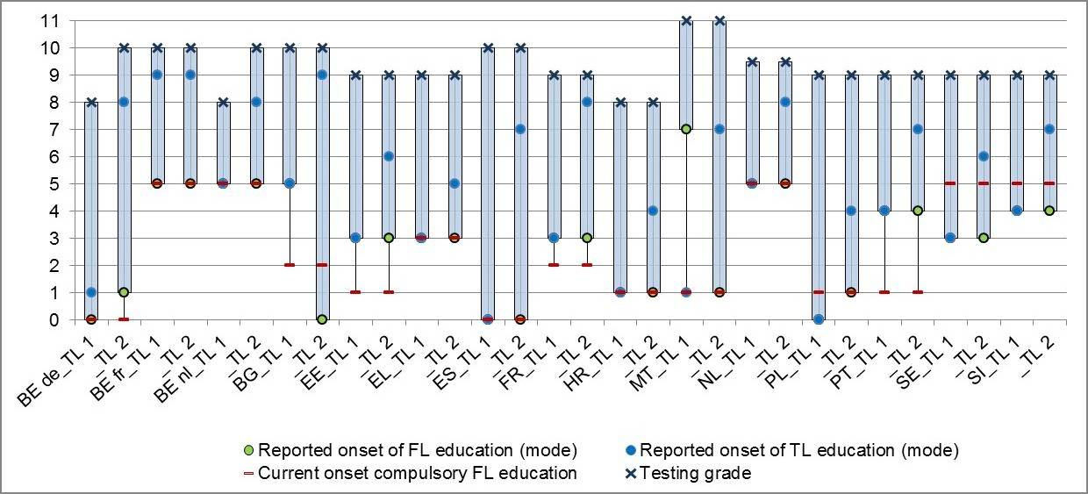
Figure 47: Onset of foreign and target language learning (SQ/NQ)

There seems to be a difference in the onset of foreign language learning between the students sampled for the first target language and those sampled for the second target language in a number of educational systems, even though the question was about foreign languages in general. In Malta this difference seems due to the fact that some Maltese students judge English as a foreign language, while others do not. The distribution of the responses in Malta shows two peaks, one at grade 7 and one at grade 1. In addition, the responses to the question on ‘onset of target language teaching’ shows that in Malta English is taught from grade 1 onwards and Italian is taught from grade 7 onwards. The apparent difference between the two samples is due to the instability of the mode for the distribution in these populations.
A similar response-pattern (two peaks in the distribution of response-options) is visible for Bulgaria (for response-options ‘before grade 1’ and ‘grade 5’), although it is not likely that there is a similar explanation for this as for Malta. If we aggregate the response-pattern over target languages, grade 5 is the most chosen response.
In five educational systems the population has been taught foreign languages from grade 1 or before grade 1 (the German Community of Belgium, Croatia, Malta, Poland and Spain), for four educational systems the population has been taught foreign languages from grade 3 (Estonia, France, Greece and Sweden), for two educational systems the population has been taught foreign languages from grade 4 (Portugal and Slovenia) and for four educational systems the population has been taught foreign languages from grade 5 (Bulgaria, the Netherlands and the Flemish and French Communities of Belgium).
As expected, the mode for onset of target language learning differs much more between target languages than the mode for onset of foreign language learning. In general, the onset for the second target language is later than the onset for the first target language, except for the French Community of Belgium.
Foreign language lesson time a week is represented in Figure 48; the columns represent the mean foreign language lesson time students say they currently have a week. This includes the target language, other foreign languages that the students may be learning and ancient languages.
Figure 48 shows that for both populations of students in all educational systems, foreign language lesson time is at least 3 hours a week on average, ranging to between 6 and 8 hours for second target language populations in the French and German communities of Belgium, Spain and the Netherlands. In most educational systems, students of the second target language report more lesson hours than students of the first target language. In most of these educational systems, the differences between the two target language populations are moderate, i.e. less than an hour on average. In some educational systems, the difference is substantial, i.e. between 1 and 3 hours more lesson time for students of the second target language. Some educational systems constitute an exception to this pattern: in Estonia, France, Greece and Portugal there is hardly any difference between the lesson times reported by each target language population.
Figure 48: Foreign language lesson time a week (SQ)
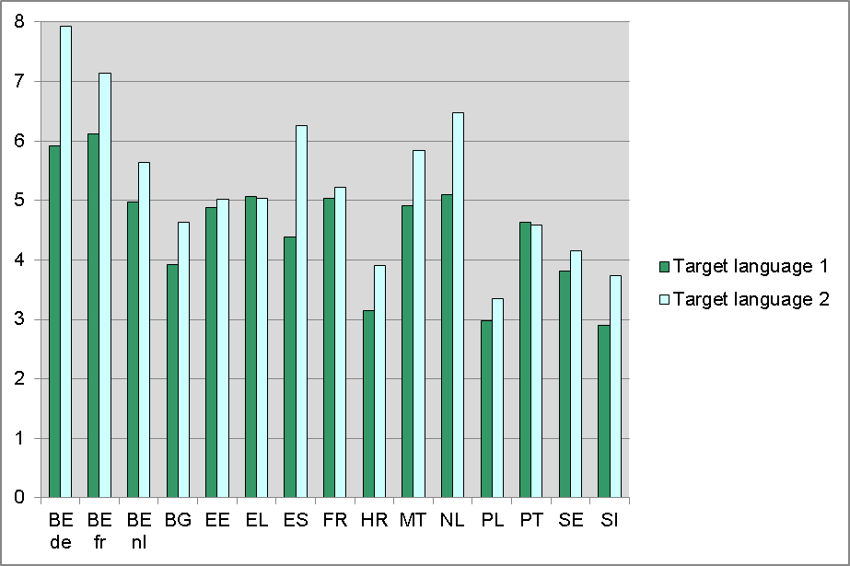
Note that, as the students were asked to report all of their foreign language lesson time, the higher means for students of the second target language do not necessarily indicate more lesson time spent on this target language. As we will show below, in the presentation of the index ‘Target language lesson time’, generally, less lesson time is allotted to the second target language. What it does indicate, however, is that students in the second target language population are often also taught another foreign (or ancient) language.
Target language lesson time a week is represented in Figure 49; the columns represent the mean target language lesson time per week (in hours of 60 minutes) that students report.
Figure 49 Target language lesson time a week (SQ)
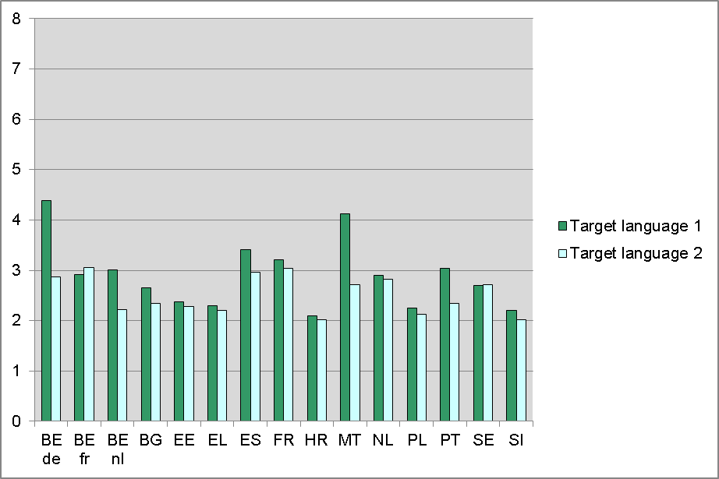Figure 49 shows that the mean lesson time reported for each of the target languages is generally between two and three hours a week. More than three hours of lesson time per week are found in the French Community of Belgium (second target language), Spain (first target language), France (both target languages) and Portugal (first target language). Students in Malta and the German Community of Belgium report over four hours, but only for the first target language. There is a clear tendency across educational systems for the first target language to be allotted more lesson time than the second, with exceptions for the French Community of Belgium (slightly more lesson time for the second target language; German) and Sweden (no difference between target languages English and Spanish).
The index ‘Target language learning time for tests’ is represented in Figure 50; the columns represent the mean learning time that students report spending on preparing for target language tests.
Figure 50: Target language learning time for tests (SQ)
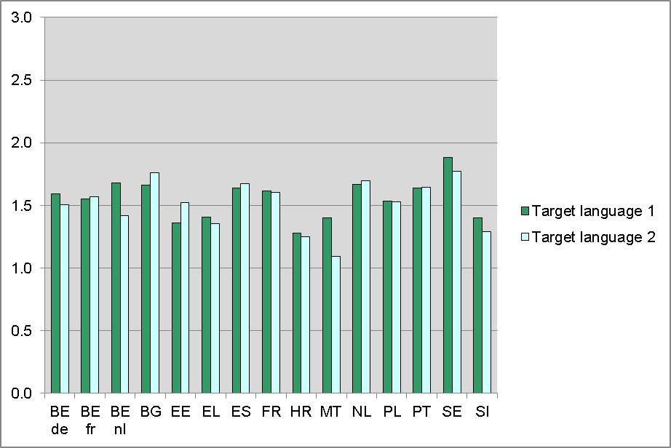
Figure 50 shows that there are no big differences between target languages in time spent on preparing for tests in the target language. Students in Sweden spend most time preparing for tests and assignments, followed by students in Bulgaria and the Netherlands. Students in Malta (second target language) spend least time on this.
Target language learning time a week for homework is represented in Table 20; the rows represent the proportion of responses per option for time that students report spending on target language homework.
Table 20: Target language learning time a week for homework (SQ)
 | Target language 1
Educational system | Zero hours | Less than one hour a week | About one to two hours a week | About two to three hours a week | More than three hours a week
BE de | 7% | 25% | 31% | 23% | 15%
BE fr | 8% | 30% | 38% | 17% | 7%
BE nl | 5% | 23% | 35% | 22% | 15%
BG | 14% | 25% | 28% | 18% | 15%
EE | 10% | 35% | 29% | 18% | 8%
EL | 14% | 18% | 26% | 19% | 23%
ES | 8% | 27% | 38% | 18% | 8%
FR | 8% | 27% | 36% | 19% | 9%
HR | 11% | 42% | 30% | 11% | 5%
MT | 7% | 24% | 35% | 20% | 15%
NL | 9% | 39% | 35% | 14% | 3%
PL | 11% | 32% | 31% | 18% | 8%
PT | 8% | 46% | 32% | 11% | 3%
SE | 10% | 47% | 25% | 13% | 4%
SI | 10% | 49% | 29% | 9% | 4%
 | Target language 2
Educational system | Zero hours | Less than one hour a week | About one to two hours a week | About two to three hours a week | More than three hours a week
BE de | 8% | 36% | 34% | 15% | 6%
BE fr | 10% | 28% | 38% | 18% | 7%
BE nl | 10% | 52% | 30% | 6% | 1%
BG | 15% | 21% | 30% | 18% | 16%
EE | 8% | 31% | 32% | 20% | 9%
EL | 15% | 21% | 23% | 22% | 19%
ES | 11% | 37% | 33% | 15% | 3%
FR | 9% | 31% | 36% | 19% | 5%
HR | 14% | 48% | 27% | 7% | 4%
MT | 25% | 37% | 26% | 8% | 3%
NL | 4% | 40% | 40% | 13% | 3%
PL | 13% | 35% | 31% | 15% | 6%
PT | 9% | 55% | 28% | 5% | 2%
SE | 14% | 55% | 23% | 6% | 2%
SI | 18% | 58% | 18% | 4% | 1%
Table 20 shows that Slovenian students spend the least time on target language homework and Greek students spend the most time on target language homework. In the Flemish Community of Belgium the difference between target languages is largest: for the first target language (French) they spend as much time on homework as Greek students, but for the second target language (English) they spend as little time on homework as Slovenian students. In general (11 out of 15 educational systems), students spend more time on homework for the first target language than for the second. Exceptions are Bulgaria, Greece, the Netherlands and the French Community of Belgium.
The questionnaire indices concerning lesson and learning time show some trends across educational systems, but mainly differences between them. In most educational systems, target language lesson time is between 2 and 3 hours a week. The amount of lesson time for foreign languages generally differs substantially between educational systems, as does the amount of time spent on homework for the target language. Within educational systems, we find that more time is spent both on lesson time and homework for the first target language compared to the second target language. The differences within educational systems, however, are smaller than the differences between the educational systems.

Diversity and order of foreign languages offered
The policy issue ‘Diversity and order of foreign languages offered’ consists of four questionnaire indices:
- number of foreign and ancient languages on offer in the school (PQ)
- number of modern foreign languages learned (SQ)
- number of ancient languages learned (SQ)
- number of languages studied before target language (SQ).
Figure 51 represents the mean number of foreign and ancient languages on offer in the school according to the principals.
Figure 51: Number of foreign and ancient languages on offer in the school (PQ)
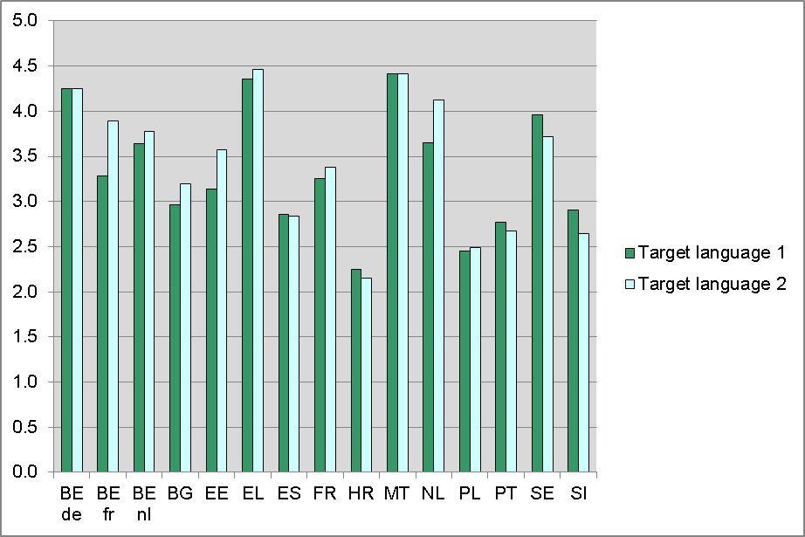
The number of foreign and ancient languages on offer in the school does not consistently differ between schools in the two target language samples. Educational systems where schools on average offer four or more languages are the German Community of Belgium, Greece, Malta and the Netherlands (second target language). Croatia and Poland have a mean lower than 2.5 foreign and ancient languages on offer in the schools.
The number of modern foreign languages learned is represented in Figure 52. The columns represent the mean number of foreign languages that the students learn or have learned in primary and/or secondary education, including the target language.
Figure 52: Number of modern foreign languages learned (SQ)
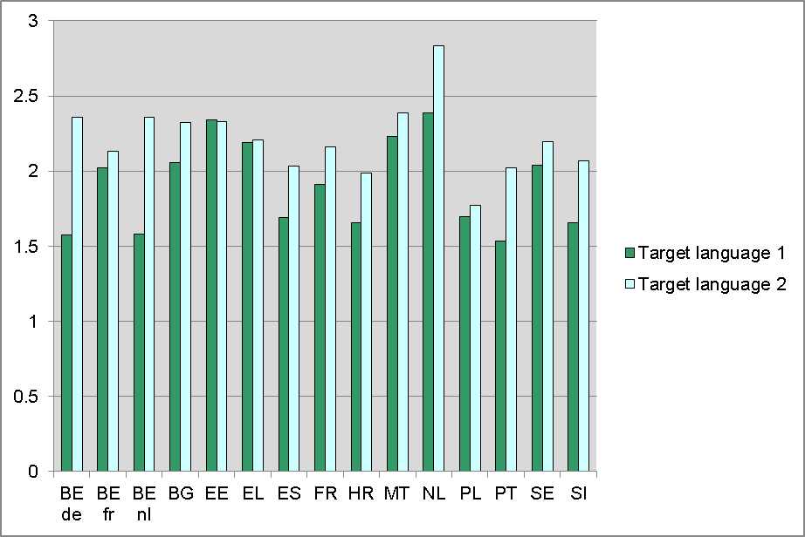
The mean number of modern foreign languages learned ranges from 1.5 for students of the first target language in Portugal, to 2.8 for students of the second target language in the Netherlands. In nearly all educational systems, we find that the students of the second target language have studied or are studying more foreign languages than students of the first target language. Exceptions are Estonia and Greece, where the difference between the two groups of students is very small. In nearly all educational systems, and for both populations of students, the mode is two. This means that in all educational systems, it is most common to learn two foreign languages. The Netherlands constitutes the one exception, as in that country, the most common number of foreign languages that students learn or have learned is three.
The number of ancient languages learned is represented in Table 21. The rows present the proportions for the number of ancient languages learned in primary and/or secondary education by students of each target language per educational system.
Table 21: Number of ancient languages learned (SQ)
 | Target language 1
Educational system | 0 ancient languages | 1 ancient language | 2 ancient languages
BE de | 71% | 29% | 0%
BE fr | 66% | 29% | 5%
BE nl | 81% | 13% | 6%
BG | 100% | 0% | 0%
EE | 100% | 0% | 0%
EL | 20% | 76% | 4%
ES | 83% | 17% | 1%
FR | 82% | 16% | 3%
HR | 100% | 0% | 0%
MT | 99% | 1% | 0%
NL | 87% | 6% | 7%
PL | 100% | 0% | 0%
PT | 100% | 0% | 0%
SE | 100% | 0% | 0%
SI | 100% | 0% | 0%
 | Target language 2
Educational system | 0 ancient languages | 1 ancient language | 2 ancient languages
BE de | 71% | 29% | 0%
BE fr | 64% | 32% | 4%
BE nl | 77% | 17% | 6%
BG | 100% | 0% | 0%
EE | 100% | 0% | 0%
EL | 19% | 75% | 6%
ES | 77% | 22% | 1%
FR | 82% | 16% | 2%
HR | 100% | 0% | 0%
MT | 99% | 1% | 0%
NL | 87% | 3% | 10%
PL | 99% | 1% | 0%
PT | 100% | 0% | 0%
SE | 100% | 0% | 0%
SI | 100% | 0% | 0%
Table 21 shows educational systems in which no ancient languages are learned (Bulgaria, Croatia, Portugal, Slovenia and Sweden) or virtually none (Estonia, Malta and Poland) by the student population of the ESLC. We also find educational systems in which a substantial proportion of the students reported they learned at least one ancient language. In one educational system, Greece, 80% of the students report that they study and/or have studied at least one ancient language. This reflects the fact that the majority of Greek students have learned or are learning ancient Greek in school. There is a slight tendency across educational systems for students of the second target language to have studied more ancient languages than students of the first target language.
‘Number of languages studied before the target language’ constitutes the fourth and final index of the policy issue ’Diversity and number of foreign languages offered‘. Students were asked how many foreign languages they had studied before taking on the target language. The rows in Table 22 represent the proportion of responses per response-option.
Table 22: Number of languages learned before the target language (SQ)
 | Target language 1
Educational system | No foreign languages | 1 foreign language | 2 foreign languages | 3 ≤ foreign languages
BE de | 75% | 19% | 5% | 1%
BE fr | 28% | 51% | 19% | 3%
BE nl | 84% | 11% | 3% | 1%
BG | 69% | 24% | 6% | 1%
EE | 73% | 23% | 4% | 0%
EL | 80% | 16% | 3% | 0%
ES | 84% | 14% | 3% | 0%
FR | 75% | 20% | 4% | 1%
HR | 74% | 23% | 3% | 0%
MT | 80% | 15% | 4% | 1%
NL | 81% | 15% | 2% | 1%
PL | 79% | 19% | 2% | 0%
PT | 88% | 10% | 1% | 0%
SE | 88% | 9% | 2% | 0%
SI | 72% | 25% | 3% | 0%
 | Target language 2
Educational system | No foreign languages | 1 foreign language | 2 foreign languages | 3 ≤ foreign languages
Educational system | No foreign languages | 1 foreign language | 2 foreign languages | 3 ≤ foreign languages
BE de | 8% | 69% | 21% | 2%
BE fr | 25% | 50% | 20% | 5%
BE nl | 5% | 79% | 15% | 2%
BG | 6% | 67% | 25% | 2%
EE | 19% | 72% | 8% | 0%
EL | 56% | 37% | 5% | 1%
ES | 4% | 92% | 4% | 1%
FR | 3% | 71% | 24% | 2%
HR | 35% | 61% | 4% | 0%
MT | 22% | 66% | 11% | 2%
NL | 2% | 32% | 53% | 13%
PL | 45% | 51% | 4% | 0%
PT | 4% | 91% | 4% | 1%
SE | 9% | 81% | 9% | 1%
SI | 20% | 74% | 6% | 0%
Table 22 shows major differences between students of the first and second target languages and to a lesser extent between educational systems. In Greece, the number of languages learned before taking on the second target language is lowest of all educational systems. The Netherlands represents the other extreme, with the highest average number of languages learned before the second target language and the largest difference between number of languages learned before first and second target languages. In all educational systems, students of the second target language have previously studied substantially more languages than students of the first target language. The exception to this rule is the French Community of Belgium, in which both students of the first and of the second target language have generally learned one foreign language previously.

Language friendly living environment

Informal language learning opportunities
The policy issue ‘Informal language learning opportunities’ consists of six subjects containing seven questionnaire indices:
- languages spoken in students’ home-environment
      - number of first languages (SQ)
      - parents’ target language knowledge (SQ)
- students' target language use at home (SQ)
- students' target language exposure through the living environment (SQ)
- students' target language exposure and use through visits abroad (SQ)
- students' target language exposure and use through traditional and new media (SQ)
use of sub-titles on television and film (NQ).Figure 53 shows the mean number of students’ first languages (a language spoken at home before the age of 5). This index, together with parental knowledge of target language, represents the concept ‘Language spoken in students’ home environment’.
Figure 53: Number of students’ first languages (SQ)
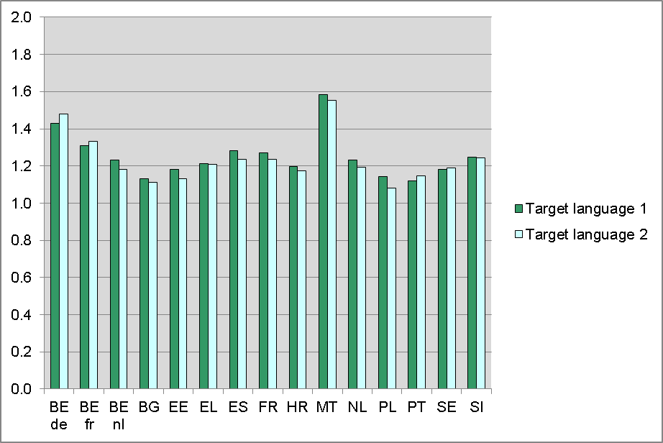
The vast majority of all respondents have one first language. That is with the exception of respondents living in Malta and the French and German Communities of Belgium, where a substantial percentage of students have more than one first language.
Figure 54 shows the mean parents’ target language knowledge, part of the concept ‘language spoken in the home environment’. This index is based on questions about the target language knowledge of the repondents’ father and mother, from ‘0=not at all’ to ‘3=very well’.
Figure 54: Parents’ target language knowledge (mean)
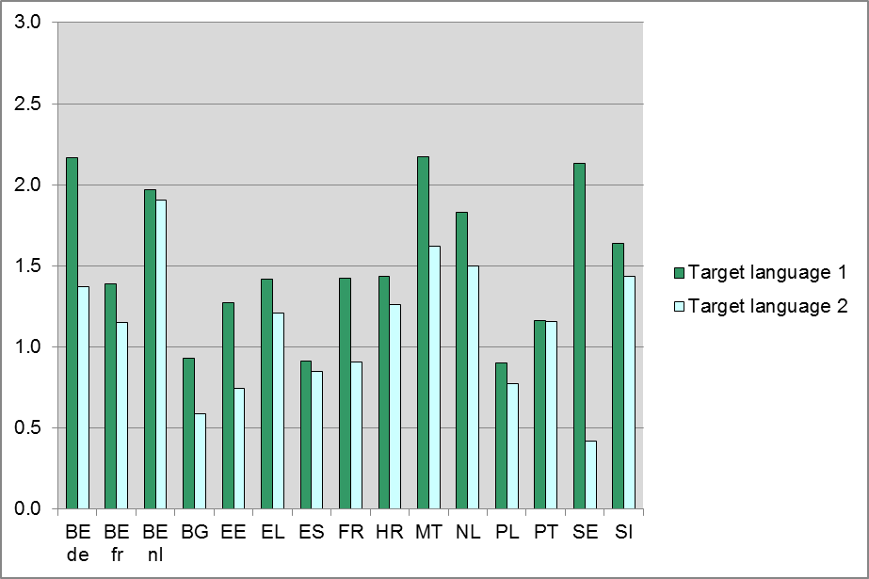
As can be seen from Figure 54 there exist rather large differences between educational systems and within educational systems between target languages. Notably, in Sweden respondents’ parents have (one of) the best knowledge of a target language (the first target language is in this case English), and the least knowledge of a target language (the second target language for Sweden is Spanish). Bulgarian, Spanish, Estonian (second target language which is actually the third most widely taught language in the educational system; German) and Polish parents have a below-average knowledge of target languages. Again, educational systems with one of the target languages as one of the official languages (Belgium and Malta) appear to have above-average rates, but this also holds for the Netherlands and to a lesser degree for Slovenia. Within Belgium it is notable that the knowledge of target languages among parents in the French Community of Belgium is somewhat lower compared to the other two communities of Belgium. However, this might be due to the fact that English and German are actually the second and third most widely taught languages in the French community. Figure 55 shows the means of target language use at home.
Figure 55: Students’ target language use at home (SQ)
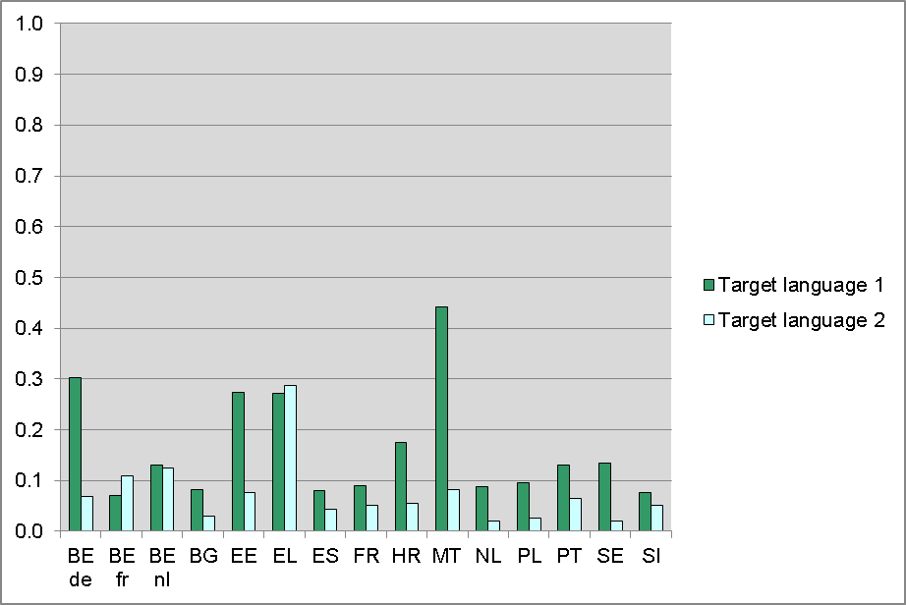
Most notable are the numbers for the first target language populations of Malta, Estonia and the German Community of Belgium and both target language populations of Greece. In Greece, both the first and the second target language (English and French, respectively) are used at home by about one third of the respondents.
Figure 56 represents the index ‘Target language exposure through the living environment’. This index is based on a question in the Student Questionnaire: “Do you, yourself, come into contact with [target language] outside school in the following ways?” Students were asked to respond for seven sub-items, for example ‘Through friends living in a [target language] speaking country’. The index is coded from ‘0=no exposure‘ to ‘7=exposure in all situations‘.
Figure 56 shows that students clearly report more exposure to the first than the second target language, except in the Flemish Community of Belgium. Relatively low means are found for the second target languages of Spain, Estonia, France, the Netherlands, Poland and Sweden. Means of 3.0 or higher are found for the first target languages of Estonia, Greece, Croatia, Malta and Slovenia.
Figure 56: Target language exposure through the living environment (SQ)
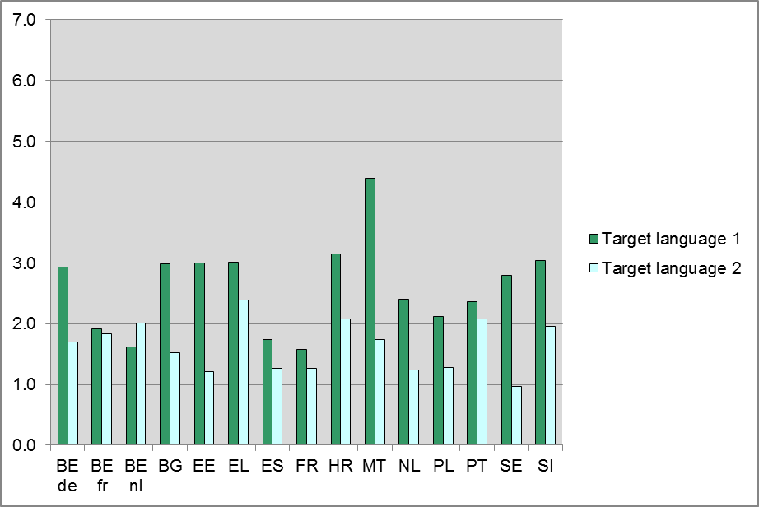
Figure 57 shows the mean students' target language exposure and use through visits abroad. This index is based on the question from the Student Questionnaire: “How often have you travelled abroad or had visitors from abroad in the past three years?” Students were asked to respond on a scale from ‘0=never‘ to ‘3=three times or more’ for six sub-items, for example ‘How often did you go with your family to a [target language] speaking country?’. The index is the mean of the six responses.
Figure 57: Target language exposure and use through visits abroad (SQ)
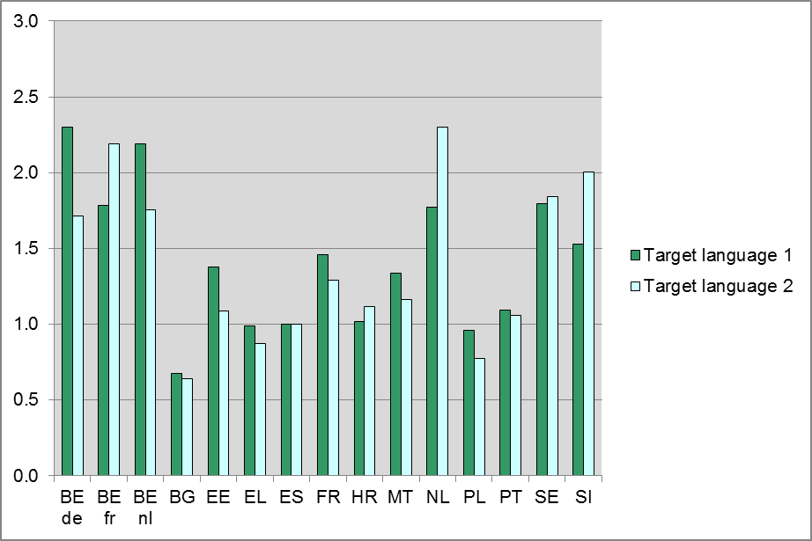
The highest means are found among respondents in the three Belgian communities, the Netherlands, Sweden and Slovenia. In Bulgaria, Greece, Spain and Poland the means are substantially lower.
Figure 58 shows the mean students' target language exposure and use through traditional and new media. This index is based on the question from the Student Questionnaire: “How often do you come into contact with [target language] through media in the following ways?” Students were asked to respond on a scale from ‘0=never‘ to ‘4=a few times a week‘ for nine sub-items, for example ‘How often do you play computer games spoken in [target language]?’. The index is the mean of the nine responses.
Figure 58: Target language exposure and use through traditional and new media (SQ)
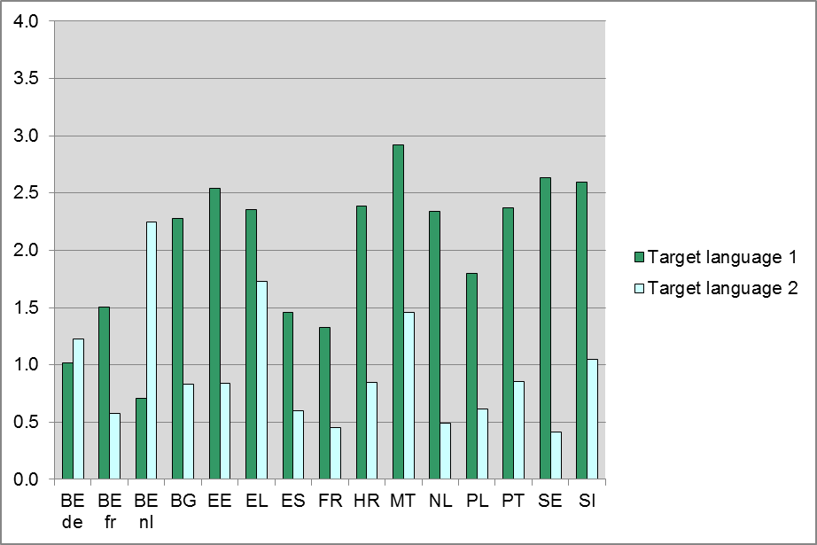
In all educational systems, large differences are found between target languages. In general, exposure and use through traditional and new media is higher for the first target language, with the exception of the Belgium Flemish and Belgium German Communities. In these two Belgian communities English is the second target language. In Estonia, Malta, Slovenia and Sweden above-average scores for students' target language exposure and use through traditional and new media are found for the first target language.
The index ‘Use of sub-titles on television and film’ is represented in Table 23. This index is based on a question in the National Questionnaire “Is it custom to subtitle or to dub?” This question was asked for television programmes and cinema movies from abroad and television programmes and cinema movies spoken in the first and second target language separately. The table only represents the responses for the items about target languages.

Table 23: Dubbing or subtitling of programmes and movies from abroad (NQ)
Educational system | Television programmes spoken in TL1 | Cinema movies spoken in TL1 | Television programmes spoken in TL2 | Cinema movies spoken in TL2
BE de | 0 | 0 | 1 | 1
BE fr | 1 | 1 | 1 | 1
BE nl | 2 | 2 | 2 | 2
BG | 1 | 2 | 1 | 2
EE | 2 | 2 | 2 | 2
EL | 2 | 2 | 2 | 2
ES | 1 | 1 | 1 | 1
FR | 1 | 1 | 1 | 1
HR | 2 | 2 | 2 | 2
MT | 0 | 0 | 0 | 0
NL | 2 | 2 | 2 | 2
PL | 0 | 2 | 0 | 2
PT | 2 | 2 | 2 | 2
SE | 2 | 2 | 2 | 2
SI | 2 | 2 | 2 | 2
UK-ENG | 2 | 2 | 2 | 2
0=Neither; 1=Usually dubbed; 2=Usually subtitled.
Table 23 shows that for most educational systems the responses are the same for television programmes and for cinema movies and for both target languages. In nine educational systems these are usually subtitled (the Flemish Community of Belgium, England, Estonia, Greece, Croatia, the Netherlands, Portugal, Slovenia and Sweden), for three educational systems they are usually dubbed (the French Community of Belgium, Spain and France) and for one educational system they are neither dubbed nor subtitled (Malta). Differences for target languages are only found for the German Community of Belgium, where the first target language (French) is a national language, which might be the reason that French is neither dubbed nor subtitled. Television programmes and cinema movies spoken in the second target language (English) are usually dubbed. Differences between television programmes and movies spoken in both target languages are found for Bulgaria and Poland. In Bulgaria, television programmes in both target languages are usually dubbed and cinema movies in both target languages are usually subtitled. In Poland, television programmes in both target languages are neither dubbed nor subtitled (but have a voice-over) and cinema movies in both target languages are usually subtitled.

Language friendly schools

School’s foreign language specialisation
The policy issue ‘School’s foreign language specialisation’ consists of three subjects:
- content and Language Integrated Learning (PQ)
- school’s specialist language profile (PQ)
- extra target language lessons in school
    - provision of extra target language lessons (PQ)
    - participation in extra target language lessons (SQ).
Figure 59 represents the index ‘Content and Language Integrated Learning’. This index is based on the question from the Principal Questionnaire: “Does your school offer the following to encourage language learning?” The proportions of ‘Yes’-responses to the item “Content and Language Integrated Learning (CLIL)” are represented in the columns.
Figure 59: Content and Language Integrated Learning (PQ)
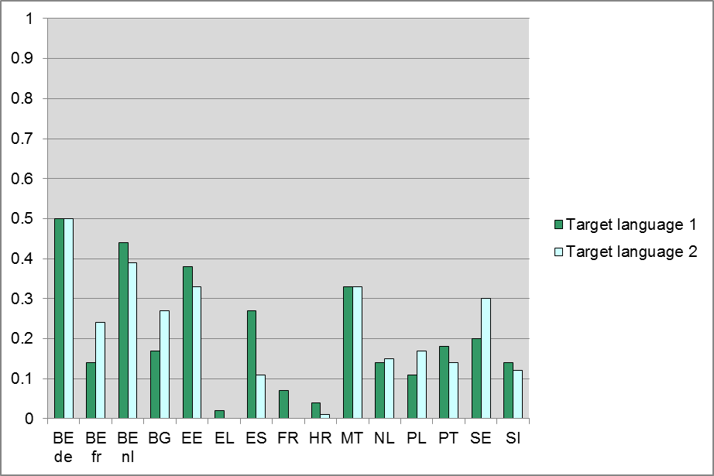
CLIL is offered most often in the German Community of Belgium, followed by the Flemish Community of Belgium, Estonia and Malta. Educational systems in which schools offer CLIL least often (fewer than 10% of the schools) are France, Greece and Croatia.
Figure 60 represents the index ‘Specialist language profile’. This index is based on the question from the Principal Questionnaire: “Does your school offer the following to encourage language learning?” Principals were asked to answer ‘Yes’ or ‘No’ to seven items, for example ‘A wider choice of languages is offered than is common or required’. The index is the sum of items answered with ‘Yes’. The means are represented in the columns.

Figure 60: specialist language profile (PQ)
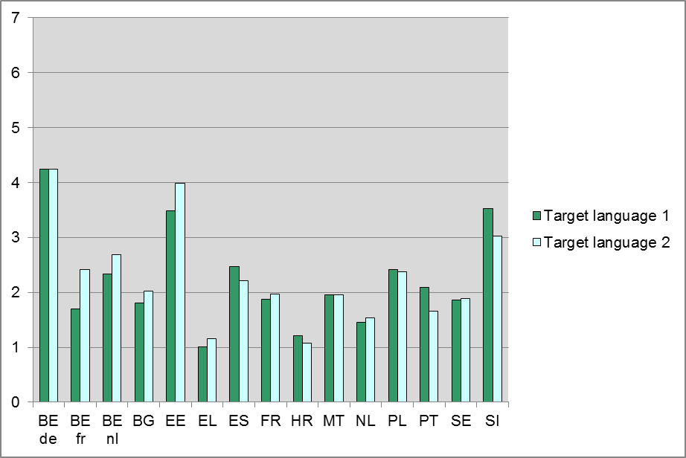
A school’s specialist language profile is observed most often in Estonia, Slovenia and the German Community of Belgium. Schools in Greece, Croatia and to a lesser extent the Netherlands on average show less strong specialist language profiles.
‘Provision of extra target language lessons’ is represented in Figure 61. This index is based on the question in the Principal Questionnaire: “What type of extra lessons does your school offer to students?” with regard to the items ‘{Enrichment lessons} for [target language]’ and ‘{Remedial lessons} for [target language]’. The index is ‘1’ when at least one of these items was answered with ‘Yes’ and ‘0’ otherwise.
Figure 61: Provision of extra target language lessons (PQ)
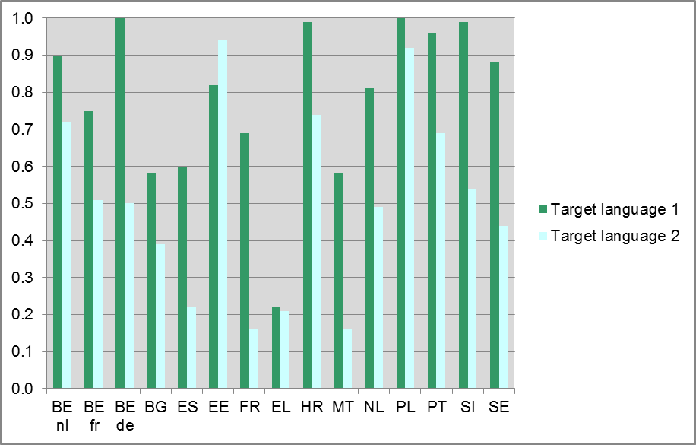
Figure 61 shows that in Poland and the German Community of Belgium all schools offer extra lessons in the first target language. In these educational systems, the Flemish Community of Belgium, Croatia, Portugal and Slovenia 90% or more of the schools offer extra lessons in the first target language. In Bulgaria, Greece and Malta less than 60% of the schools offer extra lessons in the first target language. In all educational systems, much fewer schools offer extra lessons in the second target language, except for Estonia.
Figure 62 represents the participation of students in extra target language lessons. Extra lessons comprise both enrichment and remedial lessons. The columns represent the proportion of students that say they are attending or have attended extra lessons.
Figure 62: Participation in extra target language lessons (SQ)
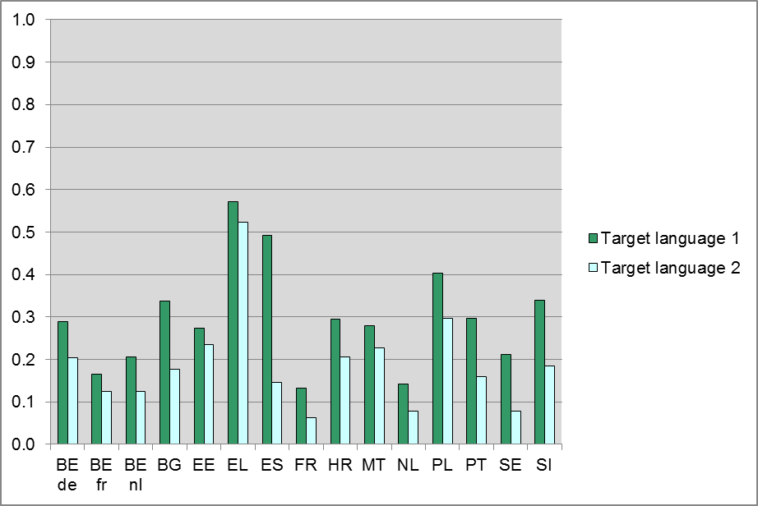
In all educational systems the students that have been tested in the first target language more often report that they have extra lessons in that language than students that have been tested in the second target lesson. This might be due to the fact that the first target language is often compulsory in an educational system, whereas the second target language often is not; if a subject is not compulsory, there will be a selection of better students. In Greece the proportion of students that say they have extra lessons is more than 50% in both target languages. In Spain 50% of the students that have been tested in English (the first target language) say they have extra lessons in that language. Of the Spanish students that have been tested in the second target language (French), only approximately 15% say they have extra lessons in that language. In France, the Netherlands and the French Community of Belgium, 20% or fewer of the students in both target languages say they have extra lessons in those languages.

ICT to enhance foreign language learning and teaching
The policy issue ‘ICT to enhance foreign language learning and teaching’ consists of three subjects with 8 indices:
- ICT facilities in school
    - Availability of a multimedia (language) lab (PQ)
    - Presence of a virtual learning environment (PQ)
    - Availability of software for language assessment or language teaching (PQ)
- Frequency and purpose of using ICT in target language teaching by teachers
    - Use of ICT outside lessons for teaching (TQ)
    - Use of ICT devices when teaching (TQ)
    - Use of web content for teaching (TQ)
- Frequency and purpose of using ICT in target language teaching by students
    - Use of ICT for foreign language learning (SQ);
    - Use of ICT outside school (SQ).
The index ‘Availability of a multimedia (language) lab’ is represented in Table 24. The index is based on principals’ responses for two sub-items of a question concerning a multimedia lab: “Does your school have the following ICT facilities?” Responses are coded ‘0=No’, ‘1=Yes, but not with specific language learning software’ and ‘2=Yes, with specific language learning software’.
Table 24 shows that schools in Slovenia, the Netherlands, Spain (first target language) and Sweden (second target language) have a multimedia language lab most often. Schools in the German Community of Belgium, Estonia (first target language), France (first target language), the French and Flemish Communities of Belgium (second target language) and Poland (second target language) have this facility least often; 25% or fewer. Half of the schools in Malta have a multimedia lab, however not specifically for languages.
Table 24: Availability of a multimedia (language) lab (PQ)
 | Target language 1
Educational system | No | Not language specific | Yes
BE de | 75% | 25% | 0%
BE fr | 71% | 7% | 22%
BE nl | 68% | 14% | 18%
BG | 47% | 41% | 12%
EE | 80% | 16% | 5%
EL | 72% | 18% | 10%
ES | 37% | 34% | 29%
FR | 89% | 4% | 7%
HR | 56% | 42% | 1%
MT | 41% | 51% | 8%
NL | 48% | 25% | 26%
PL | 71% | 4% | 25%
PT | 58% | 35% | 7%
SE | 71% | 13% | 16%
SI | 52% | 15% | 33%
 | Target language 2
Educational system | No | Not language specific | Yes
BE de | 75% | 25% | 0%
BE fr | 78% | 14% | 8%
BE nl | 76% | 17% | 7%
BG | 51% | 35% | 14%
EE | 73% | 20% | 7%
EL | 74% | 11% | 15%
ES | 60% | 21% | 18%
FR | 58% | 30% | 12%
HR | 59% | 36% | 5%
MT | 41% | 51% | 8%
NL | 67% | 9% | 24%
PL | 84% | 7% | 9%
PT | 61% | 36% | 3%
SE | 74% | 0% | 26%
SI | 54% | 15% | 31%
The index ‘Presence of a virtual learning environment’ is represented in Figure 63. The index is based on a question in the Principal Questionnaire: “Does your school have the following ICT facilities?” The columns represent the proportion of Yes-responses for the sub-item ‘A virtual learning environment to support teaching and learning, e.g. Moodle, WebCT, Blackboard, Fronter, Sakai’.
Figure 63: Presence of a virtual learning environment (PQ)
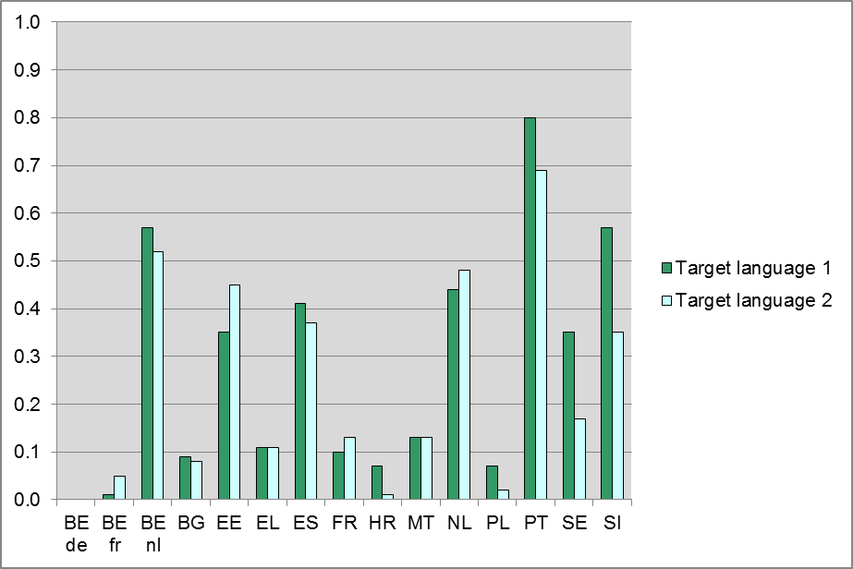
Figure 63 shows that schools in Portugal most often have a virtual learning environment, followed by schools in the Netherlands, Slovenia and the Flemish Community of Belgium. Fewer than 10% of the schools in Bulgaria, Croatia, Poland and the German and French Communities of Belgium have a virtual learning environment available.
The index ‘Availability of software for language assessment or teaching’ is represented in Figure 64. The index represents the level of availability based on principals’ responses on the availability of three sub-items: (1) Software or tools developed in house for learning and teaching languages, (2) Digital student portfolio and (3) Software for language assessment.
Figure 64: Availability of software for language assessment or teaching (PQ)
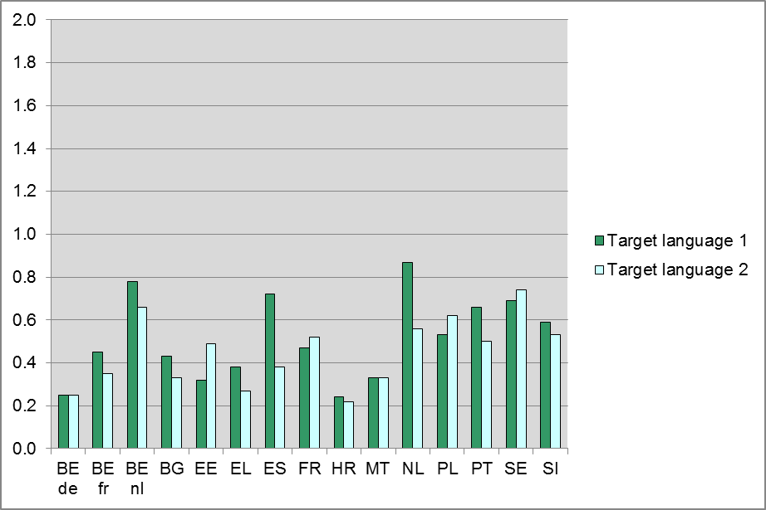
Figure 64 shows that in four educational systems schools have a slightly higher availability of software for language assessment or language teaching (a mean above 0.7 on a scale from 0 to 2): the Flemish Community of Belgium, Spain and the Netherlands for the first target language and Sweden for the second target language. In the German Community of Belgium, Greece (second target language) and Croatia the availability of software for assessment or teaching of languages is very low (a mean less than 0.3).
Figure 65 shows how often teachers use a computer outside of their lessons for teaching related activities. This index is based on the question: “How often do you use a computer outside your lessons (at home or elsewhere) for the following?” Teachers had to answer this question in regard to five activities, for example for checking students’ homework or assignments from your target language classes or for preparing [target language] lessons. The sub-questions had to be answered on a scale from ‘0=never or hardly ever’ to ‘4=almost every day’. The index is the mean of the five sub-questions.
Figure 65: Teachers’ use of ICT for teaching outside of lessons (TQ)
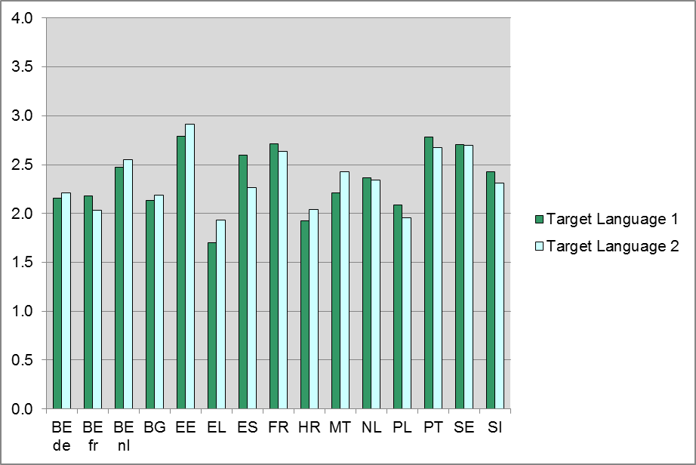
Greece (both target languages), Croatia (first target language) and Poland (second target language) have a mean score below 2. All other mean scores lie between 2 and 3 with most educational systems having a score closer to 2 than 3. Estonia has the highest mean, followed by France, Portugal and Sweden.
How often teachers use ICT-devices when teaching the target language is represented in Figure 66. This index is based on the question “How often do you use the following devices at school for teaching target language?” Teachers answered this question separately for seven different ICT-facilities, for example a PC or laptop for the teacher to use in the classroom or an interactive whiteboard in the classroom. The sub-questions had to be answered on a scale from ‘0=never, because it is not available’ to ‘4=almost every week’. The index is the mean of the seven sub-questions.
Figure 66 shows that the French Community of Belgium has the lowest mean score for this index (lower than 0.5). The scores of the Flemish Community of Belgium (second target language), Spain (first target language), Estonia, the Netherlands, Portugal, Slovenia and Sweden are 1.5 or higher.
Figure 66: Teachers’ use of ICT devices when teaching (TQ)
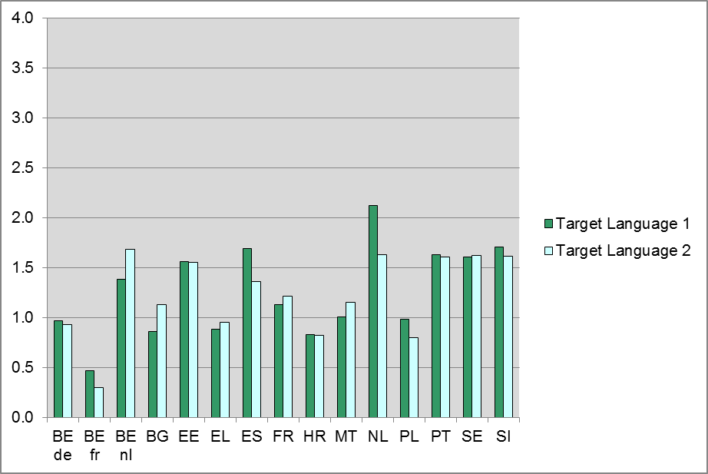
The use of web content by the teacher in target language lessons is represented in Figure 67. This index is based on the question “In general, how often do you or your students use the following |ICT facilities| for a target language class you teach?” Teachers had to answer this question for nine forms of web-content, for example software or websites specifically designed for learning languages or online news media (TV, radio, newspapers) in target language. The sub-questions had to be answered on a scale from ‘0=never or hardly ever’ to ‘4=almost every lesson’. The index is the mean of the seven sub-questions.
Figure 67: Teachers’ use of web content for teaching (TQ)
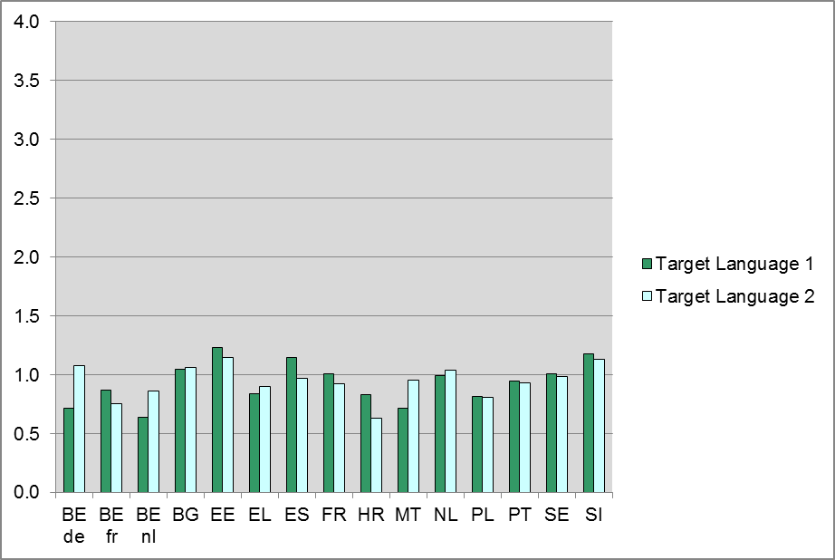
Figure 67 reflects that for most educational system means are between 0.5 and 1 for this index. The German Community of Belgium (second target language), Bulgaria, Spain (first target language), Estonia, the Netherlands (second target language) and Slovenia have a mean slightly larger than 1.
The mean of the variable ‘Use of ICT at home for foreign language learning’ is represented in Figure 68. This index is based on the question in the Student Questionnaire: “When studying and doing homework for [target language], how often do you use a computer for the following?” This question had to be answered separately for nine activities, for example for finding information for [target language] homework or assignments or for learning [target language] grammar. Students could answer on the scale from ‘0=never or hardly ever’ to ‘4=(Almost) every day’. The index is the mean of the answers for the nine activities.
Figure 68 shows that in all but one educational system (the Flemish Community of Belgium) the computer is used more often as a study-aid for the first target language than for the second target language. The mean scores in the three Belgian communities seem to be somewhat lower than the mean scores in the other educational systems. In Bulgaria students use ICT most often for foreign language learning.
Figure 68: Use of ICT at home for foreign language learning (SQ)
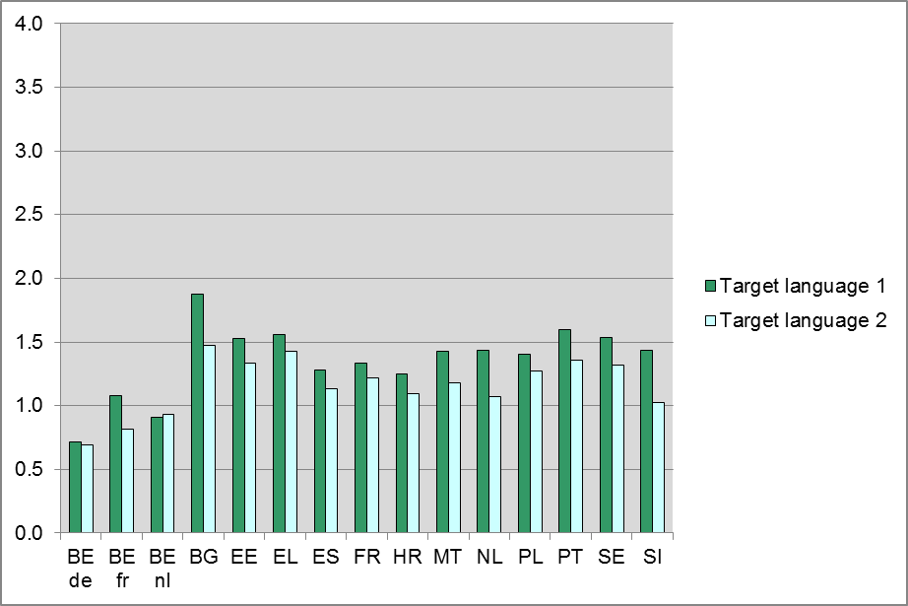
The mean of the variable ‘Use of ICT outside school’ is represented in Figure 69. This index is based on the question in the Student Questionnaire: “How often do you use a computer outside school time for the following?” This question had to be answered separately for six ICT-activities, for example for games or for contact with others (e.g. email, chatting, blogging, MySpace, Skype). Students could answer on the scale from ‘0=never or hardly ever’ to ‘4=(Almost) every day’. The index is the mean of the answers for the six ICT-facilities.
Figure 69: Use of ICT outside school (SQ)
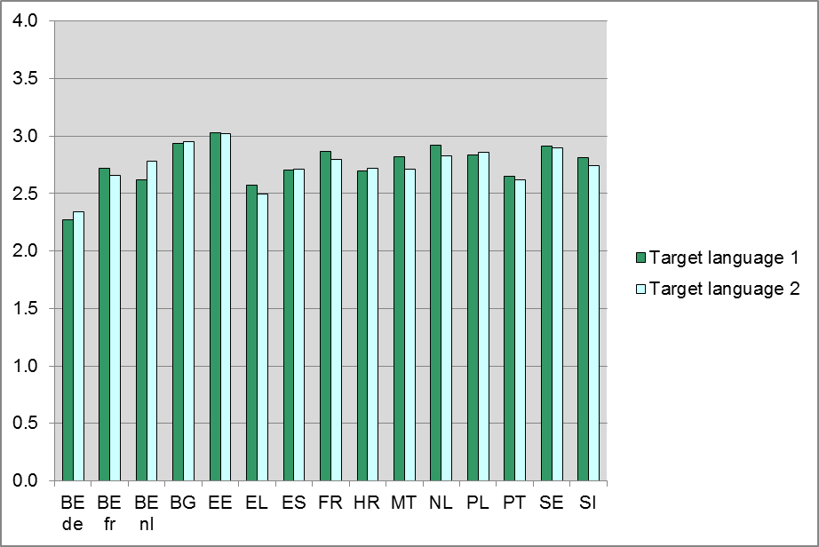
Figure 69 shows that the mean scores for use of ICT outside school in Greece and the German Community of Belgium seem to be somewhat lower than the mean scores in the other educational systems. Estonia has the highest mean, followed by Bulgaria, the Netherlands (first target language) and Sweden.

Intercultural exchanges
The policy issue ‘Intercultural exchanges’ consists of three subjects with six indices:
- Funding of intercultural exchanges
    - funding of student exchanges (PQ)
    - funding of student exchanges (NQ)
- Opportunities created for exchange visits
    - school trips to and visiting schools from foreign countries (SQ)
    - created opportunities for exchange visits (TQ)
- Opportunities created for school language projects
    - received opportunities for school language projects (SQ)
    - created opportunities for school language projects (TQ).
The index ‘Funding of student exchanges’ is represented in Figure 70. This index is based on the question in the Principal Questionnaire: “To what extent are intercultural exchanges for students (such as exchange visits) funded in the following ways? ”. The index has been recoded into categories on a scale from ‘0=Not at all’ to ‘3=Completely’.
Figure 70: Funding of student exchanges (PQ)
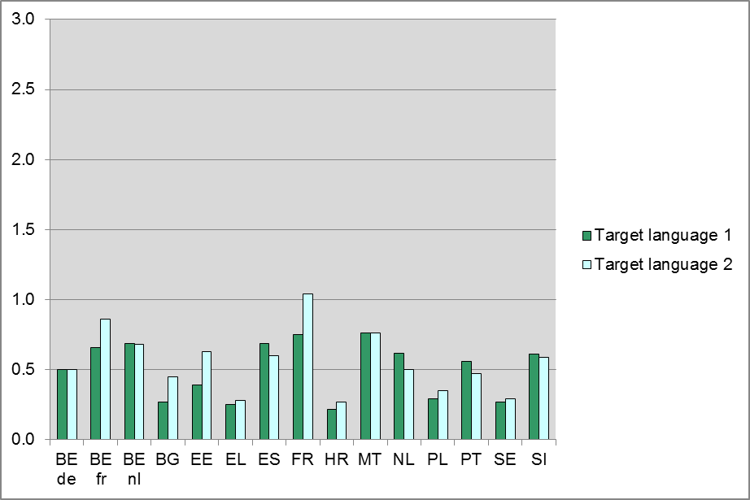
Figure 70 shows that the means for all educational systems are rather low. The educational systems with the lowest means for funding of student exchanges are Bulgaria (first target language), Greece, Croatia, Poland and Sweden. The relatively highest means are found in France, followed by the Flemish and French Communities of Belgium, Spain and Malta.
Table 25 represents an index based on the National Questionnaire reflecting whether the government in a country (including local, regional, state and national government) funds intercultural exchanges for students.
Table 25: Funding of intercultural exchanges (NQ)
Educational system | ISCED1 | General ISCED2 | Vocational ISCED2 | General ISCED3 | Vocational ISCED3
BE de | No | No | NA | No | No
BE fr | Yes | Yes | NA | No | No
BE nl | Yes | Yes | NA | Yes | Yes
BG | No | No | NA | Yes | Yes
EE | No | No | NA | No | No
EL | Yes | Yes | NA | Yes | Yes
ES | Yes | Yes | NA | Yes | Yes
FR | Yes | Yes | NA | Yes | Yes
HR | No | No | NA | No | No
MT | Yes | Yes | NA | Yes | Yes
NL | Yes | Yes | Yes | Yes | Yes
PL | Yes | Yes | NA | Yes | Yes
PT | No | No | No | No | No
SE | No | No | NA | No | No
SI | Yes | Yes | NA | Yes | Yes
UK-ENG | Yes | Yes | NA | Yes | Yes
NA=Not applicable.
Table 25 shows that in most educational systems the government funds intercultural exchanges for students either for ISCED levels 1 and 2, for ISCED3 or both. Educational systems where the government does not fund intercultural exchanges for students are: the German Community of Belgium, Estonia, Croatia, Portugal and Sweden. However, some educational systems have funds from other sources, such as Comenius and Leonardo Da Vinci.
The mean of the variable ‘School trips to and visiting schools from foreign countries’ is represented in Figure 71. This index is based on the question in the Student Questionnaire: “How often have you travelled abroad or had visitors from abroad in the past three years? The question had to be answered for four sub-items about school trips to a [target language] speaking or (non-[target language] speaking) educational system and a school class from a [target language] speaking or (non-[target language]) speaking country visiting their school. Students could answer these sub-items on the scale from ‘0=Never’ to ‘3=Three times or more’. The index is the mean for these four sub-items.
Figure 71: School trips to and visiting schools from foreign countries (SQ)
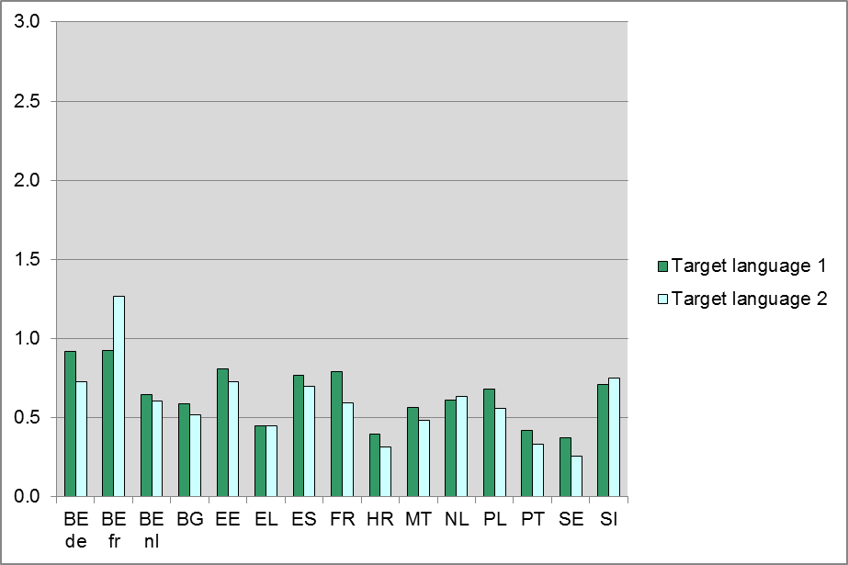
The mean score lies on the low end of the scale for all educational systems with only one educational system mean above 1 (the French Community of Belgium, second target language). Greece, Croatia, Portugal and Sweden seem to score somewhat lower than other educational systems.
The mean of the variable ‘Created opportunities for exchange visits’ is represented in Figure 72. This index is based on a question in the Teacher Questionnaire: “During the past three years, how often were you involved in the organisation of the following?” This question was followed by the same four items as the above question from the Student Questionnaire. Teachers could answer these sub-items on the scale from ‘0=Not at all’ to ‘4=Four times or more’. The index is the mean for these four items.
Figure 72 shows that exchange visits are not organised very often. Educational systems that have a mean below 0.25 are Croatia, Malta (first target language), Portugal and Sweden. Educational systems with a mean of 0.75 or more are the French Community of Belgium, the German Community of Belgium (second target language) and the Netherlands (second target language).
Figure 72: Created opportunities for exchange visits (TQ)
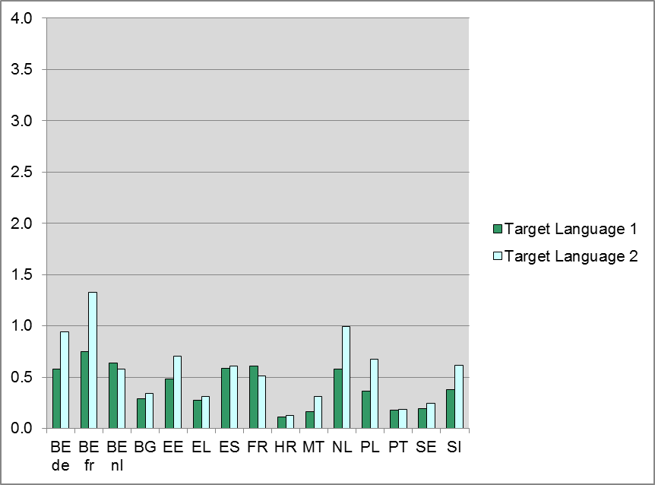
The mean of the variable ‘Received opportunities for school language projects’ is represented in Figure 73. This index is based on the question: “In the past three years, how often have you participated in the following activities for foreign languages at school?” This question had to be answered separately for seven activities, for example collaboration project with schools abroad or the European Day of Languages. Students could answer on the scale from ‘0=Never’ to ‘3=Three times or more’. The index is the mean of the answers for the seven activities.
Figure 73: Received opportunities for school language projects (SQ)
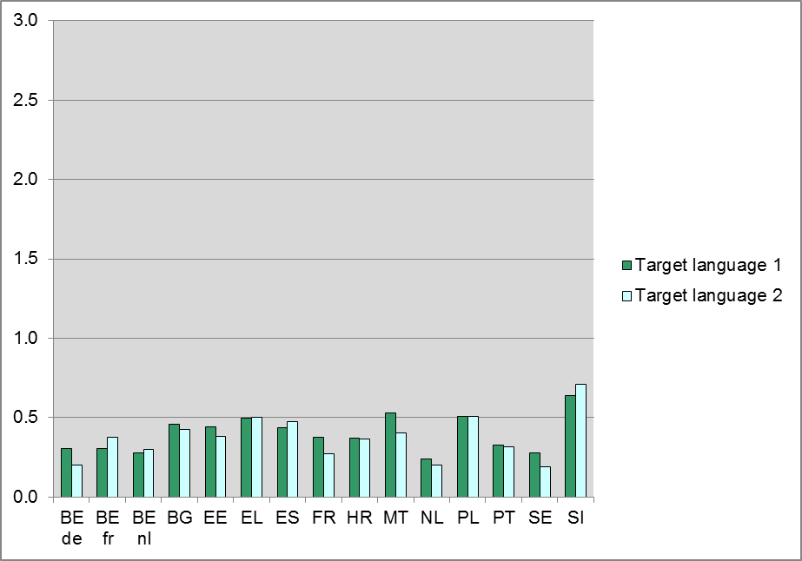
The mean score lies on the low end of the scale for all educational systems with only one educational system mean (Slovenia) above 0.6. The Flemish Community of Belgium (first target language), the German Community of Belgium (second target language), France (second target language), the Netherlands and Sweden score somewhat lower than the other educational systems.
The mean of the variable ‘Created opportunities for school language projects’ is represented in Figure 74. This index is based on a question in the Teacher Questionnaire: “In the past three years, how often were you involved in the organisation of the following activities at school?” This question was followed by seven items, for example language clubs and extracurricular language projects. Teachers could answer these questions on the scale from ‘0=Not at all’ to ‘4=Four times or more’. The index is the mean for these seven items.
Figure 74: Created opportunities for school language projects (TQ)
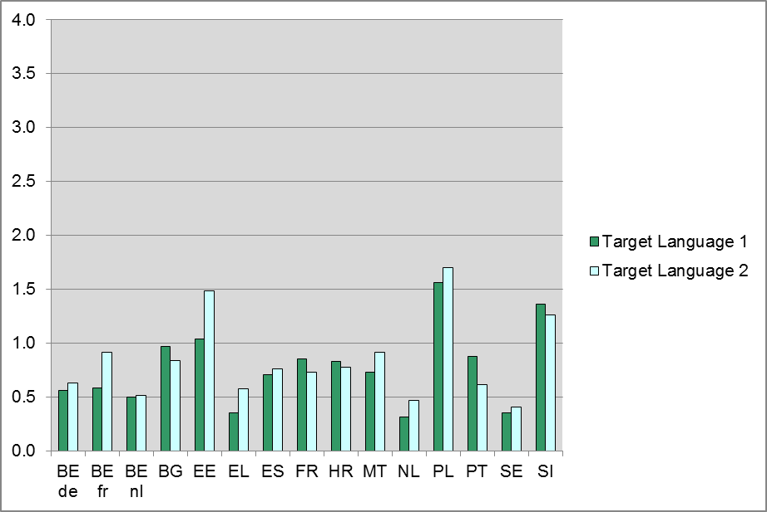
Figure 74 shows that for this index some educational systems have clearly higher means. Educational systems with means higher than 1.0 are: Estonia, Poland and Slovenia. In Greece, the Netherlands and Sweden the means are somewhat lower.

Staff from other language communities
The policy issue 'Staff from other language communities' consists of three questionnaire indices:
- guest teachers from abroad (PQ)
- target language as first language (TQ)
- training to teach target language as a foreign language (TQ).
The index ‘Guest teachers from abroad’ is represented in Figure 75. The index is based on a question in the Principal Questionnaire: “In the previous school year, how many teachers from abroad came to work in your school for longer than one month?” The columns represent the proportion of principals who said at least one guest teacher from abroad came to work in their school in the previous school year.
Figure 75: Guest teachers from abroad (PQ)
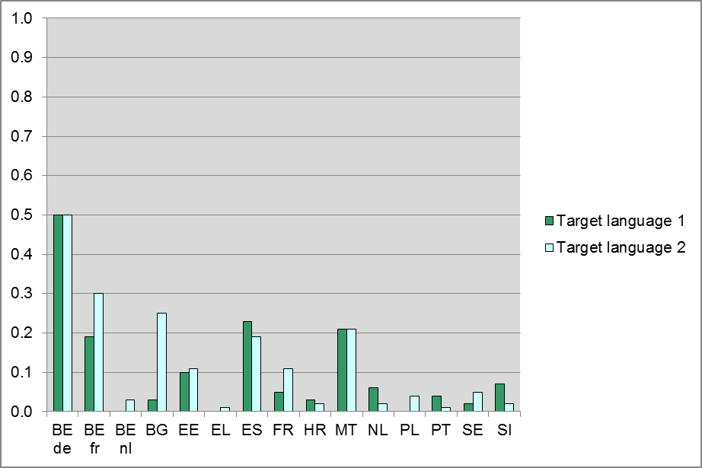
Figure 75 shows that the German Community of Belgium has the highest proportion of schools with at least one guest teacher from abroad. However, please note that ‘abroad’ was defined as ‘from other countries or language communities’ and the Belgian communities were instructed to adapt the question accordingly. Therefore, we can assume that most of the guest teachers were from other Belgian language communities. Other educational systems with about 20% or more schools who had guest teachers from abroad are the French Community of Belgium (possibly with the same explanation as for the German Community of Belgium), Bulgaria (second target language), Spain and Malta.
The proportion of teachers for whom the target language is their first language is represented in Figure 76. Someone’s ‘first language’ is defined as a language spoken at home before the age of five.
Figure 76: Teachers for which the target language is a first language (TQ)
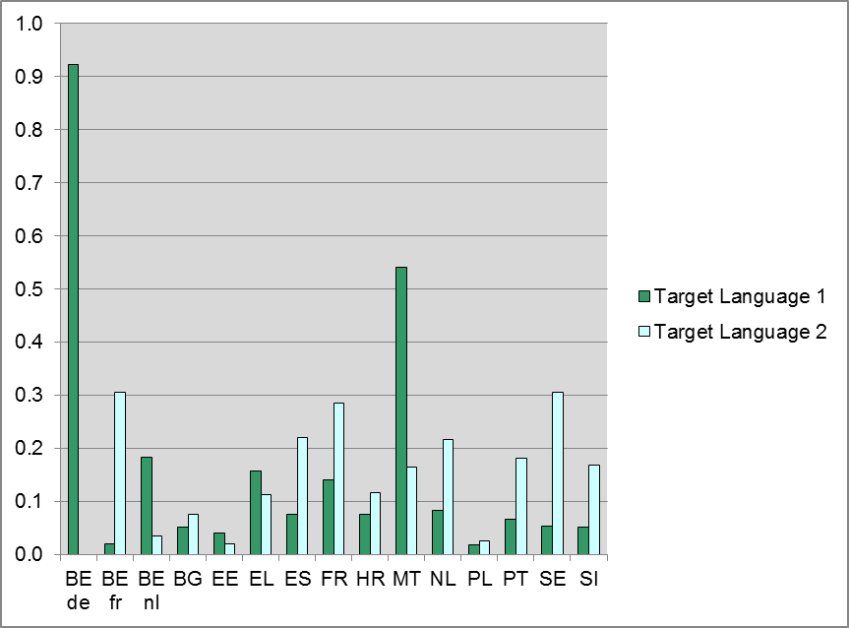
Figure 76 shows that there is quite some variation between the educational systems and the target languages with regard to the target language being the teacher’s first language. The lowest proportion is reported for the second target language in the German Community of Belgium. In this educational system, none of the second target language teachers reported that English is their first language. On the other hand, approximately 90% of the first target language teachers in the German Community of Belgium reported that French is their first language. This result stands out and could be explained by the fact that the German Community of Belgium is small with lots of French-speaking citizens. In Malta, approximately 50% of the teachers in the first target language reported that English is their first language. The proportion of teachers of the second target language who reported that Italian is their first language is much smaller.
Overall, there seems to be a difference between the first target language and second target language within the different educational systems. Only in a few educational systems the difference between the first target language and the second target language is very small. This is the case in Bulgaria, Estonia, Greece, Croatia, and Poland where the proportion of teachers for who the target language is their first language is small for both target languages.
Figure 77 shows the proportion of teachers who received training in teaching the target language as a foreign language during their initial teacher training or during in-service training.
Figure 77: Received training in teaching the target language as a foreign language (TQ)
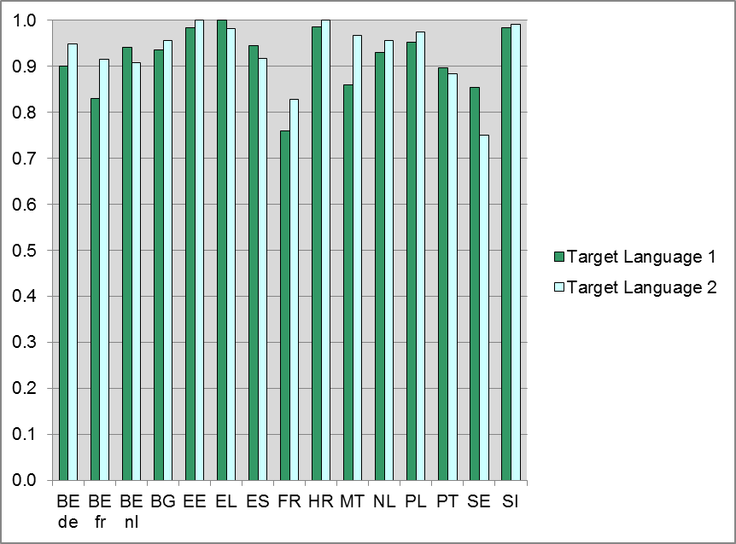
From Figure 77 it can be concluded that the majority of the teachers received training in teaching the target language as a foreign language, also in educational systems where a high proportion of teachers have the target language as their first language. The proportions range from approximately 0.75 to 1. The two educational systems with the least teachers trained to teach the target language as a foreign language are France and Sweden.
The educational systems in which almost all of the teachers received training to teach the target language as a foreign language are Estonia, Greece, Croatia, and Slovenia. Overall, the differences between the responses for the first target language and the second target language are relatively small within the educational systems. Exceptions are Malta and Sweden. In Malta, this difference is due to the fact that many teachers in the first target language, English, indicated that English is their first language. The differences in Sweden could be explained by the fact that a large proportion of teachers in the second target language, Spanish, indicated that the target language is their first language.
For most teachers in almost all educational systems, the target language is not their first language and therefore the majority of the teachers received training in teaching the target language as a foreign language. In some educational systems, a large proportion of teachers in either the first target language or the second target language the target language is their first language. In some, but not all of these educational systems, the proportion of teachers who received training in teaching the target language as a foreign language is considerably smaller.

Language learning for all
The policy issue ‘Language learning for all’ consists of two indices based on the Principal Questionnaire and two indices that focus on students with an immigrant background only:
- Provided and received help in mastering host language
    - provisions for help in mastering host language (PQ)
    - received help in mastering host language for first and second generation students (SQ)
- Provided and received formal education at school in language(s) of origin
    - provision of formal education in language(s) of origin (PQ)
    - received formal education in language(s) of origin for first and second generation students (SQ).
The index ‘Immigrant background’ consists of three categories: (1) A native student has at least one parent who was born in the country of test; (2) A ‘first generation’ student was born in another country and his or her parents were also born in another country; (3) A ‘second generation’ student was born in the country of test, but both parents were born in another country. The four indices of the policy issue ‘Language learning for all’ will only be described for educational systems where more than 10% of the students of one or both target languages have an immigrant background (first or second generation students): the Flemish, French and German Communities of Belgium, Spain (less than 10% immigrant students for the second target language), France, Greece, Croatia, the Netherlands and Sweden.
The proportion of schools in an educational system that provide extra help in mastering the host language is represented in Figure 78. This index is based on the question “What type of extra lessons does your school offer to students?”, concerning the item “Extra lessons for the host language for students with a different home language to the host language”. Principals had to answer ‘No’ or ‘Yes’.
Figure 78 shows that there are differences between the different educational systems. The proportion of schools that provide extra help in mastering the host language is relatively high in Sweden and the Flemish and German Communities of Belgium and relatively low in the French Community of Belgium, Spain, France, Greece and the Netherlands. For Croatia the proportion lies somewhere in between.

Figure 78: Provisions for help in mastering host language (PQ)
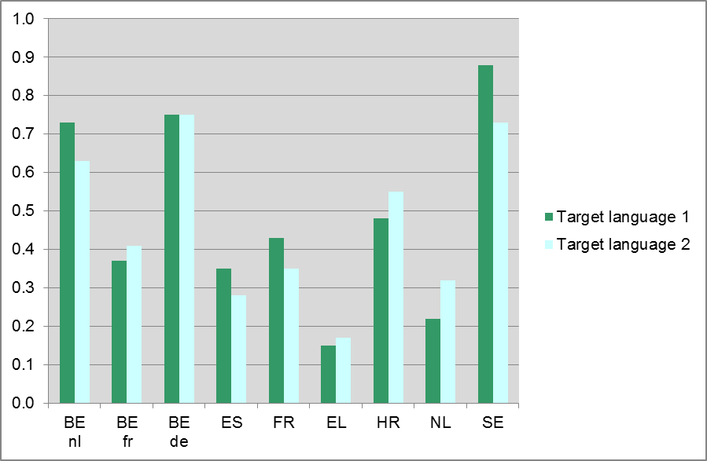
Figure 79 shows the proportions of first and second generation students that received extra help in mastering the host language. This index is based on the question “What type of extra lessons have you attended or are you attending?”, concerning the item “Extra lessons for host language”. Students had to answer ‘No’ or ‘Yes’.
Figure 79: Received help in mastering host language for first and second generation students (SQ)
The results shown in Figure 79 seem to suggest that the students’ responses for the different educational systems deviate from the principals’ responses. The proportion of immigrant students that received extra help in mastering the host language is relatively low in the three Belgian communities (while the proportion of schools providing extra help is high, except for the French Community of Belgium) and relatively high in Spain (especially the first target language population) and Greece (while the proportion of schools providing extra help is relatively low).
Figure 80 shows the proportion of schools in an educational system that provide formal education in language(s) of origin. This index is based on the question “What type of extra lessons does your school offer to students?”, concerning the item “Extra lessons in students’ home language for students with a different home language to the host language”. Principals could answer either ‘No’ or ‘Yes’.
Figure 80: Provision of formal education in language(s) of origin (PQ)
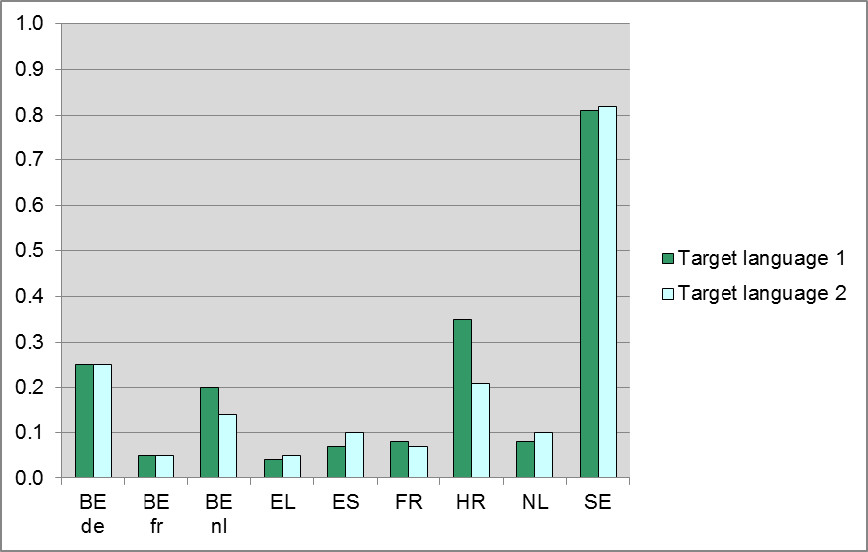
The proportions of schools providing formal education in language(s) of origin are 20% or lower, except in the German Community of Belgium, Croatia (first target language) and Sweden. In Sweden the proportion of schools that provide formal education in language(s) of origin is much higher than in any other educational system; approximately 80%. Figure 81 shows the received formal education in language of origin for first generation and second generation students. This index is based on the question “What type of extra lessons have you attended or are you attending?”, concerning the item “Extra lessons in another language than host language that is spoken regularly at your home”. Students could answer either ‘No’ or ‘Yes’.

Figure 81: Received formal education in language of origin for first and second generation students (SQ)
Figure 81 shows that the proportions are between 5 and 15 for both target language populations and both first and second generation immigrants in most educational systems. In Sweden and Greece, the proportions are clearly higher. For Sweden this is in accordance with the principal’s responses, both for Greece it does not.
The differences in proportions of schools providing help to immigrant students and proportions of immigrant students saying they received help might be explained by the fact that immigrant students in some educational systems are clustered within certain schools i.e. in the capital or a few large cities.

Foreign language teaching approach
The policy issue ‘Foreign language teaching approach’ consists of five subjects:
- Emphasis on the four communicative skills and language content within the teaching activities and resources used, which consists of eight indices comprising the four language skills (Writing, Speaking, Listening and Reading), three linguistic competences (Grammar, Pronunciation and Vocabulary), and the aspect ‘Culture and literature’ (TQ)
- Emphasis on similarities between the target language and other languages during target language lessons (SQ)
- Use of the target language during lessons, which consists of four indices
      - Teacher’s use of the target language during target language lessons, as reported by the teachers (TQ)
      - Students’ use of the target language during target language lessons, as reported by the teachers (TQ)
      - Teacher’s use of the target language during target language lessons, as reported by the students (SQ)
      - Students’ use of the target language during target language lessons, as reported by the students (SQ)
- Students’ perception (attitude) of target language, target language learning and target language lessons, which consists of three indices
      - usefulness of target language and target language learning (SQ)
      - difficulty of target language learning (SQ)
      - perception of target language lessons, teacher and textbook(s) (SQ)
- Compulsory foreign language learning (SQ).
Figure 82 to Figure 85 represent the relative emphasis the target language teachers put on average on the different communicative skills. The columns represent the mean deviation from the average emphasis the teachers put on different aspects of language learning. The different aspects of language learning are the four communicative skills (Writing, Speaking, Listening and Reading), three linguistic competences (Grammar, Vocabulary, Pronunciation) and Culture and Literature.
Figure 82: Relative emphasis teachers put on Writing (TQ)
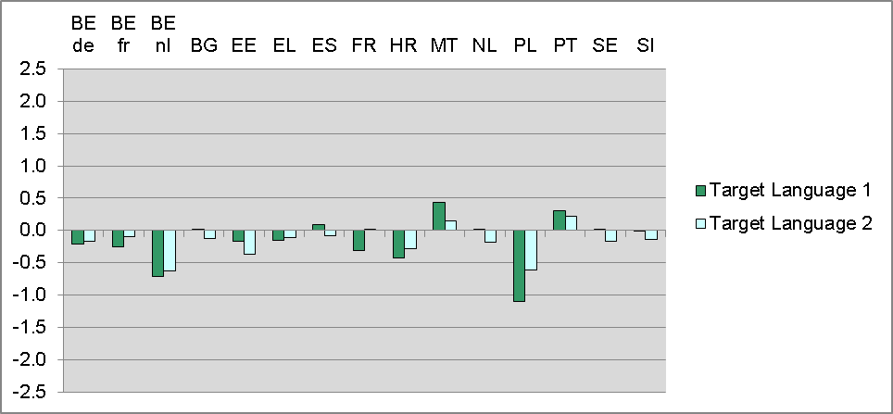
Figure 83: Relative emphasis teachers put on Speaking (TQ)
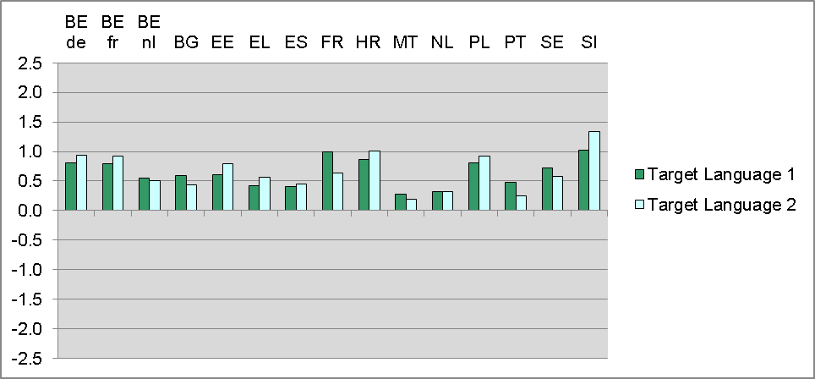
Figure 84: Relative emphasis teachers put on Listening (TQ)
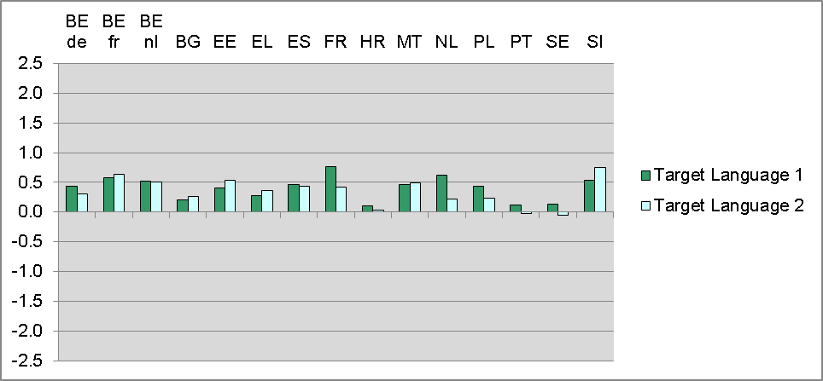
Figure 85: Relative emphasis teachers put on Reading (TQ)
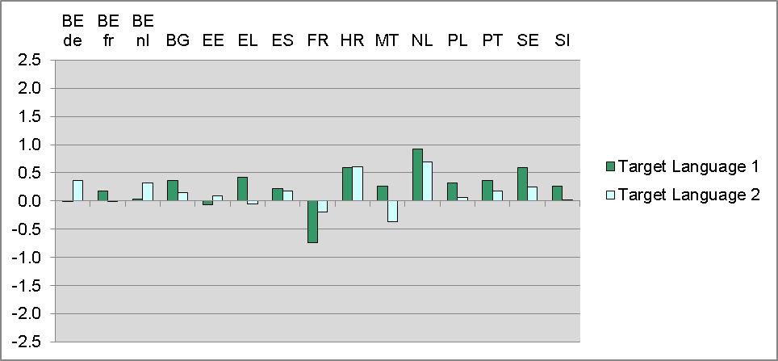
Looking at the relative emphasis on the four communicative competences, we see that in most educational systems least emphasis is placed on Writing, especially in Poland, and most emphasis on Speaking, especially in Slovenia. In contrast to this general picture, in France least emphasis is placed on Reading, while in the Netherland most emphasis is placed on Reading.
In all educational systems the differences in emphasis on the four communicative skills tend to be relatively small; this is especially true for Malta (first target language), Portugal and Spain. In Poland the differences are a bit larger, as well as in France for the first target language and in Sweden for the second target language.
Figure 86 to Figure 89 represent the relative emphasis the target language teachers put on average on Culture and Literature and on the different linguistic competences Grammar, Pronunciation and Vocabulary.
Figure 86: Relative emphasis teachers put on culture and literature (TQ)
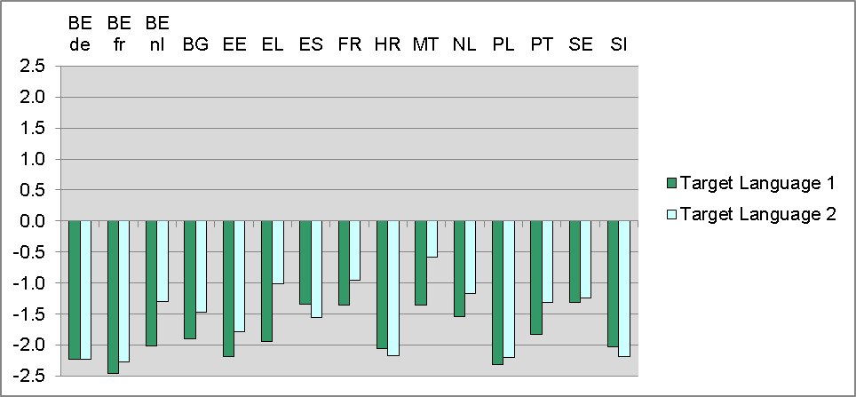
Figure 87: Relative emphasis teachers put on grammar (TQ)
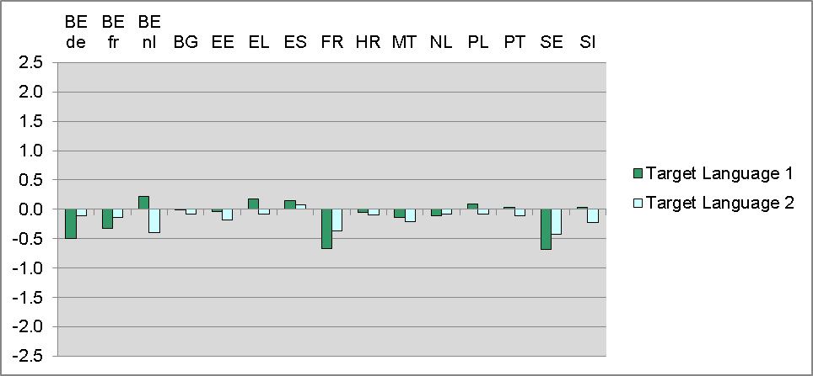
Figure 88: Relative emphasis teachers put on pronunciation (TQ)
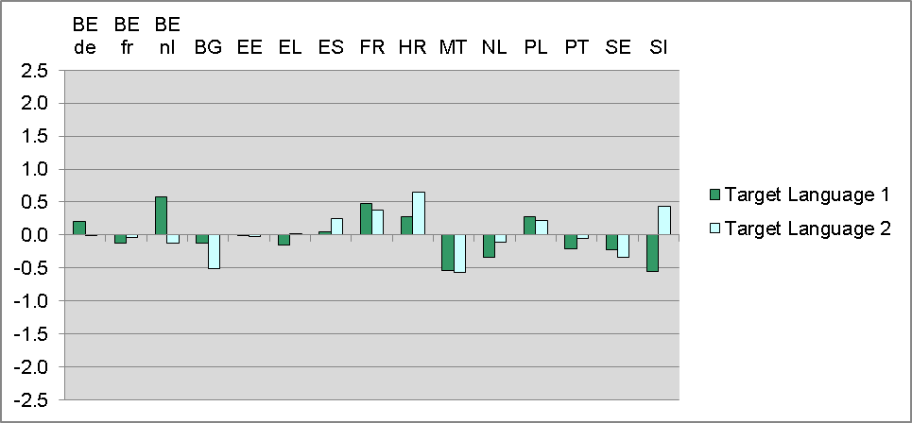
Figure 89: Relative emphasis teachers put on vocabulary (TQ)
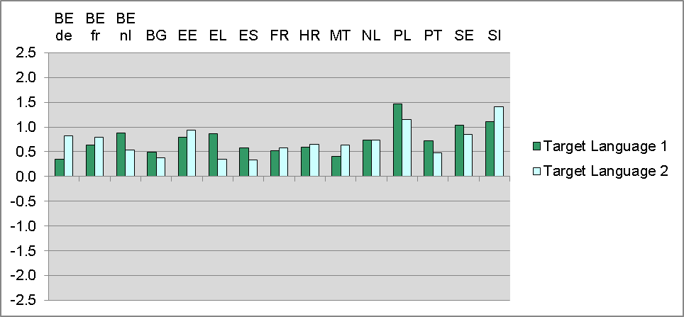
In all educational systems least emphasis is placed on Culture and Literature in comparison to the other aspects of language learning (Writing, Speaking, Listening, Reading, Grammar, Vocabulary and Pronunciation).
Of the three linguistic competences, relatively most emphasis is put on Vocabulary in all educational systems, especially in Poland and Slovenia. The difference in emphasis on Grammar and Pronunciation within educational systems tends to be quite small. In the majority of educational systems least emphasis is put on Grammar, especially in France and Sweden. Exceptions are Bulgaria for the second target language and Malta and Slovenia for the first target language where least emphasis is placed on Pronunciation instead of Grammar.
Figure 90 shows how often the students say their teachers point out similarities between the target language and languages familiar to them when teaching the different skills. The columns represent the mean frequency students say their teachers do this.
Figure 90: Emphasis on similarities between the target language and other languages (SQ)
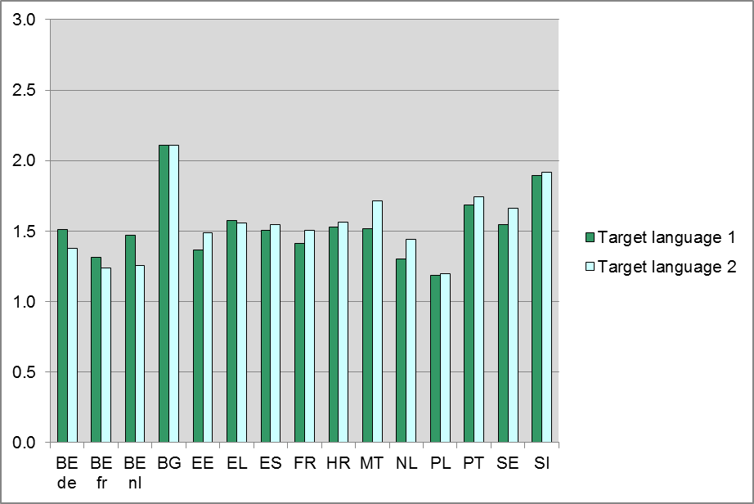
In Bulgaria the students in both target language populations report most often that their teacher points out similarities between the target language and other languages familiar to them, followed by Slovenia. In Poland the students report this least often.
Figure 91 shows how often, according to the teachers, they use the target language during the target language lessons. The columns represent the mean frequency teachers say they do this on a scale from ‘0=Never’ to ‘4=Always’.
Figure 91: Teacher’s use of the target language during target language lessons (TQ)
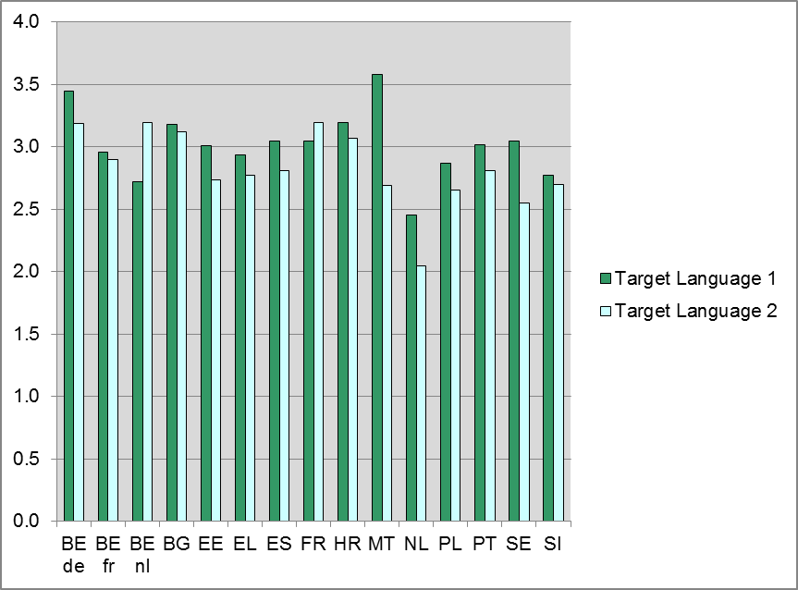
In the Netherlands the teachers in both target language populations on average least often report that they speak the target language during target language lessons. In Malta teachers in the first target language population, which is English, on average most often report they speak the target language during target language lessons. In the German Community of Belgium, Bulgaria, France and Croatia the teachers in both target language populations report more than average that they speak the target language during target language lessons.
How often according to the teachers the students use the target language during the target language lessons is represented in Figure 92. The columns represent the mean frequency teachers say the students do this on a scale from ‘0=Never’ to ‘4=Always‘.
Figure 92 shows that on average teachers in the second target language population report less often than teachers in the first target language population that the students speak the target language during the target language lessons. The only exceptions are the Flemish Community of Belgium where the teachers in the first target language report on average more often that the students speak the language during the lessons than the teachers in the second target language and the German Community of Belgium where the average is equal. The teachers of the second target language in Greece, Malta, the Netherlands and Portugal report that the students speak the target language least often during target language lessons.
Figure 92: Students’ use of the target language during target language lessons (TQ)
Figure 92 shows how often according to the students the teachers use the target language during the target language lessons. The columns represent the mean frequency students say their teachers do this on a scale from ‘0=Never’ to ‘4=Always’.
Figure 93: Teacher’s Use of the Target Language during Target Language Lessons (SQ)
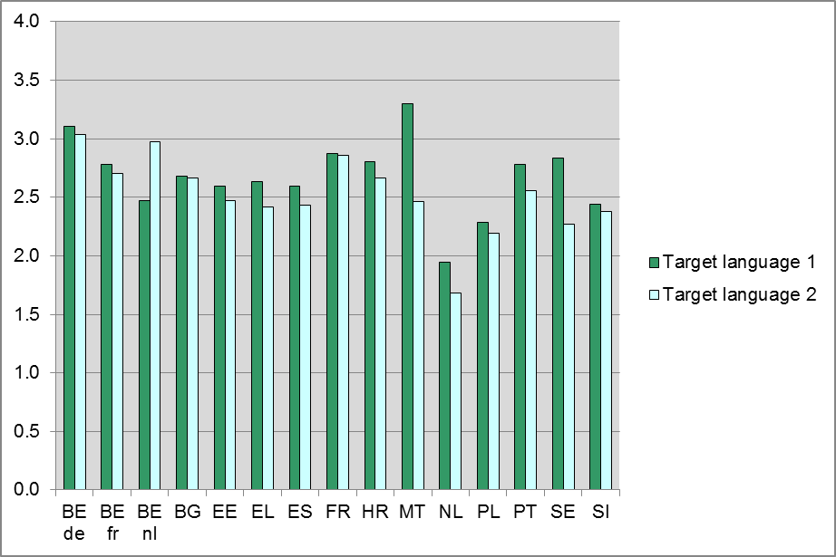
Figure 93 shows that overall teachers speak the language regularly during target language lessons, according to the students. In Malta the students of the first target language (English) say their teacher speaks the target language more often than in the other educational systems. In the Netherlands the students say that their teachers do this least often; in the second target language lessons the target language is even used less often than in the first target language lessons according to the students. In Poland the target language is also used less often than in the other educational systems. In Poland the use of the target language in the class room is about equal for the two target languages. The first target language (English) is used slightly more often than the second (German). Figure 94 shows how often students say they use the target language during target language lessons. The columns represent the mean frequency students say they do this on a scale from ‘0=Never’ to ‘4=Always’.
Figure 94: Students’ use of the target language during target language lessons (SQ)
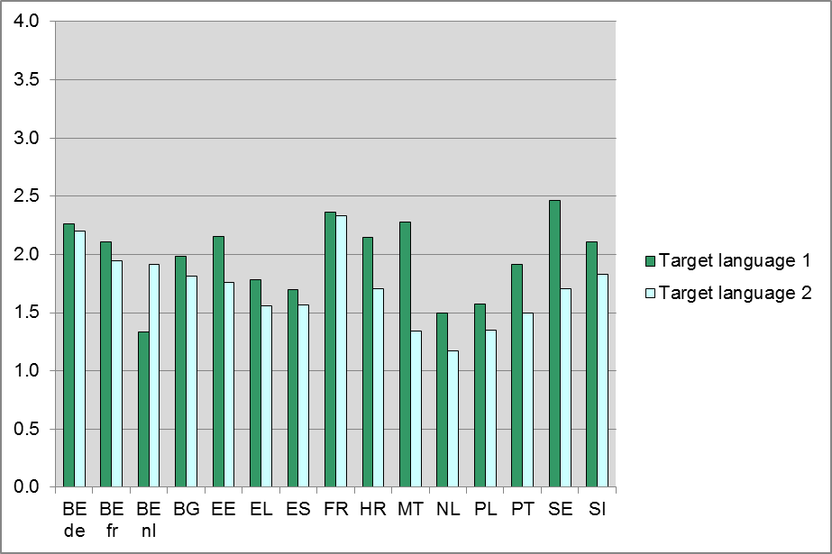
The students that have been tested in the first target language say they speak the target language during lessons more often than students that have been tested in the second target language in most educational systems. The only exception is the Flemish Community of Belgium. The students that have been tested in the second target language, which is English, say they speak the language more often during the target language lessons than the students that have been tested in the first target language, which is French. In Malta especially, but also in Sweden, the students that have been tested in the first target language report they speak the target language - in both cases English - far more often than the students that have been tested in the second target language – Italian and Spanish respectively.
In the Netherlands and in Poland the students say they speak the target language least often during the target language lessons. In the Netherlands this occurs even less often than in Poland. In both educational systems the students that have been tested in the first target language – in both cases English – report more use of the target language than the students that have been tested in the second target language – in both cases German. shows students’ perception of usefulness, based on (a) how useful students say they find the target language for different purposes such as travelling, their further education and for entertainment (movies, television programmes, music, games), (b) how much students say they like the subject of target language and (c) how useful students report the subject of target language is in general. The columns represent the mean of this index.
Figure 95: Perception of usefulness of target language and target language learning (SQ)
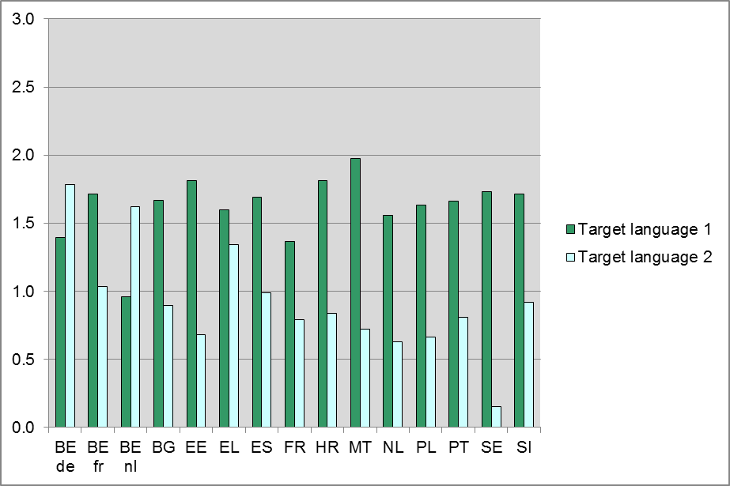
In most educational systems the students that have been tested in the first target language say that learning the target language is more useful than the students that have been tested in the second target language. The only exceptions are the Belgium Flemish and Belgium German Communities where students tested in the second target language say learning the target language is more useful than students tested in the first target language. However, the students tested in the first target language (French) in the Flemish and German Communities of Belgium, judge learning the target language as useful as most students do learning the second target language in most other educational systems. Both in the Flemish and German Communities of Belgium the second target language is English. It can be concluded that in all educational systems students generally find learning English most useful.
In Greece the students tested in both target languages say they find learning the target language very useful, although in Greece English is reported to be slightly more useful than French (the second target language). It is rather notable that in Sweden the students tested in the second target language, which is Spanish, say it is hardly useful.
Figure 96 shows how difficult students say they find it to learn the various target language skills. The skills are Writing, Speaking, Listening, Grammar, Reading, Pronouncing and Vocabulary of the target language. The columns represent the mean of the perceived difficulty by the students.
Figure 96: Perceived difficulty of target language learning (SQ)
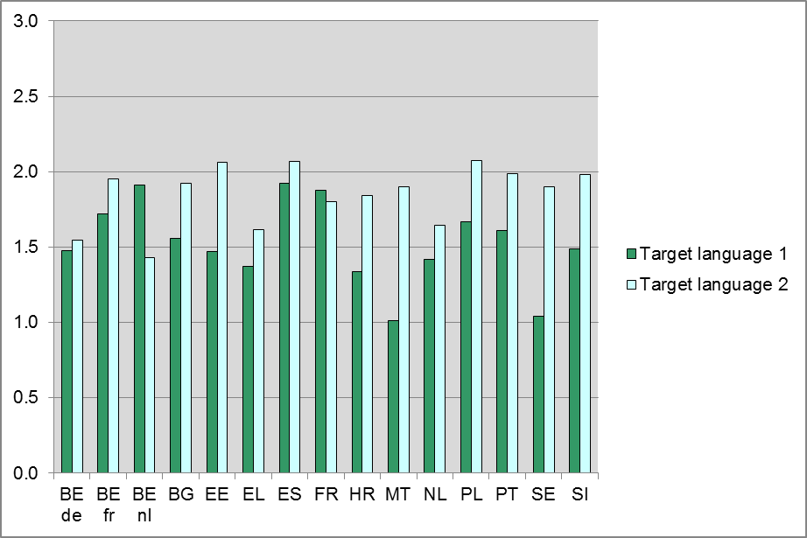
In most educational systems more students tested in the second target language say they find learning the target language difficult than students tested in the first target language. The exceptions are the Flemish Community of Belgium and France where more students tested in the first target language say they find learning the target language difficult than students tested in the second target language. In the Flemish Community of Belgium this is French versus English, in France this is English versus Spanish. In both Malta and Sweden students tested in the first target language, in both cases English, say they find learning the target language skills easy on average.
How students perceive their lessons, their teacher and their textbook(s) for learning all aspects of the target language is represented in Figure 97. The columns represent the mean for this index.
Figure 97 shows that in most educational systems the students tested in the first target language are slightly more positive about their target language lessons, teacher and textbook(s) than the students tested in the second target language. This is not the case in the Flemish and German Communities of Belgium and France, but there the differences are very small.
Figure 97: Perception of target language lessons, teacher and textbook(s) (SQ)
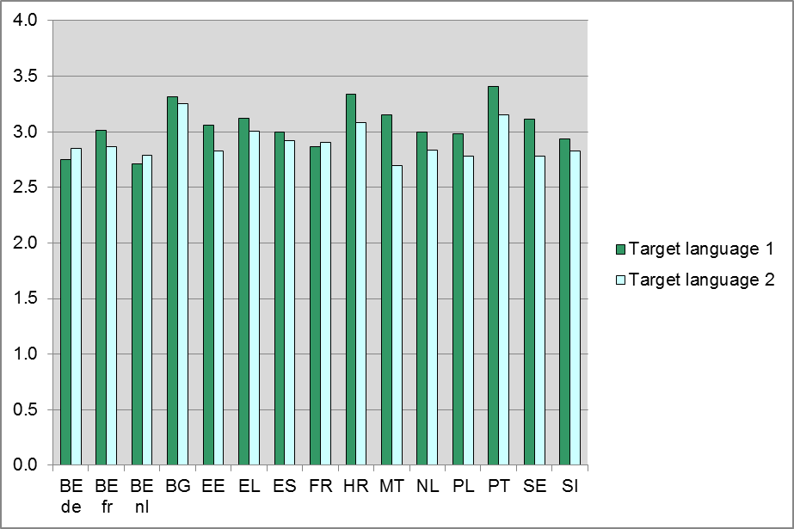
Table 26 shows proportions of the reasons why students study the target language. This index is based on the question “Why are you learning [target language]?”
In general, the first target language is more often compulsory for students than the second target language, except for the Flemish Community of Belgium where both target languages are equally often compulsory and Poland where the second target language (German) is more often compulsory than the first (English). The second target languages of the French Community of Belgium, Spain, France, Malta and Sweden are least often compulsory for students. In Spain, Croatia and Slovenia most students of the second target language indicate that they chose the target language as an optional subject. In the other seven educational systems, most students of the second target language indicate that studying a foreign language is compulsory and they chose the target language as a foreign language.
Table 26: Compulsory foreign language learning (SQ)
 | Target language 1
Educational system | Because the subject of TL is compulsory | Because studying a foreign language is compulsory and I chose TL | Because I chose TL as an optional subject
BE de | 88% | 5% | 7%
BE fr | 30% | 40% | 30%
BE nl | 90% | 9% | 2%
BG | 50% | 37% | 13%
EE | 74% | 21% | 4%
EL | 43% | 39% | 19%
ES | 78% | 20% | 2%
FR | 62% | 28% | 10%
HR | 66% | 21% | 13%
MT | 83% | 12% | 5%
NL | 90% | 8% | 2%
PL | 67% | 30% | 3%
PT | 67% | 21% | 11%
SE | 88% | 10% | 2%
SI | 77% | 18% | 5%
 | Target language 2
Educational system | Because the subject of TL is compulsory | Because studying a foreign language is compulsory and I chose TL | Because I chose TL as an optional subject
BE de | 50% | 7% | 43%
BE fr | 11% | 47% | 42%
BE nl | 91% | 7% | 2%
BG | 34% | 52% | 14%
EE | 26% | 57% | 17%
EL | 34% | 39% | 27%
ES | 20% | 6% | 75%
FR | 15% | 59% | 25%
HR | 33% | 10% | 57%
MT | 17% | 44% | 39%
NL | 66% | 13% | 21%
PL | 79% | 16% | 5%
PT | 58% | 25% | 18%
SE | 5% | 72% | 23%
SI | 36% | 9% | 55%

Teacher initial and in-service training

Teachers’ access to high quality initial and continuous training
The policy issue ‘Teachers’ access to high quality initial and continuous training’ consists of seven questionnaire subjects with 11 indices in total:
- highest educational level of teacher (TQ)
- certification for target language teaching (TQ)
- specialization of teachers (TQ)
- target language teacher shortage (PQ)
- incentives for in-service training
      - number of different financial incentives for in-service training from school (PQ)
      - number of different financial incentives for in-service training (TQ)
      - participation in in-service training is an obligation for teachers (TQ)
      - participation in in-service training is required for promotion (TQ)
      - organisation of in-service training (TQ)
- number of times participation in in-service training through different modes (TQ)
- focus of in-service training on languages or teaching related subjects (TQ).
The proportions of different education levels at which teachers have been educated (ISCED 6, ISCED 5B, ISCED 5A and ISCED3 OR 4) are represented in Table 27, which shows that most teachers of the target language indicate that they have completed ISCED 5A or higher. Only in the Netherlands (both target languages) and the Flemish and German Communities of Belgium (first target language) most teachers indicate that they have completed ISCED 5B.
Table 27: Highest educational level of teacher of target language (TQ)
 | Target language 1
Educational system | ISCED 3  or 4 | ISCED 5B | ISCED 5A | ISCED 6
BE de | 0% | 71% | 25% | 5%
BE fr | 0% | 30% | 54% | 16%
BE nl | 1% | 94% | 5% | 0%
BG | 2% | 4% | 93% | 1%
EE | 3% | 8% | 89% | 0%
EL | 2% | 0% | 66% | 32%
ES | 0% | 0% | 92% | 7%
FR | 1% | 1% | 87% | 12%
HR | 1% | 12% | 87% | 0%
MT | 8% | 17% | 74% | 0%
NL | 2% | 79% | 18% | 0%
PL | 1% | 11% | 88% | 0%
PT | 1% | 0% | 99% | 0%
SE | 1% | 1% | 97% | 1%
SI | 5% | 10% | 85% | 0%
 | Target language 2
Educational system | ISCED 3  or 4 | ISCED 5B | ISCED 5A | ISCED 6
BE de | 9% | 2% | 73% | 16%
BE fr | 0% | 21% | 63% | 16%
BE nl | 0% | 39% | 61% | 0%
BG | 0% | 2% | 96% | 2%
EE | 1% | 7% | 92% | 0%
EL | 0% | 0% | 63% | 37%
ES | 0% | 0% | 90% | 10%
FR | 4% | 0% | 86% | 10%
HR | 3% | 18% | 80% | 0%
MT | 6% | 29% | 65% | 0%
NL | 1% | 55% | 44% | 0%
PL | 2% | 4% | 92% | 1%
PT | 0% | 0% | 100% | 0%
SE | 2% | 6% | 92% | 0%
SI | 2% | 15% | 82% | 1%
The proportion of teachers’ certification are represented in Table 28.

Table 28: Certification for target language teaching (TQ)
 |  | Target language 1
Educational system | No certificate |  | Temporary/ emergency certification | Provisional certificate | Full certificate | Other certificate
BE de | 0% |  | 26% | 0% | 60% | 14%
BE fr | 0% |  | 27% | 0% | 72% | 1%
BE nl | 1% |  | 0% | 8% | 87% | 4%
BG | 2% |  | 1% | 2% | 82% | 13%
EE | 6% |  | 25% | 0% | 57% | 12%
EL | 0% |  | 0% | 2% | 90% | 8%
ES | 0% |  | 0% | 0% | 97% | 3%
FR | 2% |  | 4% | 1% | 87% | 7%
HR | 0% |  | 0% | 8% | 87% | 5%
MT | 3% |  | 12% | 3% | 81% | 1%
NL | 11% |  | 2% | 0% | 83% | 4%
PL | 3% |  | 0% | 0% | 92% | 5%
PT | 0% |  | 0% | 0% | 96% | 4%
SE | 6% |  | 0% | 0% | 85% | 9%
SI | 20% |  | 0% | 2% | 65% | 13%
 | Target language 2
Educational system | No certificate |  | Temporary/ emergency certification | Provisional certificate | Full certificate | Other certificate
BE de | 3% |  | 4% | 0% | 73% | 20%
BE fr | 1% |  | 22% | 0% | 75% | 2%
BE nl | 2% |  | 0% | 7% | 86% | 6%
BG | 0% |  | 0% | 0% | 98% | 2%
EE | 1% |  | 9% | 0% | 85% | 4%
EL | 0% |  | 0% | 0% | 100% | 0%
ES | 0% |  | 0% | 0% | 98% | 2%
FR | 3% |  | 6% | 0% | 88% | 2%
HR | 1% |  | 2% | 6% | 80% | 12%
MT | 1% |  | 6% | 7% | 86% | 0%
NL | 6% |  | 3% | 0% | 91% | 0%
PL | 1% |  | 0% | 0% | 95% | 4%
PT | 0% |  | 0% | 0% | 99% | 0%
SE | 15% |  | 0% | 0% | 65% | 20%
SI | 21% |  | 0% | 1% | 69% | 10%
Most teachers in all educational systems and for both target languages have a full certificate. In the French Community of Belgium, the German Community of Belgium (first target language) and Estonia (first target language) there is a noticeable proportion of teachers who have a temporary or emergency certification. The Netherlands, Slovenia and Sweden have a proportion of teachers of 5% or higher for both target languages without a certificate.
The proportions of different types of language teachers are represented in Table 29. This index is based on three questions: “Which school subjects are you qualified to teach?”; “How many languages are you qualified to teach?”; “Which language(s) are you qualified to teach?” These questions were combined for analysis to make a categorical index describing different levels of specialization.

 | Target language 1
Educational system | No qualification | Not qualified for languages | Generalist | Semi-specialized in languages | Specialized in languages | Completely specialized in languages | Completely specialized in target language
BE de | 0% | 13% | 3% | 6% | 38% | 37% | 3%
BE fr | 0% | 0% | 1% | 4% | 16% | 78% | 0%
BE nl | 0% | 1% | 0% | 12% | 70% | 16% | 1%
BG | 0% | 0% | 1% | 3% | 24% | 45% | 27%
EE | 3% | 0% | 13% | 2% | 17% | 33% | 32%
EL | 0% | 0% | 3% | 2% | 32% | 13% | 50%
ES | 0% | 0% | 3% | 19% | 23% | 29% | 26%
FR | 0% | 0% | 1% | 1% | 2% | 8% | 87%
HR | 0% | 0% | 14% | 0% | 28% | 35% | 22%
MT | 0% | 0% | 1% | 6% | 29% | 19% | 45%
NL | 9% | 0% | 0% | 0% | 4% | 30% | 58%
PL | 1% | 0% | 0% | 1% | 18% | 16% | 64%
PT | 0% | 0% | 1% | 0% | 5% | 91% | 3%
SE | 4% | 1% | 4% | 6% | 25% | 59% | 2%
SI | 3% | 0% | 0% | 1% | 22% | 54% | 20%
 | Target language 2
Educational system | No qualification | Not qualified for languages | Generalist | Semi-specialized in languages | Specialized in languages | Completely specialized in languages | Completely specialized in target language
BE de | 0% | 0% | 0% | 29% | 22% | 49% | 0%
BE fr | 0% | 0% | 0% | 4% | 15% | 81% | 0%
BE nl | 0% | 1% | 3% | 12% | 33% | 49% | 1%
BG | 0% | 0% | 0% | 2% | 20% | 52% | 26%
EE | 0% | 0% | 3% | 1% | 6% | 44% | 46%
EL | 0% | 0% | 1% | 4% | 43% | 24% | 28%
ES | 0% | 0% | 8% | 26% | 14% | 35% | 17%
FR | 0% | 0% | 0% | 1% | 13% | 17% | 69%
HR | 1% | 0% | 10% | 0% | 24% | 28% | 37%
MT | 1% | 0% | 0% | 3% | 25% | 24% | 48%
NL | 1% | 0% | 0% | 0% | 17% | 10% | 73%
PL | 0% | 0% | 0% | 0% | 20% | 12% | 68%
PT | 0% | 0% | 0% | 0% | 11% | 87% | 2%
SE | 9% | 0% | 0% | 7% | 23% | 46% | 16%
SI | 0% | 0% | 0% | 0% | 19% | 57% | 24%
Table 29: Target language teachers’ specialization (TQ)
There are some differences between the first and second target language with regard to specialization of teachers: Spain, France and Greece have relatively more target language specialists for target language 1 and Estonia, Croatia, the Netherlands and Sweden have relatively more target language specialists for target language 2. In the three Belgian communities and in Portugal there are hardly any teachers who teach the target language as their only subject. In contrast, Portugal has relatively the most teachers specialized in languages. France has relatively the most teachers specialized in the first target language; for the second target language the Netherlands has a few per cent more target language specialists than France (73% versus 69%, respectively).
The index ‘Target language teacher shortage’ is represented in Figure 98. This index is based on the question from the Principal Questionnaire: “During the past five years, have you had difficulty in filling teaching vacancies or covering for absent teachers for the following subjects?” concerning the item ‘For [target language]’. The columns represent the proportion of schools for which the item was answered with ‘Yes’.
Figure 98: Target language teacher shortage (PQ)
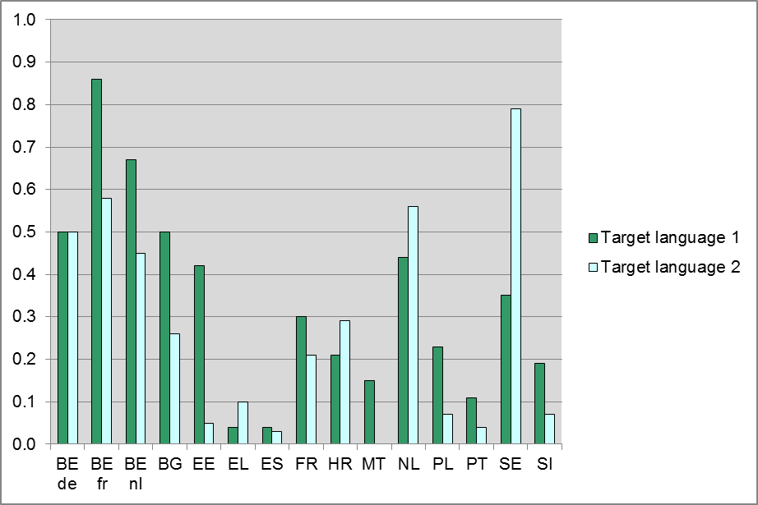
There are large differences in the proportions of target language teacher shortage. The highest proportions of teacher shortage for target language during the past five years are found in the French Community of Belgium (especially for the first target language), Sweden (second target language), the Flemish Community of Belgium (first target language) and the Netherlands (second target language). The lowest proportions of teacher shortage for both target languages are found in Spain, Greece and Portugal. In Malta there has been no teacher shortage for the second target language (Italian) at all.
The index ‘Number of different financial incentives for in-service training from school’ is represented in Figure 99. This index is based on the question from the Principal Questionnaire: “Which of the following financial compensations can teachers get from your school for participation in in-service training?” Principals could select one or more of four kinds of financial compensations, for example ‘Paid leave during training with no loss of earnings’. (PQ)
Figure 99 Number of different financial incentives for in-service training from school

Figure 99 shows that the highest mean number of different financial incentives for in-service training per school is found in Slovenia. In Estonia and Croatia (first target language) the means are also more than 2.5. In France, Malta and Portugal the number of financial incentives from school for in-service training are on average a bit lower.
The mean number of different financial incentives teachers get for in-service training is represented in Figure 100. This index is based on the question: “Which of the following financial compensations can you get for participation in in-service training?” Teachers could select zero or more of four options, for example increase in salary afterwards. The index is the number of different incentives that a teacher selected.
Figure 100: Number of different financial incentives for in-service training (TQ)
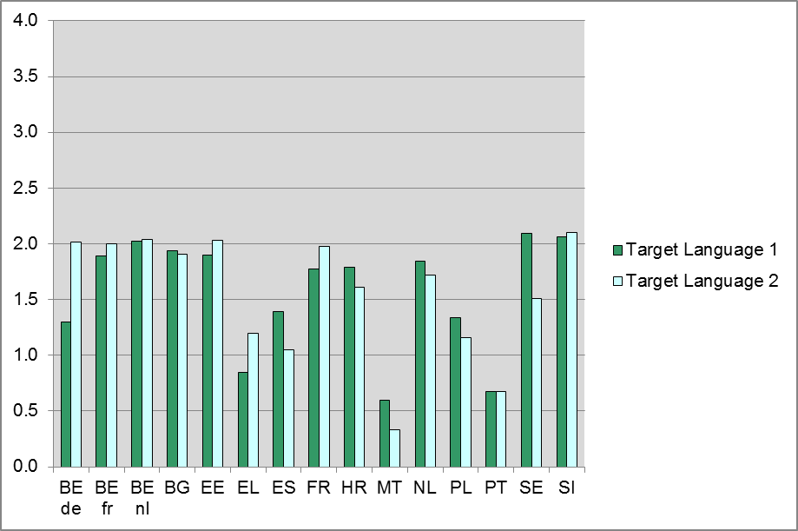
In most educational systems the mean number of incentives ranges from 1.5 to slightly more than 2.0 with the highest means for both target languages in Slovenia and the Flemish Community of Belgium, for the second target language in the French and German Communities of Belgium and for the first target language in Sweden. Malta, Greece (second target language) and Portugal have a mean of less than one. Figure 101 shows the proportions of teachers who responded that participation in in-service training is an obligation or required for promotion, respectively. These two indices are based on the question: “Is participation in in-service training an obligation, a right or an option for you?”
Figure 101: In-service training is an obligation for teachers (TQ)
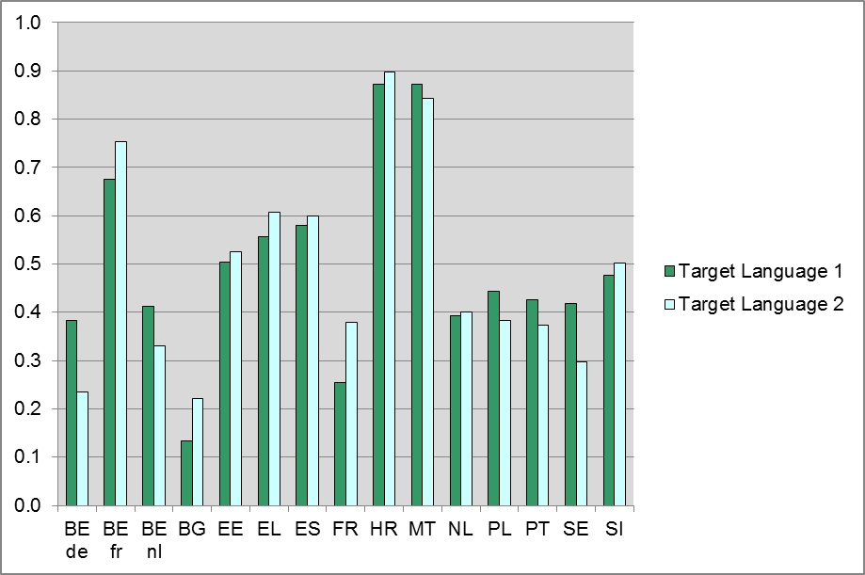

Figure 102: Participation in in-service training is required for promotion (TQ)
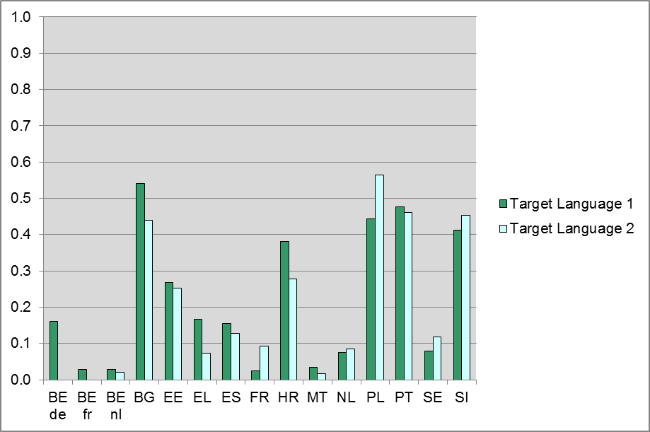
In Croatia and Malta, participation in in-service training is an obligation for more than 80% of teachers. In the French Community of Belgium about 70% of teachers are obliged to participate in in-service training. In Spain, Estonia and Greece over 50% of teachers have to participate in in-service training. In other educational systems the proportion typically lies between 30 and 50%. There is no noticeable difference between the first and the second target language.
In Bulgaria, Poland, Portugal and Slovenia more than 40% of the teachers respond that in-service training is required for promotion. This is somewhat less so in Estonia and Croatia (20-40%) and still less so in other educational systems (less than 20%). There is no obvious difference between teachers of the first and second target language.
The proportions per response-option for the situations in which teachers are allowed to participate in in-service training are represented in Table 30. This index is based on the question: “When are you normally allowed to participate in in-service training?”
In Spain, Malta and Portugal more than 50% of the teachers are only allowed to participate in in-service training outside their working hours. In the three Belgium communities, Bulgaria (the second target language), Estonia, France (the first target language), Croatia, the Netherlands (the first target language), Slovenia and Sweden (the first target language) on the other hand, more than 50% of teachers can follow in-service training during their working hours with a substitute teacher taking over their classes.

Table 30 Target language teachers’ organisation of in-service training (TQ)
 | Target language 1
Educational system | During your working hours with a substitute teacher for your classes | During your working hours but not during teaching hours | Only outside your working hours
BE de | 70% | 26% | 5%
BE fr | 58% | 24% | 18%
BE nl | 70% | 16% | 14%
BG | 45% | 14% | 42%
EE | 65% | 25% | 9%
EL | 26% | 35% | 39%
ES | 15% | 9% | 77%
FR | 57% | 32% | 11%
HR | 55% | 19% | 26%
MT | 10% | 36% | 54%
NL | 63% | 24% | 12%
PL | 47% | 14% | 39%
PT | 2% | 1% | 97%
SE | 55% | 23% | 22%
SI | 55% | 13% | 32%
 | Target language 2
Educational system | During your working hours with a substitute teacher for your classes | During your working hours but not during teaching hours | Only outside your working hours
BE de | 85% | 13% | 2%
BE fr | 58% | 29% | 12%
BE nl | 56% | 22% | 22%
BG | 59% | 7% | 34%
EE | 83% | 13% | 4%
EL | 22% | 48% | 30%
ES | 8% | 10% | 82%
FR | 44% | 38% | 18%
HR | 58% | 27% | 15%
MT | 5% | 27% | 68%
NL | 40% | 40% | 20%
PL | 37% | 16% | 46%
PT | 5% | 1% | 94%
SE | 38% | 32% | 31%
SI | 53% | 13% | 33%
The mean number of different modes in which teachers participated in in-service training in the past five years is represented in Figure 103.

Figure 103: Number of times participation in in-service training through different modes (TQ)
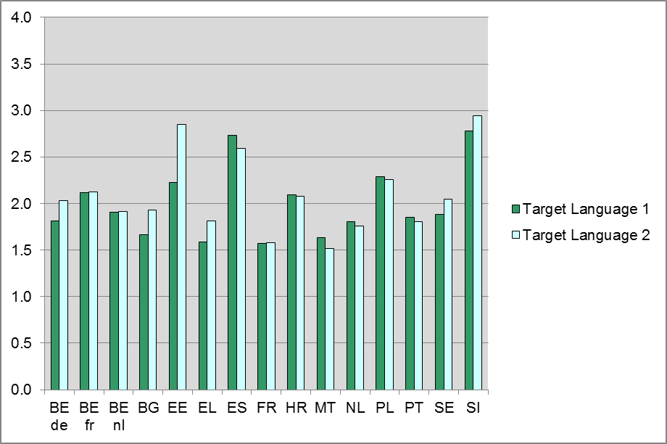
Figure 103 shows that in the French Community of Belgium, Spain, Estonia, Croatia, Poland and Slovenia the mean number of different modes in which teachers participated in in-service training is higher than two. In all other educational systems the mean lies between 1.5 and 2.
The focus of in-service training on languages or teaching-related subjects is represented in Figure 104. This index is based on two questions in which they could answer ‘Yes’ or ‘No’ to 10 different options related to teaching in general and 12 different options related to language related themes. The index is the proportion of affirmative answers to the question about language related themes minus the proportion of affirmative answers to the question about teaching in general. The resulting index has a scale of minus one (yes to all options regarding teaching in general and no to all options regarding language related themes) to plus one (no to all options regarding teaching in general and yes to all options regarding language related themes).
Figure 104 shows that in all cases except the first target language in the Netherlands and Sweden, teachers chose more in-service training focused on language-related themes than focused on teaching in general. The strongest focus on language-related themes in in-service training is found in the German Community of Belgium (first target language), Estonia (both target languages) and France (second target language).
Figure 104: Focus of In-service training on languages or teaching-related subjects (TQ)
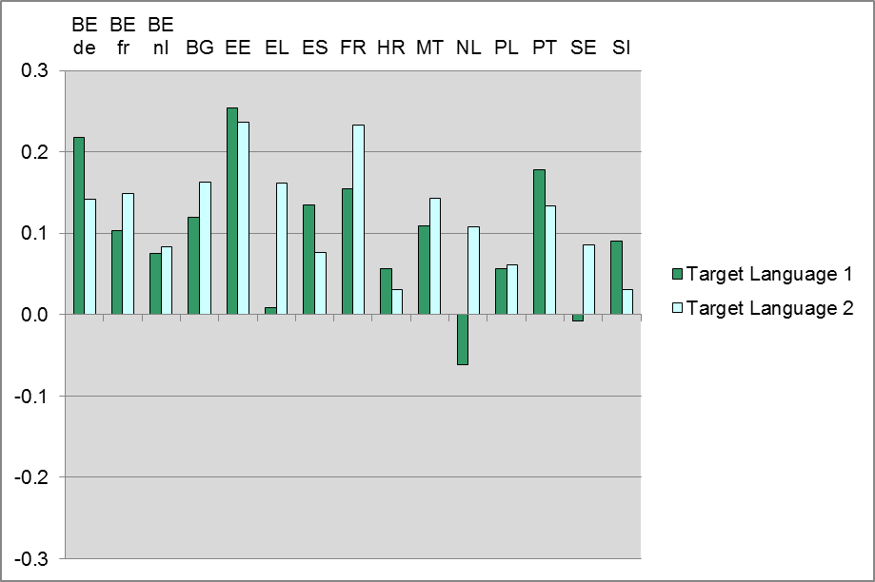

A period of work or study in another country for teachers
The policy issue ‘a period of work or study in another country for teachers’ consists of two subjects with four questionnaire indices:
- Teachers’ stays in target culture
  - target language teachers participating in exchange visits (PQ)
  - number of stays in target language culture for different reasons (TQ)
- Financial incentives (funding) for stays abroad
  - financial incentives from the government for exchange visits or stays abroad during teachers’ training (NQ)
    - initial teacher training
    - Teacher training on-the-job
  - funding for exchange visits (PQ).
The index ‘Target language teachers participating in exchange visits’ is represented in Figure 105. This index is based on the question in the Principal Questionnaire: “In the previous school year, how many teachers of target language participated in teacher exchange visits to work or study in another country for longer than one month?” The columns represent the proportions of schools where one teacher or more participated in exchange visits.

Figure 105: Target language teachers participating in exchange visits (PQ)
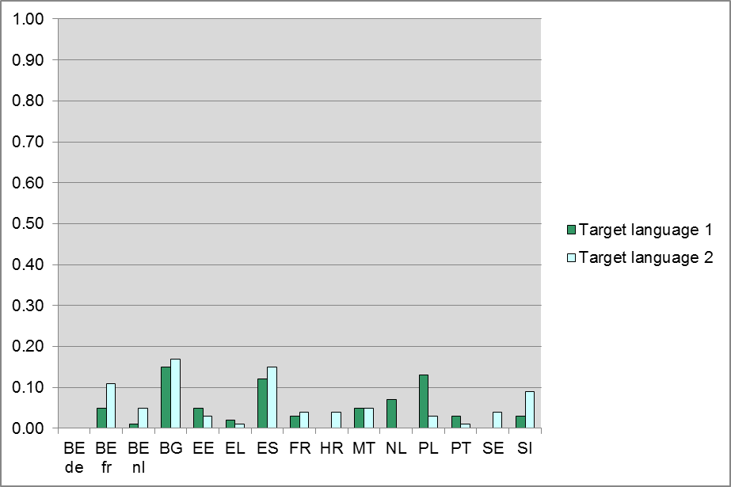
Figure 105 shows that in all educational systems very few schools have teachers of target language who participated in exchange visits. Educational systems in which more than 10% of the schools have teachers of target language who participated in exchange visits are the French Community of Belgium (second target language), Bulgaria, Spain and Poland (first target language). In the German Community of Belgium no schools have teachers of target language who participated in exchange visits.
Teachers were asked how often they have stayed in a target language speaking country for longer than one month for different reasons such as holidays, for study or courses, for teaching, for other jobs than teaching or living with their family. The teachers, for each reason, could indicate how many times they stayed for a period longer than a month in the target language speaking country. The number of ‘stays’ for different reasons (with a maximum of five different reasons) are represented in Figure 106.
Figure 106 shows the teachers report on average that they stayed in a second target language speaking country for more than a month for more different reasons than in a first target language speaking country. The reverse is the case in the Flemish and German Communities of Belgium. The differences are comparatively big in Bulgaria, Croatia and Poland.
Figure 106: Number of stays in target culture by teachers for different reasons (TQ)
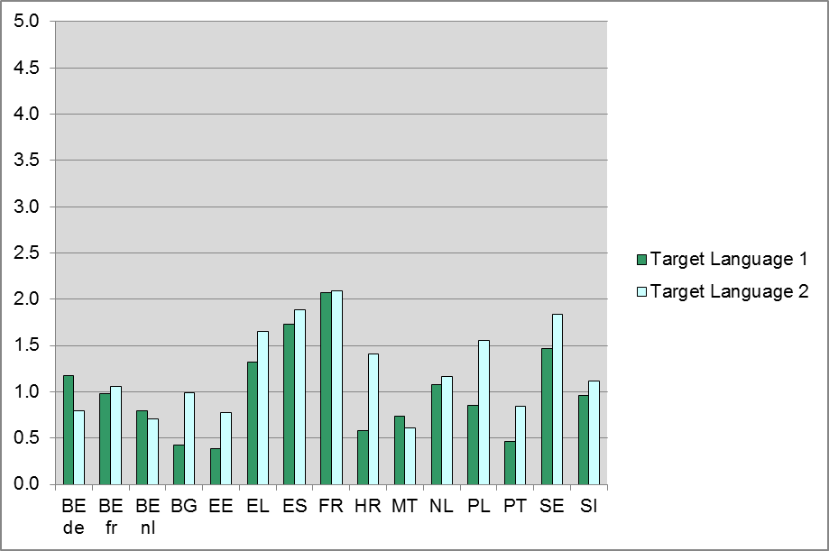
Teachers said on average they stayed in a target language speaking country for more than one month for most different reasons in Greece, Poland and Sweden for the second target language and in Spain and France for both target languages. The teachers report stays longer than a month in a target language speaking country for least different reasons in Bulgaria, Estonia and Portugal for the first target language, which is English.
National Research Coordinators were asked whether the government in their country (including local, regional, state and national government) offers financial incentives for exchange visits or stays abroad for (foreign language) teachers. Their responses are represented in Table 31 and Table 32 for exchange visits or stays abroad during teachers’ initial training and after initial training (on-the-job), respectively.

Table 31 Financial incentives for exchange visits or stays abroad during initial training (NQ)
Educational system | ISCED1 | General ISCED2 | Vocational ISCED2 | General ISCED3 | Vocational ISCED3
BE de | No | No | NA | No | No
BE fr | No | No | NA | No | No
BE nl | Yes | Yes | NA | Yes | Yes
BG | Yes | Yes | NA | Yes | Yes
EE | No | No | NA | No | No
EL | No | No | NA | No | No
ES | Yes | Yes | NA | Yes | Yes
FR | No | No | NA | No | No
HR | No | No | NA | No | No
MT | Yes | Yes | NA | Yes | Yes
NL | Yes | Yes | Yes | Yes | Yes
PL | Yes | Yes | NA | Yes | Yes
PT | No | No | No | No | No
SE | No | No | NA | No | No
SI | Yes | Yes | NA | Yes | Yes
UK-ENG | Yes | No | NA | No | No
NA=Not applicable.
Table 32 Financial incentives for exchange visits or stays abroad on-the-job (NQ)
Educational system | ISCED1 | General ISCED2 | Vocational ISCED2 | General ISCED3 | Vocational ISCED3
BE de | No | No | NA | No | No
BE fr | No | No | NA | No | No
BE nl | Yes | Yes | NA | Yes | Yes
BG | Yes | Yes | NA | Yes | Yes
EE | No | No | NA | No | No
EL | Yes | Yes | NA | Yes | Yes
ES | Yes | Yes | NA | Yes | Yes
FR | No | No | NA | No | No
HR | No | No | NA | No | No
MT | Yes | Yes | NA | Yes | Yes
NL | Yes | Yes | Yes | Yes | Yes
PL | Yes | Yes | NA | Yes | Yes
PT | No | No | No | No | No
SE | No | No | NA | No | No
SI | Yes | Yes | NA | Yes | Yes
UK-ENG | Yes | No | NA | No | No
NA=Not applicable.
Table 31 and Table 32 show that in seven educational systems the government offers financial incentives to (foreign language) teachers of all ISCED levels for exchange visits or stays abroad both during initial training and on-the-job (the Flemish Community of Belgium, Bulgaria, Spain, Malta, the Netherlands, Poland and Slovenia). In seven other educational systems the government does not offer financial incentives to teachers in any of the ISCED levels (the German and French Communities of Belgium, Estonia, France, Croatia, Portugal and Sweden). In Greece, the government does offer financial incentives to teachers in all ISCED levels for exchange visits or stays abroad on-the-job, but not during initial training. In England, the government only offers financial incentives for exchange visits or stays abroad to teachers in ISCED1, both during their initial training and on-the-job.
The index ‘Funding for exchange visits’ is represented in Figure 107. This index is based on the question from the Principal Questionnaire: “In the previous school year, did any of the teachers or guest teachers receive funding for exchange visits in the following ways?” Principals could respond whether teachers received funding through the European Union, through the government and/or through benefactors, donations, etc.
Figure 107: Funding for exchange visits (PQ)
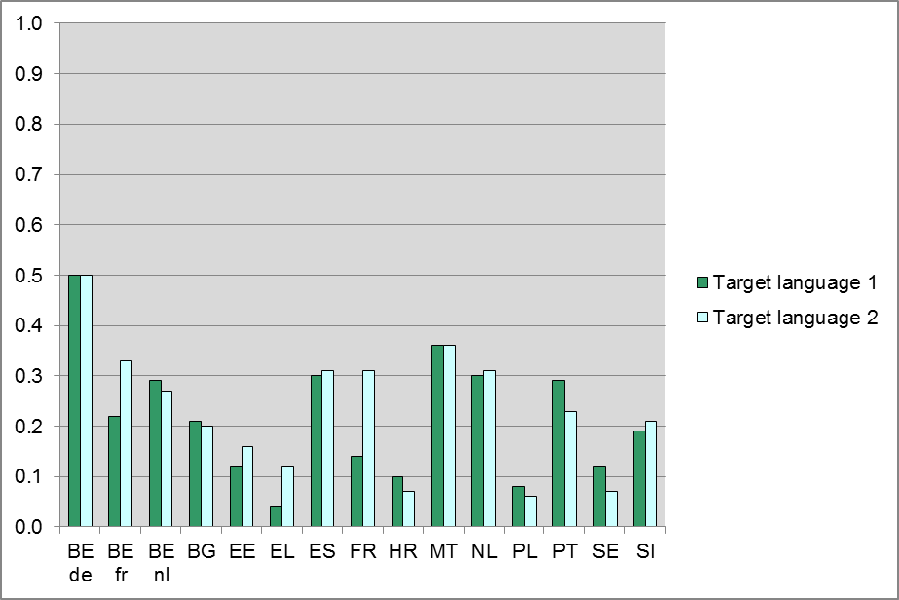
Figure 107 shows that in the German Community of Belgium half of the schools have teachers who received funding for exchange visits in the previous school year. In all other educational systems fewer than 40% of the schools have teachers who received funding. In Greece, Croatia, Poland and Sweden the percentage of schools with teachers who received funding is even 10% or lower.

Use of existing European language assessment tools
The policy issue ‘Use of existing European language assessment tools’, consists of three subjects with five indices:
- National recommendations for the use of the CEFR (NQ)
- Teachers' use of CEFR and received training in use
  - received training in the CEFR (TQ)
  - use of CEFR (TQ)
- Teachers' use of a Language Portfolio and received training in use
  - received training in use of a Portfolio (TQ)
  - use of a Language Portfolio (TQ).
Table 33 represents whether the use of the Common European Framework of Reference for languages (CEFR) is obligatory (2) or recommended (1) by the central (or highest level) authorities in each educational system for five different purposes.
Use of the CEFR is obligatory for curriculum or syllabus development and teacher training in the German Community of Belgium and for curriculum or syllabus development in France and the Netherlands. In general, the use of the CEFR is recommended by the central (or highest level) authorities for all five purposes (for curriculum or syllabus development, teacher training, testing or assessment, development or selection of instructional materials and for communication with stakeholders) in ten educational systems. In the French Community of Belgium, and England use of the CEFR is not recommended for any of the purposes. Except for curriculum or syllabus development, use of the CEFR is not obligatory or recommended in the Netherlands and Poland. In Spain and Croatia use of the CEFR is recommended for all purposes, except for communication with stakeholders.
Table 33 Use of the CEFR obligatory or recommended for five different purposes (NQ)
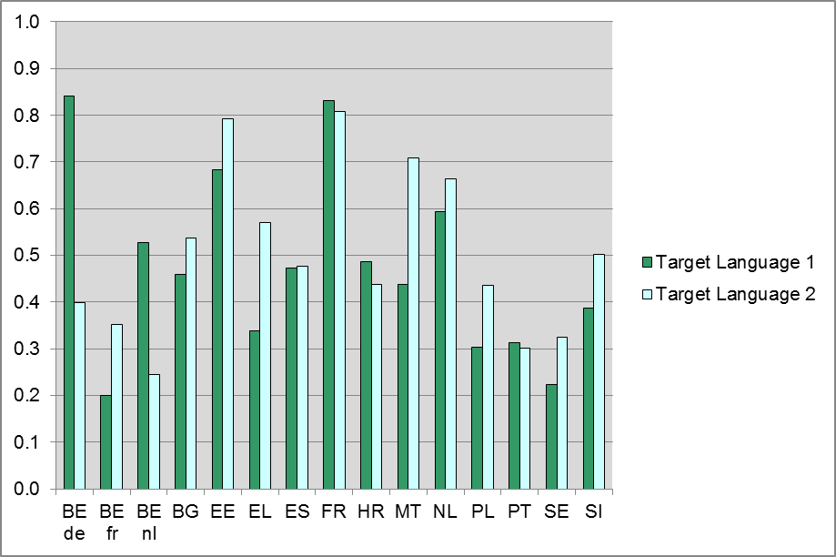  Educational system | Curriculum or syllabus development | Teacher training | Testing or assessment | Development or selection of instructional materials | Communication with stakeholders
BE de | 2 | 2 | 1 | 1 | 1
BE fr | 0 | 0 | 0 | 0 | 0
BE nl | 1 | 1 | 1 | 1 | 1
BG | 1 | 1 | 1 | 1 | 1
EE | 1 | 1 | 1 | 1 | 1
EL | 1 | 1 | 1 | 1 | 1
ES | 1 | 1 | 1 | 1 | 0
FR | 2 | 1 | 1 | 1 | 1
HR | 1 | 1 | 1 | 1 | 0
MT | 1 | 1 | 1 | 1 | 1
NL | 2 | 0 | 0 | 0 | 0
PL | 1 | 0 | 0 | 0 | 0
PT | 1 | 1 | 1 | 1 | 1
SE | 1 | 1 | 1 | 1 | 1
SI | 1 | 1 | 1 | 1 | 1
UK-ENG | 0 | 0 | 0 | 0 | 0
0=Not obligatory or recommended;1=Recommended;2=Obligatory.
Figure 108 presents the proportion of teachers who report that they have received training about the CEFR. The columns represent the proportion of teachers responding that they did receive such training.
Figure 108: Teachers who received training about the CEFR (TQ)
Figure 108 shows that percentages vary between educational systems, ranging from approximately 20% for the first target languages in the French Community of Belgium and Sweden to about 80% for teachers of the first target language in the German Community of Belgium, the second target language in Estonia and both target languages in France. The percentages also differ between target languages, but generally not very much; except for the German Community of Belgium.
The second index for the Policy Issue ‘Use of existing European language assessment tools’ consists of teachers’ use of the CEFR. Figure 109 represents this use. Teachers were asked to indicate how often they made use of possibilities offered by the CEFR, on a scale from ’0= never‘ to ’3= very often’. The possibilities for use of the CEFR included: Curriculum or syllabus development, Teacher training, Testing or assessment, Development or selection of instructional materials, and Communication with stakeholders. The columns indicate at which point on the scale the use of the CEFR is situated.
Figure 109 shows that the use of the CEFR is limited. Only two educational systems – Bulgaria (first target language) and France (both target languages) - have reported means close to 1.5.

Figure 109: Use of the CEFR (TQ)
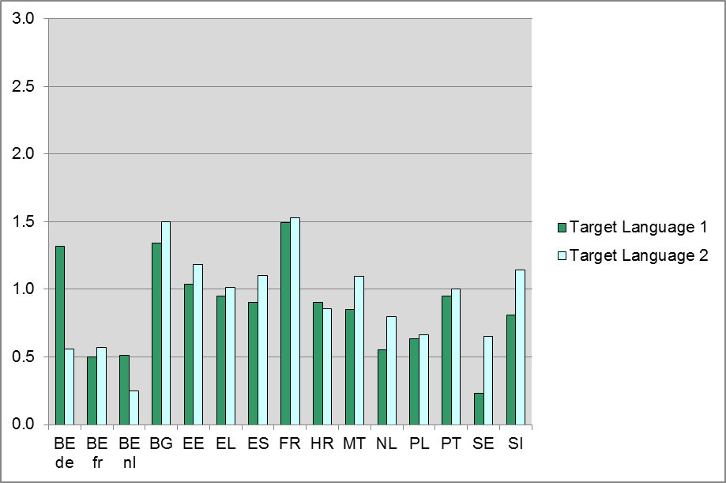
Figure 110 presents the proportion of teachers who have received training in the use of a portfolio, either the European Language Portfolio or some other portfolio. The columns represent teachers who report that they have received such training. Figure 110 shows that the proportions of teachers who have received training in the use of some type of portfolio differs across educational systems. The proportions are generally lower than the proportions of teachers who have indicated that they have received training in CEFR (see Figure 108). There are differences between the target languages, though these are generally not large and not in one particular direction.
Figure 110: Teachers who received training about a portfolio (TQ)
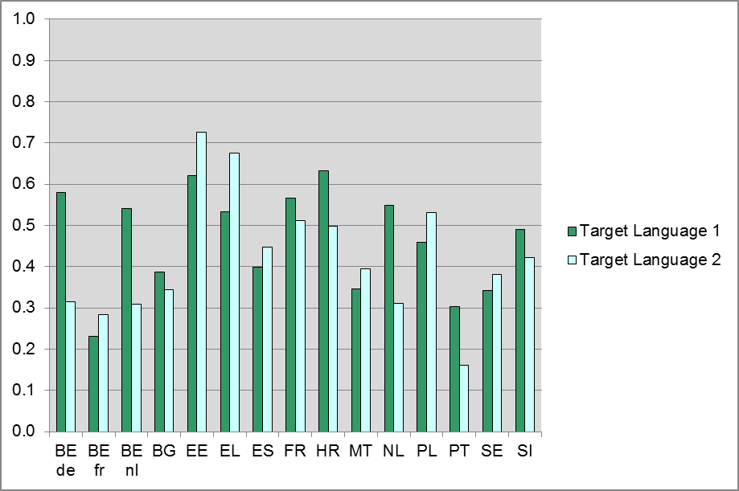

For the index ‘Use of a language portfolio’ teachers were asked how often they or their students made use of an online portfolio for their target language classes. The response-options ranged from ’0=never or hardly ever‘ to ’4=(almost) every lesson‘. The use of online language portfolios is very limited for all educational systems and target languages, with a maximum average of 0.2 for both target languages in Greece. A figure has not been included for this index as differences between educational systems and languages are small.
In sum, we find that there are rather large differences between educational systems and target languages as to whether teachers have received instruction in the use of the CEFR. Nevertheless, a majority of all teachers report that they have. A little less than half of the teachers report having received some instruction in the use of an electronic language portfolio. However, the actual use of these instruments (CEFR and portfolio) lags far behind.

Practical experience
The policy issue ‘Practical experience’, consists of four indices composed of teachers’ responses:
- Duration of in-school teaching placement (TQ)
- Teaching experience:
  - experience in teaching target language (TQ)
  - experience in teaching languages other than target language (TQ).
The mean of the variable ‘Duration of in-school teaching placement’ in months is represented in Figure 111. This index is based on the question: “How long were the following phases during your initial training as a teacher?” with regard to the sub-item ‘In-school teaching placements’.
Figure 111 shows that Greece and Slovenia have the smallest mean duration of in-school teaching placement (close to 1 month) whereas Croatia and Portugal have a mean of about 3 months. The other educational systems fall somewhere in between. There is a notable difference between teachers of the first and second target language in the Flemish and German Communities of Belgium, France and Greece; in these educational systems teachers of the first target language have had a longer in-school teaching placement than teachers of the second target language.

Figure 111: Duration of In-school teaching placement in months (TQ)
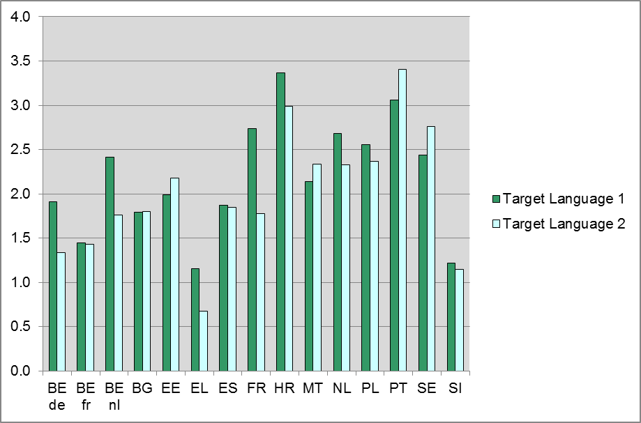
The mean experience in years in teaching the target language is represented in Figure 112. This index is based on the question: “By the end of this school year, how many years will you have been teaching target language?”
Figure 112: Experience in teaching the target language in years (TQ)
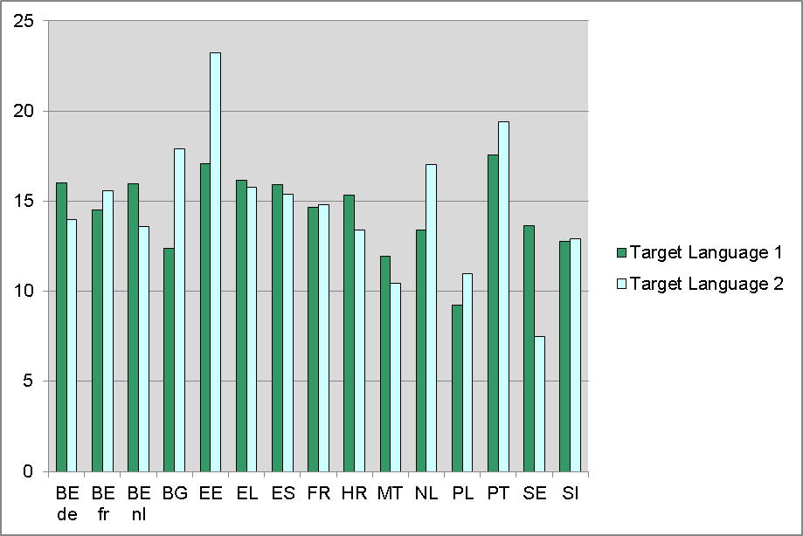
Most educational system means are between 10 and 20 years, with the highest mean for Estonia (second target language) followed by Bulgaria (second target language), the Netherlands (second target language) and Portugal (both target languages). In Malta (second target language), Poland (both target languages) and Sweden (second target language) teachers have somewhat less experience.
The mean experience in years in teaching other languages than the target language is represented in Figure 113. This index is based on the question: “By the end of this school year, how many years will you have been teaching languages other than target language?”
Figure 113: Experience in teaching languages other than target language in years (TQ)
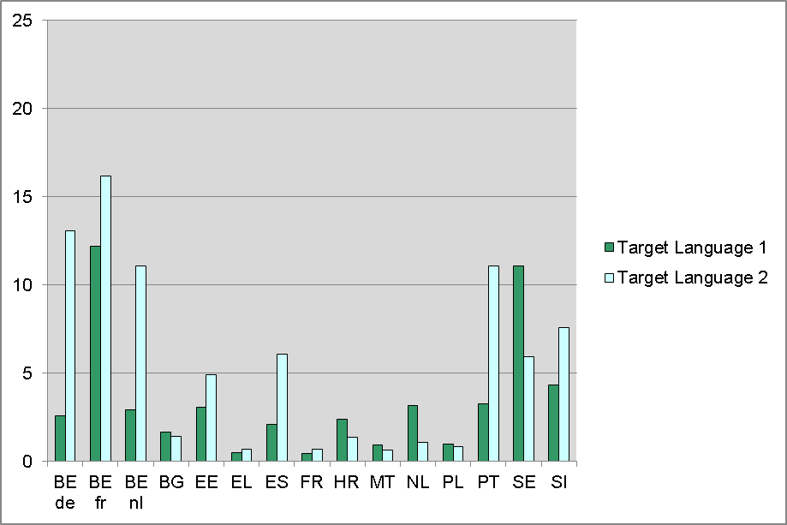
In Bulgaria, France, Croatia (second target language), Greece, Malta, the Netherlands (second target language) and Poland teachers have somewhat less experience in teaching other languages than in other educational systems. In the Flemish and German Communities of Belgium (second target language), the French Community of Belgium (both target languages), Portugal (second target language) and Sweden (first target language) teachers have on average more than 10 years of experience in teaching other languages. Other educational systems fall somewhere in between.
The mean number of languages taught over the past five years is represented in Figure 114. This index is based on the question: “Which of the following languages have you taught during the past five years?” Teachers could select different languages from a list which contained up to five of the most widely spoken indigenous languages and the five most widely taught foreign languages in the educational system and the option “other language”. The index is the number of options the teachers selected.
Figure 114: Number of languages taught over the past five years (TQ)
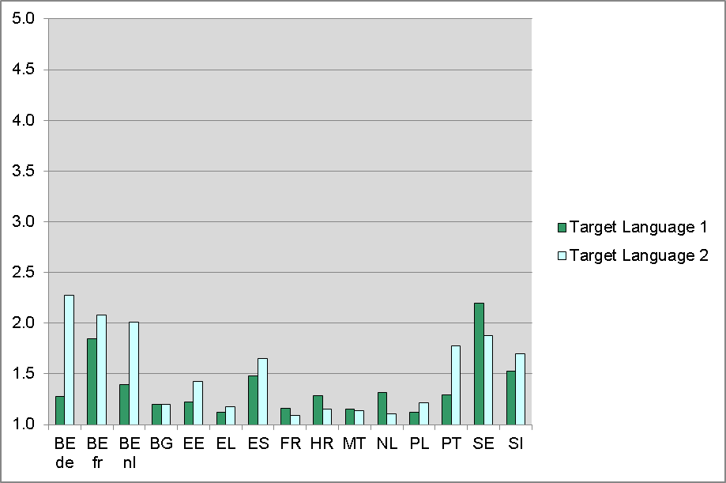
Figure 114 shows that in most educational systems most teachers teach the target language only. Exceptions with a mean number of taught languages above 1.5 are teachers of the second target language in the Flemish and German Communities of Belgium and Portugal and teachers of both target languages in the French Community of Belgium, Spain, Slovenia and Sweden. This pattern is in agreement with that of Figure 113 representing experience in teaching other languages than target language.

Managing and implementing the ESLC
The design and implementation of the European Survey on Language Competences (ESLC) was the responsibility of an international consortium, SurveyLang, led by Cambridge ESOL. The partners and key people in the consortium are outlined below.
SurveyLang partners
Institutions | Work areas | Website
Centre international d’études pédagogiques (CIEP) | Language testing (French) | www.ciep.fr
Gallup Europe | Sampling including base weights, testing tool development, translation | www.gallup-europe.be
Goethe Institut | Language testing (German) | www.goethe.de
Instituto Cervantes | language testing (Spanish) | www.cervantes.es
National Institute for Educational Measurement (Cito) | Psychometric analysis, questionnaires, sampling weights, data sets | www.cito.nl
University of Cambridge ESOL Examinations | Language testing (English), project management, field operations | www.cambridgeesol.org
Universidad de Salamanca | Language testing (Spanish) | www.usal.es
Università per Stranieri di Perugia; Centre for Assessment and Language Certification (CVCL) | Language testing (Italian) | www.cvcl.it

SurveyLang team members
SurveyLang is grateful to the many people involved in the ESLC over the course of the project, more than can be mentioned here. The table below presents the key SurveyLang contributors to their project together with their role.
SurveyLang member | Institutions | Position
Mike Milanovic | ESOL | Chair of Executive (February 2008 - December 2010), Vice Chair of Executive (December 2010 - present)
Jan Wiegers | Cito | Vice Chair of Executive (February 2008 - December 2010), Chair of Executive (December 2010 - present)
Neil Jones | ESOL | Project Director (December 2010 - present), Vice Project Director (February 2008 – December 2010)
Norman Verhelst | Cito | Project Director (February 2008 - December 2010), Testing design Lead, Standard Setting Listening and Reading
Erna Gille | Cito | Vice Project Director (December 2010 -present)
Johanna Kordes | Cito | Assistant Vice Director (December 2010-present), Reporting Lead on the results of the Questionnaires, Questionnaires Verification Coordinator
Karen Ashton | ESOL | Project Manager, Field Operations Lead
Rebecca Stevens | ESOL | Project Assistant, Field Operations Assistant
Robert Manchin | Gallup | Program Board Representative
Michaela Perlmann-Balme | Goethe | Program Board representative, German Language Testing Lead
Inma Borrego | USAL | Program Board representative, Spanish Language Testing Lead
Guiliana Bolli | CVLC | Program Board representative,
Sylvie Lepage | CIEP | Program Board representative, French Language Testing Lead
Victoria Rubini | Cervantes | Program Board representative
Sanneke Schouwstra | Cito | Questionnaires development Lead including framework and indices, Field Trial Questionnaire analyses Lead
Gunter Maris | Cito | Data Analysis Lead
Ivailo Partchev | Cito | Sampling weights Lead, Data Management Lead
Remco Feskens | Cito | Questionnaires analysis support
Jesse Koops | Cito | Data Management Co-Lead
Joost Schotten | Cito | Data Entry systems specialist
Roselyne Marty | CIEP | French Language Testing Lead
Francesca Pelliccia | CVLC | Italian Language Testing specialist (March 2009 – October 2009)
Danilo Rini | CVLC | Italian Language Testing specialist (from October 2009 to present)
Francesca Parizzi | CVLC | Italian Language Testing specialist (February 2008 to March 2009)
Barbara Spinelli | CVLC | Italian Language Testing Lead
Martin Robinson | ESOL | Language Testing Team Lead
Glyn Hughes | ESOL | English Language Testing Team Lead (July 2009 – April 2010)
Heidi Endres | ESOL | English Language Testing Team Lead (from April 2010 to present)
Andrew Balch | ESOL | English Language Testing Team Lead (February 2008 – July 2009)
Agnes Illyes | Gallup | Translation Lead
Peter Husztik | Gallup | Software systems specialist (WebTrans, sampling portal, Testing Tool), Translation Lead
Jostein Ryssevik | Gallup | Software systems Lead
Anna Chan | Gallup | Sampling specialist
Gergely Hideg | Gallup | Sampling Lead
Manas Chattopadhyay | Gallup | Sampling Lead
Claudia Schulze | Goethe | German Language Testing specialist
Julia Guess | Goethe | German Language Testing specialist
Marian Villoria | USAL | Spanish Language Testing specialist

Data tables
The data underlying the graphs in these appendices together with standard errors are provided in the EXCEL file ESLC Appendix all tables chapters 4-5-6.xls , available with this report.

Appendix: England results

Introduction
The first administration of the European Survey on Language competences secured the participation of fourteen countries – sixteen educational systems, as the three language communities of Belgium participated separately.
The main study was scheduled for the first quarter of 2011, preceded by a field trial of all systems one year earlier. England took part in the field trial together with the other participating countries, but from the outset expressed concerns that the timing of the main study would prove problematic, given that at this time of year schools in England are heavily engaged in exam preparation, and would thus be unwilling to participate. This concern was based on experience with a previous administration of PISA at a similar time of year. England proposed to conduct the survey in the autumn term, a proposal which the Commission accepted.
Administering the survey at a different time of year might be seen as a threat to the comparability of performance across countries; if only because the tested cohort is at an earlier stage in the school year. However, as the population description in Chapter 2 of the Final Report makes clear, the situation with language study in Europe is in any case very diverse, and the profile of the tested cohort varies in many respects from country to country. The onset of first or second foreign language study, the number of languages studied, the extent to which they are compulsory, the intensity of study - all these may vary widely across countries. In this situation the participation of England at a different time of year is but one of a number of factors which should be borne in mind in interpreting results and in making comparisons of observed performance.
Note that England is included in the population description in Chapter 2 of the Final Report, but is not included in any of the results reported in the other chapters. However, all the tabulated data underlying the results presented in the Final Report have been updated to include England and are available in the EXCEL file ESLC Appendix all tables 3 - 6.xls supplied with the Final Report.
The England dataset is available separately to the international dataset.

The language tests: results

Results by first and second target language
The charts in this section show the language test results for each skill, and by first and second target language. These are identified below each educational system. For England the first target language is French, the second is German.
The charts in this and following sections show results in terms of percentage of students achieving each CEFR level. Five levels are identified: Pre-A1 up to B2. It is important that A1 should be recognised as a positive learning achievement – it is not a synonym of “beginner”. The Pre-A1 category denotes students who have not achieved A1.
Educational systems are shown ordered, to make the charts easier to interpret. The ordering principle defines higher performance as having relatively more students at levels B1 and B2, and relatively fewer at Pre-A1 and A1. To be precise, performance is summarised as (1-proportion at Pre-A1 + 1-proportion at A1 + proportion at B1 + proportion at B2) / 4. The ordering is done by skill, so that the order of countries may vary across skills.
Different ordering principles would reflect different choices of priority, and produce somewhat different results. The principle used here attempts to reflect performance across the possible range of achievement.
The data underlying the graphs in this section together with standard errors are provided in the EXCEL file ESLC Appendix all tables chapters 3 - 6.xls, available with this report.
Figure 115: First target language Reading: CEFR levels by educational system
Figure 116: First target language Listening: CEFR levels by educational system
Figure 117: First target language Writing: CEFR levels by educational system
For first target language and for all skills England falls in last place a little below France (according to the ordering principle explained above). For first target language it is not unexpected that England should perform lower relative to other countries, given that for most other countries the first target language is English. The ESLC language tests and the questionnaire findings provide evidence that English enjoys a special status, in terms both of levels achieved and perceptions of its utility among students. Apart from England, the two other educational systems whose first target language in the survey is not English are the Flemish and German communities of Belgium, for whom it is French. English is the second target language for these two communities, and as shown in Figure 118 to Figure 120 below, they perform more highly in it than in French.
The status of English as a world language would thus explain the weaker performance of England in the first target language, relative to other countries.
Taken in absolute terms, achievement in first target language is also not strong, with only about 20% of students achieving a level above A1, and only about 10% achieving above A2. The proportion of students not achieving A1 is about 30%.
Figure 118: Second target language Reading: CEFR levels by educational system
Figure 119: Second target language Listening: CEFR levels by educational system
Figure 120: Second target language Writing: CEFR levels by educational system
In second language (German) England performs somewhat more strongly in Listening and Writing, coming above Sweden and Poland. In absolute terms levels of achievement are about as good as first target language, although achieved in a shorter timeframe.

Results by language
The charts in this section show results in French and German, by skill, enabling a direct comparison with countries tested in the same languages.
Figure 121: French Reading: CEFR levels by educational system
Figure 122: French Listening: CEFR levels by educational system
Figure 123: French Reading: CEFR levels by educational system
Figure 124: German Reading: CEFR levels by educational system
Figure 125: German Listening: CEFR levels by educational system
Figure 126: German Writing: CEFR levels by educational system

The contextual questionnaires: results
Chapter 5 of the Final Report gives a descriptive account of how educational systems responded to the questionnaires. Appendix 8.3 provides more detail and graphs. Chapter 6 then explores the relation of context factors with outcomes in the language tests. The data underlying the graphs and regression results, including England, are available in the EXCEL file ESLC Appendix all tables 3 - 6.xls supplied with the Final Report.
This section combines the purpose of Chapters 5 and 6 to offer a brief description of the questionnaire responses of England, focusing on indices where England ranks high or low relative to the average across educational systems (an unweighted mean). Significant and substantive differences are reported. The relation to performance in the language tests is then considered (below), reporting where effects observed for England are consistent with or differ from those found for other countries.

England’s responses compared with other educational systems

Basis for life-long learning of foreign languages
Regarding early language learning: English students report a relatively later start to FL and TL learning, and the testing grade (year 11) is the highest of any educational system.
Regarding current foreign language and target language learning time: the amount of total foreign language lesson time a week reported by English students is lower than the average by an hour per week for TL1, almost 2 hours for TL2.
English students report spending slightly more time preparing for tests for both target languages, but rather less than average on homework.
Regarding the diversity and order of foreign languages: the number of foreign languages learned as reported by students is slightly higher than average for both TLs, although there is substantially higher variation than average within the English cohort.

A language friendly living environment
The target language knowledge of students’ parents is rated significantly lower than the average by English students, as is their reported use of TL1 at home, and their exposure to either target language through the living environment.
By contrast, informal language learning opportunities through visits abroad are relatively higher for TL1, but not TL2.
Students’ exposure to and use of target language through traditional and new media is much lower than the average for TL1, and to a lesser extent for TL2.

Language friendly schools
Reported availability of multimedia labs is lower than average, but the presence of a virtual learning environment is higher, for both target languages. The availability of software for language assessment and language teaching is in line with the average.
Teachers claim to use ICT out of school somewhat more than average. Concerning ICT use in teaching teachers claim to use both ICT and web content substantially more than average.
English TL1 students’ reported use of ICT outside school and for doing homework is in line with the average, while TL2 students claim to use it significantly more.
Regarding intercultural exchanges: although funding for student exchanges as reported by principals is in line with the average across educational systems, teachers’ report of created opportunities for exchanges, and students’ reported participation, are above the average.
For TL1 the number of teachers for whom the taught language is a first language is significantly higher than average.
Regarding foreign language teaching approaches: Teachers report using the target language during lessons substantially less than average, particularly for TL1 – a perception shared by students.
For both TLs teachers’ report of emphasis placed on similarities between languages is substantially higher than average, and TL2 students also perceive significantly more emphasis.
English students’ perception of the usefulness of learning the target language is substantially lower than average. Their perception of the difficulty of learning languages is substantially higher. These differences are particularly evident for TL1.
Students’ rating of target language lessons, teacher and textbook(s) is lower than average for TL1, but not so for TL2.
For both TLs, far fewer students (26%) report that they are studying the language because it is compulsory, and far more because it is an optional subject which they chose. In fact languages are not compulsory at national level in England for the year group tested, so students’ perception of compulsion must depend on something other than the actual mandatory status of modern foreign languages.

Teacher initial and in-service training
For both TLs, substantially fewer teachers than the average claim their highest educational level to be ISCED 5B, and substantially more claim ISCED5A.
For both TLs and according to the report of both teachers and principals, the number of different financial incentives available for in-service training is higher than average.
In-service training is more frequently reported to be an obligation by teachers, but less frequently to be required for promotion.
The organisation of in-service training is far more frequently reported to be “during working hours with a substitute teacher for your classes”.
The focus of in-service training is substantially more on teaching-related subjects than the average.
Regarding the number of stays in the target culture by teachers for different reasons, English teachers report substantially more stays than average.
Regarding the use of existing European assessment tools, far fewer teachers than average report receiving training about the CEFR, or in the use of a portfolio, and far fewer report using the CEFR in their teaching.
Regarding teachers’ practical experience, teachers report a significantly longer than average duration of in-school teaching placement.
Teachers report considerably more years’ experience in teaching languages other than the target language than average, and report having taught a considerably greater number of languages over the past five years (TQ).

The relationship of context factors to language proficiency
Generally England confirms the relationship between contextual factors and language test outcomes found for the other educational systems.
Thus, the expected negative effect on test results found for ‘Perception of difficulty of target language learning’, which means that lower perceived difficulty is related to higher foreign language proficiency, is confirmed by the England results.
However, the finding that an earlier onset to language learning relates to higher test outcomes is not confirmed by the England results.
Unexpected negative effects demonstrated for ‘ICT use at home for foreign language learning’ and ‘Perceived emphasis on similarities between known languages’ are confirmed by the England results.
Expected positive effects on test results demonstrated for ‘Number of ancient and foreign languages learned’, ‘Parental target language knowledge’, ‘Target language exposure and use through traditional and new media’, ‘Perception of usefulness of target language and target language learning’ are all confirmed by the England results.
However, the finding that “teachers’ and students’ use of target language during target language lessons” relates positively to language test outcomes is not confirmed by the England results, where negative effects are found for 5 out of 6 target language/skill combinations..
The index ‘Compulsory language learning’ suggests that students who report studying the target language because it is compulsory have higher test scores than students who chose it as an option. This is confirmed by the England results for TL1 (French), but not TL2 (German).

Note, this refers only to the first and second most widely taught languages out of English, French, German, Italian and Spanish. For several educational systems, their first or second most widely taught language is not one of these languages.
The ESLC was carried out independently in the three constituent communities of Belgium
For a description of ISCED levels see: OECD (1999). Classifying Educational Programmes — Manual for ISCED-97. Implementation in OECD Countries, 1999 Edition. Paris: OECD.
In the Belgian French Community, more than 20% of students are not taken into account (Region of Brussels and in other bilingual areas where compulsory language learning starts earlier : 3rd grade of ISCED 1).
See Chapter 3 of the Technical Report for further details of these policy issues.
Malta: a considerable number of students report they start foreign language learning in grade 3, but they report they start English (the first TL) prior to grade 1.
Other data in the French Community of Belgium show a lower incidence of ISCED6 qualifications among teachers. In the questionnaire of the French Community of Belgium several examples of qualifications were included in the response options; ISCED 6: "Enseignement universitaire de 3e cycle (doctorat, agrégation de l’enseignement supérieur,...)" and ISCED 5A "Enseignement universitaire de 1er ou de 2e cycle, ou supérieur de type long (licence, études d’ingénieur civil, AESS…)". The example "agrégation de l’enseignement supérieur" might have been mistaken for "agrégation de l'enseignement secondaire supérieur" which is a ISCED 5A qualification

